**Topic 1: Model View Control**

Top of Form

Bottom of Form

**Content**

**Reading**

[Reading](https://dmacc.blackboard.com/webapps/blackboard/content/listContent.jsp?course_id=_102593_1&content_id=_7286710_1)

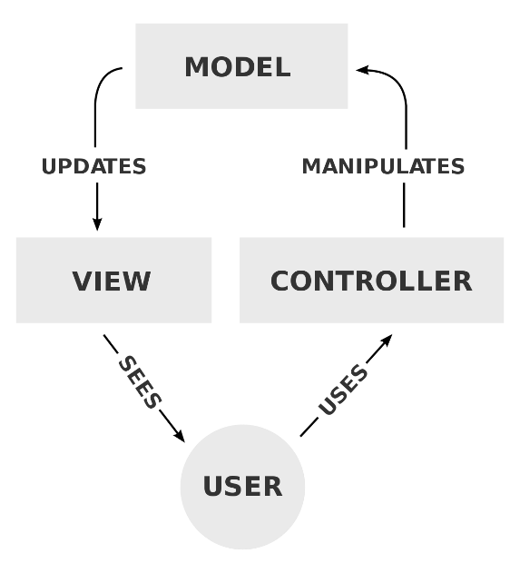Model View Controller (MVC)

* + Microsoft docs.microsoft.com
    - [ASP.NET MVC](https://docs.microsoft.com/en-us/aspnet/mvc/)
    - [Recommended tutorials and articles](https://docs.microsoft.com/en-us/aspnet/mvc/overview/getting-started/mvc-learning-sequence)
  + Geeksforgeeks geeksforgeeks.com
    - [MVC Design pattern](https://www.geeksforgeeks.org/mvc-design-pattern/)
  + TutorialsPoint tutorialspoint.com
    - [MVC Framework Introduction](https://www.tutorialspoint.com/mvc_framework/mvc_framework_introduction.htm)
    - [ASP.NET MVC - Overview](https://www.tutorialspoint.com/asp.net_mvc/asp.net_mvc_overview.htm)

**MVC**

The user interacts with the controller, the controller manipulates the model based on user interaction, then updates the view to produce a new view for the user.

* + User uses Controller
  + Controller manipulates Model
  + Model updates View
  + View displays to User

**NOTE: Newer Version look for MVC**

NOTE: Search for MVC instead of what is shown in the video. 

**Step 1. Create a project**

[Step 1. Create a project](https://dmacc.blackboard.com/webapps/blackboard/content/listContent.jsp?course_id=_102593_1&content_id=_7286710_1)

Create a Core MVC Web App Solution.

https://youtu.be/ooF_ozm8LTU

**Step 2. Add a Controller**

[Step 2. Add a Controller](https://dmacc.blackboard.com/webapps/blackboard/content/listContent.jsp?course_id=_102593_1&content_id=_7286710_1)

A controller is a C# class. It inherits from the Controller class of Microsoft.AspNetCore.Mvc. Review class and inheritance and OOP (Object-Oriented Programming) if you need a refresher.

https://youtu.be/FWnL5xmLjbQ

**Step 3. Add a view**

[Step 3. Add a view](https://dmacc.blackboard.com/webapps/blackboard/content/listContent.jsp?course_id=_102593_1&content_id=_7286710_1)

To add a view, you will use Razor. A [Razor view](https://docs.microsoft.com/en-us/aspnet/core/mvc/views/razor?view=aspnetcore-3.1) has the file extension .cshtml and contaings both HTML and C#.

https://youtu.be/Xd9LK7I7cTc

**Step 4. Core MVC Web App Configure and Run**

[Step 4. Core MVC Web App Configure and Run](https://dmacc.blackboard.com/webapps/blackboard/content/listContent.jsp?course_id=_102593_1&content_id=_7286710_1)

Startup.cs is the C# file that configures the middleware for the HTTP request in the Web App.

Now that you have a Controller and View, you can run your project. It's not terrible useful (yet) but you can continue to build on it.

https://youtu.be/C32-9YoGoeU

**Step 5. Add a Model and View Imports**

[Step 5. Add a Model and View Imports](https://dmacc.blackboard.com/webapps/blackboard/content/listContent.jsp?course_id=_102593_1&content_id=_7286710_1)

A model is a C# Class.

https://youtu.be/2n6o7pr7OSg

**Step 6. Handle GET and POST requests**

[Step 6. Handle GET and POST requests](https://dmacc.blackboard.com/webapps/blackboard/content/listContent.jsp?course_id=_102593_1&content_id=_7286710_1)

Index() methods

https://youtu.be/8Skkg_7vMpw

**Step 7. Validate User Input**

[Step 7. Validate User Input](https://dmacc.blackboard.com/webapps/blackboard/content/listContent.jsp?course_id=_102593_1&content_id=_7286710_1)

It is important to validate user input. Here you verify that the input is in the correct format and also follows business logic. An age should not be a negative number, a month has 12 possibilities, and many more.

https://youtu.be/8S6k15xctvY