**Topic 2: Tables in Databases**

Top of Form

Bottom of Form

**Content**

**Creating a database in any DBMS**

[Creating a database in any DBMS](https://dmacc.blackboard.com/webapps/blackboard/content/listContent.jsp?course_id=_102593_1&content_id=_7286672_1)

We can speak of database generically,and we have SQL to help us build database.

|  |
| --- |
| **CREATE TABLE**  **Students (**  **StudentID varchar(255),**  **FirstName varchar(255),   LastName varchar(255)  );** |

Learn more at <https://www.w3schools.com/sql/sql_create_table.asp>  
This is a great site to learn about SQL with SQL Tutorials. (And other topics!)

**Table Talk**

[Table Talk](https://dmacc.blackboard.com/webapps/blackboard/content/listContent.jsp?course_id=_102593_1&content_id=_7286672_1)

Since Computer Science has several names for the same concept, databases were not left out.

You have Rows and Columns, like a table. Rows are also records or tuples. Columns are also fields or properties.

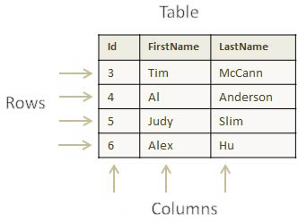

**But Wait...**

[But Wait...](https://dmacc.blackboard.com/webapps/blackboard/content/listContent.jsp?course_id=_102593_1&content_id=_7286672_1)



The next topics help you use databases.