**Topic 1: Classes and Properties**

Top of Form

Bottom of Form

**Content**

**Reading**

[Reading](https://dmacc.blackboard.com/webapps/blackboard/content/listContent.jsp?course_id=_102593_1&content_id=_7286780_1)

Object-Oriented Programming C# -- Encapsulation

* + Microsoft:docs.microsoft.com
    - [Classes and structs (C# programming guide)](https://docs.microsoft.com/en-us/dotnet/csharp/programming-guide/classes-and-structs/polymorphism)
  + GeeksForGeeks: geeksforgeeks.com
    - [C# | Encapsulation](https://www.geeksforgeeks.org/c-sharp-encapsulation/)
  + TutorialsPoint: tutorialspoint.com
    - [C# - Encapsulation](https://www.tutorialspoint.com/csharp/csharp_encapsulation.htm)
  + W3Schools: w3schools.com
    - [C# Properties (Get and Set)](https://www.w3schools.com/cs/cs_properties.asp)

**Class**

[Class](https://dmacc.blackboard.com/webapps/blackboard/content/listContent.jsp?course_id=_102593_1&content_id=_7286780_1)

C# has a class, class properties and class methods to model real world objects.

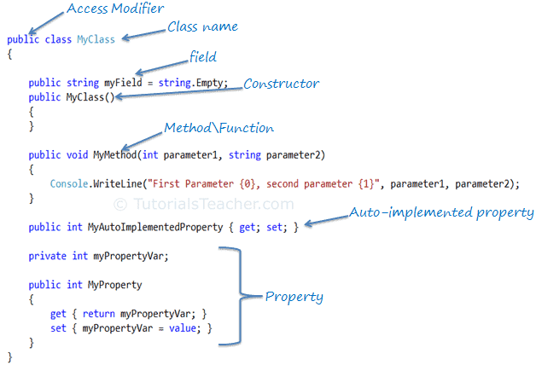

**Properties**

[Properties](https://dmacc.blackboard.com/webapps/blackboard/content/listContent.jsp?course_id=_102593_1&content_id=_7286780_1)

Properties are a special type of class member. A property contains a piece of data about the object. A house class might have NumberOfBedroom (string), NumberOfBathrooms (string), SquareFootage (int), Garage (boolean). 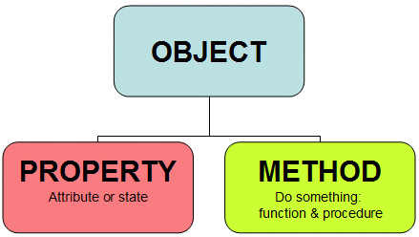

**Example House class**

[Example House class](https://dmacc.blackboard.com/webapps/blackboard/content/listContent.jsp?course_id=_102593_1&content_id=_7286780_1)

https://youtu.be/4afFypweFyw

public class House {

// fields

private string _address;

private int _numberBedrooms;

private int _numberBathrooms;

// Constructors

public House() // default no-arg

{

Address = "";

NumberBedrooms = 0;

NumberBathrooms = 0;

}

public House(string address, int numberBathrooms, int numberBedrooms)

{

Address = address;

NumberBathrooms = numberBathrooms;

NumberBedrooms = numberBedrooms;

}

//Properties with public access to set and get values

public string Address { get => _address; set => _address = value; }

public int NumberBedrooms { get => _numberBedrooms; set => _numberBedrooms = value; }

public int NumberBathrooms { get => _numberBathrooms; set => _numberBathrooms = value; }

public override string ToString()

{

return ("House at " + Address + " has " + NumberBedrooms + " bedrooms and " + NumberBathrooms + " bathrooms.");

}

}

**ToString() method**

[ToString() method](https://dmacc.blackboard.com/webapps/blackboard/content/listContent.jsp?course_id=_102593_1&content_id=_7286780_1)

https://youtu.be/5NY0MT0ZAdk

override

public String ToString()

{

return (" The house at " + this.Address + " has " + this.NumberBathrooms + " bathrooms and " +

this.NumberBedrooms + " bedrooms.");

}

[**Book Class**](https://dmacc.blackboard.com/webapps/assignment/uploadAssignment?content_id=_7286803_1&course_id=_102593_1&group_id=&mode=view)

Create a class, called Book with properties for an author, title, keywords, publication date and ISBN.

Submit Book.cs with Academic Honesty Header included.

Extra Credit: Use a collection for keywords. The collections you have used are array and List. Which is more appropriate when not all books will have the same number of key words? (up to 3 points)