**Topic 3: Creating Objects**

Top of Form

Bottom of Form

**Content**

**Creating Objects in a Driver**

[Creating Objects in a Driver](https://dmacc.blackboard.com/webapps/blackboard/content/listContent.jsp?course_id=_102593_1&content_id=_7286782_1)

https://youtu.be/Q_vs9Pb2idI

namespace Module8

{

class Program

{

static void Main(string[] args)

{

House myHouse = new House("123 Main Street, Rose City, Iowa", 2, 3);

Console.WriteLine(myHouse.ToString());

House yourHouse = new House();

yourHouse.Address = "123 Main Street, Ames, Iowa 12345";

yourHouse.NumberBathrooms = 2;

yourHouse.NumberBedrooms = 5;

Console.WriteLine(yourHouse.ToString());

Console.WriteLine(yourHouse.NumberBedrooms);

}

}

}

[**Driver for Book Class**](https://dmacc.blackboard.com/webapps/assignment/uploadAssignment?content_id=_7286791_1&course_id=_102593_1&group_id=&mode=view)

For your Book class, write a driver that creates objects, two book objects.

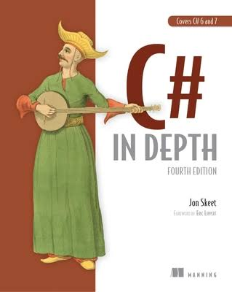

Object one:

[C# in Depth:](https://g.co/kgs/PV9A4z) 

Use the default no-arg default constructor.

Set the values using properties.

Object two:

[murach's ASP.NET Core MVC](https://www.murach.com/shop/murach-s-asp-net-core-mvc-detail)

Use the non-default constructor and set values for attribute, except include an incorrect author.

Use the set to change the author property to the correct author.

Display the information for both books.

Gotchas: If you used a collection, make a new List object or array to avoid null exception. Also, in the ToString(), you will need to do some extra coding to create a string of the keywords using the array or List.

Output:

|  |
| --- |
| murach's ASP.NET Core MVC, Mary Delamater and Joel Murach, January 2020, keywords: C#, ASP.NET, MVC, ISBN 978-1-943872-49-7  C# in Depth, Jon Skeet, Mar 23, 2019, keywords: C#, programming, ISBN 9781617294532 |

Submit your Book.cs and Program.cs file.