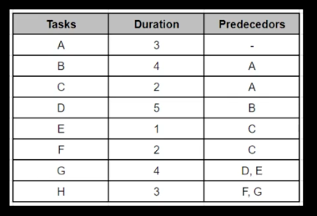

|  |  |  |
| --- | --- | --- |
| ES  2020/1/1 | D  3 | EF  2020/1/3 |
|  | Task A |  |
| LS  2020/1/1 | F  0 | LF  2020/1/3 |

|  |
| --- |
| START |

|  |  |  |
| --- | --- | --- |
| ES  2020/1/4 | D  3 | EF  2020/1/7 |
|  | Task B |  |
| LS  2020/1/4 | F  0 | LF  2020/1/7 |

|  |  |  |
| --- | --- | --- |
| ES  2020/1/4 | D  2 | EF  2020/1/6 |
|  | Task C |  |
| LS  2020/1/5 | F  2 | LF  2020/1/7 |

|  |  |  |
| --- | --- | --- |
| ES  2020/1/8 | D  5 | EF  2020/1/12 |
|  | Task D |  |
| LS  2020/1/8 | F  0 | LF  2020/1/12 |

|  |  |  |
| --- | --- | --- |
| ES  2020/1/7 | D  1 | EF  2020/1/8 |
|  | Task E |  |
| LS  2020/1/7 | F  0 | LF  2020/1/8 |

|  |  |  |
| --- | --- | --- |
| ES  2020/1/7 | D  2 | EF  2020/1/9 |
|  | Task F |  |
| LS  2020/1/7 | F  0 | LF  2020/1/9 |

|  |  |  |
| --- | --- | --- |
| ES  2020/1/13 | D  4 | EF  2020/1/16 |
|  | Task G |  |
| LS  2020/1/13 | F  0 | LF  2020/1/16 |

|  |  |  |
| --- | --- | --- |
| ES  2020/1/17 | D  3 | EF  2020/1/19 |
|  | Task H |  |
| LS  2020/1/17 | F  0 | LF  2020/1/19 |

|  |
| --- |
| FINISH |