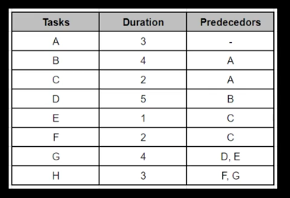

When is the delivery date?

The task is considered of 8 tasks, and will be delivers after 24 days on time

Which tasks could be delayed without delaying the schedule?

Task A : can be delayed

Task G : can be delayed

Task H : can be delayed