**­­­­­­Prognostic value of CA20, a score based on centrosome amplification-associated genes, in breast tumors**

Developed a signature, “CA20”, comprising centrosome structural genes and genes whose dysregulation is implicated in inducing CA. CA20 was a significant independent predictor of worse survival in two large independent datasets after adjusting for potentially confounding factors.

Datasets: METABRIC (1969 primary breast cancers) and TCGA (524 primary invasive breast cancers

METABRIC:

Stratification: Average CA20 and CIN35 scores , optimal cutpoints in CA20 and CIN25 scores in discovery sets using log rank test. CA20, when stratified by optimal and average cut points, significantly predicts BCSS in multivariate model.  CA20 (whether stratified by the average score or optimal cutpoint) is a significant predictor of BCSS after adjusting for stage and chemotherapy. 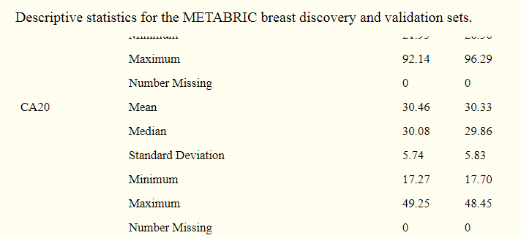 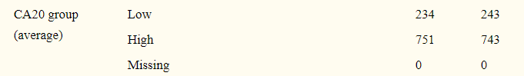

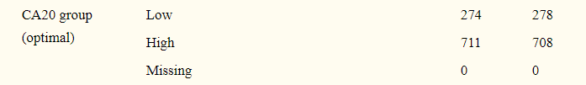

**TCGA dataset:**

Average and optimal cut point stratification

Discussion

we found that high CA20 score was associated with worse BCSS and OS after adjusting for potentially confounding factors, suggesting that CA20 could be a useful clinical tool to identify breast cancer patients at greater risk of poor outcomes. When both CA20 and CIN25 were factored into multivariable models, only CA20 was significantly associated with outcomes. This finding suggests that when CA20 is accounted for CIN25 no longer holds prognostic value.

Calculation details of CA20 Score:

Data: log2 median-centered signature gene expression levels. **METABRIC dataset:** Normal breast, benign breast neoplasms, and cases without BCSS annotation were excluded from analyses, resulting in a sample size of n = 1,969 primary breast cancers. T**CGA dataset:** Normal breast specimens, metastases, and male breast cancers were excluded from analyses, resulting in a sample size of n = 524 primary invasive breast cancers. The CA20 and CIN25 scores were calculated as the sum of the normalized (log2median-centered) expression levels of the signature genes.