

**COS221**

**Practical Assignment 5**

**May 2025**

[**GitHub Repository**](https://github.com/HamdaanMirza/Procrastinators)

**Task 1: Research**

The expansion of online shopping has surged notably since the COVID-19 pandemic, mainly because of its convenience, variety of products, competitive pricing, and simple price comparison. Consumers buy familiar and daily use products like electronics, clothing items, cosmetics etc. when doing online shopping. Prices on the internet are generally lower than offline due to reduced overhead costs, and buyers can quickly compare deals across outlets. Though there are issues in the likes of a lack of physical contact, trust issues, faulty deliveries, and inadequate personal assistance, internet shopping and physical shopping are evolving to be more towards a blend or hybrid omnichannel model.

In the modern era some of the most prevalent product categories coincide with popular global trends. Currently some of these product categories include the following: Clothing: With phenomena such as fast fashion the clothing industry continues to dominate the e-commerce market with websites such as Shein profiting from this boom. Skincare & Make-up: Fuelled by social media, the trend of using make-up and improving skincare has taken the market by storm with many emulating what they see online. Vitamins and Supplements: Following the COVID-19 pandemic, many have realised the importance of staying healthy and improving nutrition. Arts and crafts materials: Platforms such as Pinterest and Etsy have in recent years promoted creativity and increased the demand for supplies. Technology: Today’s digital and technological market is the biggest is has ever been as a result of the increasing use of technology in every day.

Looking at the online shopping scene, it appears that clothing, electronics alongside with home goods are the dominant product categories. These categories are favoured due to the variety of options and convenience. However, when it comes to using price comparison tools, categories like beauty products, tech gadgets and health supplements are more popular. Consumers compare these products prices before purchasing to save value on their purchases. Also, the pricing of such products varies significantly across retailers compared to other categories. Although luxury items and appliances are not purchased as frequently as the above-mentioned products, they remain popular in price comparison tools due to their heavy cost. The demand for specific product categories depends also on the current season and the state of the market.

The user experience (UX) is a vital part of the success of an e-commerce site. A well designed UX instils trust on the website from users and can boost the performance of the site as well. Trust in a website influence if a user will spend time or money on the website. 40% of users will stop using a website if it takes more than 3 seconds to load, 39% of users’ engagement will fade if images don’t load or load too slow and 88% of users are less inclined to re-use a site after a bad experience. According to Baymard’s research, bad UX design at the checkout process leads 18% of users not to trust the sites with their credit card information.

**References:**

* R. Pardal. “Retail vs. E-Commerce: The Future of Shopping.” ResultFirst <https://www.resultfirst.com/blog/ecommerce-seo/retail-vs-e-commerce-the-future-of-shopping/> [Accessed May 1, 2025].
* J. Dublino. “Retail or E-tail? Buying Online vs. Buying in Person.” business.com <https://www.business.com/articles/retail-or-e-tail-buying-online-vs-buying-in-person/> [Accessed April 30, 2025].
* S. Harlow. “In-store vs. Online Shopping Experiences: What’s the Deal?” GWI <https://www.gwi.com/blog/in-store-online-shopping-whats-new> [Accessed April 30, 2025].
* A. Zamfirache. N. A. Neacșu, A. Madar, S. Bălășescu, M. Bălășescu, and I.-M. Purcaru. “Behavioural differences and purchasing experiences through online commerce or offline within mall-based retail structures.” Electronic Commerce Research <https://link.springer.com/article/10.1007/s10660-024-09879-6> [Accessed May 1, 2025].
* Shopify Staff. “Top Online Shopping Categories (2025).” Shopify <https://www.shopify.com/blog/top-online-shopping-categories?term=&adid=732950216852&campaignid=22418272481&utm_medium=cpc&utm_source=google&gad_source=1&gbraid=0AAAAAC3NCDp1RotNFYTO3H6I77jzZV01v&gclid=Cj0KCQjw8cHABhC-ARIsAJnY12x1tIo8plBDZGKeaMiR2PLmL9uA6r84FCuSHj3CmplKNRNrWrpUWMMaAmk1EALw_wcB&cmadid=516752332;cmadvertiserid=10730501;cmcampaignid=26990768;cmplacementid=324494362;cmcreativeid=163722649;cmsiteid=5500011> [Accessed May 1, 2025].
* Anonymous. “Top Online Shopping Categories.” Intuit Mailchimp <https://mailchimp.com/resources/top-online-shopping-categories/> [Accessed April 29, 2025].
* Adam Rogers. “20 Trending Products and Things To Sell Online (2025).” Shopify <https://www.shopify.com/za/blog/trending-products> [Accessed April 30, 2025].
* Anynomous. “The significance of User Experience for E-Commerce Websites.” V-Hub <https://www.vodacombusiness.co.za/business/v-hub/knowledge-centre/the-significance-of-user-experience-for-ecommerce-websites> [Accessed April 30, 2025].
* Christian Holst. “40+ UX Statistics (from 150,000 hours of UX Research).” Baymard Institute <https://baymard.com/learn/ux-statistics> [Accessed May 1, 2025].

**Task 2: (E)ER-Diagram**

**Assumptions:**

1. ***Users*** can be either ***Customers*** or ***Admins* who are** distinguished by an AccessLevel attribute.
2. Each *user* must register with a **username, email, and password**, and has an ApiKey, possibly for third-party integrations.
3. Only *customers* can leave ***reviews***, and only ***admins*** can manage *categories*, *products*, *listings*, and *retailers*.
4. Both *Admins* and *Users* can leave *Review responses.*
5. *Users* can flag *reviews* or *review responses*, and *admins* can remove these comments when necessary and warn *users* or suspend accounts.
6. Each *retailer* has one or more *listings*, and each *listing* references:

* A *product*
* A price
* A date (indicating when the price was listed).

1. Each *retailer* has an address composed of Country, City, and Street attributes to contact physical *retailers* locations by *admins*, but also make them available to *customers*.
2. *Retailers* have an optional RetailerURL, assuming each has an online presence.
3. A *product* can be listed by multiple *retailers* (N:M between *Retailer* and *Product* via *Listing*).
4. Each *product*:

* Belongs to one or more *categories*(Belongs_To 1:N).
* Has an ImageURL, assuming external image hosting.
* Has attributes like ProductName, Brand, and Description.

1. Each *category* can group multiple products (1:N), and is identified by a CategoryID and CategoryName.
2. A *review*:

* Includes A Rating, Comment, and Date.
* Is linked to one *user* and one *product* (Gives, Evaluates).

1. A *review* may have one or more responses (has relationship to *ReviewResponse*), with fields such as Reply, ResponderName(username), and ResponseNumber.
2. The system generates AverageRating and ReviewCount per *product* dynamically.
3. The system also calculates the *review* count per *user.*
4. Passwords are protected using a Salt field and hashing.

**1st iteration:**

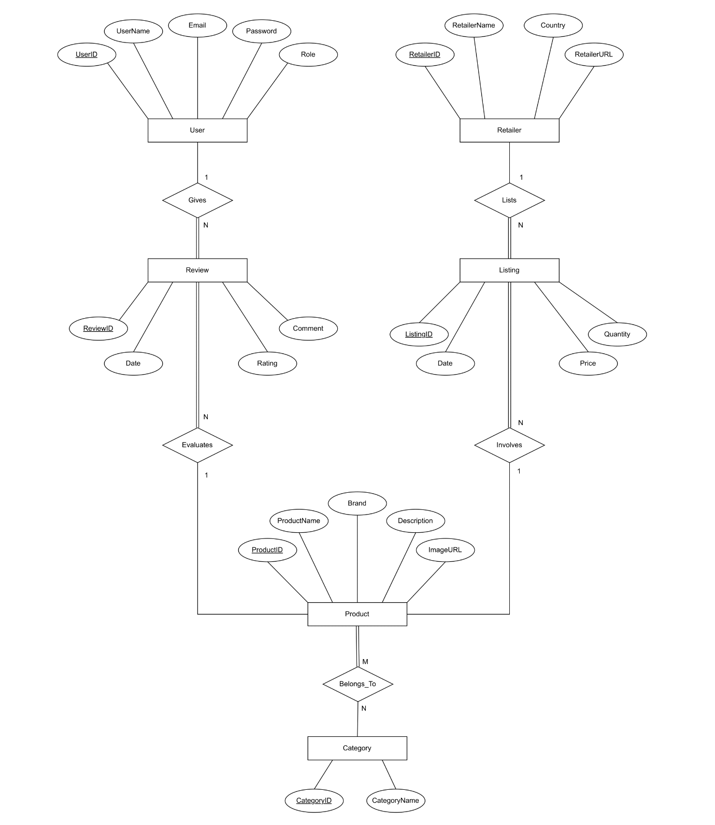

**2nd iteration:**

**Improvements:**

* Added *Admin* and *Customer* specializations, which replaced the Role attribute.
* Added a *ReviewResponse*, which is a weak entity that belongs to a *Review*.
* Changed the Country attribute in *Retailer* to a composite Address attribute.
* Removed Quantity attribute from *Listing*.

**3rd iteration (Final):**

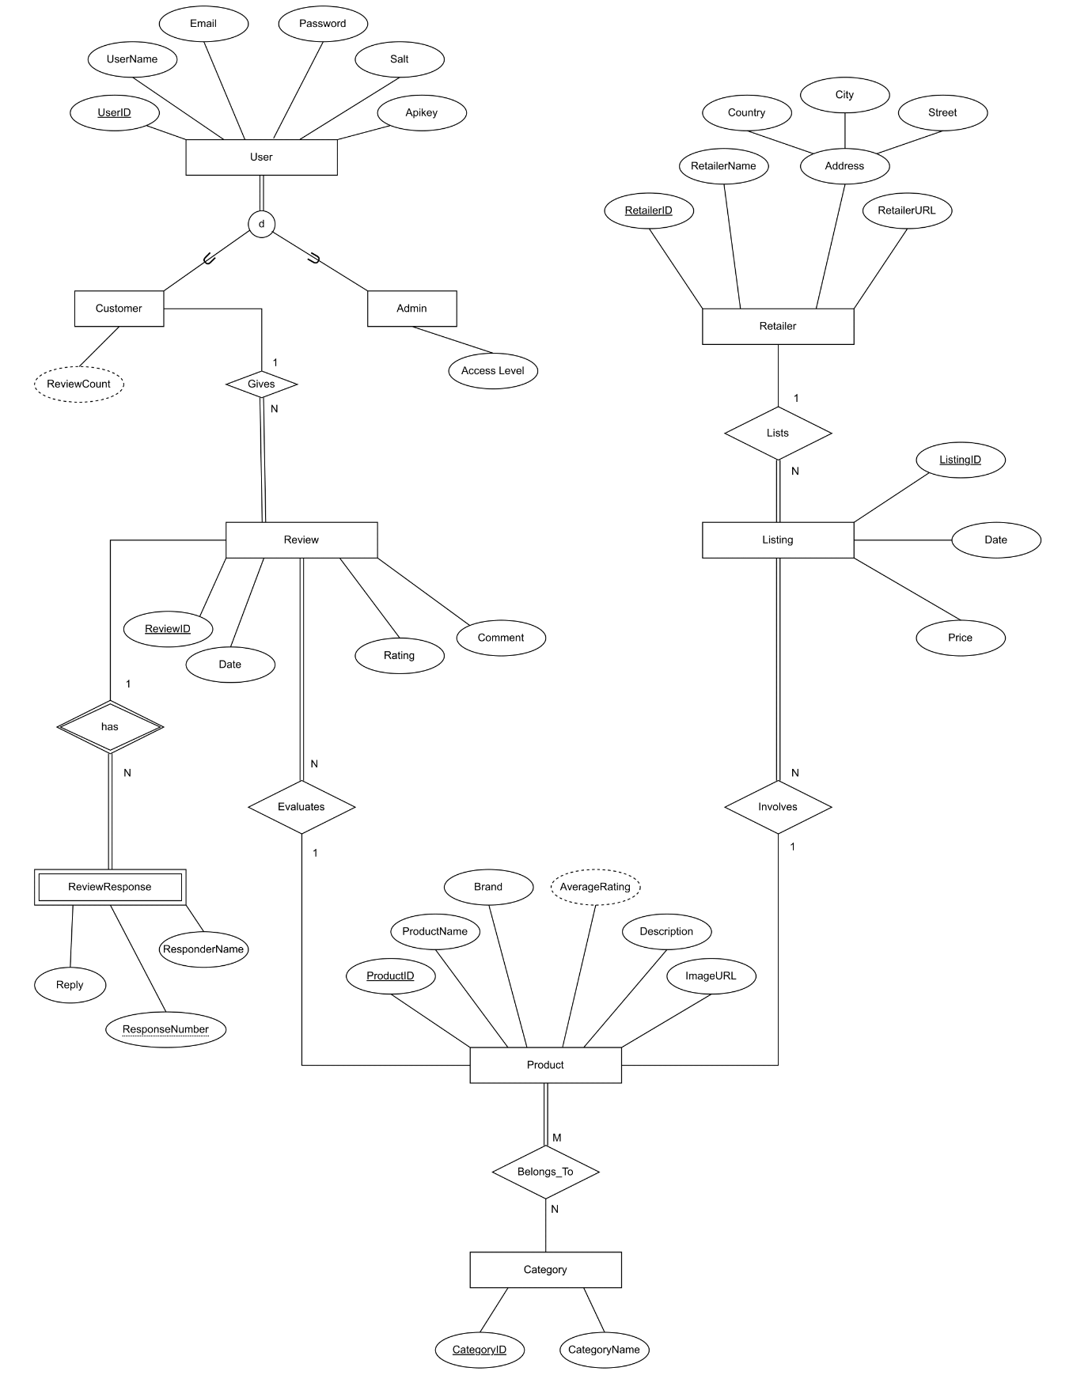

**Improvements:**

* Added AverageRating derived attribute to *Product*.
* Added Salt and Apikey attributes to *User*.

**Task 3: (E)ER-Diagram to Relational Mapping**

**Step 1: Mapping of regular(strong) entity types**

**Step 2: Mapping of weak entity types**

**Step 3: Mapping of Binary 1:1 relationships**

* No 1:1 relationship.

**Step 4: Mapping of binary 1:N relationships**

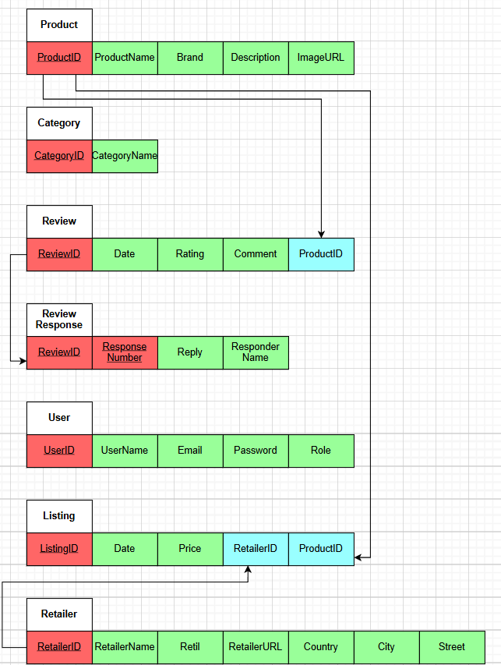

Approach:

* The mapping choice was including primary key of relation on the 1 side alongside with the relationship attributes to the relation on the N side.
* This approach was favoured because the alternative approach to create a relation with primary keys can lead to NULL values in the foreign keys.

**Step 5: Mapping of binary M:N relationships**

**Step 6: Mapping of multivalued attributes**

* No multivalued attributes.

**Step 7: Mapping of N-ary relationships**

* No N-ary relationship.

**Step 8: Mapping specialisation and generalisation**

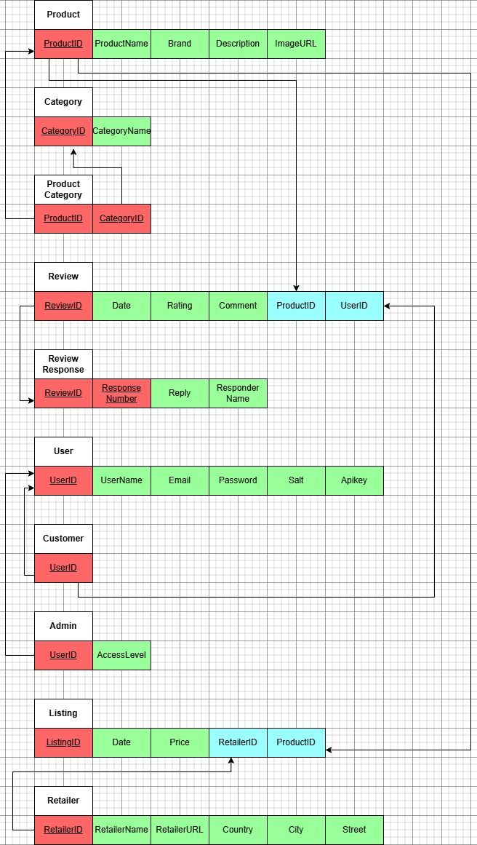

Approach:

* Multiple relations - superclass and subclasses

**Step 9: Mapping unions**

- No union types.

**Final Relational Mode:**

**Task 4: Relational Schema**

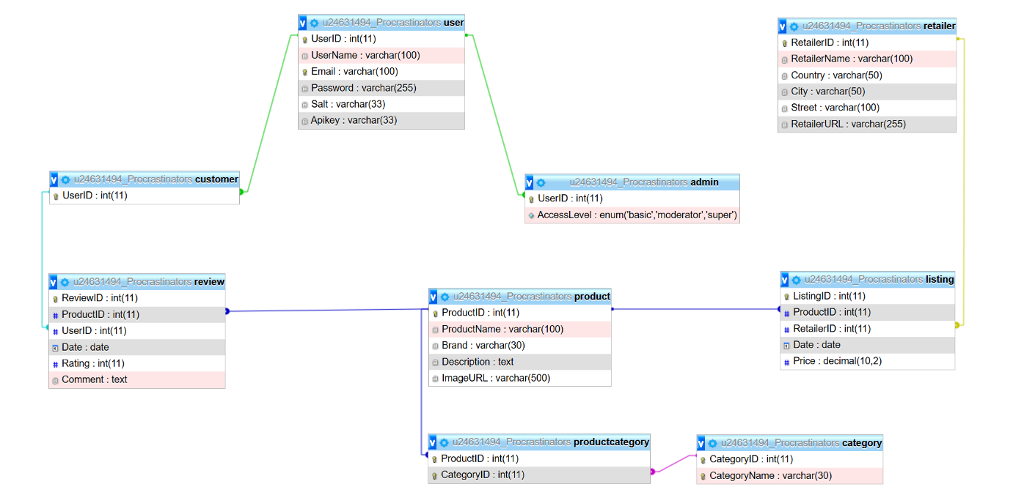

* SQL statements to create the database are also included in the database dump attached with the submission.

**Task 5: Web-based Application**

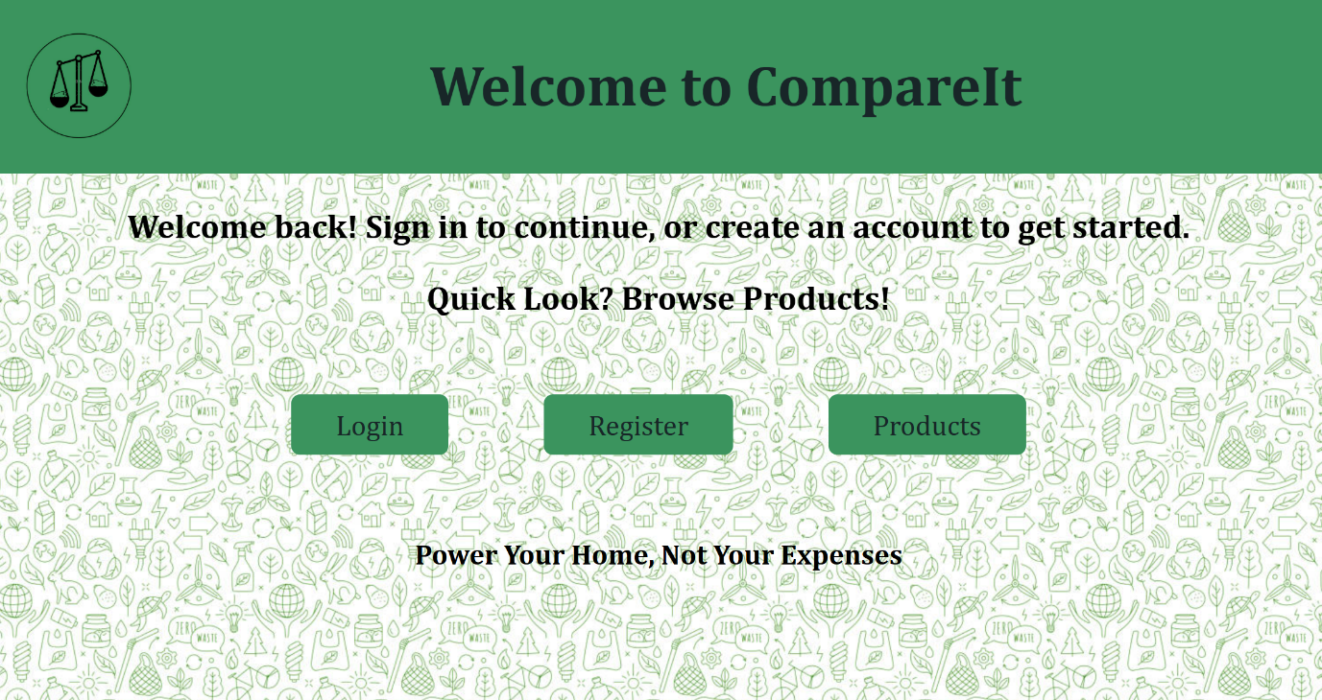

* An archive containing the web-based application is attached with the submissions.

**Task 6: Data**

* Getting access to a suitable products API was a challenge. So, we used AI to populate our database products. We then populated the products imageURL column manually, using images hosted on websites such as Vecteezy. The option of using scripts that generate artificial data was not optimal due to the need of large quantity of products. We populated the other tables manually as well, using generated scripts from AI machines like ChatGPT. These sql scripts where then executed on our database. The reason for our choice was it was the only way we could found suitable to have valid data. We chose a niche (Home Appliances), and then generated suitable retailers, categories, and products data. This process made it easier to populate the database, because it is simpler to work with related data.

**Task 7: Analyse and Optimise**

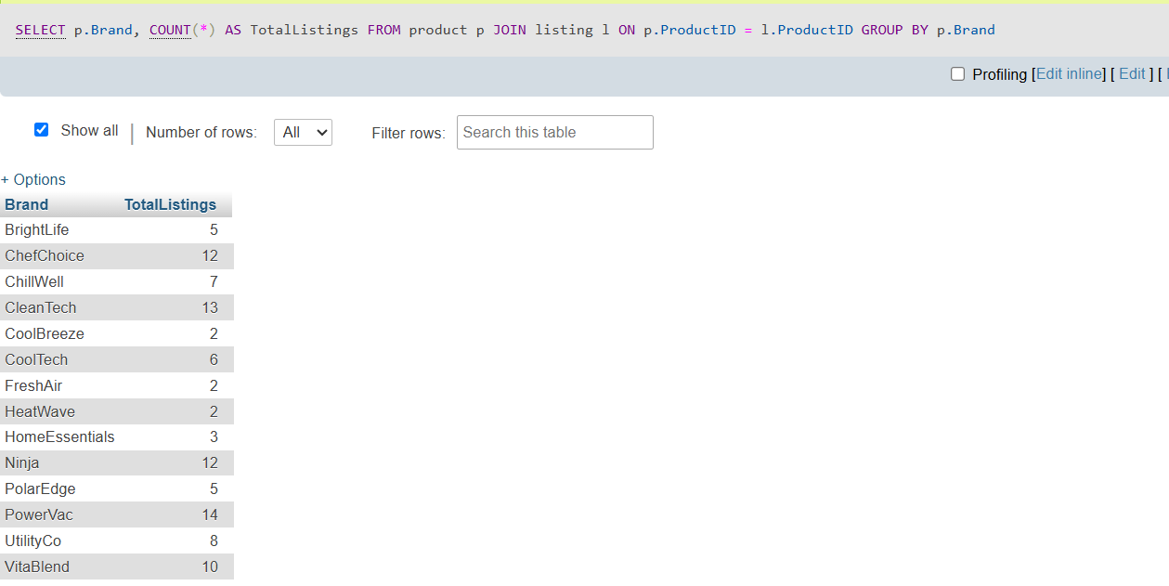

The query we executed gets listing by brand. It determines how many listings are there for each brand. The query joins the product and listing tables together by ProductID and groups the result by Brand, but this query could be optimized to generate results quicker. As can be seen in the image below, l is doing a full scan, no index helps with the join.

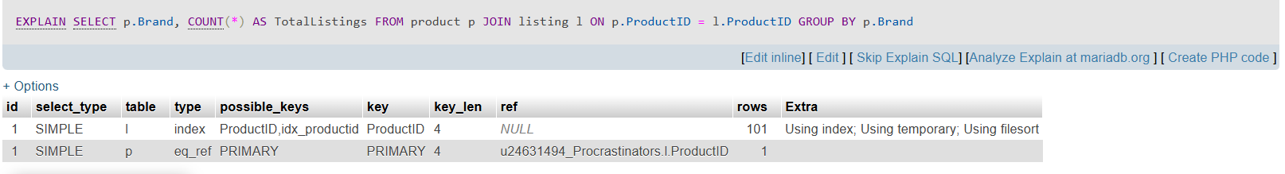  
To solve this problem we add the following:  
*CREATE INDEX index_ProductID ON listing(ProductID);*The above helps because the join is now indexed which then speeds up the process for finding matching products for each listing. The database now does not scan the whole listing table. The gain from this is that we save a lot of time especially when working with large databases. As for the loss, we need extra disk space to store index_ProductID and inserting, updating and deleting become a bit slower.

**Task 8: Development**

* This project was developed using GitHub. (Link to GitHub repository can be found in cover page).
* A README file on how to build and execute the application is attached with the submission.

**Task 9: Demo**

**Contributions:**

1. AEM Ahmed (u24898008):
2. Task 1: Price comparison tools paragraph.
3. Task 2: Creating the (E)ER diagram.
4. Task 5: Backend(php) and Linking(js).
5. Submission PDF.
6. EE Kusel (u24670058):
7. Task 1: Formatting and referencing .
8. Task 5: Backend(php) and Linking(js).
9. Task 10: Implementing security features
10. A Lange (u24587312):
11. Task 1: Popular user experience importance paragraph.
12. Task 4: Creating the databasae.
13. Task 5: Frontend(html, css).
14. Task 6: Populating the database.
15. HI Mirza (u24631494):
16. Task 1: Products bought by consumers paragraph.
17. Task 5: Frontend(html, css)
18. Task 6: Populating the database.
19. Task 7: Analysing and Optimising SQL query.
20. A Rooplall (u24568792):
21. Task 1: Popular product categories paragraph.
22. Task 3: EER to Relational Model conversion.
23. Task 5: Backend(php) and Linking(js).
24. README file.

**Task 10: Bonus**

**Our Choice: Security First– Secure Your App**

***Password Hashing:***

Implementation in api.php:

$salt = bin2hex(random_bytes(16));

$hashedPassword = hash("sha512", $data["Password"] . $salt);

Implementation process:

1. Generate a unique salt

2. Combine password with salt

3. Hash the combination

4. Store both hash and salt

***Login Attempt Rate-Limiting:***

Implementation in api.php:

private $max_attempts = 5;

private $time_window = 300; (5 minutes)

private $lockout_duration = 900; (15 minutes)

Implementation process:

1. Track attempts per user - We create a unique identifier using IP address + email combination

2. Monitor within time windows - We only count failed attempts within the last 5 minutes

3. Implement progressive lockout - After 5 failed attempts, we lock the account for 15 minutes

4. Reset on success - When login succeeds, we clear the attempt counter