EER to Relational Model Steps:  
  
Step 1:

Step 2:

Step 3:

No 1:1 relationship.

Step 4:

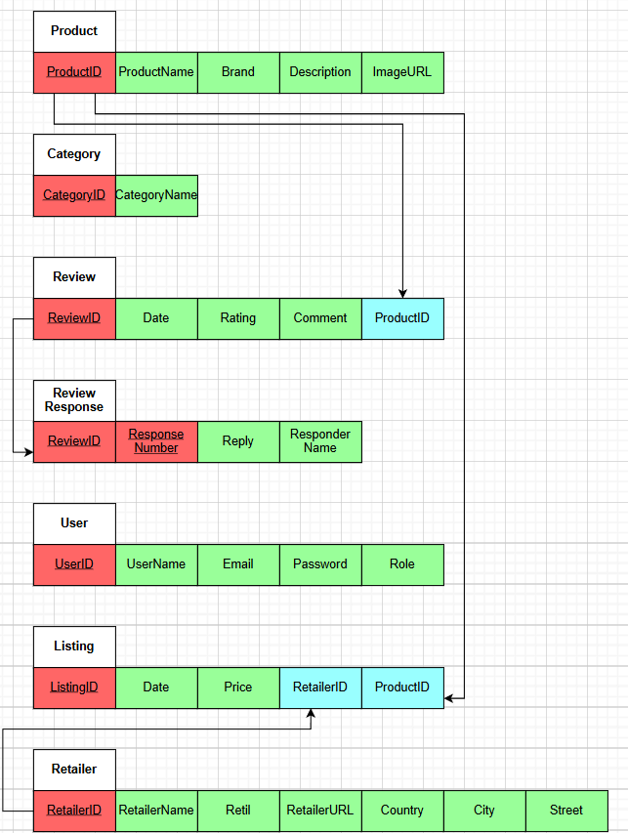

Step 5:

Step 6:

No multivalued attributes.

Step 7:

No N-ary relationship.

Step 8:  
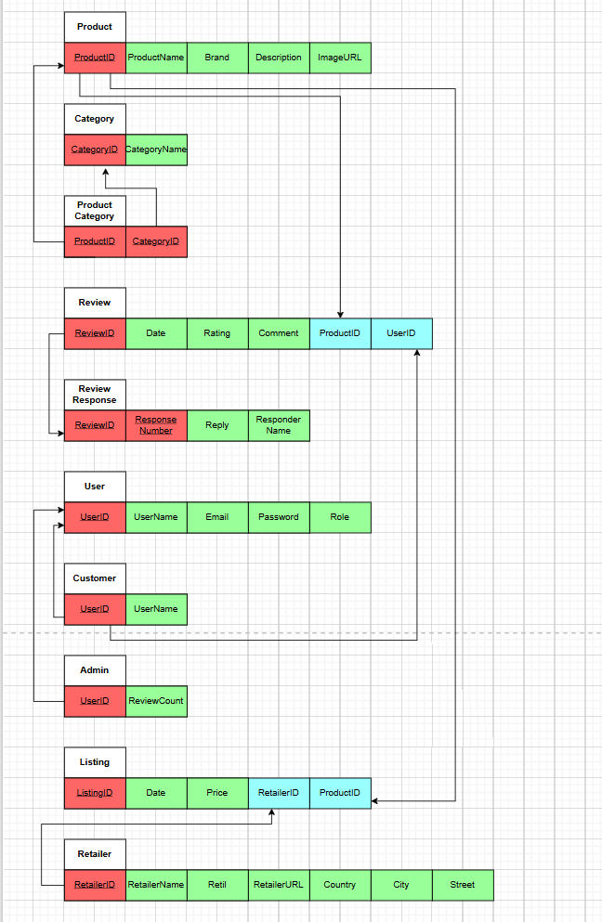

Step 9:  
No union types.

**Bonus marks:**

Password Hashing:

Implementation in api.php:

$salt = bin2hex(random_bytes(16));

$hashedPassword = hash("sha512", $data["Password"] . $salt);

Implementation process:

1. Generate a unique salt

2. Combine password with salt

3. Hash the combination

4. Store both hash and salt

Login Attempt Rate-Limiting:

Implementation in api.php:

private $max_attempts = 5;

private $time_window = 300; (5 minutes)

private $lockout_duration = 900; (15 minutes)

Implementation process:

1. Track attempts per user - I create a unique identifier using IP address + email combination

2. Monitor within time windows - I only count failed attempts within the last 5 minutes

3. Implement progressive lockout - After 5 failed attempts, I lock the account for 15 minutes

4. Reset on success - When login succeeds, I clear the attempt counter

5. Automatic cleanup - I remove old attempt records to keep the system efficient