GAME DESIGN DOCUMENT
Crossy Road: Safe Crossing
A Semester Project (Game Jam), submitted for the CS and IT Department.

Game Title | Crossy Road
Student Name | Hamdan Raza
Registration No. | 22PWBCS0926
Department | CS and IT
Submitted To | Sir Behram
Date | 06/07/2026
GitHub Repository | https://github.com/HamdanRaza309/Crossy-Road

1. Game Title
Crossy Road: Safe Crossing
The title keeps the recognizable "Crossy Road" arcade identity while the subtitle, Safe Crossing, signals the underlying road safety message the project is built around.
2. Theme Chosen
Social Issue: Road Safety Awareness.
The project addresses careless road crossing and poor traffic judgement, a common and preventable cause of pedestrian accidents, by turning the core skill of safe crossing, observation, timing, and patience, into the central game mechanic.
3. Inspiration
Road accidents caused by careless or hurried crossing are a frequent and preventable problem, especially for pedestrians who misjudge the speed or distance of oncoming traffic. Many such incidents happen not because people are unaware that roads are dangerous, but because they underestimate how quickly a gap in traffic can close, or because they cross while distracted or in a hurry. This game reimagines that everyday risk as an arcade challenge, where the player must learn to read traffic patterns, wait for safe gaps, and cross deliberately rather than rushing.
The idea was inspired by classic lane-crossing arcade games such as Frogger and Crossy Road, which naturally simulate the core skill needed for safe road crossing, timing and observation, while keeping the experience fun and replayable rather than preachy. Building the game as an individual game jam project also meant the mechanic had to communicate its message purely through gameplay, without relying on long text or cutscenes.
Message for the player: crossing a road is not about speed, it is about timing, patience, and awareness. Every reckless step, whether in-game or in real life, can have irreversible consequences, while a calm, observant crosser reaches the other side safely every time. The endless, ever-repeating structure of the game reinforces that safe crossing is a habit that must be practiced consistently, not a one-time decision.
4. Game Concept
Crossy Road: Safe Crossing is a 3D, low-poly, endless lane-crossing arcade game built in Unity using free Kenney.nl assets for characters, vehicles, and environment props. The player controls a small animal character that must advance across an infinite, procedurally generated street made of alternating grass strips and busy roads.
Grass lanes are safe but may contain trees blocking direct paths, forcing the player to sidestep rather than always moving straight ahead. Road lanes contain vehicles travelling at a constant speed in alternating directions, so no two lanes behave identically. The player hops forward one grid tile at a time, choosing when it is safe to advance, retreat, or move sideways to dodge traffic. As the player advances, old terrain behind them is cleaned up automatically so the game can run indefinitely without slowing down. The overall goal is to survive and travel as far as possible, with the player's furthest distance acting as the score.
5. Core Gameplay
What the player does:
- Moves the character one grid block at a time using WASD or Arrow keys, handled through Unity's New Input System.
- Times each hop to cross grass strips and road lanes without colliding with a vehicle or getting boxed in by trees.
- Advances continuously forward along the Z-axis while the terrain generates procedurally ahead of the player and is cleaned up behind them.
Main mechanics:
- Grid-based movement with a coroutine-driven hopping animation, using Mathf.Sin to arc the Y-axis, for a satisfying, rhythmic arcade feel instead of an instant teleport between tiles.
- Procedural terrain generation: a TerrainGenerator script randomly spawns grass or road lane prefabs ahead of the player and destroys old lanes once they fall far enough behind the player's furthest position, keeping memory use and performance stable.
- Randomized obstacle and vehicle placement, with vehicles alternating direction per lane and moving at a constant velocity, while spawn logic guarantees at least one clear path through each lane.
- Smooth camera-follow system using Mathf.Lerp, combined with an orthographic camera projection, to achieve the signature flat, isometric arcade look while avoiding jarring perspective distortion.
- Collision detection through tagged BoxColliders on both the player and vehicles, which ends the run and triggers a cube-particle explosion death effect at the point of impact.
Goals and challenges:
- Primary goal: travel as far forward as possible without being hit by traffic, maximizing the distance-based score.
- The challenge scales naturally over time, since the player must continuously judge traffic gaps across an endless, unpredictable sequence of lanes rather than a fixed, memorizable layout.
- Secondary challenge: managing sideways movement around trees on grass lanes without wasting a turn that could have been used to cross a road safely.
6. Win/Lose Conditions
Lose condition: the player character collides with a moving vehicle. This immediately triggers the death state: a boolean flag disables further input, the active hopping coroutine is halted mid-motion, the character mesh is hidden or destroyed, and a cube-particle explosion effect plays at the player's last position. This is followed by a Game Over screen with the option to restart the run, which reloads the active scene through Unity's SceneManagement library so the procedural map resets completely.
Win condition: since the game is structured as an endless runner, there is no fixed win state in the traditional sense. Success is instead measured by distance survived, shown on screen as a live, continuously increasing score. This design choice keeps the focus on the underlying message, that consistent, careful decision-making, not a single lucky crossing, is what leads to long-term safety, and every run gives the player another chance to beat their previous best through better timing and awareness.
7. Screenshots
Early gameplay: the player character stands in the starting safe zone, with procedurally generated road and grass lanes visible ahead and the score counter reading zero at the start of a fresh run.
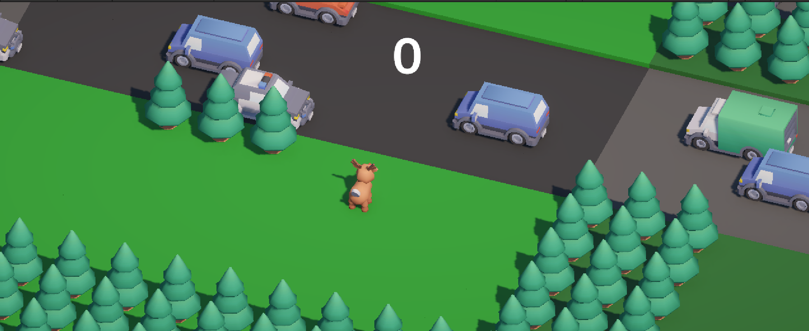
Fig. 1: Starting area with grass strip, trees, and road lanes.
Mid-run gameplay: the player weaves between vehicles across several consecutive road lanes. The live distance score at the top of the screen has climbed to 12, reflecting steady forward progress.
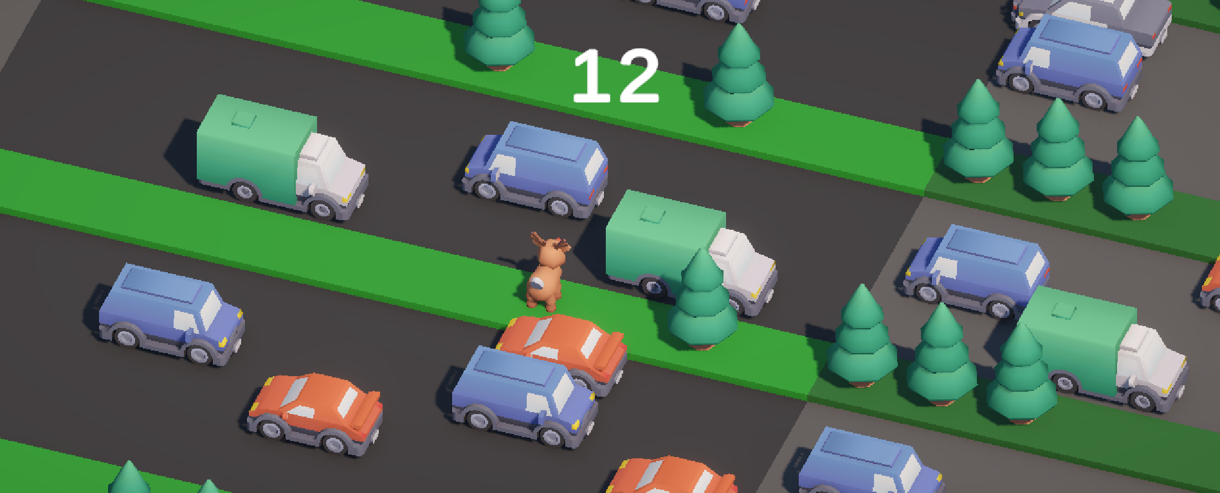
Fig. 2: Player weaving through traffic; score displayed at top.
Death effect: the exact moment of collision with a vehicle, showing the cube-particle explosion that replaces the player character on impact, immediately before the death state and restart flow are triggered.
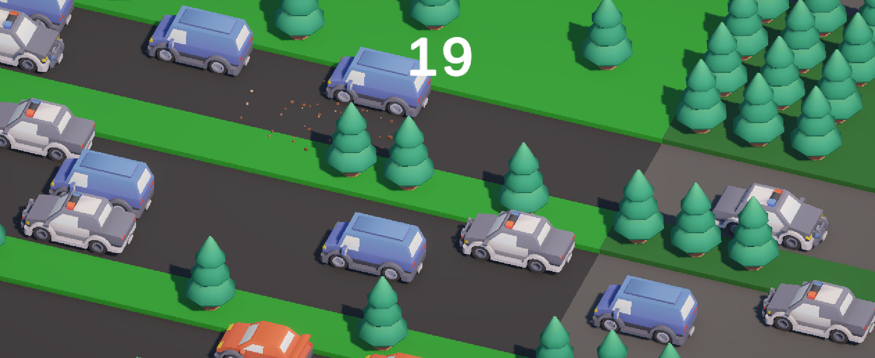
Fig. 3: Collision with traffic triggering the particle death effect.
8. Challenges Faced
- Grid-based movement initially felt jarring because the character teleported instantly between tiles. This was solved by using a C# coroutine with Mathf.Sin interpolation to animate a smooth hopping arc between blocks, giving the movement a rhythmic, arcade-like feel.
- Infinite terrain generation caused rising memory use and lag during long runs, since old lanes and vehicles stayed active behind the camera. This was solved by having the TerrainGenerator track spawned lanes in a list or queue and destroy any lane that fell far enough behind the player's furthest achieved position.
- Random obstacle placement occasionally produced completely blocked lanes, trapping the player with no legal move. The spawn logic was tuned with probability checks and slot validation to guarantee at least one clear path through every lane.
- Camera motion felt shaky and disorienting when it followed the player's left-right movement too closely. This was resolved by heavily smoothing and partially locking the camera's X-axis follow, while keeping tight, Lerp-based tracking on the forward Z-axis.
- Vehicle prefabs occasionally clipped into trees and the ground due to inconsistent import scales between asset packs. This was fixed by adjusting prefab bounds and aligning every asset to the same grid unit scale used by the terrain generator.
- Particle collisions initially fell straight through the terrain instead of settling on it. This was fixed by enabling the Collision module on the particle system and correctly assigning ground and environment layers so particles only reacted to the intended surfaces.
- Balancing traffic difficulty took several iterations, since vehicle speed and spawn frequency that felt fair on early lanes quickly became overwhelming further into a run. Values were adjusted through repeated playtesting until the difficulty curve felt gradual rather than sudden.

