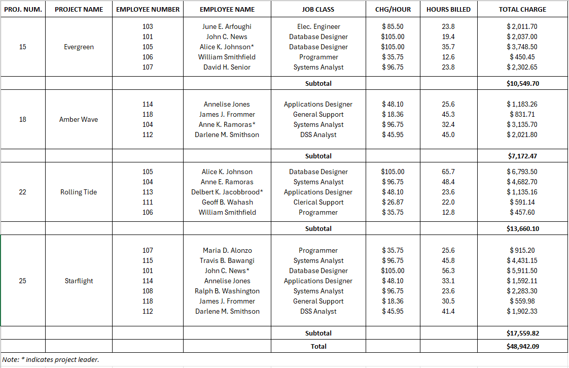

Important Note :
🟨 Highlighted Text ➡ PK
🔴 Underlined Text ➡ FK
0 Normal Form :
Project ( Project_Num , Project_Name , Employee_Number , Employee_Name , Job_Class , CHG/HOUR , Hours_Billed , Total_Charge )

1. 1NF — First Normal Form
- A relation must contain no Multivalued Attributes.
- No Repeating Groups.
- No Composite Attributes.
- To achieve 1NF:
  - Repeating Group: Move it to a new table + add the original PK as a FK.
  - Multi-valued Attribute: Move it to a new table + add the original PK as a FK.
  - Composite Attribute: Split its subparts into separate columns.
Project ( Project_Num , Project_Name )
Project_Employee ( Project_Num , Employee_Number , Employee_Name , Job_Class , CHG/HOUR , Hours_Billed )

2. 2NF — Second Normal Form
- Must be in 1NF.
- No Partial Dependency.
- Every Non-Key Attribute must depend on the whole PK.
- To achieve 2NF:
  - Move the partially dependent Non-Key Attributes to a new table.
  - Add the part of the PK they depend on as the new table's PK/FK.
Project ( Project_Num , Project_Name )
Project_Employee ( Project_Num , Employee_Number , Hours_Billed )
Employee ( Employee_Number, Employee_Name , Job_Class , CHG/HOUR )

3. 3NF — Third Normal Form
Must be in 2NF.
- No Transitive Dependency.
- A Non-Key Attribute must not depend on another Non-Key Attribute.
- To achieve 3NF:
  - Move the dependent Non-Key Attributes to a new table.
  - Keep the Non-Key Attribute they depend on in the new table.
  - Keep that determining Non-Key Attribute in the original table as well.
Project ( Project_Num , Project_Name )
Project_Employee ( Project_Num , Employee_Number , Hours_Billed )
Employee ( Employee_Number, Employee_Name , Job_Class , CHG/HOUR )
Job_Class ( Job_Class , CHG/HOUR )

