Machine Learning – Midterm Assignment Report
Classification and K-Means Clustering on the Breast Cancer Wisconsin and Wine Classification Datasets
Student Name: Hamdi Küçük
Student ID: 23040102043
Course: Machine Learning
Submission date: November 11, 2026 (before class)
GitHub repository: https://github.com/HamdiKucuk298
Video (2–3 min):not

1. Loading the Datasets
Both datasets were loaded using scikit-learn (load_breast_cancer, load_wine). The features were separated into X (a pandas DataFrame retaining the original feature names) and the target into y; X does not contain the target column. The original class labels provided by scikit-learn were preserved.
Table 1. Dataset overview and class-label mapping (full datasets).
Dataset | Samples | Features | Label = class name (count)
Breast Cancer Wisconsin | 569 | 30 | 0 = malignant (212); 1 = benign (357)
Wine Classification | 178 | 13 | 0 = class_0 (59); 1 = class_1 (71); 2 = class_2 (48)

For Breast Cancer, 0 = malignant and 1 = benign. When discussing malignant-class errors, class 0 (malignant) was treated as the positive class. Wine labels remained 0, 1, and 2. Neither dataset is perfectly class-balanced (Breast Cancer: 37.26% malignant / 62.74% benign; Wine: 33.15% / 39.89% / 26.97%). Therefore, stratification was used for splitting and macro averaging was used for evaluation.

2. Dataset Quality Checks
Table 2. Quality-check summary (full datasets; Num. / cat. = numerical / categorical). Per-column tables are in the notebooks (Section 2).
Dataset | Missing | Duplicates | Num. / cat. features | Rows with ≥1 IQR outlier | Most IQR outliers
Breast Cancer | 0 | 0 | 30 / 0 | 171 | area error (65), radius error (38), perimeter error (38), worst area (35)
Wine | 0 | 0 | 13 / 0 | 17 | magnesium, alcalinity_of_ash, color_intensity (4 each)

Neither dataset contains missing values or duplicate rows, so no imputation step was added. All features are of type float64. In the Breast Cancer dataset, six features have a minimum value of 0 (features related to concavity and concave points). These values may represent genuine measurements, so they were not modified and were only reported.
Outliers were counted using the IQR rule (Q1 − 1.5·IQR, Q3 + 1.5·IQR) and z-scores (|z| > 3); none were removed or clipped. In Breast Cancer, outliers are mostly found in the right-skewed “error” and area features (for example, area error has a mean of 40.34 and a median of 24.53). Large values can dominate distances in distance-based methods such as KNN and K-Means, and can pull K-Means centroids toward themselves. They can also distort GaussianNB estimates of class-specific means and variances. Decision trees are less affected because they split using threshold values. Wine contains few outliers; the main issue is the difference in feature scales (proline: 278–1680, hue: 0.48–1.71).

3. Exploratory Data Analysis (EDA)
Sections 2 and 3 are descriptive only. No feature selection, preprocessing fitting, or sample removal was performed using these full-dataset summaries. Tables of the mean, median, minimum, maximum, standard deviation, Q1, and Q3 are provided in Appendix A.
Table 3. Three strongest unique feature pairs by absolute Pearson correlation (full datasets; diagonal and mirrored pairs excluded).
Dataset | Feature 1 | Feature 2 | Pearson r
Breast Cancer Wisconsin | mean radius | mean perimeter | 0.9979
Breast Cancer Wisconsin | worst radius | worst perimeter | 0.9937
Breast Cancer Wisconsin | mean radius | mean area | 0.9874
Wine Classification | total_phenols | flavanoids | 0.8646
Wine Classification | flavanoids | od280/od315_of_diluted_wines | 0.7872
Wine Classification | total_phenols | od280/od315_of_diluted_wines | 0.6999

The Breast Cancer feature pairs show geometrically expected relationships: perimeter increases with radius, while area increases with the square of the radius. All three highly correlated pairs in Wine involve phenolic compounds. These strong correlations indicate that the Naive Bayes assumption of feature independence is not fully satisfied in these datasets. All features were retained in the models as required by the assignment instructions.
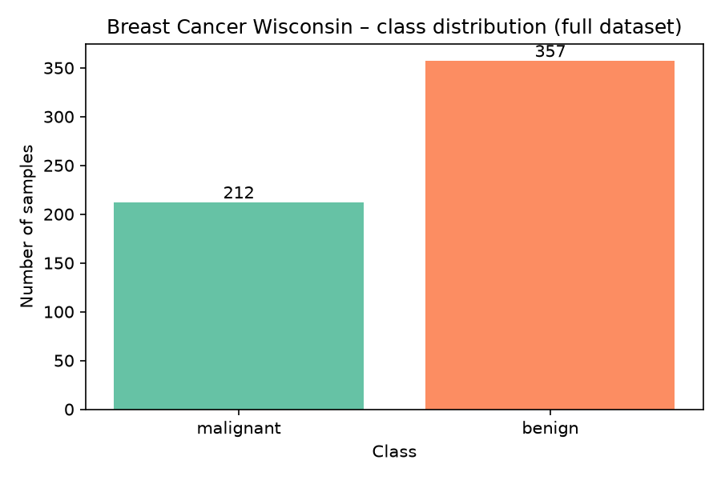
Figure 1. Breast Cancer Wisconsin – class distribution (full dataset).
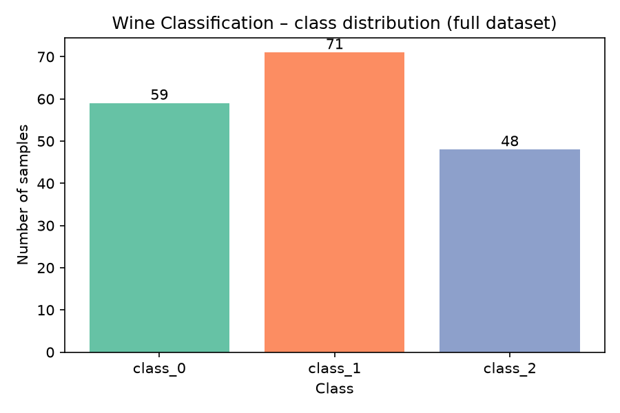
Figure 2. Wine Classification – class distribution (full dataset).
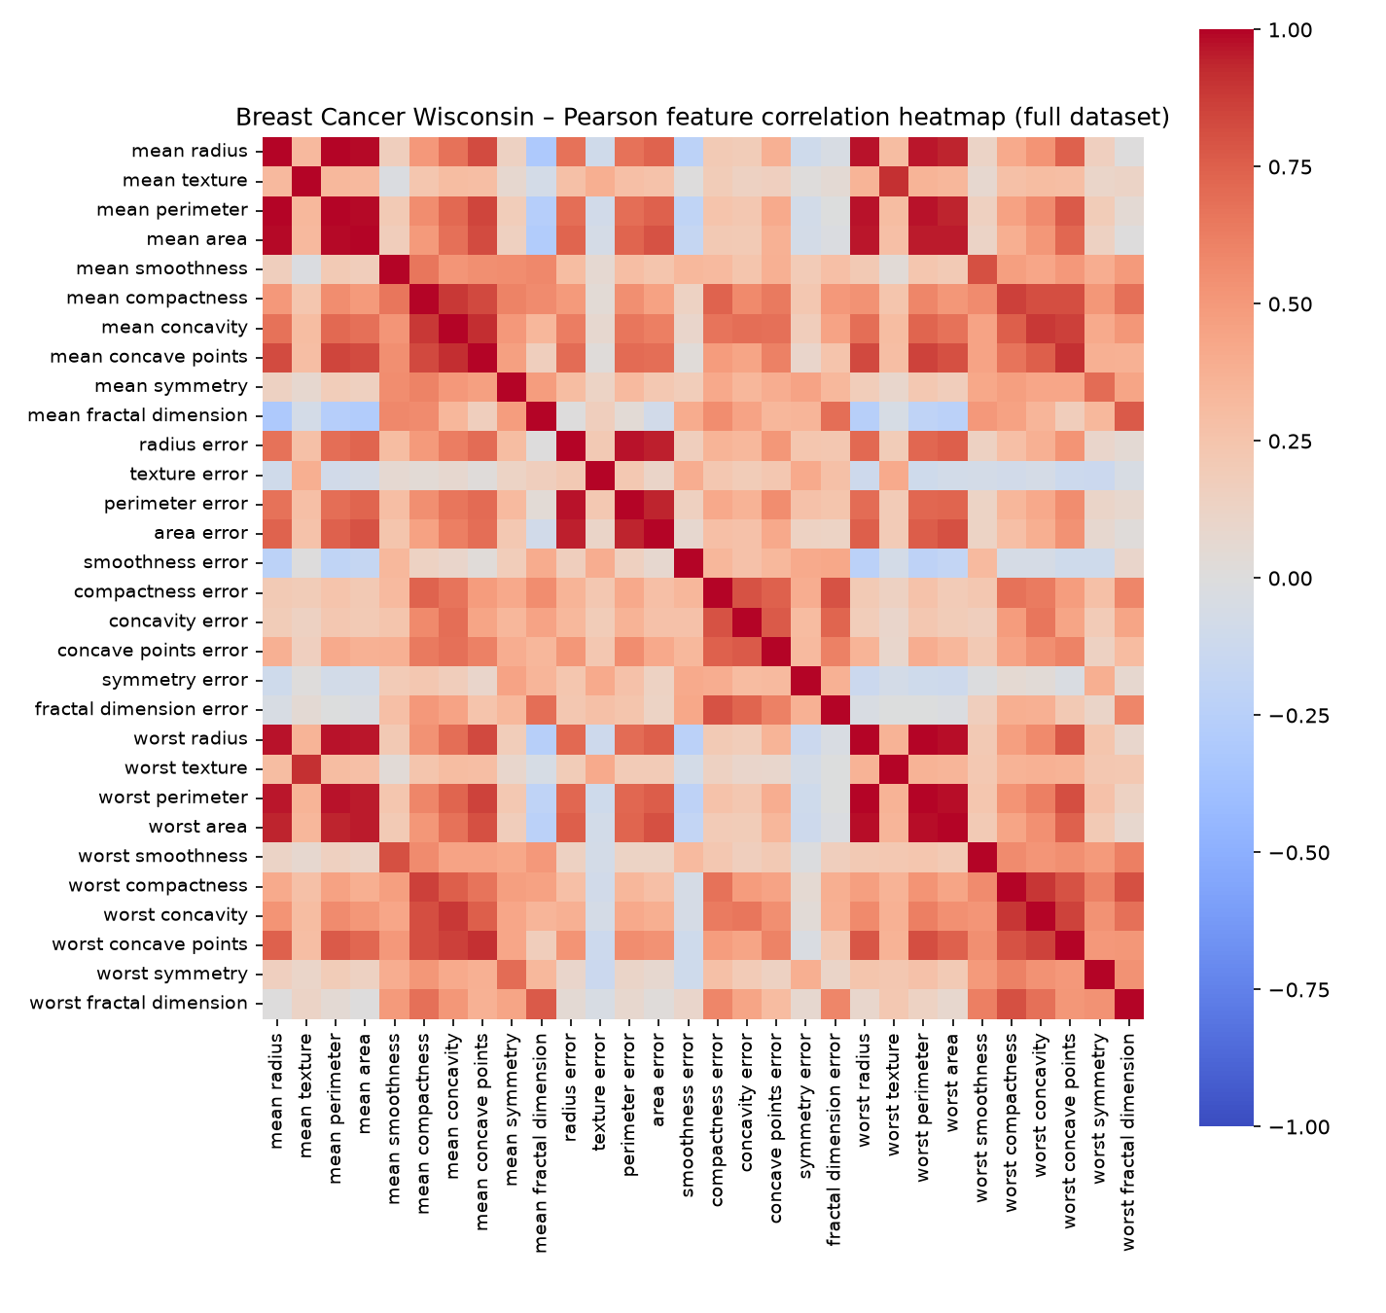
Figure 3. Breast Cancer Wisconsin – Pearson feature correlation heatmap (full dataset).
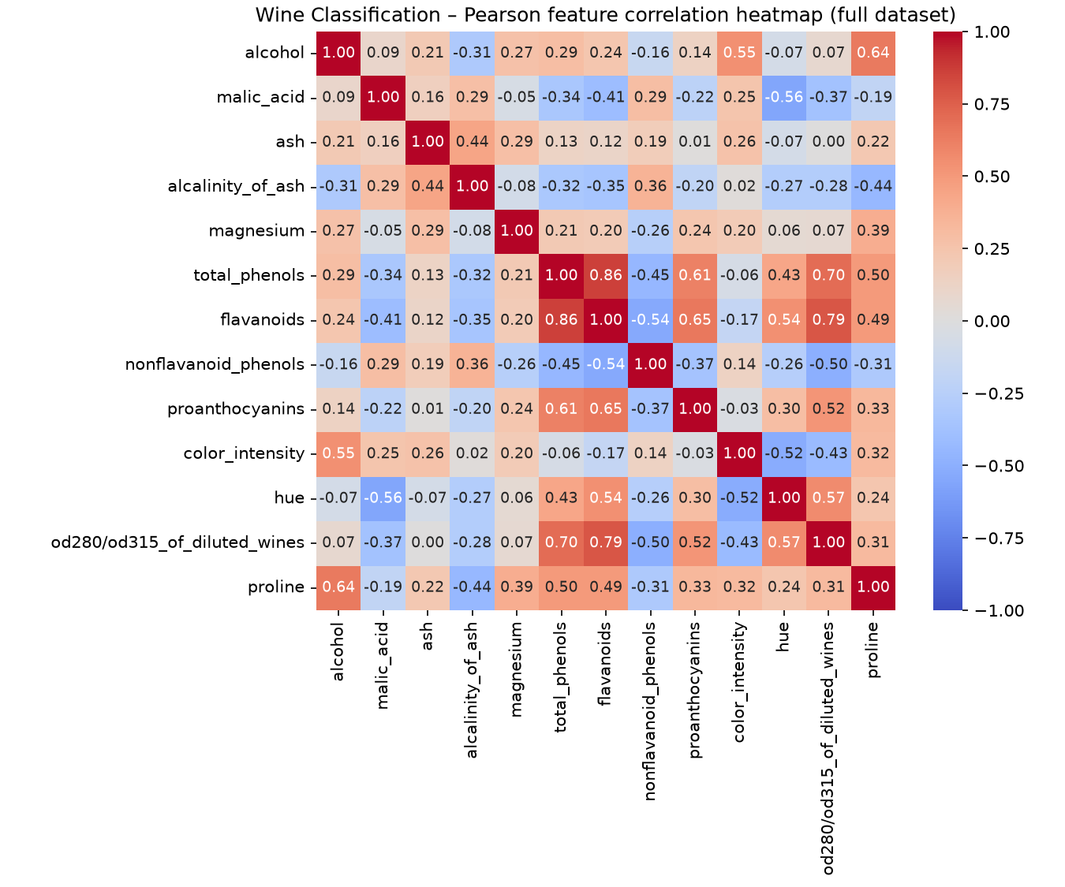
Figure 4. Wine Classification – Pearson feature correlation heatmap (full dataset).
The boxplots (Appendix B) support two observations. (1) Feature scales differ substantially: in Breast Cancer, mean area ranges from 143.5 to 2501, while mean smoothness is approximately 0.05–0.16; in Wine, proline ranges from hundreds to thousands, whereas hue is around 1. (2) Some features separate the classes well: in Breast Cancer, malignant cases have higher values for size and concavity features; in Wine, class_2 has lower flavanoids values than the other classes, while class_0 has higher proline values. Many points lie beyond the whiskers in the “error” features of both Breast Cancer classes.

4. Splitting the Datasets
First, 20% of each dataset was set aside once as the test set (train_test_split, test_size=0.20, stratify=y, random_state=42). These test indices remained unchanged throughout the study. The remaining 80% was split into training and validation sets for SEEDS = [42, 52, 62], using test_size=0.125, stratify, and random_state=seed (0.80 × 0.125 = 0.10). The seeds change only the membership of the training and validation sets; they do not create three different test sets.
Table 4. Subset sizes (identical for seeds 42, 52 and 62; the full nine-row tables per dataset are in Appendix C).
Dataset | Subset | Samples | % of full dataset
Breast Cancer Wisconsin | train | 398 | 69.95%
Breast Cancer Wisconsin | validation | 57 | 10.02%
Breast Cancer Wisconsin | test | 114 | 20.04%
Wine Classification | train | 124 | 69.66%
Wine Classification | validation | 18 | 10.11%
Wine Classification | test | 36 | 20.22%

The notebook used assertions to verify that there was no overlap for each seed, that the subset sizes sum to the full dataset sizes (569 and 178), and that the test indices are identical across all three seeds. Because stratification keeps class counts fixed, class distributions are identical across seeds. The rows themselves change: for example, the validation sets for seeds 42 and 52 share 5 of 57 rows in Breast Cancer and 2 of 18 rows in Wine. The original row indices are stored in results/breast_cancer_split_indices.csv and results/wine_split_indices.csv. Within each dataset and seed, all algorithms, parameters, and representations use the same indices. Seed 42 was selected in advance for the final test.

5. Data Preprocessing and Scaling
Because there were no missing values, no imputation was performed. A single scaler was selected before the experiments: StandardScaler. It transforms each feature using z = (x − mean) / standard deviation. As noted in the course materials, distance-based algorithms such as KNN and K-Means are sensitive to feature scales. A new scaler was created for each dataset and seed and fitted only on that seed’s training data; six scalers were used in total. Validation data was only transformed using the corresponding scaler. Test data was transformed only with the seed-42 scaler. The target variable was not scaled.
The first five training rows before and after scaling for seed 42 are shown in the notebooks. For example, in Breast Cancer, the mean area value for row 301 changed from 471.3 to −0.519; in Wine, the proline value for row 163 changed from 675.0 to −0.209. The scaled training data has a mean of 0 and a standard deviation of 1. The validation means are not exactly 0 (from −0.241 to 0.255 for Breast Cancer and from −0.135 to 0.403 for Wine). This difference shows that the scaler did not see the validation data, meaning that no data leakage occurred.

6. Preparing the Two Data Representations
Two representations were prepared for each dataset and seed: unscaled (all original features) and scaled (the same features and rows after StandardScaler). The notebooks verified that the indices and feature lists were identical in both representations. All other settings were kept constant to examine the effect of scaling. No dimensionality reduction or feature selection was performed.

7. Training the Classification Models
Table 5. Required classifier grid (each setting × 2 representations × 3 seeds).
Algorithm | Settings | Fits per dataset
Decision Tree | max_depth = 2, 3, 5, 10, None; random_state = seed | 30
KNN | n_neighbors = 1, 3, 5, 7, 11; weights='uniform'; metric='euclidean' | 30
Gaussian Naive Bayes | default settings | 6

A total of 132 classifier runs were performed: 66 for Breast Cancer and 66 for Wine. The experiments were executed using nested loops in ml_helpers.py (seed → representation → model), rather than writing a separate cell for each experiment. Each model was fitted using training data only. Every run has an experiment ID, such as wine_knn_scaled_k5_s42. All runs, including those with lower scores, were saved in classifier_runs.csv. This file contains training accuracy and macro-F1, along with five validation metrics. Since KNN and GaussianNB do not use random_state, differences between their repeated runs arise only from changes in training/validation membership. Package versions are listed in README.md and requirements.txt (Python 3.12.3, scikit-learn 1.9.1, pandas 3.1.1, numpy 2.5.4).

8. Measuring Validation Performance
Each run was evaluated on its own validation set using accuracy, macro precision, macro recall, macro-F1, and ROC-AUC. The average='macro' and zero_division=0 settings were used for precision, recall, and F1. Before applying this setting, undefined precision or recall values were checked; none occurred in any run. Breast Cancer ROC-AUC was calculated with malignant as the positive class: the evaluation target was set to 1 for original class 0, and the probability of original class 0 was used as the score. Wine ROC-AUC was calculated from class probabilities using multi_class='ovr' and average='macro'. The order of probability columns was checked against model.classes_.
Model selection was based only on validation results. The criterion was the highest mean validation macro-F1. In case of a tie, the following criteria were applied in order: higher mean validation accuracy, lower macro-F1 standard deviation, and the configuration ID in alphabetical order. The tables below show the mean and sample standard deviation across the three seeds (ddof=1). The means and standard deviations of all metrics are in classifier_summary.csv; the 66-row run tables are in the notebooks and classifier_runs.csv.
Table 6. Breast Cancer Wisconsin – 22-row classifier summary over seeds 42, 52, 62 (validation subsets; mean ± sample std). * = selected configuration.
Configuration | Train F1 (mean) | Val accuracy | Val macro-F1 | Val ROC-AUC
dt_unscaled_depth2 | 0.9527 | 0.9181 ± 0.0203 | 0.9117 ± 0.0236 | 0.9220 ± 0.0404
dt_unscaled_depth3 | 0.9739 | 0.9240 ± 0.0268 | 0.9177 ± 0.0304 | 0.9414 ± 0.0209
dt_unscaled_depth5 | 0.9946 | 0.9240 ± 0.0203 | 0.9188 ± 0.0227 | 0.9301 ± 0.0250
dt_unscaled_depth10 | 1.0000 | 0.9240 ± 0.0101 | 0.9195 ± 0.0112 | 0.9266 ± 0.0170
dt_unscaled_depthNone | 1.0000 | 0.9240 ± 0.0101 | 0.9195 ± 0.0112 | 0.9266 ± 0.0170
dt_scaled_depth2 | 0.9527 | 0.9181 ± 0.0203 | 0.9117 ± 0.0236 | 0.9220 ± 0.0404
dt_scaled_depth3 | 0.9739 | 0.9240 ± 0.0268 | 0.9177 ± 0.0304 | 0.9414 ± 0.0209
dt_scaled_depth5 | 0.9946 | 0.9240 ± 0.0203 | 0.9188 ± 0.0227 | 0.9301 ± 0.0250
dt_scaled_depth10 | 1.0000 | 0.9240 ± 0.0101 | 0.9195 ± 0.0112 | 0.9266 ± 0.0170
dt_scaled_depthNone | 1.0000 | 0.9240 ± 0.0101 | 0.9195 ± 0.0112 | 0.9266 ± 0.0170
knn_unscaled_k1 | 1.0000 | 0.8889 ± 0.0506 | 0.8786 ± 0.0566 | 0.8757 ± 0.0630
knn_unscaled_k3 | 0.9558 | 0.9006 ± 0.0405 | 0.8910 ± 0.0449 | 0.9299 ± 0.0235
knn_unscaled_k5 | 0.9469 | 0.9181 ± 0.0268 | 0.9107 ± 0.0297 | 0.9480 ± 0.0348
knn_unscaled_k7 | 0.9442 | 0.9123 ± 0.0000 | 0.9040 ± 0.0013 | 0.9581 ± 0.0291
knn_unscaled_k11 | 0.9404 | 0.9240 ± 0.0101 | 0.9155 ± 0.0113 | 0.9605 ± 0.0311
knn_scaled_k1 | 1.0000 | 0.9415 ± 0.0203 | 0.9369 ± 0.0213 | 0.9339 ± 0.0160
knn_scaled_k3 | 0.9793 | 0.9591 ± 0.0203 | 0.9547 ± 0.0228 | 0.9793 ± 0.0162
knn_scaled_k5 | 0.9721 | 0.9591 ± 0.0203 | 0.9547 ± 0.0228 | 0.9795 ± 0.0174
knn_scaled_k7 * | 0.9702 | 0.9708 ± 0.0268 | 0.9677 ± 0.0297 | 0.9782 ± 0.0194
knn_scaled_k11 | 0.9694 | 0.9649 ± 0.0351 | 0.9608 ± 0.0395 | 0.9945 ± 0.0048
gnb_unscaled_default | 0.9323 | 0.9415 ± 0.0203 | 0.9369 ± 0.0226 | 0.9797 ± 0.0126
gnb_scaled_default | 0.9307 | 0.9298 ± 0.0175 | 0.9248 ± 0.0201 | 0.9760 ± 0.0149

Table 7. Wine Classification – 22-row classifier summary over seeds 42, 52, 62 (validation subsets; mean ± sample std). * = selected configuration.
Configuration | Train F1 (mean) | Val accuracy | Val macro-F1 | Val ROC-AUC
dt_unscaled_depth2 | 0.9365 | 0.8519 ± 0.0321 | 0.8481 ± 0.0365 | 0.9050 ± 0.0219
dt_unscaled_depth3 | 0.9926 | 0.9444 ± 0.0556 | 0.9462 ± 0.0545 | 0.9611 ± 0.0431
dt_unscaled_depth5 | 1.0000 | 0.9444 ± 0.0556 | 0.9462 ± 0.0545 | 0.9552 ± 0.0457
dt_unscaled_depth10 | 1.0000 | 0.9444 ± 0.0556 | 0.9462 ± 0.0545 | 0.9552 ± 0.0457
dt_unscaled_depthNone | 1.0000 | 0.9444 ± 0.0556 | 0.9462 ± 0.0545 | 0.9552 ± 0.0457
dt_scaled_depth2 | 0.9365 | 0.8519 ± 0.0321 | 0.8481 ± 0.0365 | 0.9050 ± 0.0219
dt_scaled_depth3 | 0.9926 | 0.9444 ± 0.0556 | 0.9462 ± 0.0545 | 0.9611 ± 0.0431
dt_scaled_depth5 | 1.0000 | 0.9444 ± 0.0556 | 0.9462 ± 0.0545 | 0.9552 ± 0.0457
dt_scaled_depth10 | 1.0000 | 0.9444 ± 0.0556 | 0.9462 ± 0.0545 | 0.9552 ± 0.0457
dt_scaled_depthNone | 1.0000 | 0.9444 ± 0.0556 | 0.9462 ± 0.0545 | 0.9552 ± 0.0457
knn_unscaled_k1 | 1.0000 | 0.7037 ± 0.0321 | 0.6714 ± 0.0226 | 0.7654 ± 0.0181
knn_unscaled_k3 | 0.8294 | 0.6667 ± 0.0556 | 0.6456 ± 0.0429 | 0.8333 ± 0.0311
knn_unscaled_k5 | 0.7739 | 0.7037 ± 0.0321 | 0.6667 ± 0.0399 | 0.8645 ± 0.0115
knn_unscaled_k7 | 0.7804 | 0.6667 ± 0.0000 | 0.6356 ± 0.0316 | 0.8459 ± 0.0084
knn_unscaled_k11 | 0.7309 | 0.6296 ± 0.0321 | 0.6005 ± 0.0010 | 0.8216 ± 0.0254
knn_scaled_k1 | 1.0000 | 0.9630 ± 0.0321 | 0.9658 ± 0.0296 | 0.9749 ± 0.0218
knn_scaled_k3 | 0.9687 | 0.9444 ± 0.0556 | 0.9457 ± 0.0558 | 1.0000 ± 0.0000
knn_scaled_k5 | 0.9762 | 0.9815 ± 0.0321 | 0.9814 ± 0.0323 | 1.0000 ± 0.0000
knn_scaled_k7 | 0.9603 | 0.9815 ± 0.0321 | 0.9814 ± 0.0323 | 1.0000 ± 0.0000
knn_scaled_k11 * | 0.9656 | 0.9815 ± 0.0321 | 0.9814 ± 0.0323 | 1.0000 ± 0.0000
gnb_unscaled_default | 0.9840 | 0.9630 ± 0.0321 | 0.9638 ± 0.0314 | 1.0000 ± 0.0000
gnb_scaled_default | 0.9840 | 0.9630 ± 0.0321 | 0.9638 ± 0.0314 | 1.0000 ± 0.0000

Selection. The selected configurations were knn_scaled_k7 for Breast Cancer (mean validation macro-F1 = 0.9677, std = 0.0297) and knn_scaled_k11 for Wine (0.9814, std = 0.0323). For Wine, knn_scaled_k5, knn_scaled_k7, and knn_scaled_k11 were exactly tied in mean macro-F1, mean accuracy, and standard deviation. Therefore, the final tie-break rule—alphabetical order—was applied (“knn_scaled_k11” comes before “knn_scaled_k5” alphabetically). This selection does not mean that k=11 is better.
Effect of scaling. The Decision Tree results were exactly the same with and without scaling for both datasets. A tree splits each feature using thresholds; because StandardScaler does not change the ordering of values, the same splits are produced. KNN was the algorithm most affected by scaling. In Breast Cancer, scaling increased mean validation macro-F1 by 0.0440 (k=5) to 0.0636 (k=7). The increase was much larger in Wine; for example, for k=11 it changed from 0.6005 to 0.9814. In unscaled Wine, proline almost entirely determines the distances. GaussianNB was unchanged in Wine and decreased slightly in Breast Cancer (0.9369 → 0.9248). GaussianNB is theoretically scale-independent; this small difference is caused by the var_smoothing setting, which adds a small fraction of the largest feature variance to the variances.
Depth, number of neighbors, and the training/validation gap. In Breast Cancer, increasing tree depth only slightly improved mean validation macro-F1 (0.9117 at depth 2 and 0.9195 at depth 10/None). Training macro-F1 reached 1.0, while the training–validation gap increased from 0.041 to 0.081. This indicates that the tree began memorizing the training data (overfitting). In Wine, the validation score remained constant at 0.9462 from depth 3 onward. Depths of 10 and None produced the same result in both datasets, meaning the trees stopped growing before reaching 10 levels. For KNN, k=1 always achieves 1.0 on the training set (each point is its own nearest neighbor) and produces the largest training–validation gap. This gap is especially large for unscaled Wine (0.3286).
Variation across seeds. The validation sets are small: 57 samples for Breast Cancer and 18 for Wine. In Wine, a single error changes accuracy by approximately 5.6 percentage points. Therefore, standard deviations can be as large as some of the differences between means. The standard deviation describes variability across these three repeated splits only; it is not evidence of a confidence interval or statistical significance.
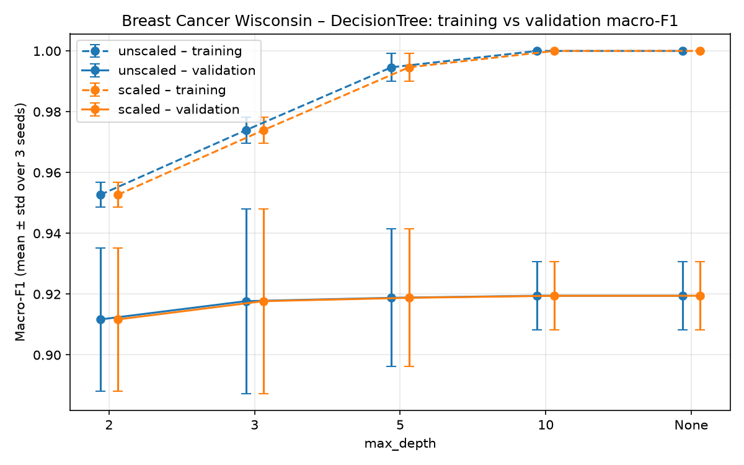
Figure 5. Breast Cancer Wisconsin – Decision Tree: mean training and validation macro-F1 by max_depth (error bars = std over 3 seeds; points shifted slightly for readability).
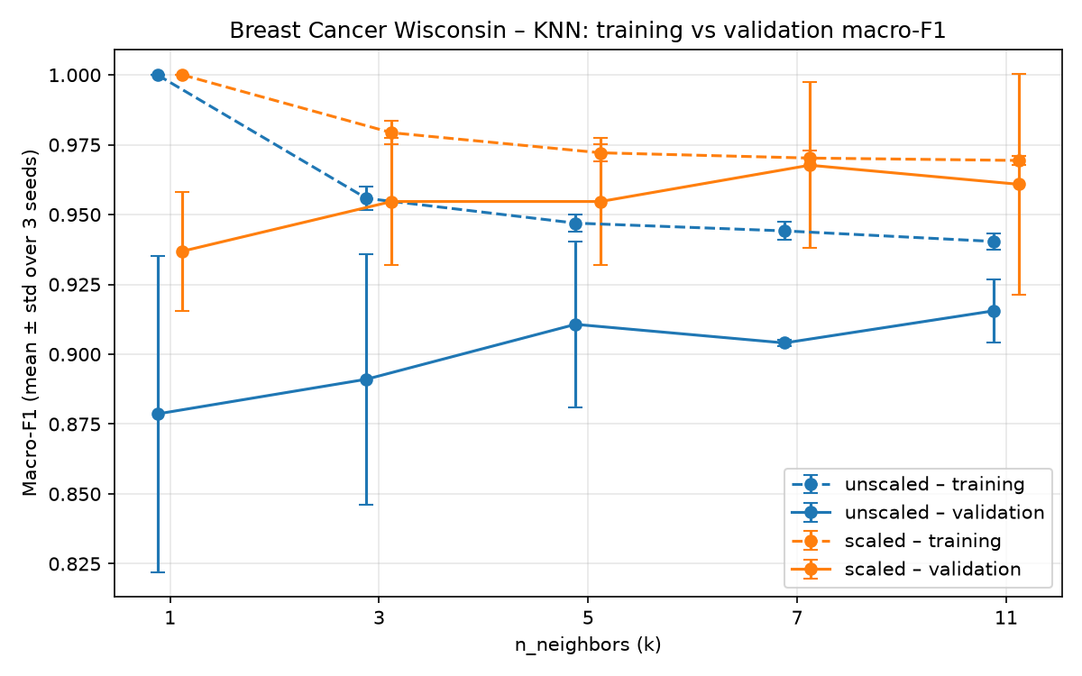
Figure 6. Breast Cancer Wisconsin – KNN: mean training and validation macro-F1 by n_neighbors (error bars = std over 3 seeds; points shifted slightly for readability).
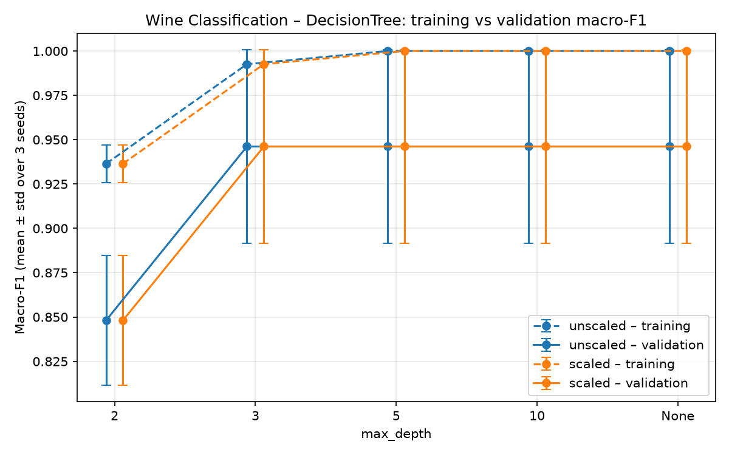
Figure 7. Wine Classification – Decision Tree: mean training and validation macro-F1 by max_depth (error bars = std over 3 seeds; points shifted slightly for readability).
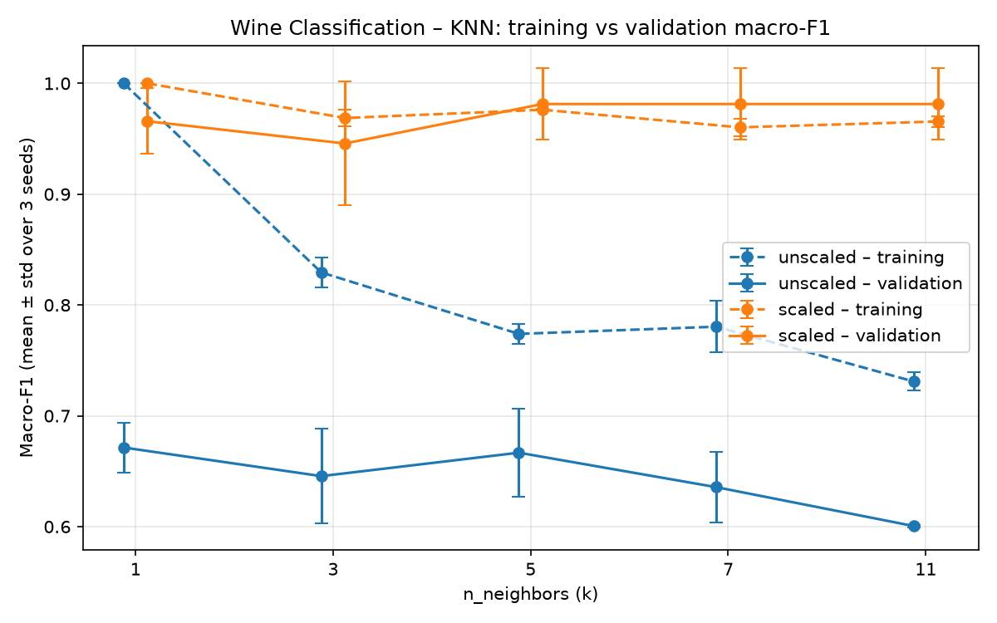
Figure 8. Wine Classification – KNN: mean training and validation macro-F1 by n_neighbors (error bars = std over 3 seeds; points shifted slightly for readability).

9. Evaluating the Selected Models on the Test Sets
After the selections were finalized, the model for each selected configuration—fitted using seed 42 only—was evaluated once on the fixed test set using seed-42 preprocessing. No retraining was performed, and no other candidate was tested.

9.1 Final performance metrics
Table 8. Final test evaluation of the two selected classifiers (fixed test sets, seed-42 fitted models). The same two-row table is in classifier_test.csv and in the notebooks; it is shown transposed here for readability.
 | Breast Cancer Wisconsin | Wine Classification
Selected configuration | knn_scaled_k7 | knn_scaled_k11
Evaluation seed | 42 | 42
Mean validation macro-F1 | 0.9677 | 0.9814
Std of validation macro-F1 (ddof=1) | 0.0297 | 0.0323
Test accuracy | 0.9737 | 1.0000
Test macro precision | 0.9800 | 1.0000
Test macro recall | 0.9643 | 1.0000
Test macro-F1 | 0.9713 | 1.0000
Test ROC-AUC | 0.9888 | 1.0000

Table 9. Breast Cancer Wisconsin – classification report on the test set (knn_scaled_k7, seed 42).
Class / average | Precision | Recall | F1 | Support
malignant | 1.0000 | 0.9286 | 0.9630 | 42
benign | 0.9600 | 1.0000 | 0.9796 | 72
macro avg | 0.9800 | 0.9643 | 0.9713 | 114
weighted avg | 0.9747 | 0.9737 | 0.9735 | 114

Table 10. Wine Classification – classification report on the test set (knn_scaled_k11, seed 42).
Class / average | Precision | Recall | F1 | Support
class_0 | 1.0000 | 1.0000 | 1.0000 | 12
class_1 | 1.0000 | 1.0000 | 1.0000 | 14
class_2 | 1.0000 | 1.0000 | 1.0000 | 10
macro avg | 1.0000 | 1.0000 | 1.0000 | 36
weighted avg | 1.0000 | 1.0000 | 1.0000 | 36

The Breast Cancer test macro-F1 (0.9713) is slightly higher than the mean validation macro-F1 (0.9677). The difference is within the standard deviation across seeds, and the test set contains 114 samples. In Wine, all test metrics are 1.0000; the same model also achieved a seed-42 validation macro-F1 of 1.0, while its mean across the three seeds was 0.9814. The selected models were not changed after these results.

9.2 Confusion matrices
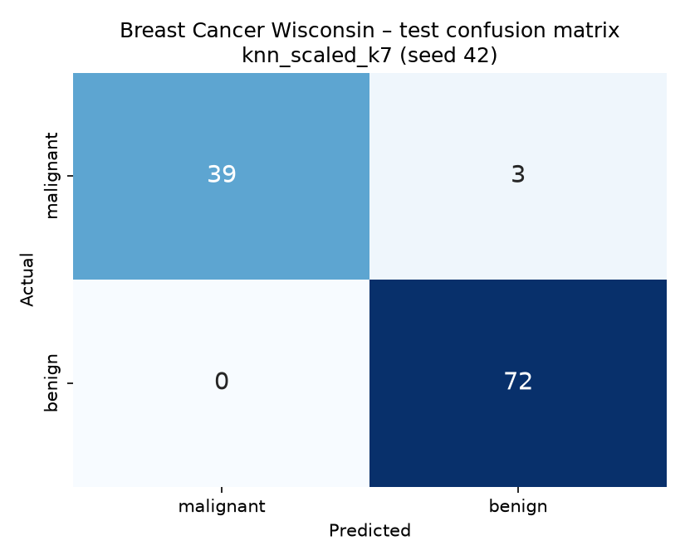
Figure 9. Breast Cancer Wisconsin – test confusion matrix (knn_scaled_k7, seed 42); rows = Actual, columns = Predicted, order [malignant, benign].
Because the class order is [0, 1] = [malignant, benign] and malignant is the positive class, the matrix is not in the standard TN-FP/FN-TP layout. The top-left cell is TP = 39 (actual malignant, predicted malignant), the top-right cell is FN = 3 (actual malignant, predicted benign), the bottom-left cell is FP = 0 (actual benign, predicted malignant), and the bottom-right cell is TN = 72. All errors are false negatives: 3 malignant cases were predicted as benign. This is the most medically risky type of error. There were no false alarms (false positives).
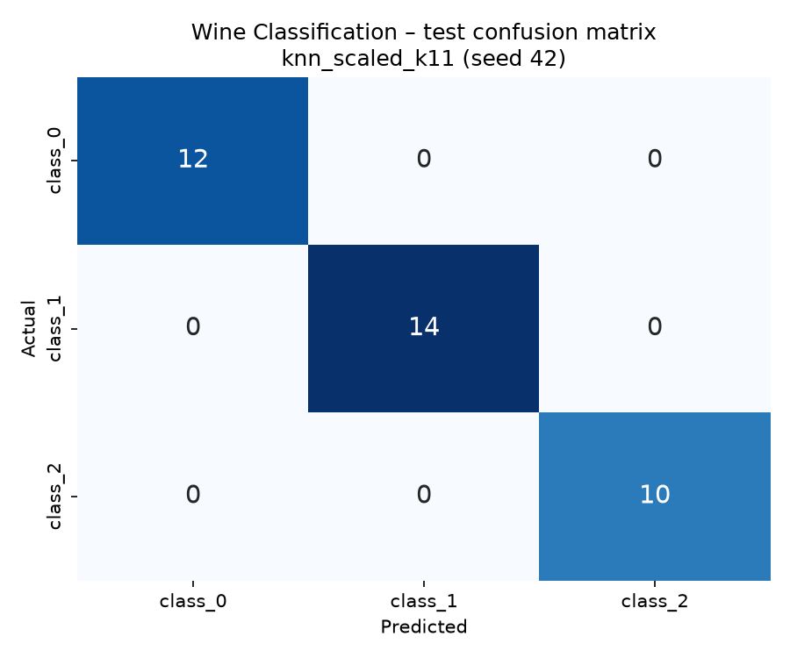
Figure 10. Wine Classification – test confusion matrix (knn_scaled_k11, seed 42); rows = Actual, columns = Predicted.
In Wine, the diagonal of the 3 × 3 matrix contains 12, 14, and 10; all off-diagonal cells are 0. Since there is no misclassification in this test set, there is no largest off-diagonal error example; no example has been fabricated.
Table 11. Manual metric checks on the test set, compared with the per-class rows (not the macro averages) of the classification reports.
Dataset | Class | Metric | Manual (from counts) | Classification report (per class)
Breast Cancer Wisconsin | malignant | precision | 1.0000 | 1.0000
Breast Cancer Wisconsin | malignant | recall | 0.9286 | 0.9286
Breast Cancer Wisconsin | malignant | f1 | 0.9630 | 0.9630
Wine Classification | class_1 | precision | 1.0000 | 1.0000
Wine Classification | class_1 | recall | 1.0000 | 1.0000
Wine Classification | class_1 | f1 | 1.0000 | 1.0000

For Breast Cancer (malignant): precision = TP/(TP+FP) = 39/39 = 1.0000, recall = TP/(TP+FN) = 39/42 = 0.9286, and F1 = 2PR/(P+R) = 0.9630. For Wine, class_1 was selected before examining the results and evaluated against the other two classes (one-vs-rest): TP = 14, FP = 0, FN = 0, TN = 22. Thus, precision = recall = F1 = 14/14 = 1.0000. The manually calculated values match the corresponding class rows in the reports. No denominator is zero.

9.3 ROC curves
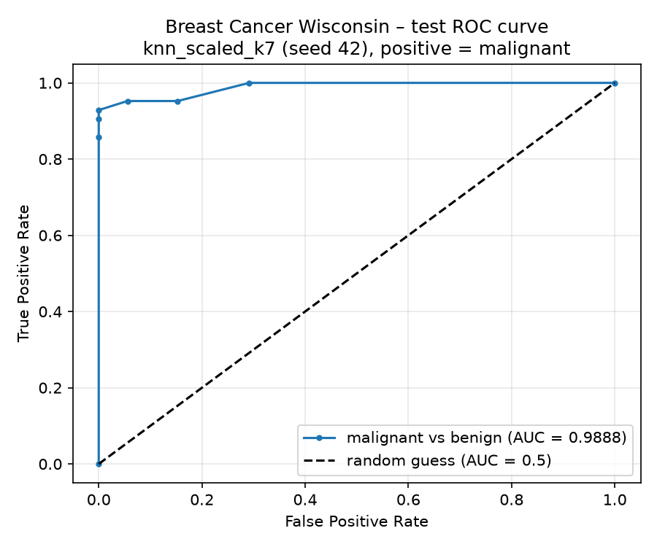
Figure 11. Breast Cancer Wisconsin – test ROC curve, malignant vs benign (knn_scaled_k7, seed 42).
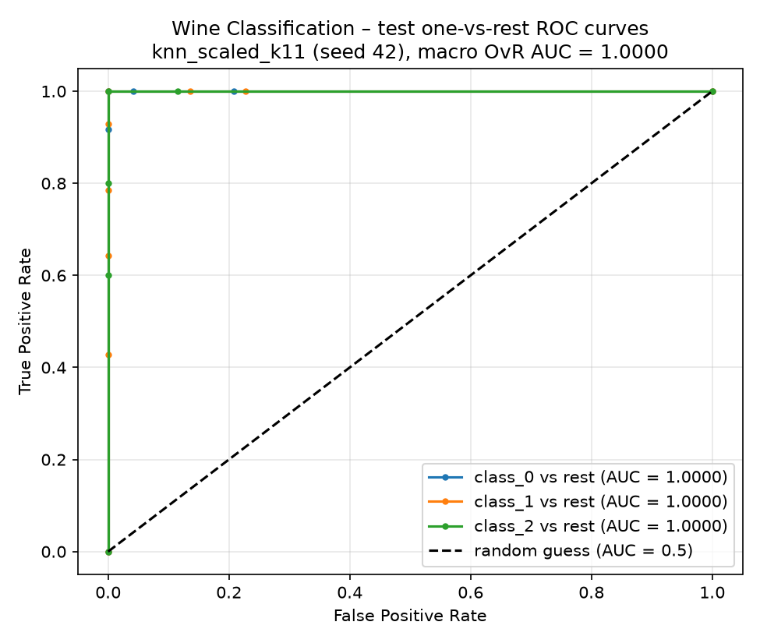
Figure 12. Wine Classification – test one-vs-rest ROC curves for all three classes (knn_scaled_k11, seed 42).
Breast Cancer ROC-AUC = 0.9888. The curve is step-shaped because k=7 KNN can produce only probabilities of 0, 1/7, …, 1. In Wine, all three one-vs-rest AUC values and the macro OvR AUC are 1.0000. Lowering the decision threshold classifies more samples as positive: false negatives decrease and false positives increase. Raising the threshold has the opposite effect. The ROC curves were used for descriptive purposes only; no new threshold was selected and no model was tuned using the test set.

9.4 Error interpretation
There are 3 errors in the Breast Cancer test set (rows 41, 73, and 205); all were actual malignant cases predicted as benign. The first error in the list, row 41, was examined. Of its 7 neighbors, 3 were malignant, giving P(malignant) = 0.4286, so the majority vote remained benign. The sample is small in terms of size: its mean radius is 10.95, compared with a training mean of 17.47 for malignant cases and 12.10 for benign cases. In contrast, shape features such as smoothness and worst concave points are closer to the malignant mean; 19 of the 30 features are closer to the benign mean. Because strongly correlated size features jointly contribute to KNN distance, this case may have fallen among benign neighbors. In practice, this error represents a missed cancer case.
The selected classifier made no errors on the Wine test set (0/36). This result does not prove perfect generalization: the test set is small and comes from a single fixed split. The same configuration achieved a macro-F1 of 0.944 on the seed-62 validation set, showing that it can make errors on other samples.
Limitations. The validation sets are small, and the three training/validation repetitions overlap. Only one preselected seed (42) was evaluated on the final test set. Therefore, the validation repetitions should not be presented as independent test results.

10. K-Means Clustering
K-Means was fitted on the training features for each dataset, representation, and seed (2 × 2 × 3 = 12 fits). Labels were not passed to KMeans.fit. The number of clusters was fixed at 2 for Breast Cancer and 3 for Wine; these values were selected as comparison settings based on the number of classes. In addition, random_state=seed and n_init=10 were used. n_init=10 means that 10 different initializations were tried within each fit; it does not mean 10 separate experiments.
Table 12. K-Means across-seed summaries (validation subsets; mean ± sample std over seeds 42, 52, 62). The 12 run-level rows are in kmeans_runs.csv.
Dataset | Scaling | Train inertia | Val ARI | Val silhouette | Valid seeds
Breast Cancer | unscaled | 5.127e+07 ± 1.95e+06 | 0.5043 ± 0.1064 | 0.6773 ± 0.0334 | 3/3
Breast Cancer | scaled | 7948 ± 47.6 | 0.5813 ± 0.1424 | 0.3121 ± 0.0547 | 3/3
Wine | unscaled | 1.348e+06 ± 4.36e+04 | 0.3613 ± 0.0680 | 0.5765 ± 0.1014 | 3/3
Wine | scaled | 879.1 ± 9.86 | 1.0000 ± 0.0000 | 0.2751 ± 0.0248 | 3/3

Inertia depends on the units of the features; therefore, scaled and unscaled inertia values were not compared. Silhouette also depends on the feature space, so a difference in silhouette between representations was not considered, by itself, evidence of a better model.
Table 13. Final K-Means evaluation on the fixed test sets (seed-42 fitted models, no new fits; Scaling = feature representation).
Dataset | Scaling | Seed | Test cluster counts | Test ARI | Test silhouette
Breast Cancer | unscaled | 42 | cluster 0: 86; cluster 1: 28 | 0.5585 | 0.7120
Breast Cancer | scaled | 42 | cluster 0: 74; cluster 1: 40 | 0.7354 | 0.3251
Wine | unscaled | 42 | cluster 0: 14; cluster 1: 10; cluster 2: 12 | 0.3733 | 0.4929
Wine | scaled | 42 | cluster 0: 13; cluster 1: 13; cluster 2: 10 | 0.9088 | 0.2711

Table 14. Breast Cancer Wisconsin – class vs cluster contingency table, unscaled, seed 42, test set.
Actual class | cluster 0 | cluster 1
benign | 72 | 0
malignant | 14 | 28

Table 15. Breast Cancer Wisconsin – class vs cluster contingency table, scaled, seed 42, test set.
Actual class | cluster 0 | cluster 1
benign | 69 | 3
malignant | 5 | 37

Table 16. Wine Classification – class vs cluster contingency table, unscaled, seed 42, test set.
Actual class | cluster 0 | cluster 1 | cluster 2
class_0 | 2 | 10 | 0
class_1 | 5 | 0 | 9
class_2 | 7 | 0 | 3

Table 17. Wine Classification – class vs cluster contingency table, scaled, seed 42, test set.
Actual class | cluster 0 | cluster 1 | cluster 2
class_0 | 12 | 0 | 0
class_1 | 1 | 13 | 0
class_2 | 0 | 0 | 10

In the unscaled Breast Cancer solution, all 72 benign samples belong to a single cluster. However, 14 of the 42 malignant samples also fall into this cluster (ARI = 0.5585). In the unscaled feature space, distances are determined by large-valued features such as area, so K-Means separates large tumors while confusing smaller malignant samples with benign ones. In the scaled solution, ARI is 0.7354, and only 3 benign and 5 malignant samples are assigned to the opposite cluster. In unscaled Wine (ARI = 0.3733), one cluster consists only of class_0 samples, but class_1 and class_2 are distributed across two clusters. In scaled Wine (ARI = 0.9088), only one class_1 sample is assigned to the wrong group. ARI is an agreement measure adjusted for chance; it is not classification accuracy. Cluster IDs were not converted into class labels.
Two original features were selected for the plots using the seed-42 training data. The first feature had the highest ANOVA F-score; the second had the highest F-score among features whose absolute correlation with the first was below 0.7. The selected features were worst concave points and radius error for Breast Cancer, and flavanoids and proline for Wine. The plots are projections onto only two features; the models used all features.
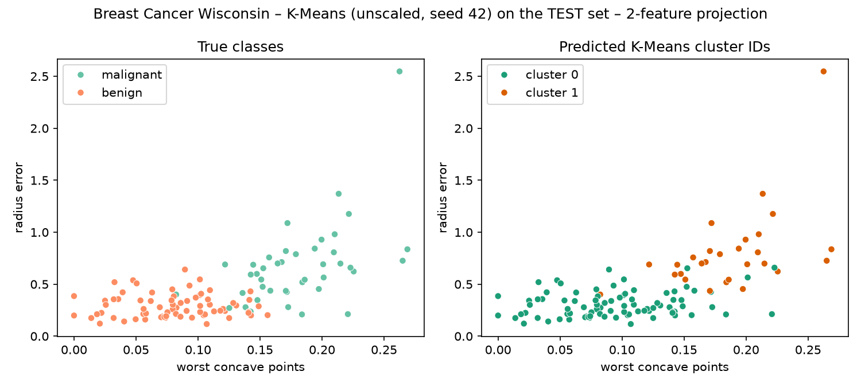
Figure 13. Breast Cancer Wisconsin – K-Means (unscaled, seed 42), test set: true classes (left) vs predicted cluster IDs (right).
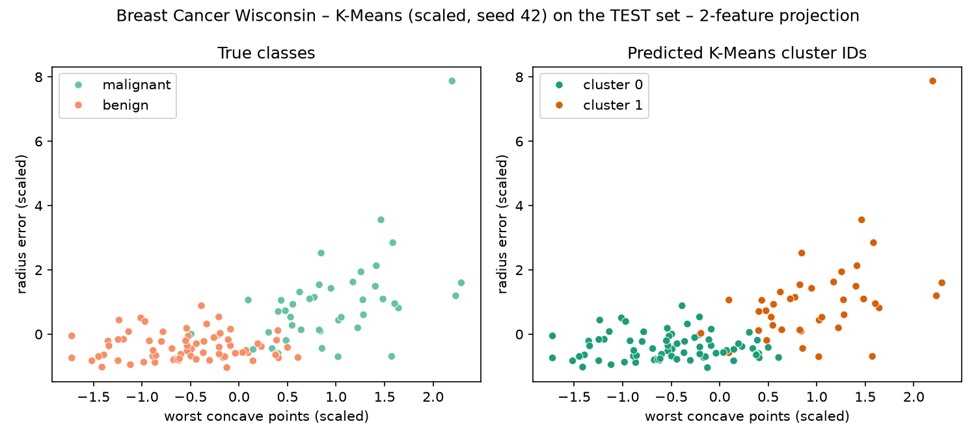
Figure 14. Breast Cancer Wisconsin – K-Means (scaled, seed 42), test set: true classes (left) vs predicted cluster IDs (right).
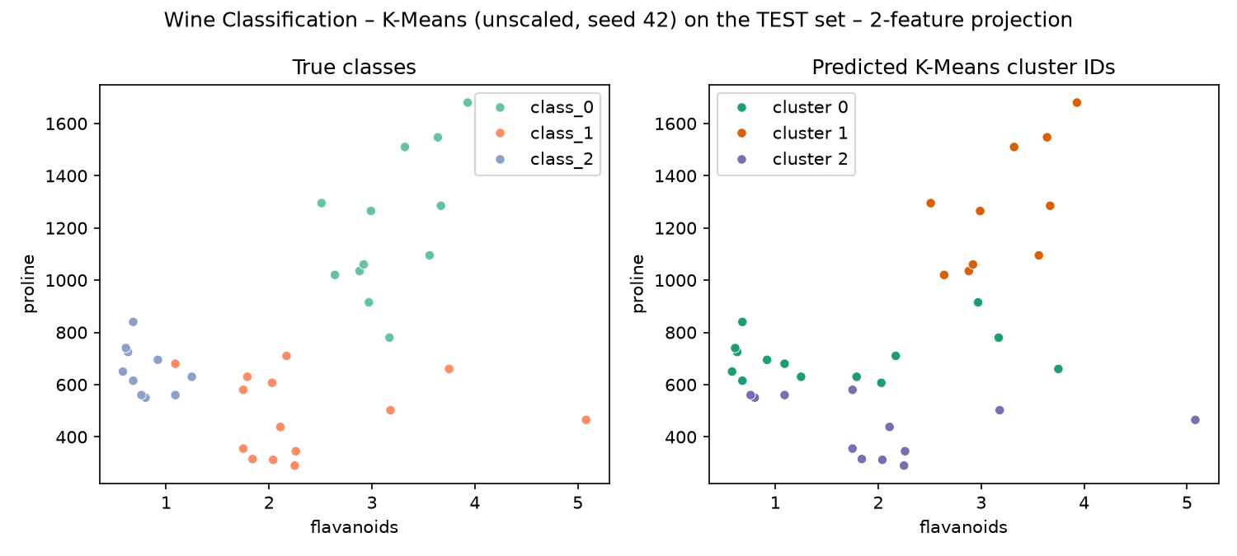
Figure 15. Wine Classification – K-Means (unscaled, seed 42), test set: true classes (left) vs predicted cluster IDs (right).
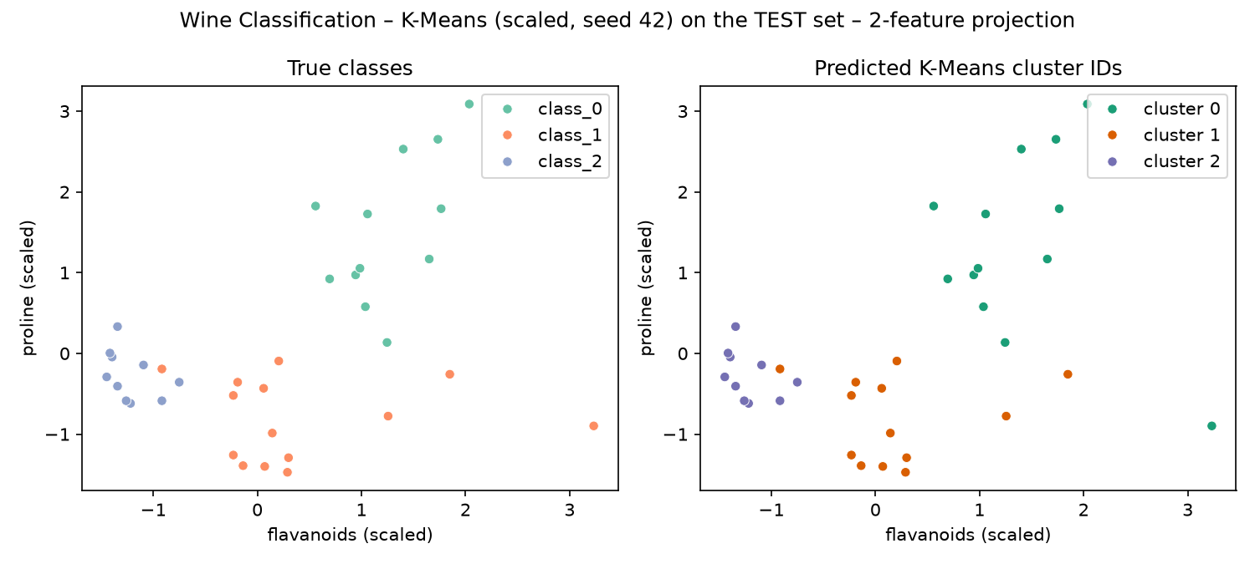
Figure 16. Wine Classification – K-Means (scaled, seed 42), test set: true classes (left) vs predicted cluster IDs (right).
In the unscaled Wine plot, the clusters form nearly horizontal bands along proline. In the scaled plots, the clusters more closely resemble the true classes. Classifiers learn to distinguish classes by seeing the y_train labels during training. K-Means does not see labels; it groups samples only according to distances between features and a fixed number of clusters. Labels were used with K-Means only afterward, for evaluation through ARI and contingency tables.

11. Comparing the Two Datasets
Did the same classifier and representation perform best on both datasets? Partly. Scaled KNN was the best algorithm and representation on the validation sets for both datasets, but the number of neighbors differed: k=7 for Breast Cancer and k=11 for Wine. The selection of k=11 for Wine was made using the alphabetical tie-break rule because k=5 and k=7 were tied. The validation means were 0.9677 and 0.9814. On the test sets, the Breast Cancer model achieved a macro-F1 of 0.9713 (3 errors), while the Wine model achieved 1.0000 (0 errors).
Which algorithm was most affected by scaling? KNN. Scaling increased mean validation macro-F1 by +0.0440 to +0.0636 for Breast Cancer and by +0.2944 to +0.3809 for Wine (for example, 0.6005 → 0.9814 for Wine at k=11). The difference for Decision Tree was 0.0000. For GaussianNB, the difference was 0.0000 for Wine and −0.0121 for Breast Cancer.
Did deeper trees or more neighbors always improve validation performance? No. Deeper trees raised the training score to 1.0 but changed the validation score only slightly (0.9117 → 0.9195 for Breast Cancer; constant at 0.9462 after depth 3 for Wine). For scaled KNN on Breast Cancer, the best value was k=7 (0.9677), and the score decreased at k=11 (0.9608). For Wine, k=3 (0.9457) was lower than k=1 (0.9658). The standard deviations across seeds ranged from 0.0013 to 0.0566 for Breast Cancer and from 0.0010 to 0.0558 for Wine. These values show that rankings among nearby configurations are not definitive.
How did the main classification errors differ? All 3 Breast Cancer errors were false negatives (malignant → benign); there were no false positives. The Wine test confusion matrix contains no off-diagonal entries.
How did K-Means agreement with the true classes differ? K-Means was much more consistent with the classes in Wine: the scaled test ARI was 0.9088, and the validation ARI across the three seeds was 1.0000. In Breast Cancer, the scaled test ARI was 0.7354. The contingency tables show only one misassigned sample in Wine, whereas the two classes overlap near the boundary in Breast Cancer (3 benign + 5 malignant samples in the opposite cluster). The unscaled solution was more mixed for both datasets. ARI was not interpreted as classification accuracy.
What would I investigate next? Because the validation sets are very small (especially the 18 samples in Wine), three configurations tied on Wine and the standard deviations were high. Therefore, in future work, I would investigate model selection using repeated stratified k-fold cross-validation on the 80% development data while keeping the same fixed test set. This could allow each configuration to be compared using more validation samples. This is a proposal for future work; it was not implemented in this report.

12. Required Run and Output Inventory
A total of 66 classifiers and 6 K-Means fits were performed per dataset, for 132 + 12 = 144 model fits overall. The two classifier test evaluations and four clustering test evaluations reuse models trained with seed 42; they do not add new fits.
Table 18. Output inventory (checked against the files in the project folder).
Output | Required rows / files | Produced
classifier_runs.csv | 132 | 132
classifier_summary.csv | 44 | 44
classifier_test.csv | 2 | 2
kmeans_runs.csv | 12 | 12
kmeans_summary.csv | 4 | 4
kmeans_test.csv | 4 | 4
figures/*.png | ≥ 18 | 19

In addition, dataset overviews, quality-check tables, descriptive statistics, two nine-row split summaries, two before/after scaling demonstrations, two class-specific reports, two manual calculations, and four contingency tables are available in the notebooks and in the results/supporting/ folder.

Appendix A. Descriptive statistics (full datasets)
Table 19. Breast Cancer Wisconsin – mean, median, min, max, std, Q1, Q3 for every feature (full dataset).
Feature | mean | median | min | max | std | Q1 | Q3
mean radius | 14.1273 | 13.3700 | 6.9810 | 28.1100 | 3.5240 | 11.7000 | 15.7800
mean texture | 19.2896 | 18.8400 | 9.7100 | 39.2800 | 4.3010 | 16.1700 | 21.8000
mean perimeter | 91.9690 | 86.2400 | 43.7900 | 188.5000 | 24.2990 | 75.1700 | 104.1000
mean area | 654.8891 | 551.1000 | 143.5000 | 2501.0000 | 351.9141 | 420.3000 | 782.7000
mean smoothness | 0.0964 | 0.0959 | 0.0526 | 0.1634 | 0.0141 | 0.0864 | 0.1053
mean compactness | 0.1043 | 0.0926 | 0.0194 | 0.3454 | 0.0528 | 0.0649 | 0.1304
mean concavity | 0.0888 | 0.0615 | 0.0000 | 0.4268 | 0.0797 | 0.0296 | 0.1307
mean concave points | 0.0489 | 0.0335 | 0.0000 | 0.2012 | 0.0388 | 0.0203 | 0.0740
mean symmetry | 0.1812 | 0.1792 | 0.1060 | 0.3040 | 0.0274 | 0.1619 | 0.1957
mean fractal dimension | 0.0628 | 0.0615 | 0.0500 | 0.0974 | 0.0071 | 0.0577 | 0.0661
radius error | 0.4052 | 0.3242 | 0.1115 | 2.8730 | 0.2773 | 0.2324 | 0.4789
texture error | 1.2169 | 1.1080 | 0.3602 | 4.8850 | 0.5516 | 0.8339 | 1.4740
perimeter error | 2.8661 | 2.2870 | 0.7570 | 21.9800 | 2.0219 | 1.6060 | 3.3570
area error | 40.3371 | 24.5300 | 6.8020 | 542.2000 | 45.4910 | 17.8500 | 45.1900
smoothness error | 0.0070 | 0.0064 | 0.0017 | 0.0311 | 0.0030 | 0.0052 | 0.0081
compactness error | 0.0255 | 0.0204 | 0.0023 | 0.1354 | 0.0179 | 0.0131 | 0.0324
concavity error | 0.0319 | 0.0259 | 0.0000 | 0.3960 | 0.0302 | 0.0151 | 0.0420
concave points error | 0.0118 | 0.0109 | 0.0000 | 0.0528 | 0.0062 | 0.0076 | 0.0147
symmetry error | 0.0205 | 0.0187 | 0.0079 | 0.0790 | 0.0083 | 0.0152 | 0.0235
fractal dimension error | 0.0038 | 0.0032 | 0.0009 | 0.0298 | 0.0026 | 0.0022 | 0.0046
worst radius | 16.2692 | 14.9700 | 7.9300 | 36.0400 | 4.8332 | 13.0100 | 18.7900
worst texture | 25.6772 | 25.4100 | 12.0200 | 49.5400 | 6.1463 | 21.0800 | 29.7200
worst perimeter | 107.2612 | 97.6600 | 50.4100 | 251.2000 | 33.6025 | 84.1100 | 125.4000
worst area | 880.5831 | 686.5000 | 185.2000 | 4254.0000 | 569.3570 | 515.3000 | 1084.0000
worst smoothness | 0.1324 | 0.1313 | 0.0712 | 0.2226 | 0.0228 | 0.1166 | 0.1460
worst compactness | 0.2543 | 0.2119 | 0.0273 | 1.0580 | 0.1573 | 0.1472 | 0.3391
worst concavity | 0.2722 | 0.2267 | 0.0000 | 1.2520 | 0.2086 | 0.1145 | 0.3829
worst concave points | 0.1146 | 0.0999 | 0.0000 | 0.2910 | 0.0657 | 0.0649 | 0.1614
worst symmetry | 0.2901 | 0.2822 | 0.1565 | 0.6638 | 0.0619 | 0.2504 | 0.3179
worst fractal dimension | 0.0839 | 0.0800 | 0.0550 | 0.2075 | 0.0181 | 0.0715 | 0.0921

Table 20. Wine Classification – mean, median, min, max, std, Q1, Q3 for every feature (full dataset).
Feature | mean | median | min | max | std | Q1 | Q3
alcohol | 13.0006 | 13.0500 | 11.0300 | 14.8300 | 0.8118 | 12.3625 | 13.6775
malic_acid | 2.3363 | 1.8650 | 0.7400 | 5.8000 | 1.1171 | 1.6025 | 3.0825
ash | 2.3665 | 2.3600 | 1.3600 | 3.2300 | 0.2743 | 2.2100 | 2.5575
alcalinity_of_ash | 19.4949 | 19.5000 | 10.6000 | 30.0000 | 3.3396 | 17.2000 | 21.5000
magnesium | 99.7416 | 98.0000 | 70.0000 | 162.0000 | 14.2825 | 88.0000 | 107.0000
total_phenols | 2.2951 | 2.3550 | 0.9800 | 3.8800 | 0.6259 | 1.7425 | 2.8000
flavanoids | 2.0293 | 2.1350 | 0.3400 | 5.0800 | 0.9989 | 1.2050 | 2.8750
nonflavanoid_phenols | 0.3619 | 0.3400 | 0.1300 | 0.6600 | 0.1245 | 0.2700 | 0.4375
proanthocyanins | 1.5909 | 1.5550 | 0.4100 | 3.5800 | 0.5724 | 1.2500 | 1.9500
color_intensity | 5.0581 | 4.6900 | 1.2800 | 13.0000 | 2.3183 | 3.2200 | 6.2000
hue | 0.9574 | 0.9650 | 0.4800 | 1.7100 | 0.2286 | 0.7825 | 1.1200
od280/od315_of_diluted_wines | 2.6117 | 2.7800 | 1.2700 | 4.0000 | 0.7100 | 1.9375 | 3.1700
proline | 746.8933 | 673.5000 | 278.0000 | 1680.0000 | 314.9075 | 500.5000 | 985.0000

Appendix B. Boxplots (full datasets)
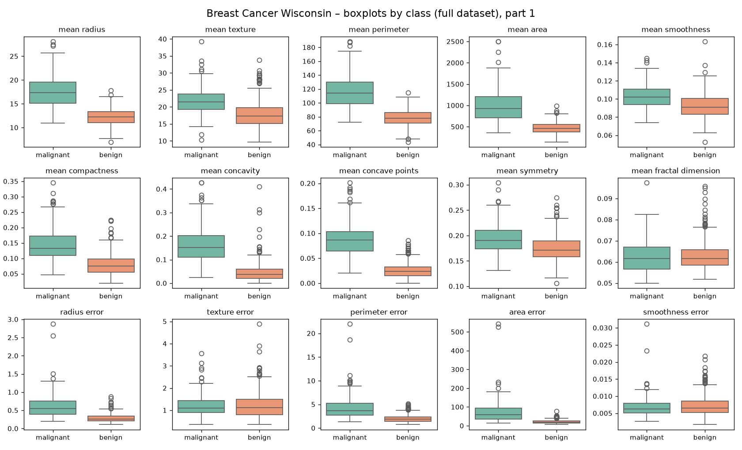
Figure 17. Breast Cancer Wisconsin – boxplots of all features by class, part 1 (full dataset).
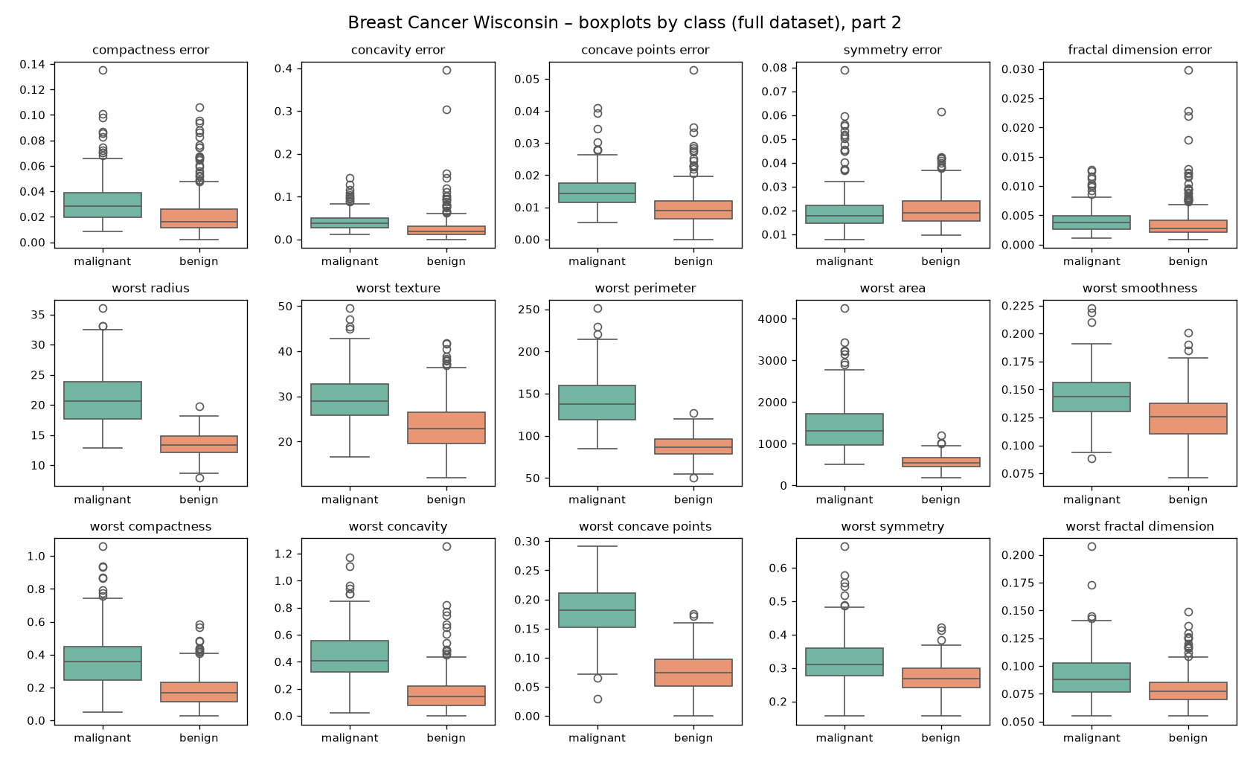
Figure 18. Breast Cancer Wisconsin – boxplots of all features by class, part 2 (full dataset).
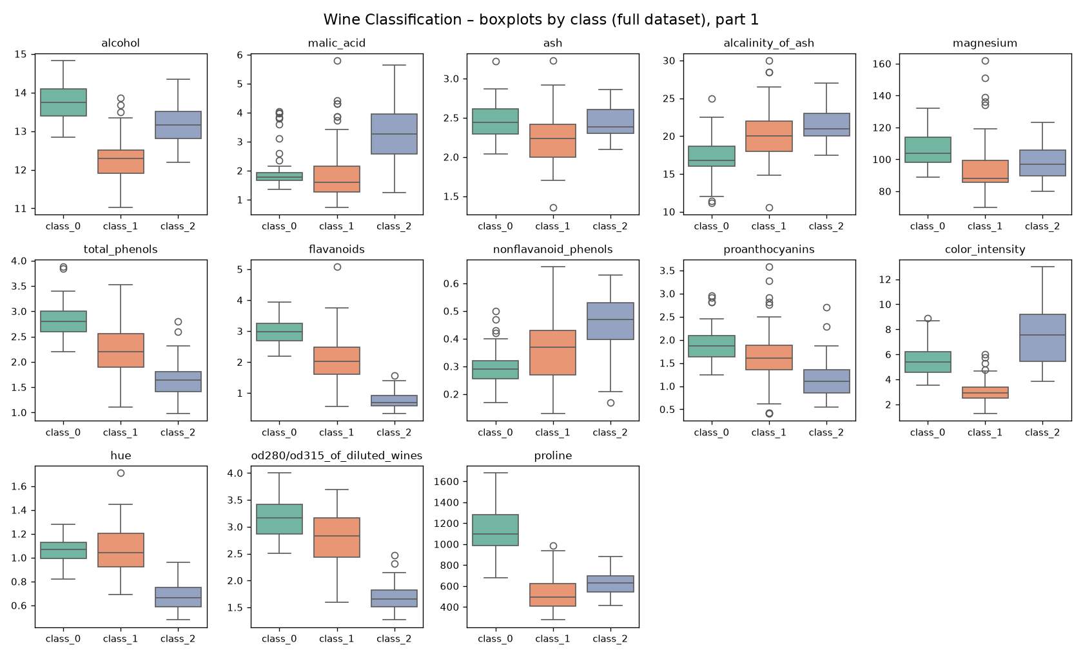
Figure 19. Wine Classification – boxplots of all features by class, part 1 (full dataset).

Appendix C. Split summaries (nine rows per dataset)
Table 21. Breast Cancer Wisconsin – split summary for seeds 42, 52, 62 (test subset identical across seeds).
seed | subset | n_samples | percent_of_full | n_malignant | n_benign
42 | train | 398 | 69.95% | 149 | 249
42 | validation | 57 | 10.02% | 21 | 36
42 | test | 114 | 20.04% | 42 | 72
52 | train | 398 | 69.95% | 149 | 249
52 | validation | 57 | 10.02% | 21 | 36
52 | test | 114 | 20.04% | 42 | 72
62 | train | 398 | 69.95% | 149 | 249
62 | validation | 57 | 10.02% | 21 | 36
62 | test | 114 | 20.04% | 42 | 72

Table 22. Wine Classification – split summary for seeds 42, 52, 62 (test subset identical across seeds).
seed | subset | n_samples | percent_of_full | n_class_0 | n_class_1 | n_class_2
42 | train | 124 | 69.66% | 41 | 50 | 33
42 | validation | 18 | 10.11% | 6 | 7 | 5
42 | test | 36 | 20.22% | 12 | 14 | 10
52 | train | 124 | 69.66% | 41 | 50 | 33
52 | validation | 18 | 10.11% | 6 | 7 | 5
52 | test | 36 | 20.22% | 12 | 14 | 10
62 | train | 124 | 69.66% | 41 | 50 | 33
62 | validation | 18 | 10.11% | 6 | 7 | 5
62 | test | 36 | 20.22% | 12 | 14 | 10

