Appendix

Transformations
I am doing the following transformations:
Variable | Description
SML_UNIT = 1 IF UNIT <= 18, 0 otherwise | Indicator if the apartment has 18 or fewer units
SP_UNIT = PRICE/UNIT | Sale price per unit
SP_SQFT = PRICE/AREA | Sale price per square foot
CAP_RATE = NOI/PRICE | Capitalization rate
GIM = PRICE/EFF_INC | Gross income multiplier
LOT_AREA = LOTSIZE/AREA | Ratio of lot size to building area
AREA_UNIT = AREA/UNIT | Building area per unit
EXP_EGI = EXPENSES/EFF_INC | Expense ratio
GI_UNIT = GROSS_IN/UNITS | Gross income per unit
NOI_UNIT = NOI/UNITS | Net operating income per unit
NBHD_1 = 1 IF NBHD = 1, 0 otherwise | Indicator if the property is in NBHD = 1
NBHD_3 = 1 IF NBHD = 3, 0 otherwise | Indicator if the property is in NBHD = 3
NBHD_4 = 1 IF NBHD = 4, 0 otherwise | Indicator if the property is in NBHD = 4
CONDITION_1 = 1 IF CONDITION = 1, 0 otherwise | Indicator if the property’s conditions is 1
CONDITION_3 = 1 IF CONDITION = 3, 0 otherwise | Indicator if the property’s conditions is 3
STORY_2 = 1 IF STORY = 2, 0 otherwise | Indicator if the property has 2 stories
STORY_4 = 1 IF STORY = 3, 0 otherwise | Indicator if the property has 4 stories

Relationship between Variables

Scatter Plot
Fig A 1. Scatter Plots Demonstrating the Relationship between Variables and SP_SQFT
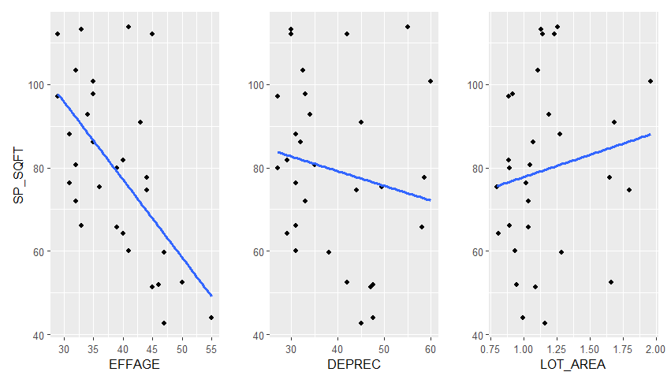
Fig A 2. Scatter Plots Demonstrating the Relationship between Variables and CAP_RATE
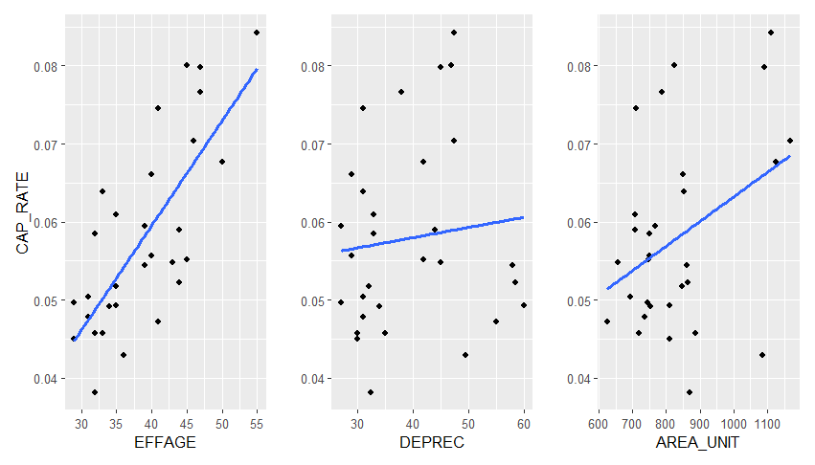
Fig A 3.Scatter Plots Demonstrating the Relationship between Variables and GIM
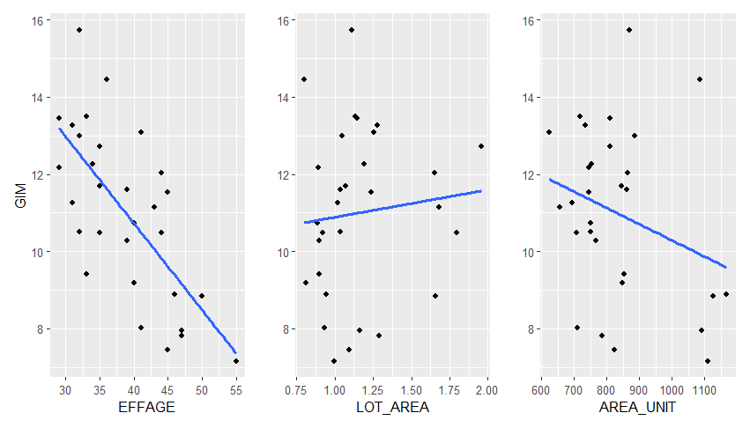
Fig A 4. Scatter Plots Demonstrating the Relationship between Variables and SP_UNIT
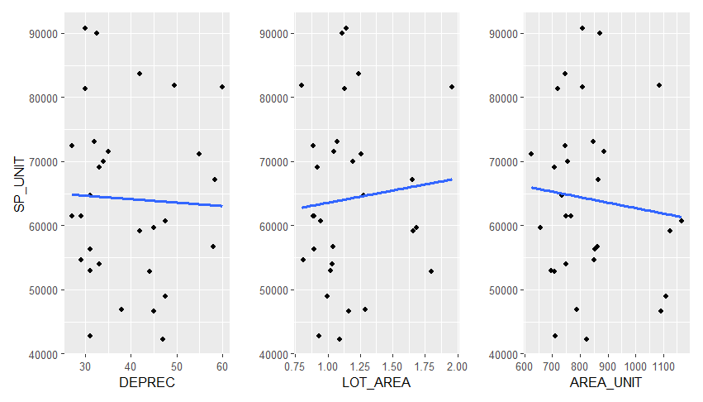

Box plots
Fig A 5. Box Plots Demonstrating the relationship between GIM and categorical variables
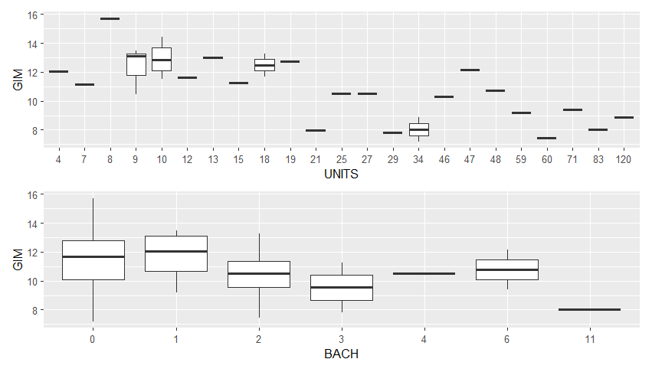
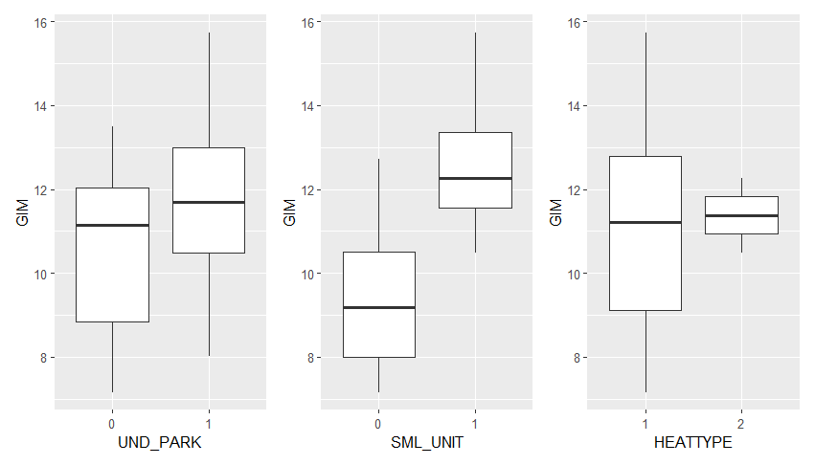

Correlation Matrix
Correlation Matrix for Coefficients
 | UNITS | EFFAGE | DEPREC | UND_PARK | ELEVATOR | LOT_AREA | AREA_UNIT | EXP_EGI | NBHD_1
UNITS | 1.000 | 0.290 | -0.250 | 0.135 | 0.226 | -0.169 | 0.265 | 0.339 | -0.238
EFFAGE |  | 1.000 | 0.500 | -0.545 | -0.485 | 0.254 | 0.451 | -0.136 | -0.383
DEPREC |  |  | 1.000 | -0.553 | -0.476 | 0.522 | 0.308 | -0.433 | -0.083
UND_PARK |  |  |  | 1.000 | 0.629 | -0.501 | -0.118 | 0.130 | 0.235
ELEVATOR |  |  |  |  | 1.000 | -0.379 | -0.155 | 0.185 | 0.101
LOT_AREA |  |  |  |  |  | 1.000 | -0.120 | -0.216 | -0.140
AREA_UNIT |  |  |  |  |  |  | 1.000 | -0.090 | -0.117
EXP_EGI |  |  |  |  |  |  |  | 1.000 | -0.127
NBHD_1 |  |  |  |  |  |  |  |  | 1.000
NBHD_3
NBHD_4
CONDITION_1
CONDITION_3
STORY_2
STORY_4
SML_UNIT
GIM
 | NBHD_3 | NBHD_4 | CONDITION_1 | CONDITION_3 | STORY_2 | STORY_4 | SML_UNIT | GIM
UNITS | 0.060 | -0.224 | 0.425 | -0.200 | -0.402 | -0.196 | -0.703 | -0.602
EFFAGE | -0.443 | 0.375 | 0.536 | -0.508 | -0.123 | -0.131 | -0.325 | -0.692
DEPREC | -0.410 | 0.395 | 0.367 | -0.334 | 0.280 | 0.164 | 0.135 | -0.031
UND_PARK | 0.537 | -0.482 | -0.247 | 0.331 | -0.323 | 0.036 | -0.067 | 0.246
ELEVATOR | 0.375 | -0.313 | -0.033 | 0.211 | -0.313 | -0.036 | -0.336 | 0.102
LOT_AREA | -0.265 | 0.462 | 0.149 | -0.127 | 0.383 | -0.079 | 0.234 | 0.098
AREA_UNIT | -0.172 | 0.138 | 0.524 | -0.054 | -0.266 | 0.067 | -0.276 | -0.280
EXP_EGI | 0.156 | 0.019 | 0.063 | 0.290 | -0.266 | -0.078 | -0.075 | -0.141
NBHD_1 | -0.302 | -0.276 | -0.208 | 0.224 | 0.118 | 0.200 | 0.333 | 0.624
NBHD_3 | 1.000 | -0.333 | -0.146 | 0.337 | 0.024 | -0.161 | 0.000 | 0.028
NBHD_4 |  | 1.000 | 0.234 | -0.247 | 0.068 | -0.147 | -0.079 | -0.277
CONDITION_1 |  |  | 1.000 | -0.340 | -0.256 | -0.203 | -0.484 | -0.551
CONDITION_3 |  |  |  | 1.000 | 0.176 | 0.239 | 0.268 | 0.480
STORY_2 |  |  |  |  | 1.000 | -0.147 | 0.394 | 0.420
STORY_4 |  |  |  |  |  | 1.000 | 0.267 | 0.330
SML_UNIT |  |  |  |  |  |  | 1.000 | 0.723
GIM |  |  |  |  |  |  |  | 1.000

Variable Selection and Calibration
 | ANOVA (model 3 after removing UND_PARK)
 | Sum of Squares | df | Mean Square | F | Sig.
Regression | 130.15 | 12 | 10.85 | 18.61 | 0.00
Residuals | 9.91 | 17 | 0.58
Total | 140.06 | 29
 | Coefficient
Variable | Coefficient | Standard Coefficient | t_Statistic | Significance | Tolerance | VIF
(Intercept) | 13.132 | 5.975 | 5.936 | 0.000
ELEVATOR | 0.749 | 0.341 | 1.670 | 0.113 | 0.393 | 2.543
LOT_AREA | 1.025 | 0.466 | 1.596 | 0.129 | 0.532 | 1.879
AREA_UNIT | 0.002 | 0.001 | 1.125 | 0.276 | 0.459 | 2.177
NBHD_1 | 1.261 | 0.574 | 2.331 | 0.032 | 0.415 | 2.409
NBHD_3 | -0.449 | -0.204 | -0.821 | 0.423 | 0.332 | 3.009
NBHD_4 | -0.387 | -0.176 | -0.900 | 0.381 | 0.588 | 1.701
STORY_2 | 1.009 | 0.459 | 2.285 | 0.035 | 0.557 | 1.796
STORY_4 | 0.946 | 0.430 | 1.485 | 0.156 | 0.770 | 1.299
HEATTYPE | -0.101 | -0.046 | -0.151 | 0.882 | 0.700 | 1.430
BACH | -0.113 | -0.052 | -1.310 | 0.207 | 0.435 | 2.298
SML_UNIT | 1.661 | 0.756 | 3.657 | 0.002 | 0.377 | 2.655
EFFAGE | -0.154 | -0.070 | -4.151 | 0.001 | 0.318 | 3.144

Stepwise Regression
Coefficients for the Stepwise Regression Models
Model 1
Term | Estimate | Std. Error | t value | Pr(>|t|)
(Intercept) | 13.132 | 2.212 | 5.936 | 0.000
ELEVATOR | 0.749 | 0.449 | 1.670 | 0.113
LOT_AREA | 1.025 | 0.642 | 1.596 | 0.129
AREA_UNIT | 0.002 | 0.001 | 1.125 | 0.276
NBHD_1 | 1.261 | 0.541 | 2.331 | 0.032
NBHD_3 | -0.449 | 0.547 | -0.821 | 0.423
NBHD_4 | -0.387 | 0.430 | -0.900 | 0.381
STORY_2 | 1.009 | 0.442 | 2.285 | 0.035
STORY_4 | 0.946 | 0.637 | 1.485 | 0.156
HEATTYPE | -0.101 | 0.668 | -0.151 | 0.882
BACH | -0.113 | 0.086 | -1.310 | 0.207
SML_UNIT | 1.661 | 0.454 | 3.657 | 0.002
EFFAGE | -0.154 | 0.037 | -4.151 | 0.001
Model 2
Term | Estimate | Std. Error | t value | Pr(>|t|)
(Intercept) | 12.996 | 1.965 | 6.613 | 0.000
ELEVATOR | 0.768 | 0.419 | 1.833 | 0.083
LOT_AREA | 1.010 | 0.618 | 1.636 | 0.119
AREA_UNIT | 0.002 | 0.001 | 1.226 | 0.236
NBHD_1 | 1.254 | 0.524 | 2.393 | 0.028
NBHD_3 | -0.474 | 0.507 | -0.934 | 0.363
NBHD_4 | -0.396 | 0.414 | -0.957 | 0.351
STORY_2 | 1.021 | 0.423 | 2.415 | 0.027
STORY_4 | 0.951 | 0.619 | 1.537 | 0.142
BACH | -0.111 | 0.083 | -1.341 | 0.197
SML_UNIT | 1.661 | 0.442 | 3.760 | 0.001
EFFAGE | -0.154 | 0.036 | -4.272 | 0.000
Model 3
Term | Estimate | Std. Error | t value | Pr(>|t|)
(Intercept) | 12.635 | 1.920 | 6.580 | 0.000
ELEVATOR | 0.696 | 0.410 | 1.696 | 0.106
LOT_AREA | 1.047 | 0.614 | 1.705 | 0.105
AREA_UNIT | 0.001 | 0.001 | 1.003 | 0.328
NBHD_1 | 1.581 | 0.389 | 4.067 | 0.001
NBHD_4 | -0.268 | 0.389 | -0.690 | 0.499
STORY_2 | 0.939 | 0.412 | 2.278 | 0.034
STORY_4 | 1.073 | 0.603 | 1.780 | 0.091
BACH | -0.138 | 0.077 | -1.795 | 0.089
SML_UNIT | 1.544 | 0.422 | 3.656 | 0.002
EFFAGE | -0.140 | 0.033 | -4.291 | 0.000
Model 4
Term | Estimate | Std. Error | t value | Pr(>|t|)
(Intercept) | 12.838 | 1.872 | 6.856 | 0.000
ELEVATOR | 0.733 | 0.401 | 1.827 | 0.083
LOT_AREA | 0.879 | 0.556 | 1.580 | 0.130
AREA_UNIT | 0.001 | 0.001 | 0.952 | 0.352
NBHD_1 | 1.614 | 0.381 | 4.236 | 0.000
STORY_2 | 0.955 | 0.406 | 2.353 | 0.029
STORY_4 | 1.106 | 0.593 | 1.866 | 0.077
BACH | -0.141 | 0.076 | -1.856 | 0.078
SML_UNIT | 1.563 | 0.416 | 3.759 | 0.001
EFFAGE | -0.141 | 0.032 | -4.382 | 0.000
Model 5
Term | Estimate | Std. Error | t value | Pr(>|t|)
(Intercept) | 13.832 | 1.551 | 8.915 | 0.000
ELEVATOR | 0.708 | 0.400 | 1.771 | 0.091
LOT_AREA | 0.742 | 0.536 | 1.384 | 0.181
NBHD_1 | 1.653 | 0.378 | 4.375 | 0.000
STORY_2 | 0.873 | 0.396 | 2.206 | 0.039
STORY_4 | 1.132 | 0.591 | 1.916 | 0.069
BACH | -0.176 | 0.066 | -2.671 | 0.014
SML_UNIT | 1.456 | 0.400 | 3.645 | 0.002
EFFAGE | -0.133 | 0.031 | -4.290 | 0.000

