Income-Based Modeling for Apartment Building: Predicting Gross Income Multiplier

Project 3 | BUSI 444

Hamed Helisaz

4305475

April 6, 2025

Contents
Introduction 3
Choose a Valuation Model 3
Review and Examine the Variables 4
Transformations 4
Relationship with Variables 4
Scatterplot 4
Boxplots 5
Correlation Matrix 6
Variable Selection and Calibration 7
Stepwise Regression 8
Analysis of Results 10
Conclusion 11
Appendix 12
Transformations 12
Relationship between Variables 13
Scatter Plot 13
Box plots 15
Correlation Matrix 16
Variable Selection and Calibration 17
Stepwise Regression 17
Syntax for Variable Transformation 19

Introduction
This report examines the income-based modeling of apartment building sales, employing a similar methodology to Lesson 7's framework. The primary objective is to construct a robust model for estimating the gross income multiplier (GIM), using 30 sales for the apartments. Initially, a coefficient of variation (COV) analysis was conducted on SP_UNIT, SP_SQFT, and GIM, revealing GIM as the most suitable dependent variable due to its lower COV. The subsequent analysis of variables, including transformations and correlation assessments, resulted in a final model derived through stepwise regression. This model incorporates key factors such as the presence of an elevator, neighborhood, number of stories, bachelor units, small unit indicator, and effective age. The model's efficacy was validated through ratio statistics and Kruskal-Wallis tests, demonstrating its accuracy in estimating GIM, effective income, and price, with coefficient of variation (COV) values of 6.61%, 6.36%, and 6.61% for PRICE_RATIO, EFF_INC_RATIO, and PRICE_RATIO, respectively. The results of the Kruskal-Wallis test indicate that the model effectively captures variations in GIM, effective income, and price across different property segments.

Choose a Valuation Model
The dataset for this project is the same as the dataset for lesson 7 and so I skip describing the variables in the dataset. Following the general framework in lesion 7, I am using an additive model in this section. First, I need to find the response variable for the model. Referring to the video for project 3, I am doing COV analysis on SP_UNIT (sale price per unit), SP_SQFT (sale price per squared feet), and GIM (gross income model) to pick the right dependent variable from those.
Coefficient of Variable for Three Dependent Variable
 | SP_UNIT | SQ_SQF | GIM
COV | 0.212 | 0.265 | 0.200

Based on the table above, I am proceeding with GIM as the dependent variable. Following the model provided in Lesson 7, I am proposing the model below:
$$GIM=b_{0}+\left(b_{1}×LOCATION\right)+\left(b_{2}×AGE\right)+\left(b_{3}×UNITS\right)+\left(b_{4}×SUITSIZE\right)+\left(b_{5}×LANDRATIO\right)+\left(b_{6}×AMENITIES\right)$$
Having established GIM as the response variable, the next step involves a thorough review and examination of the dataset's variables to understand their potential relevance to the model.

Review and Examine the Variables
Since this dataset is the same as in Lesson 7, this section replicates the corresponding analysis. Here, I am providing a summary of the variable review. The sales data covers January 31, 2025, to February 27, 2017, for apartments with 4 to 120 units, but more than 50% of them have fewer than 20 units. There is an outlier in building area with 135,147 square feet, but more than 50% of the cases have less than 15,400 square feet. Similarly, there is an outlier in land size with 224,334 square feet, but around 60% of the data has lot sizes under 27,000 square feet. Apartments are between 25 to 50 years old, but around 80% were built between 1977 and 1992, with a large number constructed in 1991 alone.
With an understanding of the variables' distributions and ranges, the next step involves applying appropriate transformations to prepare the data for modeling.

Transformations
Similar transformations as those explained in Lesson 7 are followed here too. I am creating a new column SML_UNIT that is 1 if the apartment has 18 or fewer and 0 otherwise. Other transformations are listed in Appendix (Table A.1), including transformations for neighborhoods, conditions and stories. Following the instruction in the Video for Project 3, I am only including the Syntax for variable transformation in the Appendix and not for all the steps. As I already spoke with my tutor, I am using R as my programming language. Having transformed the variables as necessary, the analysis proceeds to explore the relationships between these variables and the response variable, GIM, through scatterplots and boxplots.

Relationship with Variables

Scatterplot
To understand the relationship between the variables, I first consider the Pearson correlation coefficients between our return variables (SP_UNIT, SP_SQFT, CAP_RATE, and GIM) and continuous variables (EFFAGE, DEPREC, LOT_AREA, AREA_UNIT). High correlation coefficient indicates higher influence of the measure of return. Not surprisingly, I come up with the same results as those in Lesson 7.
Correlation between Variables
 | EFFAGE | DEPREC | LOT_AREA | AREA_UNIT | EXP_EGI
SP_UNIT | -0.525 | -0.040 | 0.085 | -0.091 | -0.230
SP_SQFT | -0.600 | -0.169 | 0.153 | -0.619 | -0.174
CAP_RATE | 0.744 | 0.109 | -0.101 | 0.377 | 0.051
GIM | -0.692 | -0.031 | 0.098 | -0.280 | -0.141

Some of the scatter plots corresponding the same variables shown in the table above are considered below and more in Appendix (Fig. A.1 – A.4). Note that the value for R² is always the squared of the Pearson correlation coefficient given in the table above. The table above and the scatter plots show that EFFAGE and AREA_UNIT have high correlation with the response variable and should be included in the model. In addition to examining continuous variables, the relationship between categorical variables and GIM is explored using boxplots to provide further insights into potential model predictors.
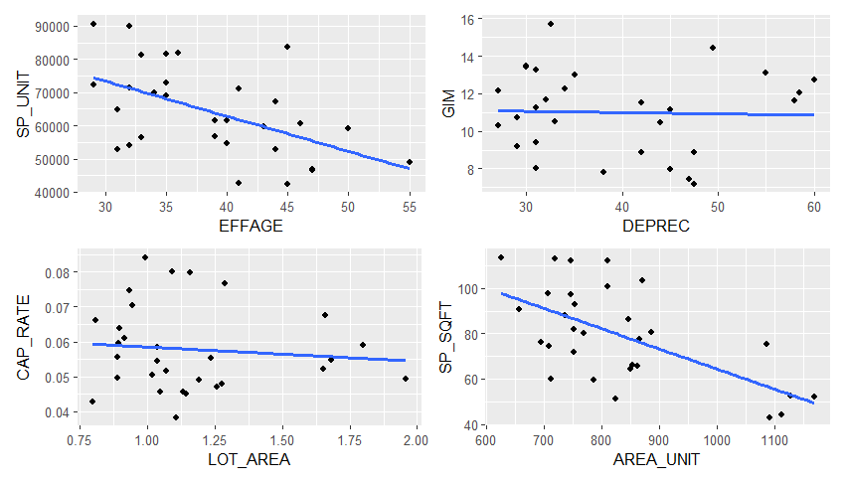
R² = 0.275
R² = 0.0.00
R² = 0.010
R² = 0.383

Boxplots
Similarly, the relationship between the categorical variables and the response variable is shown using box plots. Here, I include only the box plots for the selected response variable (GIM). Four box plots are included in the main text, while the rest can be found in the Appendix (Fig. A.5). Following Lesson 7, I do not consider unit-specific variables such as ONEBED or TWOBED, as we are evaluating building market value, and their effects should be captured by other variables.
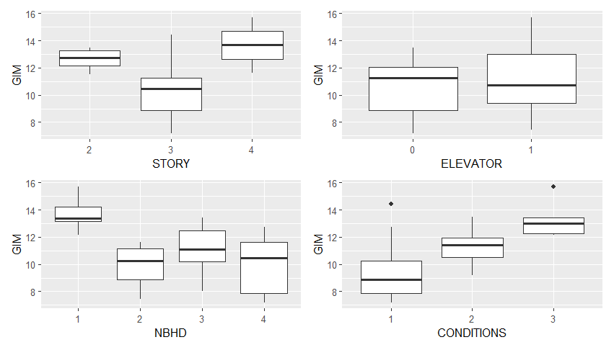
The results show that buildings in better condition tend to have higher GIM, which is expected-investing in well-maintained buildings leads to faster returns. Apartments with three stories appear to have the lowest GIM compared to those with two or four stories. Having an elevator slightly increases GIM, and neighborhood 1 has the highest GIM compared to other neighborhoods. Additionally, buildings with fewer units tend to have higher GIM and faster returns, supporting the inclusion of the new column in the model. A lower number of bachelor units also increases GIM, as do factors like under-parking and heat type 2, though the effect of the latter is not significant. To further refine the variable selection process and identify potential multicollinearity issues, a correlation matrix is examined

Correlation Matrix
The correlation matrix Table is included in the Appendix and it shows the correlation coefficients between different variables. Those with high correlation (above 0.5 or less than -0.5) are highlighted with red indicating they could cause collinearity in the model. According to the table, EFFAGE and CONDITION_1 and CONDITION_3 have high correlation as well as SML_UNITS and UNITS. Since theses variables are representing similar things, we should include only one of them in the model. Not surprisingly, the results here are consistent with finding in Lesson 7 as the independent variables are the same.
Given the plots and the table in this section, I am finalizing the list of variables as follows:
Either: | UNITS | or | SML_UNIT
Either: | EFFAGE | or | CONDITION_1 and CONDITONS_3
Common: | UND_PARK  ELEVATOR  LOT_AREA  AREA_UNIT  NBHD  STORY  HEATTYPE  BACH

Note that the last two common variables are not listed in Lesson 7 but I am including them as well as they have been shown to have high correlation with the response variable GIM. With a refined set of variables, the next step involves variable selection and calibration to build the most effective model.

Variable Selection and Calibration
Following a similar discussion in Lesson 7, I am introducing the following variable groups
Group 1 | Common + UNITS + EFFAGE
Group 2 | Common + SML_UNIT + EFFAGE
Group 3 | Common + SML_UNIT +EFFAGE
Group 4 | Common + UNITS + CONIDTIONS

Table below shows the statistics for model summary for the models above.
 | R² | Adjusted R² | SEE | F | Sig. | Max VIF
Model 1 | 0.915 | 0.845 | 0.632 | 13.176 | 0.000 | 3.698
Model 2 | 0.892 | 0.792 | 0.709 | 8.894 | 0.000 | 4.056
Model 3 | 0.940 | 0.891 | 0.529 | 19.280 | 0.000 | 3.697
Model 4 | 0.872 | 0.753 | 0.773 | 7.305 | 0.000 | 5.258

Table above shows Model 3 has the highest adjusted R² as well as highest F statistics. However, all models have a VIF larger than 3.33 which causes potential collinearity. This issue should be addressed for calibrating the variables to ensure that no variable have VIF larger than 3.33. Based on the results, I am following with Model 3, which results in the following coefficients.

 | ANOVA
 | Sum of Squares | df | Mean Square | F | Sig.
Regression | 131.66 | 13 | 10.13 | 19.28 | 0.00
Residuals | 8.41 | 16 | 0.53
Total | 140.06 | 29
 | Coefficient
Variable | Coefficient | Standard_Coefficient | t_Statistic | Significance | Tolerance | VIF
(Intercept) | 13.185 | 5.999 | 6.278 | 0.000
UND_PARK | 0.869 | 0.395 | 1.692 | 0.110 | 0.271 | 3.697
ELEVATOR | 0.460 | 0.209 | 1.002 | 0.331 | 0.339 | 2.953
LOT_AREA | 1.205 | 0.548 | 1.947 | 0.069 | 0.516 | 1.936
AREA_UNIT | 0.001 | 0.001 | 1.024 | 0.321 | 0.455 | 2.196
NBHD_1 | 0.945 | 0.430 | 1.729 | 0.103 | 0.367 | 2.728
NBHD_3 | -0.797 | -0.363 | -1.428 | 0.173 | 0.287 | 3.482
NBHD_4 | -0.269 | -0.122 | -0.649 | 0.525 | 0.571 | 1.750
STORY_2 | 1.241 | 0.565 | 2.814 | 0.012 | 0.503 | 1.989
STORY_4 | 0.957 | 0.435 | 1.583 | 0.133 | 0.770 | 1.299
HEATTYPE | -0.519 | -0.236 | -0.763 | 0.457 | 0.607 | 1.647
BACH | -0.121 | -0.055 | -1.470 | 0.161 | 0.434 | 2.305
SML_UNIT | 1.662 | 0.756 | 3.853 | 0.001 | 0.377 | 2.655
EFFAGE | -0.148 | -0.067 | -4.181 | 0.001 | 0.315 | 3.176

The table of coefficients show that UND_PARK has the VIF>3.33 which causes collinearity. This is expected since UND_PARK shows to have high correlation with EFFAGE and hence high VIF. Since EFFAGE has higher effect on the response variable, I will keep EFFAGE and remove UND_PARK to reduce the VIF. The results after removing UND_PARK are available in the Appendix (Table A.3). The table shows that removing UND_PARK solves the problem with VIF and the VIF for the coefficients in the new model are all below 3.33. With the issue of multicollinearity addressed, the next step is to refine the model by removing statistically insignificant coefficients. This is achieved through stepwise regression.

Stepwise Regression
To refine the model by removing statistically insignificant coefficients, a stepwise regression method was employed. This process led to the removal of NBHD_3, NBHD_4, and HEATTYPE from the model. The detailed steps of the stepwise regression, along with the detailed coefficient values at each step, are included in the Appendix (Table A.4).

Stepwise Method
Model | Predictors:
Model1 | ELEVATOR, LOT_AREA, AREA_UNIT, NBHD_1, NBHD_3, NBHD_4, STORY_2, STORY_4, HEATTYPE, BACH, SML_UNIT, EFFAGE
Model2 | ELEVATOR, LOT_AREA, AREA_UNIT, NBHD_1, NBHD_3, NBHD_4, STORY_2, STORY_4, BACH, SML_UNIT, EFFAGE
Model3 | ELEVATOR, LOT_AREA, AREA_UNIT, NBHD_1, NBHD_4, STORY_2, STORY_4, BACH, SML_UNIT, EFFAGE
Model4 | ELEVATOR, LOT_AREA, AREA_UNIT, NBHD_1, STORY_2, STORY_4, BACH, SML_UNIT, EFFAGE

 | ANOVA
 | Sum of Squares | df | Mean Square | F | Sig.
Regression | 128.92 | 8 | 16.11 | 30.36 | 0.00
Residuals | 11.15 | 21 | 0.53
Total | 140.06 | 29
 | Coefficients
 | Coefficients | Standard_Coefficient | t_Statistic | Significance | Tolerance | VIF
(Intercept) | 13.832 | 6.294 | 8.915 | 0.000
ELEVATOR | 0.708 | 0.322 | 1.771 | 0.091 | 0.451 | 2.217
LOT_AREA | 0.742 | 0.338 | 1.384 | 0.181 | 0.695 | 1.438
NBHD_1 | 1.653 | 0.752 | 4.375 | 0.000 | 0.775 | 1.291
STORY_2 | 0.873 | 0.397 | 2.206 | 0.039 | 0.631 | 1.584
STORY_4 | 1.132 | 0.515 | 1.916 | 0.069 | 0.815 | 1.227
BACH | -0.176 | -0.080 | -2.671 | 0.014 | 0.677 | 1.477
SML_UNIT | 1.456 | 0.663 | 3.645 | 0.002 | 0.443 | 2.255
EFFAGE | -0.133 | -0.061 | -4.290 | 0.000 | 0.414 | 2.413

And therefore, the final model is achieved as follows:
$$GIM= \left(INTERCEPT\right)+0.708 \left(ELEVATOR\right)+0.742 \left(LOT_AERA \right)+1.653 \left(NBHD_1 \right)+0.873 \left(STORY_2 \right)+1.132 \left(STORY_4 \right)-0.176\left(BACH\right)+1.456 \left(SML_UNIT\right)-0.133 (EFFAGE)$$
The model's coefficients generally align with expectations: elevators, increased stories, and smaller units positively correlate with higher GIM, as does property location in neighborhood 1. Conversely, bachelor units and older effective age negatively impact GIM. While a larger lot area exhibits a positive relationship with GIM, its effect is statistically less significant. It is important to mention that while the LOT_AREA does not seem to be statistically significant, including it results in lower AIC than removing it and hence stepwise process ends up including it in the model. The model summary shows no variables with a VIF exceeding 3.33 indicates that multicollinearity is unlikely to be a concern in this model. With the final model established, the next section details the analysis of the results, comparing predicted values against actual values to assess the model's accuracy and effectiveness. Using the model, I am predicting the GIM_PRED which is the predicted value for GIM based on the model above. Next section, I am analysing the results by comparing the predicted values and the actual values.

Analysis of Results
Following the discussion in Lesson 7, I am defining the following variables:
Variable | Description
GIM_RATIO = GIM_PRED/GIM | Ratio of predicted GIM to actual GIM
EFF_INC_PRED = PRICE / GIM_PRED | Effective Income Prediction using predicted GIM
EFF_INC_RATIO = EFF_INC_PRED/ EFF_INC | Ratio of predicted effective income to actual effective income
PRICE_PRED = EFF_INC * GIM_PRED | Price prediction using predicted GIM and Effective Income
PRICE_RATIO = PRICE_PRED/ PRICE | Ratio of predicted price to actual price

Following table shows the ratio statistics for the GIM_RATIO and EFF_INC_RATIO
 |  | PRICE_RATIO | EFF_INC_RATIO | PRICE_RATIO
MEAN |  | 1.00 | 1.00 | 1.00
MEDIAN |  | 1.00 | 1.00 | 1.00
STD.DEV |  | 0.07 | 0.06 | 0.07
COV |  | 6.61% | 6.36% | 6.61%
Percentile | 0.93 | 0.94 | 0.93 | 0.94
 | 0.95 | 0.96 | 0.95 | 0.96
 | 1.04 | 1.05 | 1.04 | 1.04
 | 1.06 | 1.08 | 1.06 | 1.06

The median and the mean are very close to one for both ratios. Also, the standard deviation is small relative to the mean. In fact, the COVs are 6.61%, 6.36%, and 6.61% for PRICE_RATIO, EFF_INC_RATIO, and PRICE_RATIO respectively. Also, the percentiles are close enough to one for all ratios showing the accuracy of the model. The results show that the model is not only good for estimating GIM, but also EFF_INC and PRICE. Suggested by Lesson 7, I finalized this section by doing K-W test for different variable to ensure the prediction is equal and fair. The table below summarizes the K-W test for different variables.
Title | df | p.value | CH
NBHD | 3 | 0.800 | 1.005
STORY | 2 | 0.984 | 0.033
CONDITN | 2 | 0.860 | 0.302
SML_UNIT | 1 | 0.917 | 0.011
ELEVATOR | 1 | 0.950 | 0.004
BACH | 6 | 0.822 | 2.891

Interestingly, the p-value for all the tests is well above 5%, indicating that the evaluation is equitable across different variables. Consequently, no further adjustments are needed, and the final model remains as derived previously:
$$GIM= \left(13.832\right)+0.708 \left(ELEVATOR\right)+0.742 \left(LOT_AERA \right)+1.653 \left(NBHD_1 \right)+0.873 \left(STORY_2 \right)+1.132 \left(STORY_4 \right)-0.176\left(BACH\right)+1.456 \left(SML_UNIT\right)-0.133 (EFFAGE)$$

Conclusion
This study successfully developed and validated an income-based model for estimating apartment building Gross Income Multiplier (GIM) using 30 apartment sales. GIM is selected as the dependent variable due to its low Coefficient of Variation (COV) of 0.2. Stepwise regression refined the model, confirming that factors like elevators, specific neighborhoods, number of stories, and smaller unit indicator positively correlate with GIM, while bachelor units and effective age have a negative impact. Multicollinearity was addressed, ensuring all Variance Inflation Factors (VIFs) remained below the 3.33 threshold. The model demonstrated strong predictive accuracy, with ratio analyses yielding Mean and Median values near 1.00 and low COVs for price, effective income, and GIM ratios (6.61%, 6.36%, and 6.61% respectively). Furthermore, Kruskal-Wallis tests confirmed equitable predictions across different property variables, with all p-values exceeding the 5% significance level, validating the model's robustness for estimating GIM.

Appendix

Transformations
I am doing the following transformations:
Table A 1. Transformation of Variables
Variable | Description
SML_UNIT = 1 IF UNIT <= 18, 0 otherwise | Indicator if the apartment has 18 or fewer units
SP_UNIT = PRICE/UNIT | Sale price per unit
SP_SQFT = PRICE/AREA | Sale price per square foot
CAP_RATE = NOI/PRICE | Capitalization rate
GIM = PRICE/EFF_INC | Gross income multiplier
LOT_AREA = LOTSIZE/AREA | Ratio of lot size to building area
AREA_UNIT = AREA/UNIT | Building area per unit
EXP_EGI = EXPENSES/EFF_INC | Expense ratio
GI_UNIT = GROSS_IN/UNITS | Gross income per unit
NOI_UNIT = NOI/UNITS | Net operating income per unit
NBHD_1 = 1 IF NBHD = 1, 0 otherwise | Indicator if the property is in NBHD = 1
NBHD_3 = 1 IF NBHD = 3, 0 otherwise | Indicator if the property is in NBHD = 3
NBHD_4 = 1 IF NBHD = 4, 0 otherwise | Indicator if the property is in NBHD = 4
CONDITION_1 = 1 IF CONDITION = 1, 0 otherwise | Indicator if the property’s conditions is 1
CONDITION_3 = 1 IF CONDITION = 3, 0 otherwise | Indicator if the property’s conditions is 3
STORY_2 = 1 IF STORY = 2, 0 otherwise | Indicator if the property has 2 stories
STORY_4 = 1 IF STORY = 3, 0 otherwise | Indicator if the property has 4 stories

Relationship between Variables

Scatter Plot
Fig A 1. Scatter Plots Demonstrating the Relationship between Variables and SP_SQFT
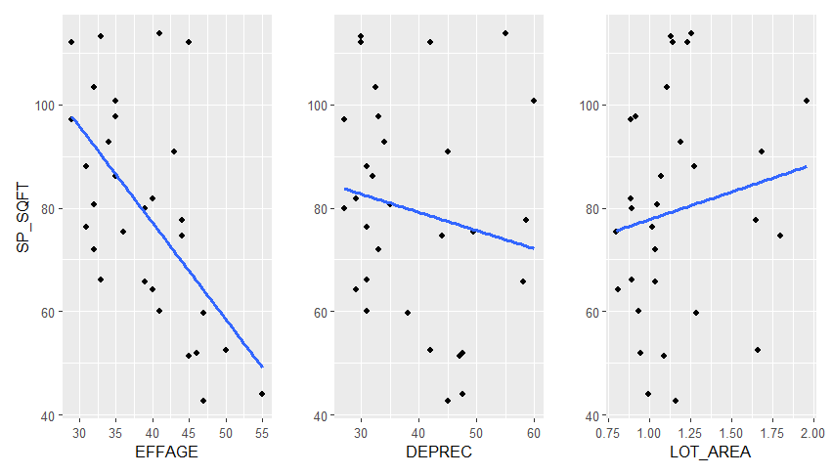
Fig A 2. Scatter Plots Demonstrating the Relationship between Variables and CAP_RATE
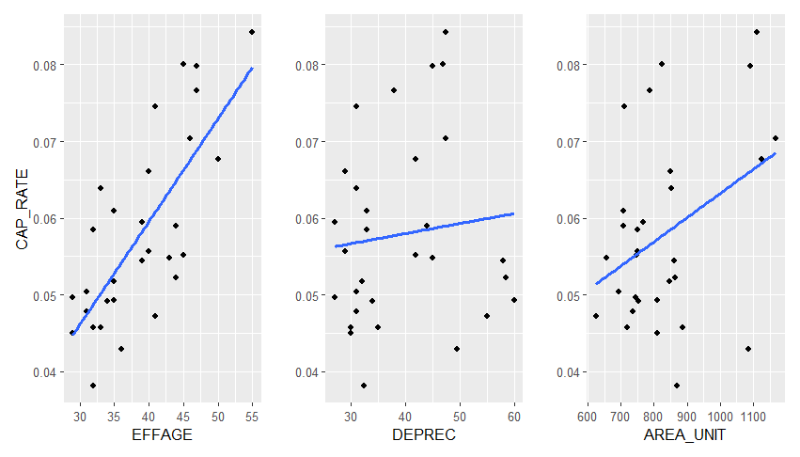
Fig A 3.Scatter Plots Demonstrating the Relationship between Variables and GIM
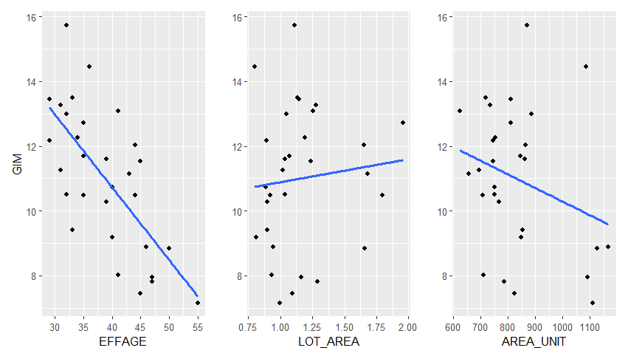
Fig A 4. Scatter Plots Demonstrating the Relationship between Variables and SP_UNIT
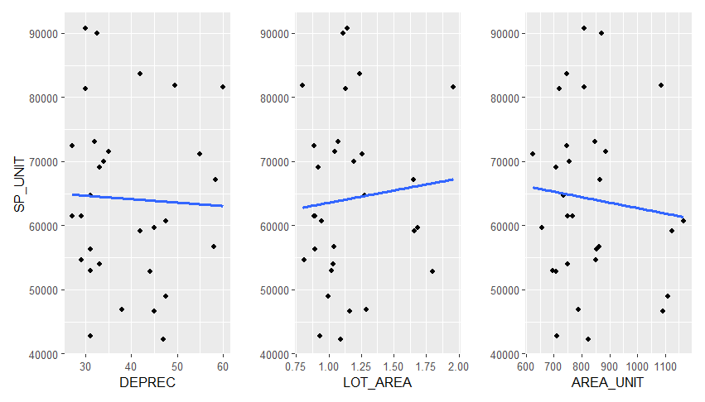

Box plots
Fig A 5. Box Plots Demonstrating the relationship between GIM and categorical variables
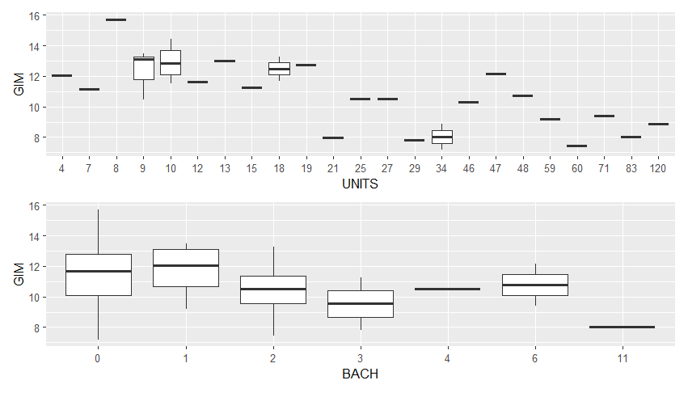
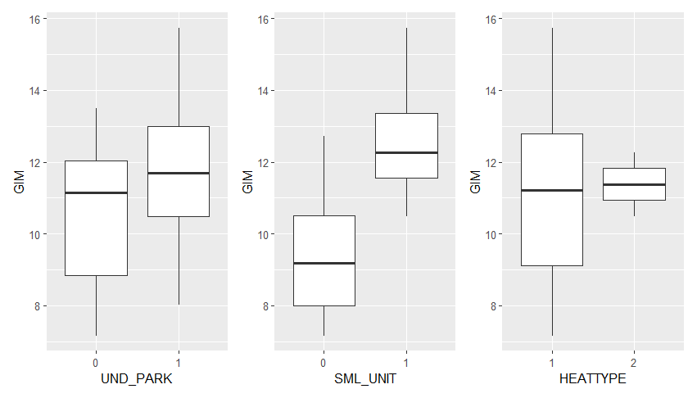

Correlation Matrix
Correlation Matrix for Coefficients
Table A 2. Correlation Matrix
 | UNITS | EFFAGE | DEPREC | UND_PARK | ELEVATOR | LOT_AREA | AREA_UNIT | EXP_EGI | NBHD_1
UNITS | 1.000 | 0.290 | -0.250 | 0.135 | 0.226 | -0.169 | 0.265 | 0.339 | -0.238
EFFAGE |  | 1.000 | 0.500 | -0.545 | -0.485 | 0.254 | 0.451 | -0.136 | -0.383
DEPREC |  |  | 1.000 | -0.553 | -0.476 | 0.522 | 0.308 | -0.433 | -0.083
UND_PARK |  |  |  | 1.000 | 0.629 | -0.501 | -0.118 | 0.130 | 0.235
ELEVATOR |  |  |  |  | 1.000 | -0.379 | -0.155 | 0.185 | 0.101
LOT_AREA |  |  |  |  |  | 1.000 | -0.120 | -0.216 | -0.140
AREA_UNIT |  |  |  |  |  |  | 1.000 | -0.090 | -0.117
EXP_EGI |  |  |  |  |  |  |  | 1.000 | -0.127
NBHD_1 |  |  |  |  |  |  |  |  | 1.000
NBHD_3
NBHD_4
CONDITION_1
CONDITION_3
STORY_2
STORY_4
SML_UNIT
GIM
 | NBHD_3 | NBHD_4 | CONDITION_1 | CONDITION_3 | STORY_2 | STORY_4 | SML_UNIT | GIM
UNITS | 0.060 | -0.224 | 0.425 | -0.200 | -0.402 | -0.196 | -0.703 | -0.602
EFFAGE | -0.443 | 0.375 | 0.536 | -0.508 | -0.123 | -0.131 | -0.325 | -0.692
DEPREC | -0.410 | 0.395 | 0.367 | -0.334 | 0.280 | 0.164 | 0.135 | -0.031
UND_PARK | 0.537 | -0.482 | -0.247 | 0.331 | -0.323 | 0.036 | -0.067 | 0.246
ELEVATOR | 0.375 | -0.313 | -0.033 | 0.211 | -0.313 | -0.036 | -0.336 | 0.102
LOT_AREA | -0.265 | 0.462 | 0.149 | -0.127 | 0.383 | -0.079 | 0.234 | 0.098
AREA_UNIT | -0.172 | 0.138 | 0.524 | -0.054 | -0.266 | 0.067 | -0.276 | -0.280
EXP_EGI | 0.156 | 0.019 | 0.063 | 0.290 | -0.266 | -0.078 | -0.075 | -0.141
NBHD_1 | -0.302 | -0.276 | -0.208 | 0.224 | 0.118 | 0.200 | 0.333 | 0.624
NBHD_3 | 1.000 | -0.333 | -0.146 | 0.337 | 0.024 | -0.161 | 0.000 | 0.028
NBHD_4 |  | 1.000 | 0.234 | -0.247 | 0.068 | -0.147 | -0.079 | -0.277
CONDITION_1 |  |  | 1.000 | -0.340 | -0.256 | -0.203 | -0.484 | -0.551
CONDITION_3 |  |  |  | 1.000 | 0.176 | 0.239 | 0.268 | 0.480
STORY_2 |  |  |  |  | 1.000 | -0.147 | 0.394 | 0.420
STORY_4 |  |  |  |  |  | 1.000 | 0.267 | 0.330
SML_UNIT |  |  |  |  |  |  | 1.000 | 0.723
GIM |  |  |  |  |  |  |  | 1.000

Variable Selection and Calibration
Table A 3. Model Coefficients and Summary after Removing UN_PARK variable
 | ANOVA (model 3 after removing UND_PARK)
 | Sum of Squares | df | Mean Square | F | Sig.
Regression | 130.15 | 12 | 10.85 | 18.61 | 0.00
Residuals | 9.91 | 17 | 0.58
Total | 140.06 | 29
 | Coefficient
Variable | Coefficient | Standard Coefficient | t_Statistic | Significance | Tolerance | VIF
(Intercept) | 13.132 | 5.975 | 5.936 | 0.000
ELEVATOR | 0.749 | 0.341 | 1.670 | 0.113 | 0.393 | 2.543
LOT_AREA | 1.025 | 0.466 | 1.596 | 0.129 | 0.532 | 1.879
AREA_UNIT | 0.002 | 0.001 | 1.125 | 0.276 | 0.459 | 2.177
NBHD_1 | 1.261 | 0.574 | 2.331 | 0.032 | 0.415 | 2.409
NBHD_3 | -0.449 | -0.204 | -0.821 | 0.423 | 0.332 | 3.009
NBHD_4 | -0.387 | -0.176 | -0.900 | 0.381 | 0.588 | 1.701
STORY_2 | 1.009 | 0.459 | 2.285 | 0.035 | 0.557 | 1.796
STORY_4 | 0.946 | 0.430 | 1.485 | 0.156 | 0.770 | 1.299
HEATTYPE | -0.101 | -0.046 | -0.151 | 0.882 | 0.700 | 1.430
BACH | -0.113 | -0.052 | -1.310 | 0.207 | 0.435 | 2.298
SML_UNIT | 1.661 | 0.756 | 3.657 | 0.002 | 0.377 | 2.655
EFFAGE | -0.154 | -0.070 | -4.151 | 0.001 | 0.318 | 3.144

Stepwise Regression
Coefficients for the Stepwise Regression Models
Table A 4. Details of Coefficients Value during the Stepwise Method.
Model 1
Term | Estimate | Std. Error | t value | Pr(>|t|)
(Intercept) | 13.132 | 2.212 | 5.936 | 0.000
ELEVATOR | 0.749 | 0.449 | 1.670 | 0.113
LOT_AREA | 1.025 | 0.642 | 1.596 | 0.129
AREA_UNIT | 0.002 | 0.001 | 1.125 | 0.276
NBHD_1 | 1.261 | 0.541 | 2.331 | 0.032
NBHD_3 | -0.449 | 0.547 | -0.821 | 0.423
NBHD_4 | -0.387 | 0.430 | -0.900 | 0.381
STORY_2 | 1.009 | 0.442 | 2.285 | 0.035
STORY_4 | 0.946 | 0.637 | 1.485 | 0.156
HEATTYPE | -0.101 | 0.668 | -0.151 | 0.882
BACH | -0.113 | 0.086 | -1.310 | 0.207
SML_UNIT | 1.661 | 0.454 | 3.657 | 0.002
EFFAGE | -0.154 | 0.037 | -4.151 | 0.001
Model 2
Term | Estimate | Std. Error | t value | Pr(>|t|)
(Intercept) | 12.996 | 1.965 | 6.613 | 0.000
ELEVATOR | 0.768 | 0.419 | 1.833 | 0.083
LOT_AREA | 1.010 | 0.618 | 1.636 | 0.119
AREA_UNIT | 0.002 | 0.001 | 1.226 | 0.236
NBHD_1 | 1.254 | 0.524 | 2.393 | 0.028
NBHD_3 | -0.474 | 0.507 | -0.934 | 0.363
NBHD_4 | -0.396 | 0.414 | -0.957 | 0.351
STORY_2 | 1.021 | 0.423 | 2.415 | 0.027
STORY_4 | 0.951 | 0.619 | 1.537 | 0.142
BACH | -0.111 | 0.083 | -1.341 | 0.197
SML_UNIT | 1.661 | 0.442 | 3.760 | 0.001
EFFAGE | -0.154 | 0.036 | -4.272 | 0.000
Model 3
Term | Estimate | Std. Error | t value | Pr(>|t|)
(Intercept) | 12.635 | 1.920 | 6.580 | 0.000
ELEVATOR | 0.696 | 0.410 | 1.696 | 0.106
LOT_AREA | 1.047 | 0.614 | 1.705 | 0.105
AREA_UNIT | 0.001 | 0.001 | 1.003 | 0.328
NBHD_1 | 1.581 | 0.389 | 4.067 | 0.001
NBHD_4 | -0.268 | 0.389 | -0.690 | 0.499
STORY_2 | 0.939 | 0.412 | 2.278 | 0.034
STORY_4 | 1.073 | 0.603 | 1.780 | 0.091
BACH | -0.138 | 0.077 | -1.795 | 0.089
SML_UNIT | 1.544 | 0.422 | 3.656 | 0.002
EFFAGE | -0.140 | 0.033 | -4.291 | 0.000
Model 4
Term | Estimate | Std. Error | t value | Pr(>|t|)
(Intercept) | 12.838 | 1.872 | 6.856 | 0.000
ELEVATOR | 0.733 | 0.401 | 1.827 | 0.083
LOT_AREA | 0.879 | 0.556 | 1.580 | 0.130
AREA_UNIT | 0.001 | 0.001 | 0.952 | 0.352
NBHD_1 | 1.614 | 0.381 | 4.236 | 0.000
STORY_2 | 0.955 | 0.406 | 2.353 | 0.029
STORY_4 | 1.106 | 0.593 | 1.866 | 0.077
BACH | -0.141 | 0.076 | -1.856 | 0.078
SML_UNIT | 1.563 | 0.416 | 3.759 | 0.001
EFFAGE | -0.141 | 0.032 | -4.382 | 0.000
Model 5
Term | Estimate | Std. Error | t value | Pr(>|t|)
(Intercept) | 13.832 | 1.551 | 8.915 | 0.000
ELEVATOR | 0.708 | 0.400 | 1.771 | 0.091
LOT_AREA | 0.742 | 0.536 | 1.384 | 0.181
NBHD_1 | 1.653 | 0.378 | 4.375 | 0.000
STORY_2 | 0.873 | 0.396 | 2.206 | 0.039
STORY_4 | 1.132 | 0.591 | 1.916 | 0.069
BACH | -0.176 | 0.066 | -2.671 | 0.014
SML_UNIT | 1.456 | 0.400 | 3.645 | 0.002
EFFAGE | -0.133 | 0.031 | -4.290 | 0.000

Syntax for Variable Transformation
data%<>%mutate(
SML_UNIT = ifelse(units<=18 , 1, 0),
SP_UNIT = price/units,
SP_SQFT = price/area,
CAP_RATE = noi/price,
GIM = price/eff_inc,
LOT_AREA = lotsize/area,
AREA_UNIT = area/units,
EXP_EGI = expenses/eff_inc,
GI_UNI = gross_in/units,
NO_UNIT = noi/units,
NBHD_1 = ifelse(nbhd == 1 , 1, 0),
NBHD_3 = ifelse(nbhd == 3 , 1, 0),
NBHD_4 = ifelse(nbhd == 4 , 1, 0),
CONDITION_1 = ifelse(conditn == 1 , 1, 0),
CONDITION_3 = ifelse(conditn == 3 , 1, 0),
STORY_2 = ifelse(story == 2 , 1, 0),
STORY_4 = ifelse(story == 4 , 1, 0))

