Potential relations between education, professional occupation and crime
Hamed K. Pour 04/06/2021

Executive Summary

The Census dataset, among other information, provides data on education and occupation at the Middle Super Output Area (MSOA) level while the Deprivation Index dataset provides information on crime ranking at the Lower Super Output Area (LSOA). These two dataset can help uncover interesting relations between students, professional occupations and crime. In this study the Census dataset is used to present the proportion of full time students (16-24) and the proportion of higher professional occupation (25-49) for each MSOA. The Deprivation dataset is used to represent crime ranking for each LSOA. A degree of processing is preformed to convert LOSA data to MSOA. This report initially examines whether there is a relation between the proportions of full time students (16-24) and higher professional occupation (25-49). It next identifies K-nearest neighbour classifiers for different areas to help determine high or low conversion of full time students to higher professional occupation. Finally, the combination of the two datasets is used to investigate whether crime plays a factor in limiting the mobility of full time students into higher professional occupation.
This study finds there to be an overall positive correlation between the proportion of full time students (16-24) and higher professional occupation (25-49) at the MSOA level. It further finds that although there is no relation between the proportion of full time students and crime rank, there seems to be a positive relation between the proportion of higher professional occupation and crime rank. Further to this, when examining high conversion areas compared to low conversion areas the data suggests that being in a higher crime area may be a factor that influences the number of people moving into higher occupations.
This study recommands that additional research be carried out to further investigate the relation between full time education, higher profession occupation and crime at the MSOA and LSOA levels.

Aims and Objectives

This study considers two questions: First it aims to investigate whether there is any connection between the proportion of full time students between the age of 16 and 24 and the proportion of higher professional occupations between 25 and 49 in the different MSOAs of England. Second, it aims to investigate where crime rank in an MSOA plays a factor in limiting the number of full time students moving into higher professional occupations. The study combines two datasets: First, Census dataset that covers the number of full time students and the number of individuals in higher professional occupation. Second dataset covers the Indices of Deprivation which contains crime ranks for LSOAs.

Background to the investigation

Census data helps provide an overview of the state of people in society. It helps local authorities and organisations better understand their local and national demographics which help inform private and public services such as education, policing and employment(REF1111).

Similar to the census dataset, the Indices of Deprivation dataset helps measure relative deprivation in small areas within England(REF1122). Such information is vital for different organisation as it allows them to allocate resources where most needed.

This investigation uses Census data provided for two groups at the MSOA level: full time students between 16 and 24, and higher profession occupations between 25 and 49. First age range presents the main educational years and the second age group the main working years.

In combination with the Census dataset The Indices of Deprivation dataset was also used as a second dataset. The Deprivation Index only contains deprivation data at the LSOA level. The combination of these two dataset allows the examination of education and occupation data alongside crime data for different areas of England.

One limitation on both datasets is that they are not directly comparable and their data represents different geographical sizes. The Deprivation dataset covers LSOAs which are smaller than MSOAs used in the Census dataset. To overcome this issue I grouped and aggregated all the LSOAs in the Deprivation dataset into MSOAs. Median was used instead of mean to aggregate since median is less influenced by potential outliers in the dataset. It is worth noting that aggregation the dataset results in a reduction of overall accuracy for the study. I decided that this was an acceptable trade off. Finally in order to merge the two dataset a third dataset was used to connect each LSOA to its respective MSOA.

Scope and sources of data

Census Dataset

The first dataset used in this report is the UK census report DC6206EW (nomis, n.d.a) {{{REF1133}}. This dataset covers census data for resident populations aged 16 and over in England and Wales. It is important to note that in order to protect the privacy of residence and abide by data protection regulations a range of statistical disclosure controls have been applied to this dataset to anonymise the results. This is important to guarantee the protection of the individuals associated with the census.(REF1144)

Deprivation Dataset

The second dataset used is The English indices of deprivation 2015 (Gov.uk, n.d.a). The Gov.uk website states that this dataset provides statistics on relative deprivation for small areas in England. Similar to the Census dataset this dataset has also been subjected to rigorous data control measures to ensure the protection of individual privacies.

Both datasets are licensed under the Open Government Licence v3.0 which allows the adaptation and manipulation of their information.

The analysis pipeline

Indices of Deprivation data import and preparation

Before the Deprivation dataset was imported into memory the filename was simplified to make future referencing easier. For the same reason, all empty spaces were removed from the column heading. Beyond this the data did not require any further cleaning.

Census data import and preparation

The census dataset consisted of several files. Before any of these files were imported into memory each file was renamed to reflect the age category it represented. For example file “85043238.csv” was renamed to “NS_SeC_16_to_24.csv”. Beyond this each file also contained metadata which was not needed for the study and was therefore removed. Finally empty spaces and dashes were removed from column headings and ambiguous column names were renamed. Beyond this no further cleaning was required.

Census data pipeline

Of the four datasets two were selected for the study: NS_SeC_16_to_24 and NS_SeC_24_49. The study focused on two columns in each dataset. Number of Full time students and number of Higher Professional Occupation. My initial attempts at comparing the number of full time students aged 16 to 24 in each MOSA to the number of higher professional occupations aged 25 to 49 did not bear useful results. This was due to the fact that numbers alone were not a very accurate representation as some areas were much larger than others and had therefore more numbers. In order to overcome this issue I decided to used proportions instead of numbers and created a new dataset.

The Proportions dataset consisted of three columns: The proportion of full time student aged 16 to 24, the proportion of higher professional occupations aged 25 to 49, and the MSOA name for each entry. This dataset was saved to csv for future reuse. It is worth pointing out that I opted not to use a complex database solution such as Postgres or MongoDB for this study since the data I was saving was relatively small. More robust database management software, however, would be a great option for further, more complex, exploration of this dataset.

To help explore whether there was a connection between these two proportions I created a scatter plot of the Proportion dataset (see figure 1.0).

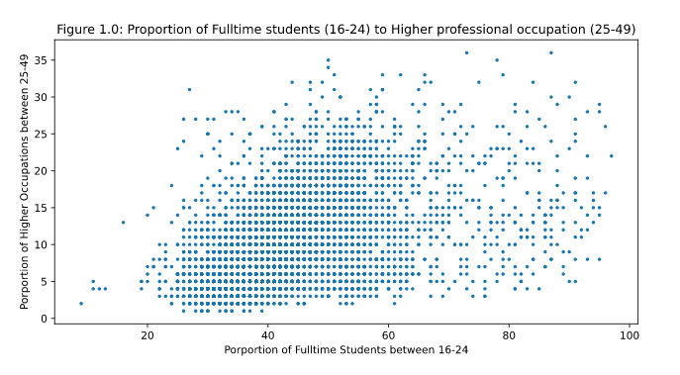
Figure 1.0: Proportion of Full time students (16-24) to Higher Professional Occupation (25-49) for each MSOA

As seen in the scatter plot some form of relation seems to exist but it was difficult to be certain without a proper regression line. To this effect I included a regression line with the proportion dataset (see figure 1.2).

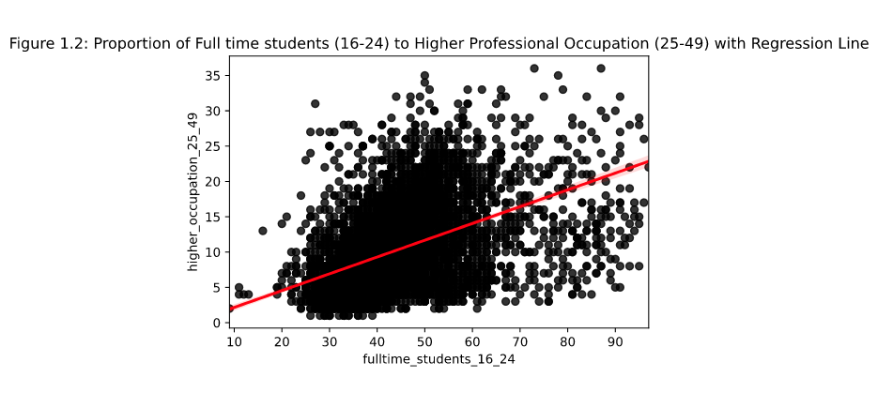
Figure 1.2: Proportion of Full time students (16-24) to Higher Professional Occupation (25-49) with Regression Line

The regression line shows that there is a positive relation between these two proportions.

k-NN Classifiers

The regression line in the Proportions dataset revealed an interesting relation between full time students and higher professional occupations. To further explore this dataset, I decided to create four categories of conversion and utilise the k-nearest neighbours technique. k-NN could help classify and identify different groups of MSOAs based on the proportion of their full time students to higher professional occupation. To this effect a new column called quadrants was added to the Proportions dataset representing the following classifiers:

- Quadrant I : High Conversion – this group represents MSOAs having low proportions of full time students while having high proportions of professional occupations.

- Quadrant II : High Proportional – this group represents MSOAs having high proportion of full time students and a high proportion of professional occupations.

- Quadrant III : Low Conversion– this group represents MSOAs having high proportion of full time students while having a low proportion of professional occupations.

- Quadrant IV : Low Proportional – this group represents MSOAs having low proportions of full time students and a low proportion of professional occupations.

The breakdown of each quadrant is shown in Table 1.0.

Table 1.0: Percentage breakdown of Quadrants
 |  | Full Time Students (16-24)
 |  | 0 – 49% | 50% - 100%
Higher Professional Occupation (25-49) | 0 – 17% | Q4 – Low Proportional | Q3 – Low Conversion
Higher Professional Occupation (25-49) | 17% - 35% | Q1 – High Conversion | Q2 – High Proportional

To see whether the K-NN preforms as required I randomly divided the dataset into two sets. 80% for training and the remaining 20% for testing. I used two variants on the k-NN classifier, 3-NN and 5-NN as well as a range of dummy data. In all instances the predicted results were satisfactory.

Deprivation data pipeline

In order to merge the Deprivation dataset with the Proportions dataset I imported a third dataset, “output-area-classification”, into memory. This dataset required cleaning as it had a lot of duplication and extra entries for Scotland and Wales. After the dataset was cleaned a range of redundant columns were removed. Next, the Deprivation dataset was merged with the output-areas dataset. This merger provided the Deprivation dataset with an MSOA column which allowed it to be successfully merge with the Proportions dataset. At this stage the new merged dataset had columns and entries for both MSOAs and LSOAs. This was problematic since all the Deprivation data was at the LSOA level while the study required the data to be at the MSOA level. To resolve this the dataset was grouped and aggregated on the MSOA column.

The following assumptions were made:

- Grouping and aggregating LSOAs to MSOAs would result in a loss of accuracy which was considered as a necessary trade off.

- Median instead of mean was used in the aggregation as median is less susceptible to potential outliers.

- The aggregated crime decile results were not rounded. It was reasoned that an MSOA with a crime decile of 4.5 would have a higher decile than 4 and a lower decile than 5.

With all three datasets merged and aggregated. I next examined two questions: 1. Is there a relation between the proportion of students (16-24) and crime rank for each MSOA? And 2. Is there a relation between the proportion of higher professional occupation (24-49) and crime rank for each MSOA?

In the case of the former question I plotted a scatter plot using the Aggregated Proportions dataset and reach the follow result:

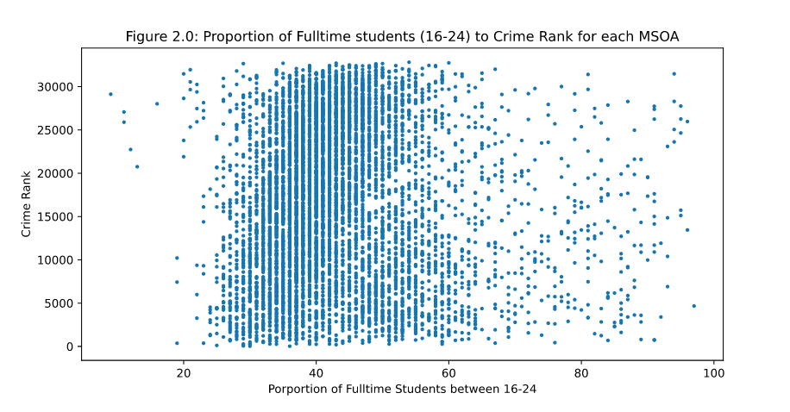
Figure 2.0: Proportion of full time students (16-24) to crime rank for each MSOA

The data looked very even so I decided to run another regression line.

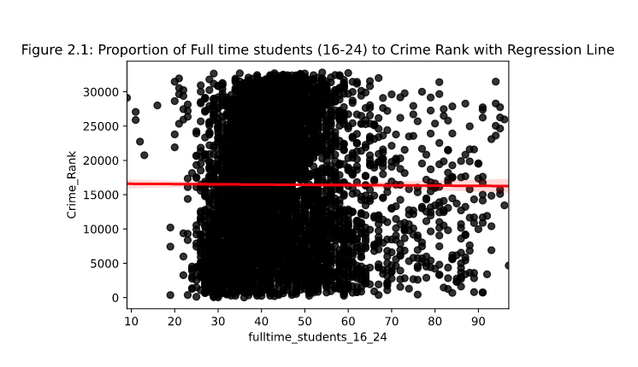
Figure 2.1: Proportion of full time students (16-24) to crime rank with regression line

As the regression line shows there seems to be no significant relation between the proportion of full time students and crime rank.

In the case of the latter question, a second scatter plot was created.

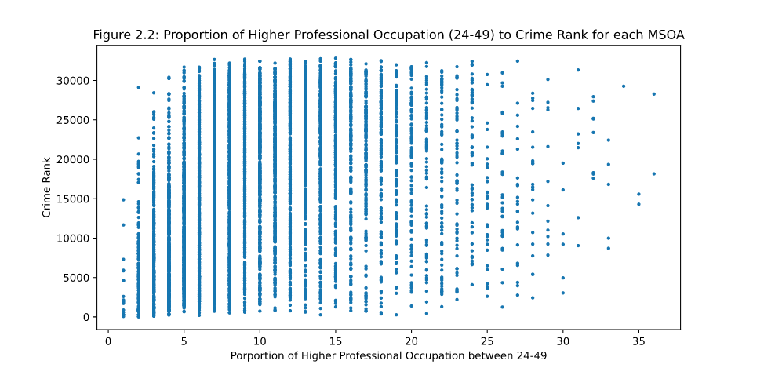
Figure 2.2: Proportion of higher profession occupation (23-49) to crime rank for each MSOA

The scatter plot seemed different from the previous one. A regression line was added to the plot.

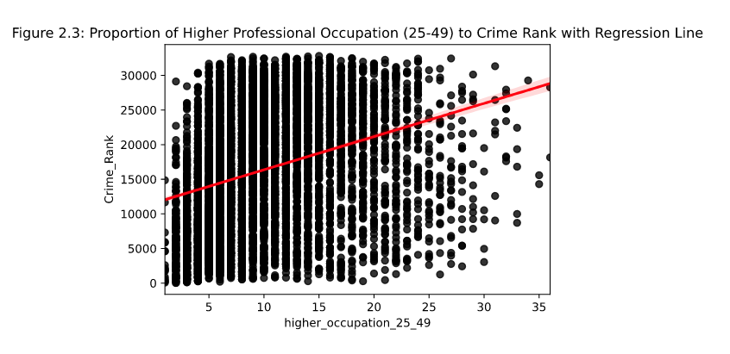
Figure 2.3: Proportion of higher profession occupation (23-49) to crime rank with regression line

The regression line (figure 2.3) shows a positive relation between the proportion of higher professional occupation and crime rank.

With the establishment of a positive relation between higher professional occupation and crime rank, I next examined whether there was a crime rank trend between high conversion areas (Q1) and low conversion areas (Q3).

In order to examine this, I calculated the mean and standard deviation of all the MSOAs in the Q1 and Q3 categories and displayed the results as a bar chart (see figure 3.0).

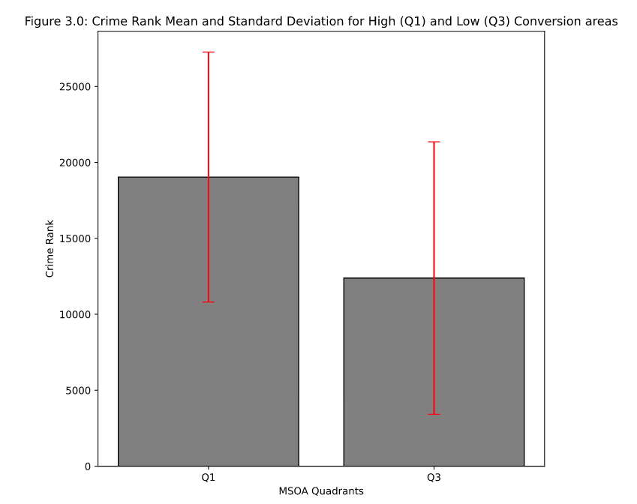
Figure 3.0: Crime Rank Mean and Standard Deviation for High (Q1) and Low (Q3) Conversion areas

The bar char shows that areas in Q1 have a higher crime rank than areas in Q3. The standard deviation seems to be roughly the same in both instances which suggest similar dispersion from the mean in both datasets.

Findings

Census data findings

The investigation of the Census dataset showed that there is a positive relation between the proportions of full time students (16-24) and the proportions of higher professional occupation (25-49) for each MSOA (see figure 1.2). The regression line suggests that there is a strong relation. However further research is required in order to make a more definitive claim on the matter.

The study also produced K-NN classifiers with the ability to predict which conversion quadrants an MSOA would full under if given proportional student and occupation data.

Combined Deprivation and Census data findings

The combination of the Proportions and Deprivation datasets showed that between crime ranks and proportion of full time students (16-24) in an MSOA there seemed to be no significant relation (see figure 2.1). However, there appeared to be a strong relation between the proportion of higher professional occupation (25-49) in an MSOA and crime ranking (see figure 2.3). Whether higher professional occupation proportions alone cause a higher crime ranking can not be inferred with the current findings alone and further research would be required to make a more definitive claim.

Finally the study found that areas with higher conversion (Q1) have a higher crime rank than areas with lower conversion (Q3) (see figure 3.0). This, of course, warrants more investigation but if further results demonstrate there to be a statistical significance, it could suggest that being in a higher crime area limits the ability for full time students to move into higher occupations roles despite being in a higher students population. This could imply that even though these areas have good education levels, crime plays a factor in limiting student progression into better roles in the labour market.

=============================== Conclusions and recommendations

Census data can help reveal many interesting facts, not only about groups of people but also about the areas they reside in. Combined with Deprivation data it can help shed light on areas of educational and occupational vulnerabilities within society. This study aimed to use the census data to highlight relations between full time students in early years of their lives and higher professional occupations in the prime of their working years. It aimed to show that there is a relation between crime ranking, full time students and professional occupation. This study however did not manage to show the degree of statistical significance between these areas. It is therefore, this author’s recommendation to the board that increased importance be placed on the issue of crime and education and additional studies be carried out to further expand on our understanding of the relations between crime, education and professional occupation. I believe that the results we uncover could be paramount in improving the proportions of students entering better occupations.

=============================== Reflective section ????? here or ?????

The Census files, the Deprivation files as well as my own Proportions files were saved as CSVs. The datasets were simple and small enough not to need more complex storage methods. Should this study be continued and expanded on in the future a more robust database solution such as Postgres or MongoBD would be a suitable option.

The Census datasets were all clean and fairly easy to work with. The combination of the 16-24 and 25-49 datasets also resulted in similar size dataset which was also very easy to work with and could fit into memory and be used for k-NN training and testing without any issues.

I found the whole K-NN premise to be fairly confusing and felt that my classifiers were to subjective at the end. However, despite that I was very pleased with how well they predicted MSOA quadrants.

My biggest challenge was merging the deprivation dataset containing LSOAs with the census datasets containing MSOAs while using the lookup dataset. There were a lot of duplication and confusing terminology. However, with a little guidance and a lot of googling I managed to merge the two dataset.

On a persona note, I found this module, after M269 Algorithms, to be the most useful OU module that I have done.

=============================== References
REF1111
https://census.gov.uk/about-the-census/why-you-should-take-part

REF1122
https://www.gov.uk/government/statistics/english-indices-of-deprivation-2019

REF1133
https://www.nomisweb.co.uk/query/construct/summary.asp?mode=construct&version=0&dataset=682

REF1144
https://webarchive.nationalarchives.gov.uk/20160129174312/http://www.ons.gov.uk/ons/guide-method/census/2011/census-data/2011-census-user-guide/quality-and-methods/methods/statistical-disclosure-control-methods/index.html

=============================== Appendices

