  - COSC 336 Introduction to Software Engineering

Campus Item Exchange
  - Phases Four and Five Architecture and Detailed Design
30 October 2026 | Prepared for Natnael Abule and Basima Kurungudan
This combined design implements the Phase Three baseline: one campus, two sample departments, about 20 sample items, nine permission profiles, and all five AI feature families. We choose a modular Flask application with SQLite and a hosted AI adapter. Designs specify intended behavior; implementation and test results belong to later phases.
Member | Student ID | Cumulative addition
Mohammed Siam | 100064837 | 1 Context, DFDs, architecture and AI design
Zayed Alnuaimi | 100063561 | 2 Controls, mockups and data model
Hamed Qayed | 100066581 | 3 Classes and behavioral models
Ali Alameri | 100066635 | 4 Components, deployment and contracts

1 Context diagram
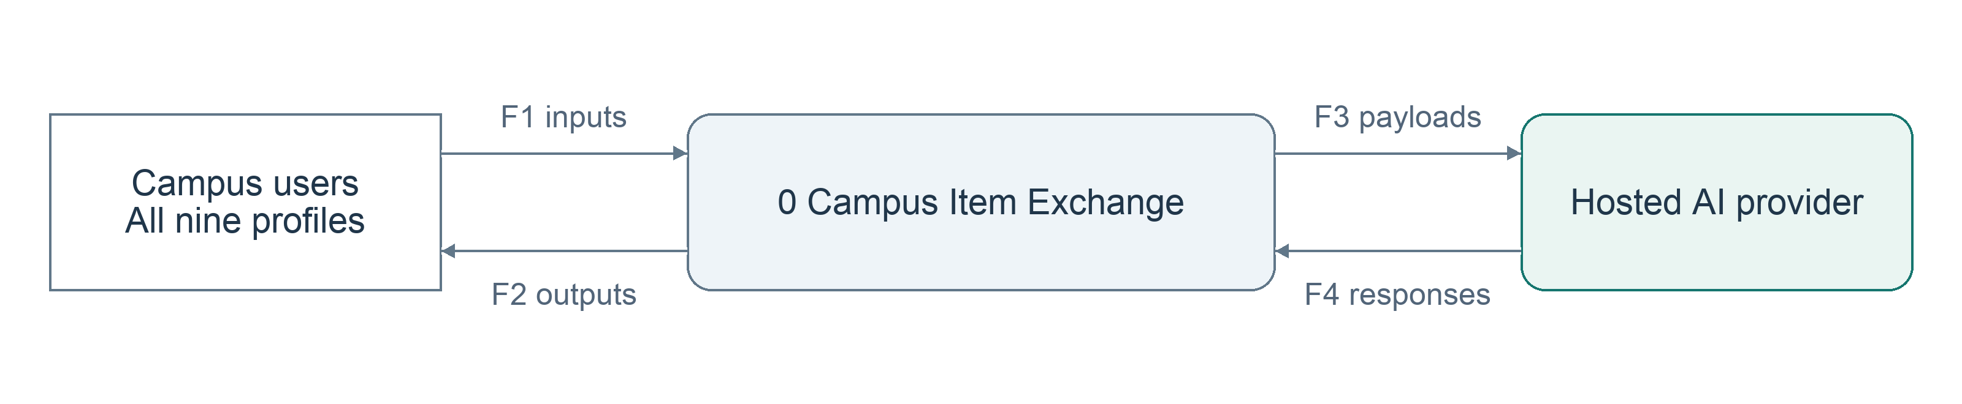
Figure 1 has one system process, two grouped external entities, four directed noun flows and no stores. Campus users includes all nine profiles; their permitted data is separated by the access matrix in Section 6.
Flow | Contents
F1 user inputs | Credentials, account/department changes, asset/evidence data, needs, decisions, receipts, service events, report periods and questions.
F2 system outputs | Sessions, catalogues, statuses, decision queues, notifications, histories, reports, answers and reviewed suggestions.
F3 AI payloads | Authorized classification evidence, candidate and need data, condition/impact data, questions and computed totals.
F4 AI responses | Classification, semantic relevance, ranked explanations, action advice, answers and report drafts.

2 Data flow diagrams
Level 1 uses six numbered processes, repeated user entities and five stores. Paired arrows show inputs and outputs; the register below specifies interprocess flows. FR01–FR18 and AI01–AI08 apply.
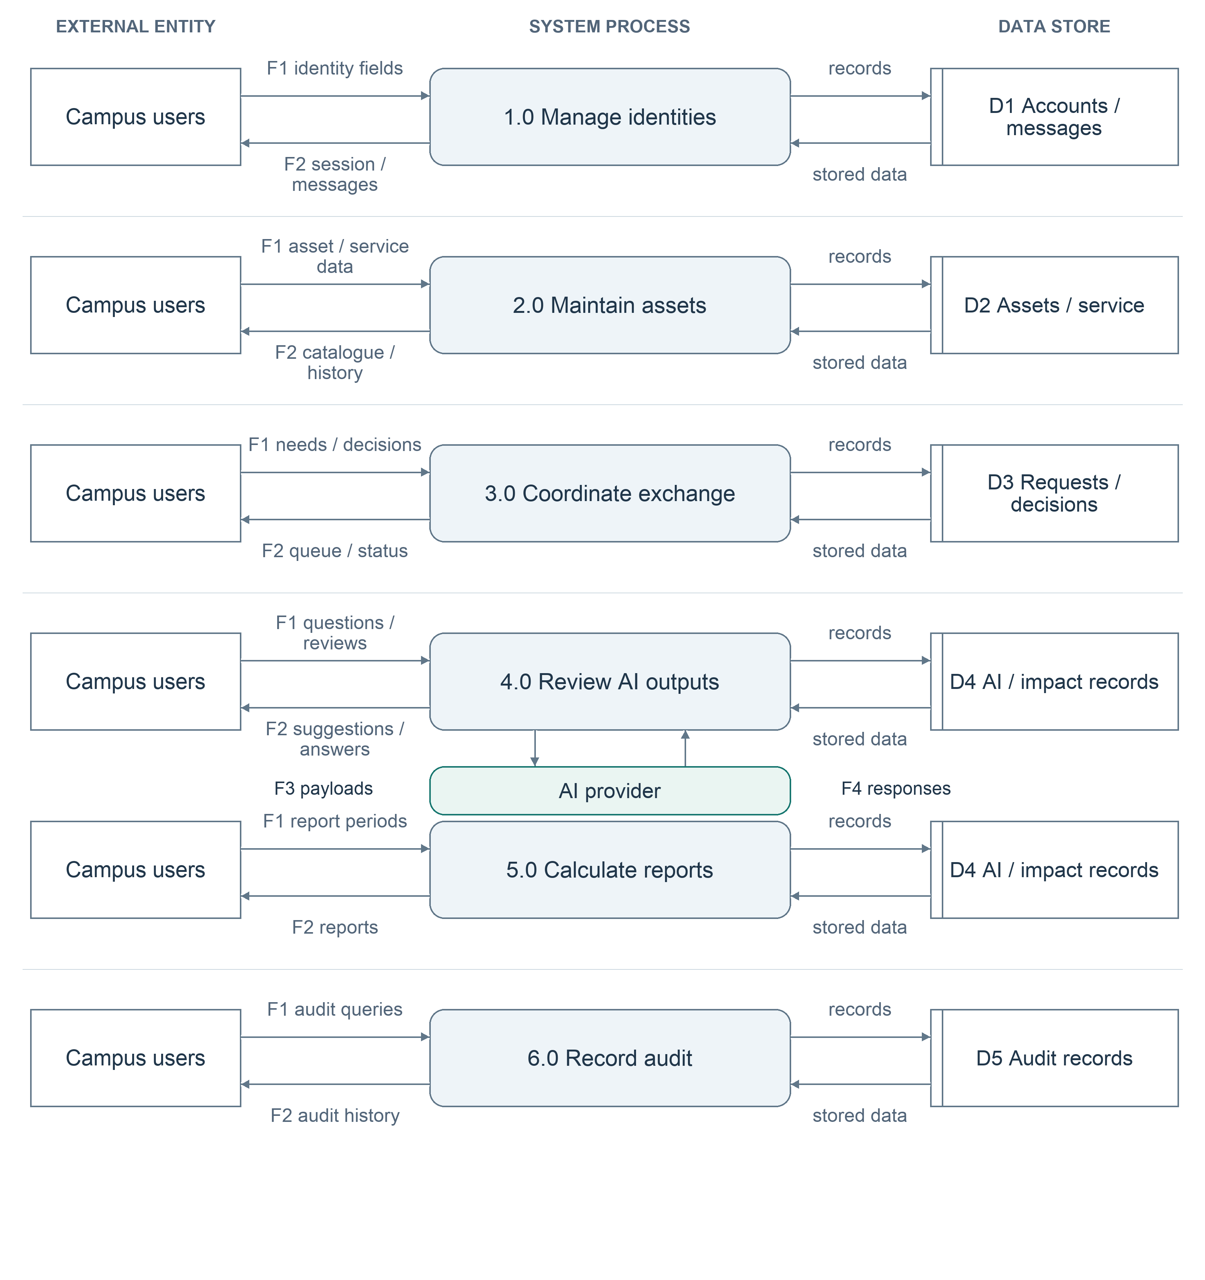
Repeated Campus users and D4 boxes denote the same entity/store. Interprocess data-flow register: D1 → 4.0: access scope; D2 and D3 → 4.0: candidates and needs; D2 and D3 → 5.0: completed events; D4 → 5.0: factors and accepted summaries; 5.0 → 4.0: computed totals. Processes 2.0–5.0 → 1.0: notification events, and 1.0–5.0 → 6.0: audit events. D5 → 6.0: authorized audit history. Each process reads its own store for validation before writes.

2 Detailed AI flow and balancing
Level 2 expands 4.0 because AI output is uncertain and must never bypass permissions or inventory controls. It covers classification, matching, action advice, assistant responses, and report drafts through one guarded pipeline.
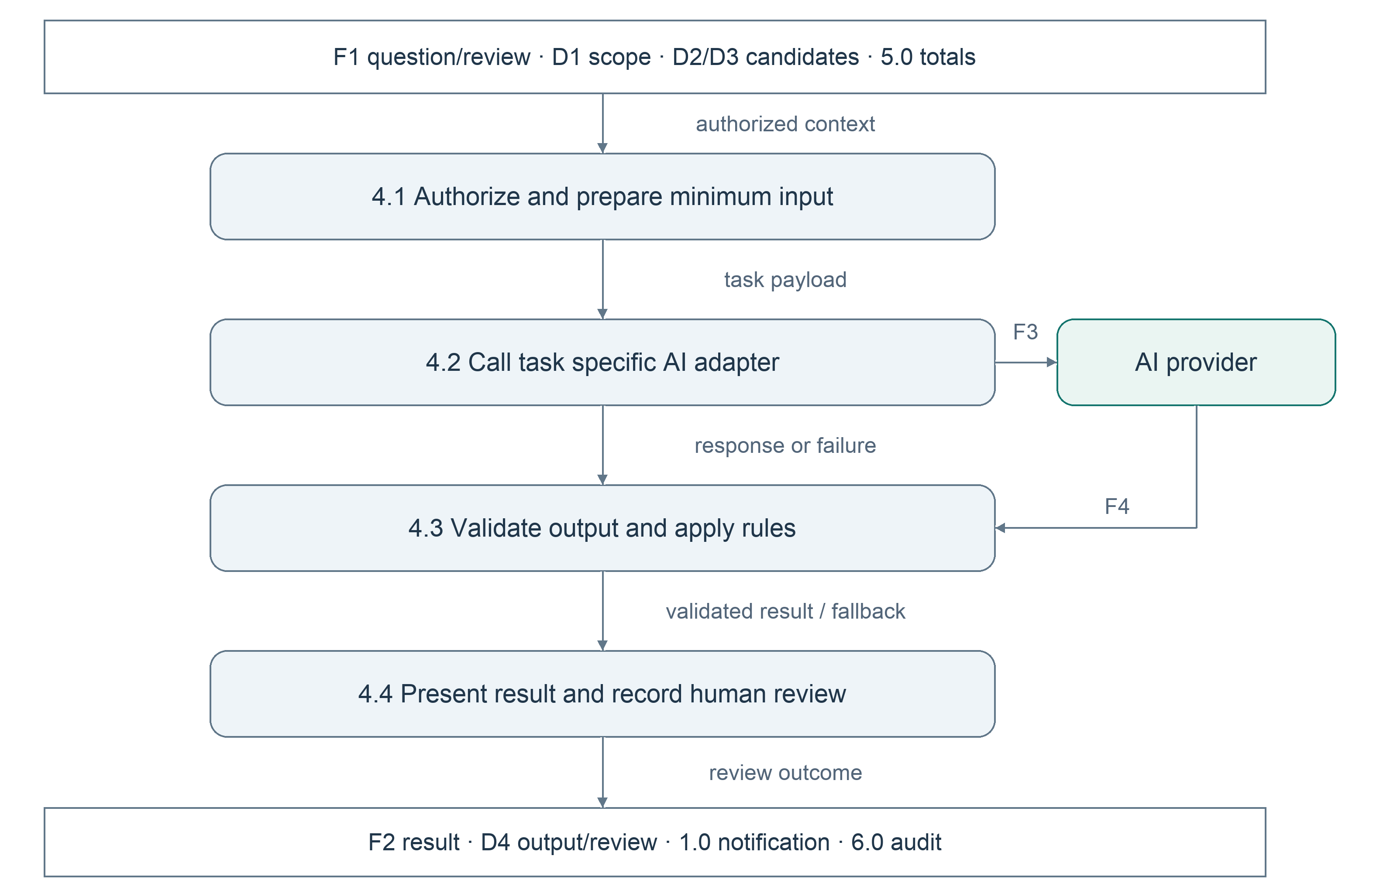
Context boundary | Level 1 destination or source | Balance
F1 users → system | 1.0 identities; 2.0 assets/service; 3.0 requests; 4.0 AI; 5.0 reports; 6.0 audit | Same grouped inputs
F2 system → users | 1.0–6.0 return their permitted outputs | Same grouped outputs
F3 system → AI | 4.0 sends authorized task payloads | Same direction
F4 AI → system | 4.0 receives suggestions and drafts | Same direction

Level 2 preserves every 4.0 boundary input and output listed on page 2. Rejected input returns an error; failed AI returns a labelled manual fallback. No process creates unexplained data, no store connects directly to another store, and no external entity accesses a store directly.

3 Architecture and 4 AI services
Decision: modular monolith versus a separate AI microservice. We choose one Flask deployment with feature modules because four students share a small database and atomic transfer transactions. We give up independent module scaling. A separate service would isolate load but add deployment, authentication, and failure coordination. Within each module, routes call services; services use repositories. Routes never write tables directly.
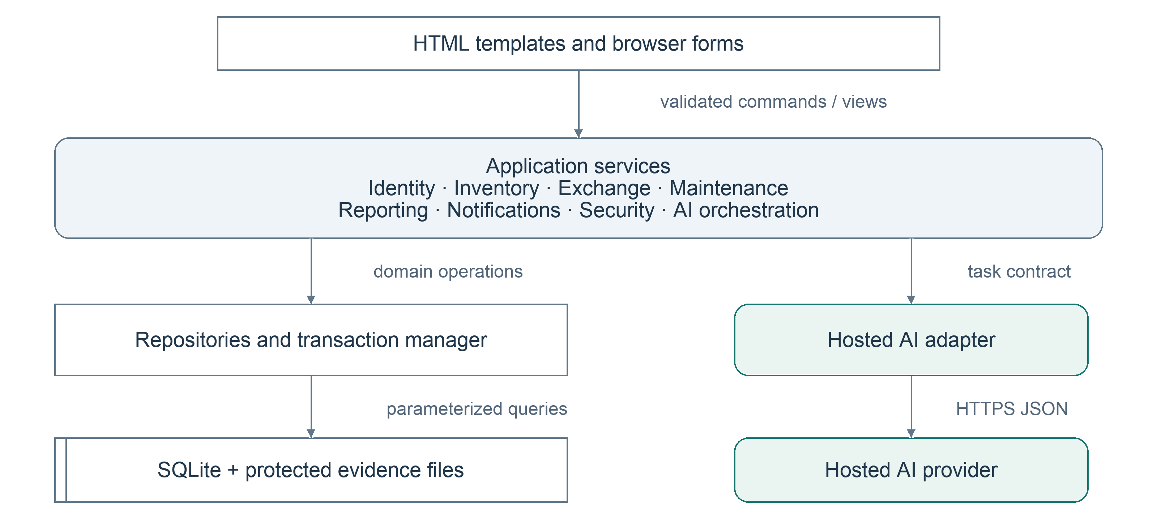
AI function | Pattern and limit | Failure or uncertainty
Classification | Ask and wait, 10 s; user reviews immediately | Manual category form; confidence < 0.70 or missing: review warning.
Semantic matching and ranking | Ask and wait, 10 s total; small catalogue avoids embedding infrastructure | Keyword/rule results; score < 70 is a weak match, not a confidence probability.
Sustainable actions | Ask and wait, 10 s; advice requested per asset | No new advice; ordinary service/disposition form. Confidence < 0.70 or missing: manual review.
Assistant | Ask and wait, 10 s; interactive preview | Normal pages remain; uncertain facts marked. Explicit confirmation required for every action.
Report generation | Ask and wait, 10 s; only small aggregates sent | Numeric report remains; reject invented totals; uncertain narrative marked as draft.

All calls have a 15-second end-to-end ceiling (NFR06), with no automatic user-request retry. Alternative: background queue and precomputed embeddings. We give up background throughput to retain the Phase Three response target and a simpler prototype. Provider, model ID, prompt version, confidence availability, and human review are logged per invocation.

