Magnetic Flux Calibration Tool – Operator Quick Guide (SOP)

Purpose
This tool calculates the Function Generator Voltage (Vpp) required to achieve a desired magnetic field B (mT) using pre-measured calibration data.
⚠️ The voltage shown is FG voltage BEFORE the amplifier.
⚠️ The amplifier gain is fixed and must NOT be changed.

Data Source
Interpolation values are taken from the Excel file:
“B_flux_Table”
based on measurements of the large coil.

⚠️ Safety Attention
❗ Do NOT enter or apply more than 5 Vpp from the Function Generator.
Higher voltage may damage the amplifier.

How to Use
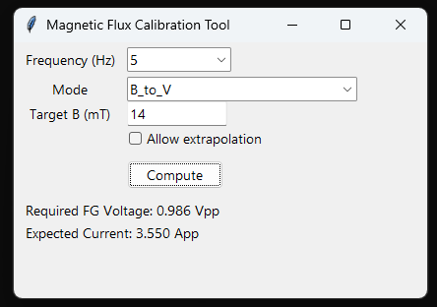
- Open the program (EXE or HTML file).
- Select the Frequency (Hz):
  - 5 Hz
  - 10 Hz
- Select the Mode:
  - B → FG Voltage → Find required FG voltage for a target field.
  - FG Voltage → B → Estimate magnetic field from a known FG voltage.
- Enter the value:
  - Target B (mT) or
  - FG Voltage (Vpp)
- Press Compute.
The tool will display:
- Required FG Voltage (Vpp)
- Expected Coil Current (App)
- Estimated Magnetic Flux (mT)

Important Notes
- Operator should ONLY adjust FG Voltage on the generator.
- Do NOT change amplifier gain.
- Do NOT exceed 5 Vpp.
- Results are based on interpolation of calibration data from B_flux_Table.
- Values outside measured range require Allow Extrapolation.

Example
Target field = 5 mT at 10 Hz
→ Select 10 Hz
→ Mode = B → FG Voltage
→ Enter 5
→ Press Compute

If Something Looks Wrong
- Check correct frequency is selected.
- Verify FG output is enabled.
- Confirm calibration file/version.
- Ask Hamed if unsure.

