Research & Documentation on SQL Server Views
1. Standard View
What is it?
A Standard View is a virtual table in SQL Server created using a SELECT query on one or more base tables. It does not store data physically but provides a way to simplify complex queries or restrict access to specific columns and rows.
Key Differences:
- Does not store data physically.
- Does not support indexes (except via indexed view technique).
- Mainly used for query simplification and security.
Real-life Use Cases:
- Banking: A view showing customers' basic information without sensitive details like account numbers.
- University System: A view showing enrolled students per course without revealing their contact details.
- E-commerce: A product view showing only in-stock items and their prices.
Limitations & Performance Considerations:
- Slower for large datasets as the data is retrieved dynamically.
- Cannot always be updated directly (e.g., views with GROUP BY, JOINs, DISTINCT).
- Does not improve performance unless used to simplify complex logic.

2. Indexed View
What is it?
An Indexed View (also called a materialized view) stores the result of the view physically on disk and maintains a unique clustered index. It improves query performance for complex joins and aggregations.
Key Differences:
- Physically stores the data.
- Supports indexing, which improves performance.
- Has stricter creation and maintenance rules compared to standard views.
Real-life Use Cases:
- Banking: Summary of total balance per customer across all accounts, updated in real-time.
- E-commerce: Daily sales summary per product category.
- University System: Average grades per course and semester.
Limitations & Performance Considerations:
- Can impact performance due to overhead of maintaining the index on data change.
- Must follow schema binding, deterministic functions, and other strict requirements.
- Not all queries are eligible for indexed views (e.g., use of outer joins, subqueries).

3. Partitioned View (Union View)
What is it?
A Partitioned View is a union of multiple tables (often with identical schema), typically used to simulate table partitioning across databases or servers. It logically divides data based on a partitioning column.
Key Differences:
- Combines data horizontally from multiple tables using UNION ALL.
- Used to manage large datasets across partitions or servers.
- Can support distributed partitioned views (across servers) with certain conditions.
Real-life Use Cases:
- Banking: Transaction history split by year into separate tables (e.g., Transactions_2023, Transactions_2024) and combined in a partitioned view.
- E-commerce: Sales data split by region or store.
- University System: Student records partitioned by batch year.
Limitations & Performance Considerations:
- Manual maintenance required; not automatic like table partitioning.
- Check constraints must be defined for optimization (partition elimination).
- Updates require extra care to ensure they target the correct base table.

View Type | Stores Data | Indexing Supported | Use Case Example | Limitations
Standard View | No | No | Hide sensitive customer data | Limited update support, slower for large queries
Indexed View | Yes | Yes (Clustered) | Real-time balance summaries | Complex to maintain, strict rules
Partitioned View | No (Union) | No (but can optimize) | Year-wise transaction data | Manual partitions, requires check constraints

  - The types of views:
View Type | DML Allowed? | Notes
Standard View | Yes | Allowed if the view is simple and directly maps to base tables.
Indexed View | Yes | Allowed under strict conditions and when the base tables allow it.
Partitioned View | Yes (with restrictions) | For local partitioned views, DML is allowed. For distributed partitioned views, DML requires special setup and constraints.

  - Restrictions and Limitations When Performing DML on Views
Allowed When the View:
- Refers to a single base table.
- Does not use aggregate functions (SUM, AVG), DISTINCT, GROUP BY, or UNION.
- Does not include joins or subqueries.
- Does not include set operations like UNION, INTERSECT, or EXCEPT.
Not Allowed or Restricted When:
- The view contains JOINs (especially outer joins).
- It uses computed columns, aggregates, or DISTINCT.
- It involves read-only functions, TOP, OFFSET-FETCH, or ORDER BY.
- The view is defined with WITH CHECK OPTION and the update violates the condition.
- For partitioned views, each table must have CHECK constraints and consistent schema.

  - Real-Life Example: Updating a View
Example-HR systems
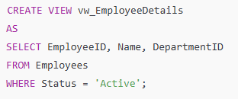

- Simplifying JOIN-Heavy Queries with Views
In large database systems like banking, queries often involve multiple JOINs across related tables (e.g., Customers → Accounts → Transactions). These JOINs can become long, repetitive, and hard to maintain—especially when the same logic is reused in reports, dashboards, or by support teams.
By creating a View, you can:
- Encapsulate complex logic once.
- Reuse the view like a table in future queries.
- Improve readability, maintenance, and security by controlling what’s exposed.

Create View:
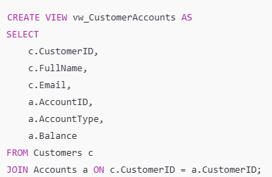
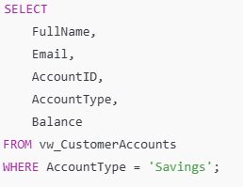

Without View:
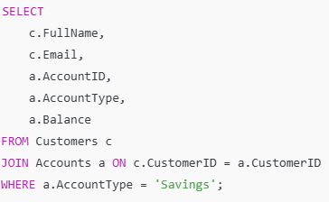

Summary of View:
Benefit | Explanation
Cleaner SQL Code | No need to repeat JOIN logic
Easy Maintenance | Update logic in one view, not everywhere
Better Collaboration | Easier for support teams and analysts to use safely
Reusability | Can be used in reports, dashboards, procedures, etc.

