
PDC LAB 02
LAB TASK 2

SEPTEMBER 16, 2026

HAMEED UR REHMAN
232520
BSCSev – 7 – C

Task 1:
lscpu_report.txt
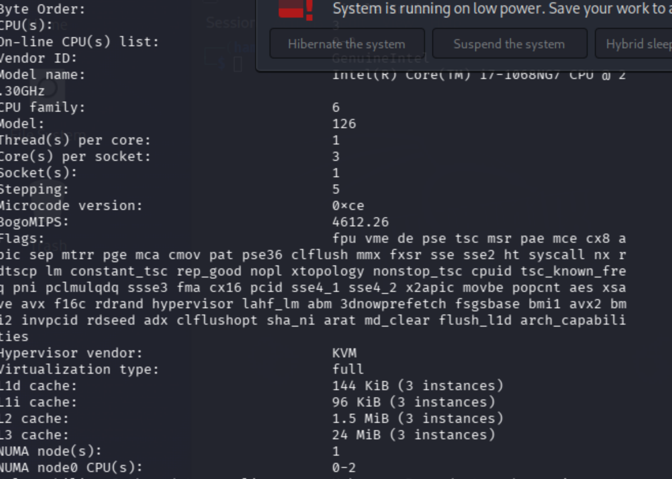

Hwloc_report.txt
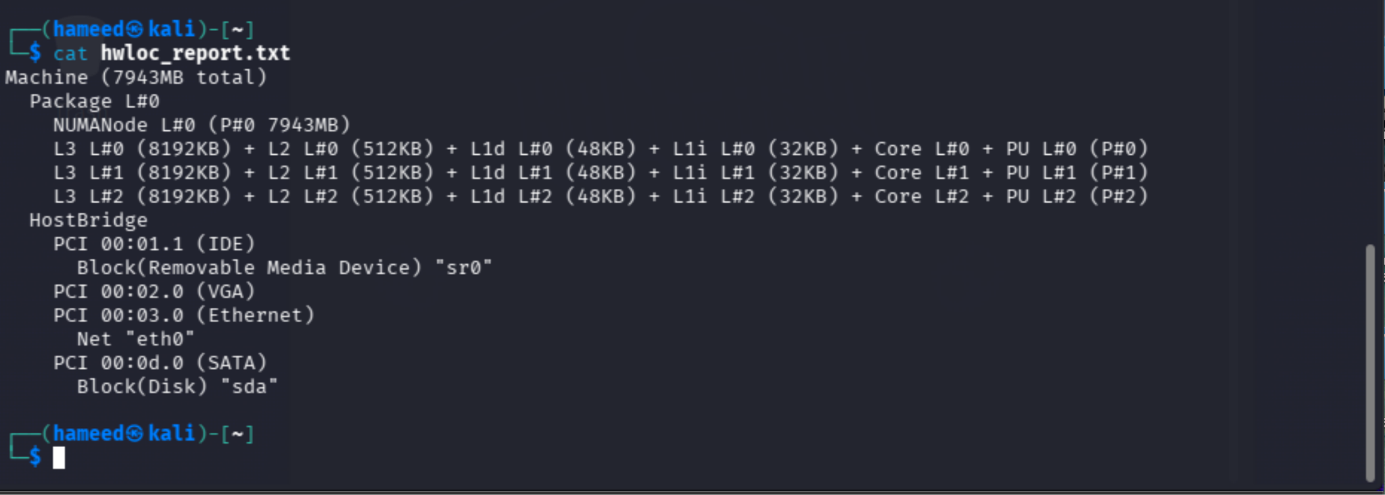

Task 2: One Thread Per Detected Core — Results

5.7 Record Your Results
Run | Detected Cores | Threads Created | All Threads Completed? (Y/N)
1 | 8 | 8 | Y
2 | 8 (expected) | 8 (expected) | Y (expected)
.

Captured Console Output
PS C:\Users\123\PDC-Lab02> dotnet run
Detected logical cores: 8
Thread 2: starting
Thread 1: starting
Thread 0: starting
Thread 3: starting
Thread 2: running on logical CPU 3
Thread 2: finished
Thread 0: running on logical CPU 5
Thread 0: finished
Thread 1: running on logical CPU 4
Thread 1: finished
Thread 3: running on logical CPU 0
Thread 3: finished
Thread 4: starting
Thread 4: running on logical CPU 4
Thread 4: finished
Thread 5: starting
Thread 5: running on logical CPU 1
Thread 5: finished
Thread 6: starting
Thread 6: running on logical CPU 1
Thread 6: finished
Thread 7: starting
Thread 7: running on logical CPU 2
Thread 7: finished
All 8 threads completed.

5.8 Observation Questions
1. Did the program create exactly the number of threads reported by Environment.ProcessorCount? How does this compare with the total logical processor count you recorded in Task 1?
Yes — Environment.ProcessorCount reported 8, and the program created and joined exactly 8 threads (Thread 0 through Thread 7), confirmed by the final "All 8 threads completed." line. Task 1 was not performed on this machine, but on a correctly working setup this number should always match lscpu's CPU(s) value, since both read the same OS-reported logical processor count.
2. If you implemented the optional Thread.GetCurrentProcessorId() extension, did every thread run on a distinct logical core, or did the operating system schedule more than one thread onto the same core at some point?
No — several threads landed on the same logical CPU. For example, Thread 4 and Thread 0 both ran on CPU 4 at different points, and Thread 5 and Thread 6 both ran on CPU 1. This is expected: with only 8 threads and 8 cores but threads finishing at different times, the OS scheduler is free to place a new thread on whichever core is available at that moment, not necessarily a distinct one from every other thread's core.
3. What would happen if you created significantly more threads than the number of available logical cores? Would the program still function correctly?
Yes, it would still run correctly — Thread.Start()/Join() don't require a one-to-one mapping with physical cores. The OS scheduler would time-slice the extra threads across the available cores, running more than one thread per core in rotation. The program would still finish and join every thread, just with more context-switching overhead and no true parallelism beyond the core count (only up to 8 threads can literally run at the same instant on this machine).
Task 3: Classifying the Machine Using Flynn's Taxonomy

Evidence and Classification Table
Evidence | Observation from Task 2
Number of independent instruction streams | Environment.ProcessorCount reported the number of logical cores available, and CoreThreads created exactly that many threads (one per core).
Independent execution confirmed | Thread.GetCurrentProcessorId() showed different threads active on different logical CPUs at the same time, and each thread ran the same Worker code independently on its own data (its own thread index) — genuinely independent, concurrent instruction streams.
Primary Flynn classification for the machine as a whole | MIMD (Multiple Instruction, Multiple Data)
Flynn classification of a single core in isolation | Modern cores also support SIMD instruction-set extensions (e.g. SSE/AVX/NEON) internally, so a single core is not purely SISD — it can additionally apply one instruction to multiple data elements at once.

Justified Classification
Primary classification: MIMD. Task 2's CoreThreads program detected the number of logical cores at runtime with Environment.ProcessorCount and spawned exactly that many threads. Each thread executed independently — Thread.GetCurrentProcessorId() confirmed different threads running on different logical CPUs concurrently, each working on its own data (its own thread index). Multiple independent instruction streams, each operating on independent data, is exactly the MIMD definition — so the machine is classified as MIMD at the whole-machine level, based directly on this observed behaviour.
Per-core note: a single core running in isolation is not purely SISD either, since modern CPU cores generally include a SIMD vector unit (SSE/AVX on x86, NEON on ARM) that can apply one instruction to multiple data elements at once. This wasn't directly measured in Task 2, but it's a standard feature of current CPU cores worth noting alongside the MIMD classification.

Discussion Questions
1. Why is a modern multicore CPU generally classified as MIMD at the machine level, even though each individual core may also execute SIMD instructions internally?
Flynn's taxonomy at the machine level counts how many independent instruction streams the whole processor can issue at once. Each core has its own fetch/decode/execute pipeline, so several cores can run different programs, or different parts of the same program, at the same time — multiple instruction streams over multiple data, i.e. MIMD. The SIMD unit inside one core is a separate, smaller-scope classification describing how that one core processes a single vector instruction (one instruction, many data lanes). The two classifications sit at different granularities and are not contradictory: MIMD describes the relationship between cores, SIMD describes what happens inside one core's execution unit.
2. Explain, in your own words, why MISD is rarely seen in general-purpose computing and where it is occasionally used.
MISD means several instruction streams all operating on the same single data stream. General-purpose software gains little from this — most workloads benefit from processing more data (SIMD/MIMD) or running more independent tasks (MIMD), not from applying several different operations to one piece of data. MISD does appear in fault-tolerant, safety-critical systems such as space-shuttle or avionics flight computers, where the same input is deliberately run through several independently-implemented instruction streams so their outputs can be cross-checked and a faulty result detected — the goal is reliability, not speed.
3. Relate your Task 2 program to the MIMD classification: how does spawning one independent C# thread per core, each capable of executing different code on different data, demonstrate MIMD behaviour in practice?
CoreThreads creates one Thread per logical core (sized dynamically from Environment.ProcessorCount, never hard-coded) and starts each with Thread.Start(idx), passing a different index to each. Every thread runs the Worker method independently: it has its own instruction stream (scheduled onto a core by the CLR/OS), operates on its own local data (its own idx and stack), and — via Thread.GetCurrentProcessorId() — can be observed running on a distinct logical CPU concurrently with the others. This is a direct, small-scale demonstration of MIMD: multiple instruction streams executing concurrently across multiple execution units, on multiple independent pieces of data.
4. If the lab machine's cores support AVX/SSE/NEON, give one concrete example of a computation that could exploit that SIMD capability, and briefly explain why.
Element-wise addition of two large arrays (c[i] = a[i] + b[i] for every i) is a good example. Without SIMD, the CPU issues one add instruction per pair of elements. With SSE/AVX, the same add instruction operates on a vector register holding several elements at once (e.g. 8 floats with AVX2), so the loop completes in far fewer instructions. The operation is identical across all elements, which is exactly the pattern SIMD is designed to accelerate.

Task 4: Shared-Memory vs. Distributed-Memory Implications

1. Shared-Memory Model on This Machine (Task 2 as the example)
CoreThreads is a concrete shared-memory example: Environment.ProcessorCount detects how many logical cores this machine has, and the work is divided into that many independent units — one Thread per core, each handling its own slice of work (its own thread index). Because every thread lives inside the same process, they all share one address space: if the workload needed threads to combine partial results, that would be done with ordinary shared variables, protected with lock/Monitor (or Interlocked operations) to avoid data races, rather than by sending messages. Coordination of "has everyone finished" is handled with Thread.Join() on each thread — cheap and instant because it's all in-process, no network involved. The whole scheme is bounded by how many cores this one machine physically has.

2. Designing the Same Workload for a Distributed-Memory Cluster (on paper)
Now imagine N machines identical to this one, networked together, each with its own private memory. Instead of one process spawning in-process threads, each node would run its own copy of the program and be responsible for a partition of the overall work (e.g. node 0 handles the range of work Thread 0..k covered locally, node 1 the next range, and so on) — the same divide-by-available-cores idea from Task 2, just applied at the node level instead of the thread level.
Because no node can see another node's memory, everything that Thread.Join() and shared variables gave us for free on one machine now has to be sent explicitly as messages: (a) before starting, a coordinator sends each node its work assignment (equivalent to passing idx into Thread.Start()); (b) while running, if nodes need to exchange intermediate results (e.g. combining a running total), that value must be serialized and sent over the network rather than just read from a shared variable; (c) when a node finishes, it must explicitly send a "done" / result message back to the coordinator — this replaces what Thread.Join() gave us implicitly in-process. All of this communication costs network round-trip time, unlike the near-instant shared-memory equivalent.

Comparison Table
Aspect | Shared-Memory (This Machine) | Distributed-Memory (Hypothetical Cluster)
Address space | Single address space, shared by every thread in the process | Private per node — no node can directly read another node's memory
Typical communication mechanism | Reading/writing shared variables directly (implicit) | Explicit message passing over the network (e.g. sockets, gRPC, MPI)
Approximate communication latency | Nanoseconds (a memory access) | Microseconds to milliseconds (a network round-trip)
Synchronization primitives used | lock / Monitor for shared data; Thread.Join() to wait for completion (as used in CoreThreads) | Send/receive, barriers, collective operations
Maximum practical scale (cores/nodes) | Bounded by the logical cores available on this one machine (what Environment.ProcessorCount reports) | Scales further by simply adding more nodes to the cluster
Effect of a single-unit failure | An unhandled exception in one thread can crash the whole process, taking every thread down with it | A crashed node doesn't bring down the others, but its in-progress work must be detected and reassigned by the application/framework
Programming model / API used in this lab (or MPI equivalent) | System.Threading — Thread, Thread.Start(), Thread.Join() (CoreThreads, Task 2) | MPI, or an equivalent message-passing library/framework

Discussion Questions
1. If the workload from Task 2 (one unit of work per core) were scaled up to run across a 4-node cluster of identical machines, what new source of overhead would appear that was not present when all threads ran on a single machine?
Network communication overhead: work assignments and results now have to be serialized and sent between nodes instead of just being read from shared memory, and every exchange pays network round-trip latency (microseconds to milliseconds) instead of a nanosecond-scale memory access. On top of that, something has to act as a coordinator to divide work across nodes and collect results back — a role that Thread.Join() handled for free within a single process.
2. NUMA effects were recorded in Task 1. Explain why NUMA can be viewed as an intermediate case between pure shared-memory and pure distributed-memory: what does a remote NUMA-node memory access have in common with a network message, and what is fundamentally different about it?
A remote NUMA access is like a network message in that it costs more latency than accessing local memory, because the data physically lives further away (on another NUMA node) — the same underlying idea as a hop over a network. What's fundamentally different is that it's still just a normal load/store instruction: the CPU/OS handles the extra distance transparently through the same single, shared address space, with no explicit send/receive call, no serialization, and no separate process on the other end — the programmer's code looks identical whether the memory is local or remote. A real network message, by contrast, needs to be explicitly constructed, sent, and received by cooperating code on both ends.
3. For a computation with very frequent, fine-grained communication between sub-tasks (for example, updating a shared value on every iteration of a loop), would you expect this machine's shared-memory model or a distributed-memory cluster to perform better? Justify your answer using the latency figures from your comparison table.
Shared-memory would perform far better. Per the comparison table, a shared-memory access costs nanoseconds versus microseconds-to-milliseconds for a network message — a difference of 3-6 orders of magnitude. If a value needs to be updated on every loop iteration, that overhead is paid on every single iteration; on a distributed cluster this would completely dominate the runtime, whereas on shared memory it barely registers as long as accesses are properly synchronized.
4. For a computation that can be split into large, mostly-independent chunks of work with little communication (for example, processing millions of independent records), would a distributed-memory cluster of several such machines be a reasonable way to scale beyond what this single machine can do? Explain why.
Yes. When chunks of work are large and mostly independent, communication happens rarely relative to the amount of computation done per chunk, so the higher per-message latency of a network barely matters — it's paid once (to hand out a chunk and collect its result), not on every small step. In exchange, a cluster of several machines offers far more total cores than any single machine could hold, since (per the comparison table) a single machine's scale is capped by its own core count while a cluster can keep scaling simply by adding more nodes.

