AI-Driven Study Companion: An Integrated Platform for Interactive, Summarized, and Video-Based Learning

Artificial Intelligence
Project Proposal
BSCS-V-C
Fall-25

Group Members
Hameed Ur Rehman 232520
Sheikh Abdul Hadi 232038
Muhammad Abubaker 232493

Submission Date
23-11-2025

1. Introduction
In the modern academic landscape, students are often overwhelmed by the sheer volume of static textual resources, such as dense PDF textbooks and lengthy research papers. While these documents contain critical information, the linear format often leads to cognitive overload and reduced engagement. Furthermore, different learning scenarios require different modalities: quick revision requires summarization, deep conceptual understanding often benefits from interactive questioning, and visual learners struggle without dynamic audio-visual aids. Existing tools usually offer these features in isolation, forcing students to fragment their workflow across multiple disconnected platforms.
To address these challenges, this project proposes the development of an "AI-Driven Study Companion." This is a comprehensive, full-stack web application that unifies three powerful learning modalities into a single system. The platform allows users to upload a document once and seamlessly switch between: (1) Interacting with the content via a "Chat with PDF" interface using RAG technology, (2) Revising via an intelligent "Summarization Module," and (3) Watching automatically generated, narrated video lectures. By leveraging Large Language Models (LLMs) and programmatic video rendering, this system democratizes access to personalized, high-quality educational content.

2. Objective of project
The main objectives of our project are as follows:
- To create a unified platform that supports three distinct learning styles: Reading (Summarization), Interacting (Chat), and Watching (Video).
- To implement a Retrieval-Augmented Generation (RAG) system that allows users to query specific details from a PDF and receive context-aware answers with citations.
- To develop an Automated Lecture Generator that transforms static text into dynamic MP4 videos with synchronized voiceovers and visual slides for visual learners.
- To provide an Intelligent Summarization tool that instantly extracts key concepts and themes from lengthy documents for efficient exam revision.
- To demonstrate the integration of Microservices Architecture, Vector Databases, and Generative AI in a practical EdTech solution.

3. Abstract View
The project operates as a multi-module hub centered around a robust Python backend. The workflow begins with Data Ingestion, where the user uploads a PDF. The system parses the text and offers a central dashboard with three pathways. The Chat Module vectorizes the text for interactive querying; the Summary Module utilizes LLMs to distill core concepts; and the Video Module triggers a complex pipeline of script generation, audio synthesis, and frame-by-frame rendering.
Below is the high-level architectural flow of the system:
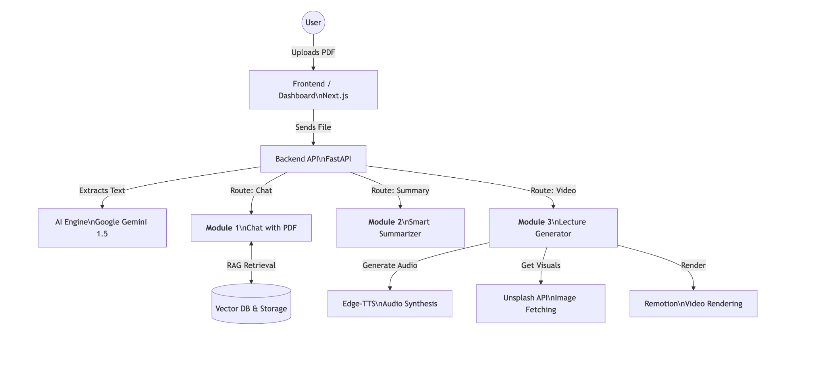

4. Tools & Technologies (Tech Stack)
The project utilizes a modern, scalable tech stack designed for high performance and AI integration.
- Frontend:
  - Next.js (React): For building a responsive user interface and managing application state.
  - Tailwind CSS: For styling the dashboard and video player components.
- Backend:
  - Python (FastAPI): High-performance API framework for handling AI requests and file processing.
  - PyMuPDF: For extracting raw text from uploaded PDF documents.
- Artificial Intelligence:
  - Google Gemini 1.5 Flash: The core LLM used for summarizing text, answering chat queries, and writing video scripts.
  - LangChain: Framework for implementing the RAG (Chat with PDF) logic.
  - FAISS / ChromaDB: Vector database for storing document embeddings for the chat feature.
- Media Generation:
  - Remotion: A React library for programmatically rendering video frames.
  - Edge-TTS: A Python library for generating natural-sounding neural voiceovers.
  - Unsplash API: For fetching contextually relevant stock images for video slides.

5. Methodology (Detailed Workflow)
The system follows a strict logic flow depending on the user's chosen module. The diagram below illustrates the decision process and the parallel processing required for video generation.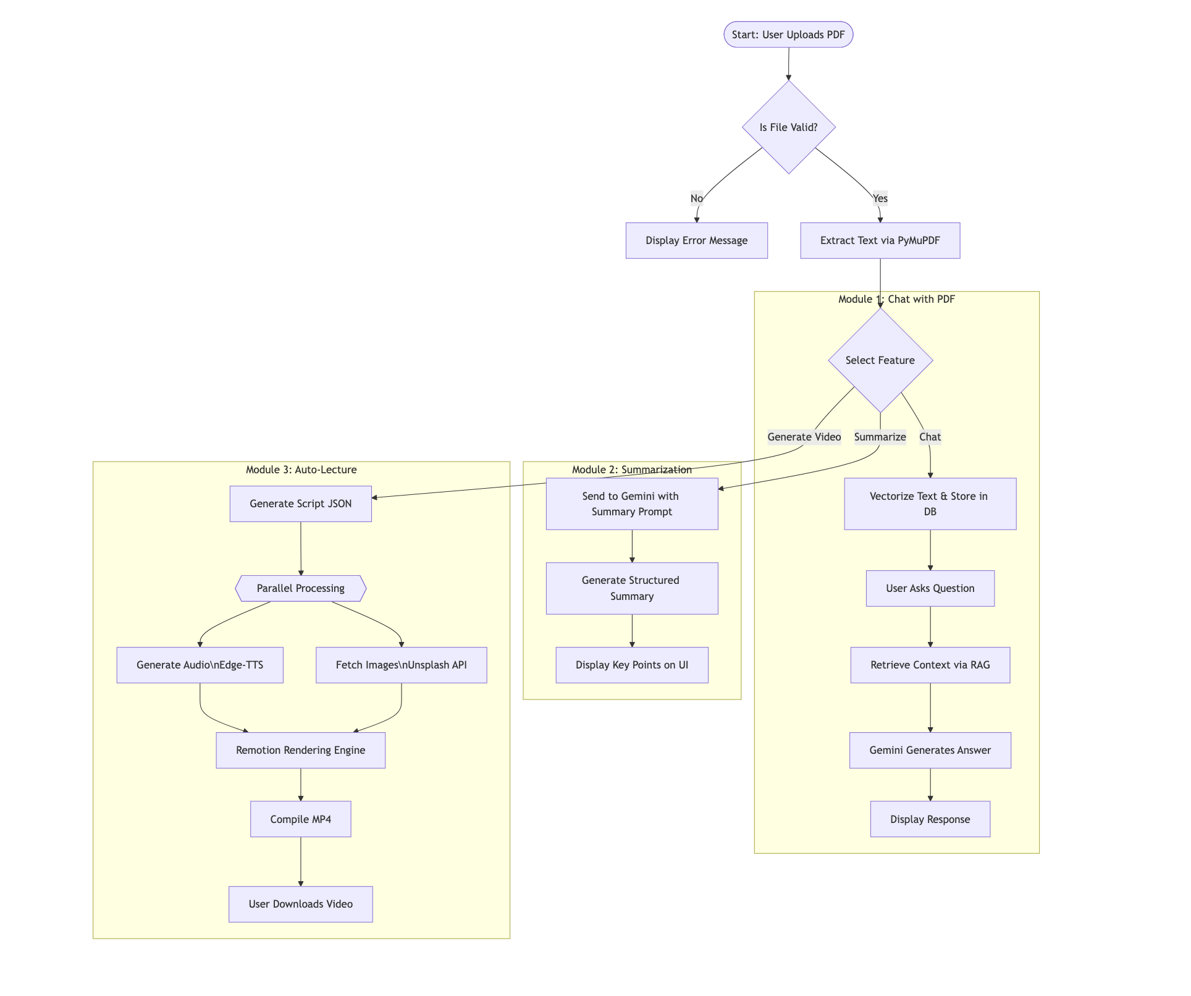

6. Key Responsibilities
Project Manager Responsible for defining the overall scope, managing the integration of the three distinct modules, and maintaining the project Gantt chart to ensure timely delivery of the prototype.
Frontend Designer & Developer Responsible for the UI/UX of the platform. This includes creating the Chat Interface (message bubbles, history), the Summarization View (clean typography), and the Video Player controls in Next.js.
Backend & AI Engineer Responsible for the Python architecture. Key tasks include setting up the Vector Database for the RAG system, engineering prompts for the Gemini API to ensure accurate summaries, and handling the asynchronous tasks for video generation.
Media Systems Specialist Responsible for the video rendering pipeline. This involves configuring the Remotion engine, synchronizing the TTS audio timestamps with the visual slides, and ensuring the final MP4 output is high quality.

7. Conclusion
In conclusion, the AI-Driven Study Companion bridges the gap between static information and dynamic learning. By combining the interactivity of a chatbot, the efficiency of an automated summarizer, and the engagement of video lectures, this project offers a holistic solution to modern educational challenges. It not only reduces the workload for educators but also empowers students to learn in the way that best suits their needs, demonstrating the transformative potential of Generative AI in the education sector.

