DATA ANALYTICS TRACK

Consumer Complaint Intelligence Report

What complaint growth, response records and CFPB forwarding data actually show
Bank of America consumer complaint extract | 1 May 2017 – 28 August 2023
Prepared for AnalystLab Africa | Experience Lab Internship Programme | Week 4

BY HAMEEDAT ISA-USMAN

THE CENTRAL STORY

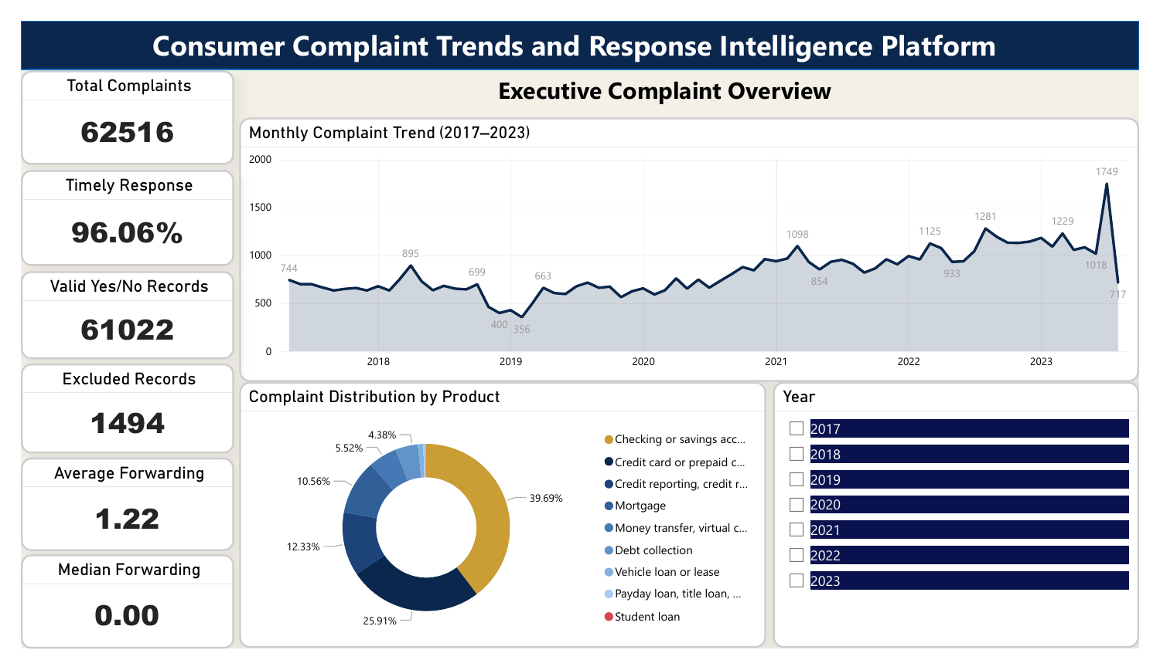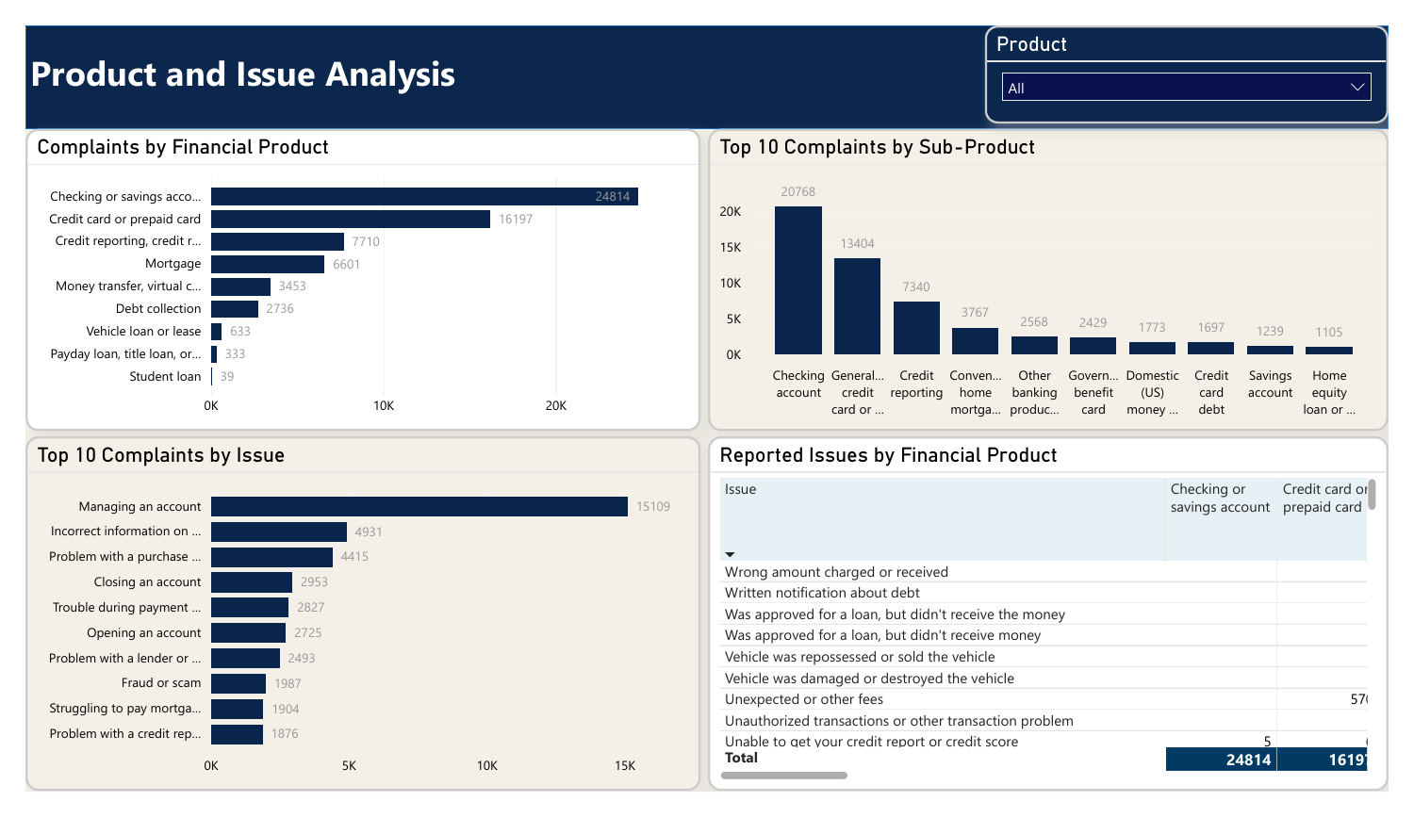
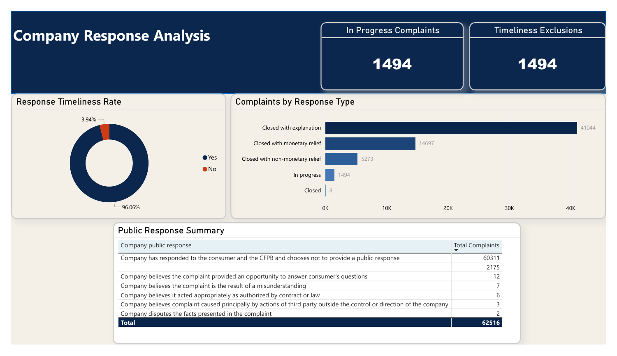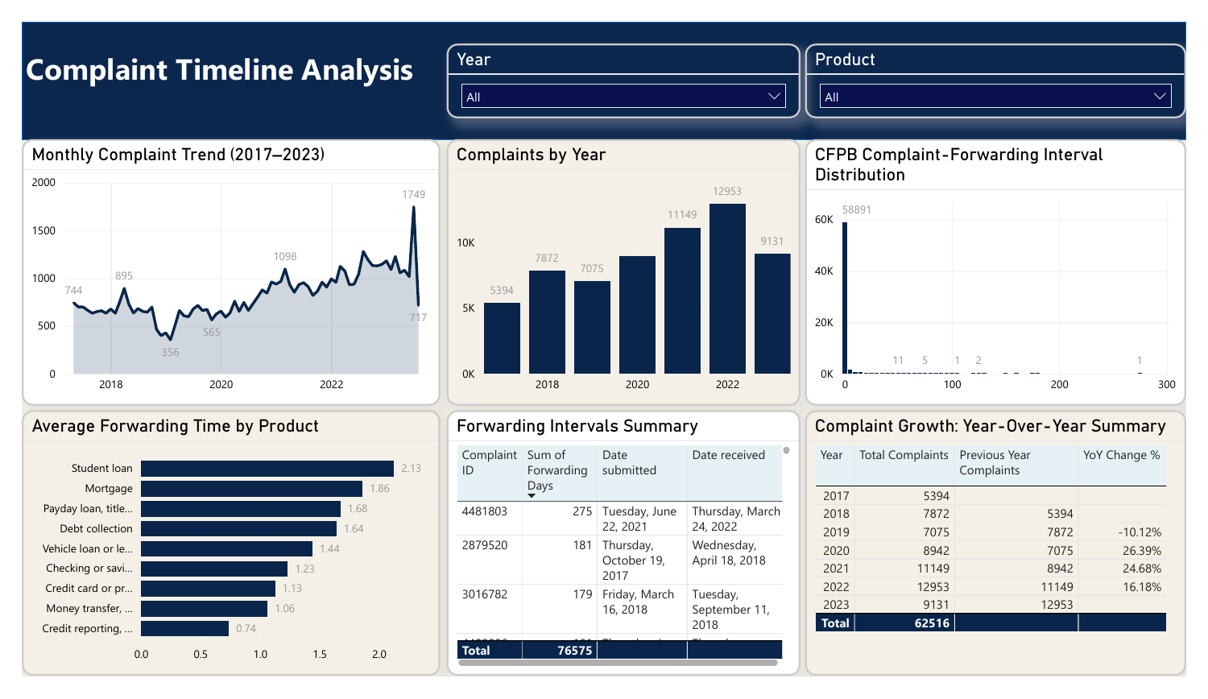
Figure 1. Dashboard screenshots
VALUE | WHAT IT ACTUALLY MEASURES
62,516 | Distinct consumer complaint records
83.1% | Complaint-volume growth, full-year 2019 to 2022
96.06% | Recorded timely Yes among 61,022 eligible Yes/No records
1.22 days | Average CFPB receipt-to-forwarding interval

EXECUTIVE DECISION BRIEF

The volume trend is clear. The service-response interpretation requires care.
Analysis indicates a rise from 7,075 complaints in 2019 to 12,953 in 2022: 5,878 additional records, or 83.08%. Four product groups account for 96.89% of that net increase. This supports targeted monitoring, not a claim that complaint *rates* or verified misconduct rose, because no customer/account denominators or investigation outcomes are provided.
The overall timely-response field reads 96.06% Yes, but this hides an 89.02% eligible rate for 2021 and a June 2021 low of 58.35%. At the other end of the history, 1,494 complaints marked In progress have blank timeliness values, 1,450 of them submitted in July–August 2023. Comparing recent months without acknowledging those open records would be misleading.

Six figures to retain
VERIFIED COUNT | MEANING
62,516 | Unique complaints; 2017–2023 (partial boundary years)
24,814 | Checking/savings complaints, 39.69% of total
15,109 | Managing an account: leading issue, all in checking/savings
58,619 / 61,022 | Timely Yes / valid Yes+No; 96.06%
1,494 | Missing timeliness records, all marked In progress
49,634 | 0-day CFPB forwarding records (79.39% of total)

Management implications
- Prioritise issue-specific diagnostic reviews where complaint counts concentrate: account management, card purchase disputes, and credit-reporting accuracy.
- Track recorded timeliness by *submission month and product* rather than relying on one all-period percentage.
SOURCE INTEGRITY AND METHODS

A trustworthy complaint record comes before a trustworthy chart
Each row is one consumer complaint record, identified by Complaint ID. The 12-field source workbook is the controlling source, and the flat table has no pre-existing relationship model. The supplied CFPB data dictionary defines Date submitted as the date the CFPB received the complaint, and Date received as the date it forwarded the record to the company.
DATA-QUALITY CHECK | VERIFIED RESULT
Records and key | 62,516 rows; 62,516 unique IDs; 0 duplicate IDs; 0 fully duplicated rows
Date validation | All date pairs valid; 0 negative forwarding intervals; 1 May 2017–28 Aug 2023
Sub-issue blank | 10,858 (17.37%); kept missing because not all issues have sub-issues
Public response blank | 2,175 (3.48%); optional category, kept missing
Sub-product blank | 7 (0.01%); kept missing
Timeliness blank | 1,494 (2.39%); all In progress, excluded from Yes/No denominator
Categorical cleaning | Trim/control-character checks: 0 source rows required changes
New columns | Year, Month, Month Start, Quarter, Forwarding Days

What is calculated and what is not
Forwarding Days = Date received − Date submitted in calendar days. This records CFPB administrative forwarding, not company response time or resolution. Timely Response % = Yes / (Yes + No), explicitly excluding blank entries. Complaint counts use distinct Complaint ID, equal to row count here because IDs are unique.
No records were removed, blanks were not filled with invented categories, and the source Excel workbook is retained unchanged.

DEMAND TREND

Complaint volume rose 83.08% from 2019 to 2022
The 2019–2022 comparison uses complete calendar years. Annual complaints increased from 7,075 to 12,953, a net rise of 5,878 records. Year-over-year counts grew 26.39% in 2020, 24.68% in 2021 and 16.18% in 2022. This is sustained growth in recorded complaint volume, not a customer-normalised complaint rate.
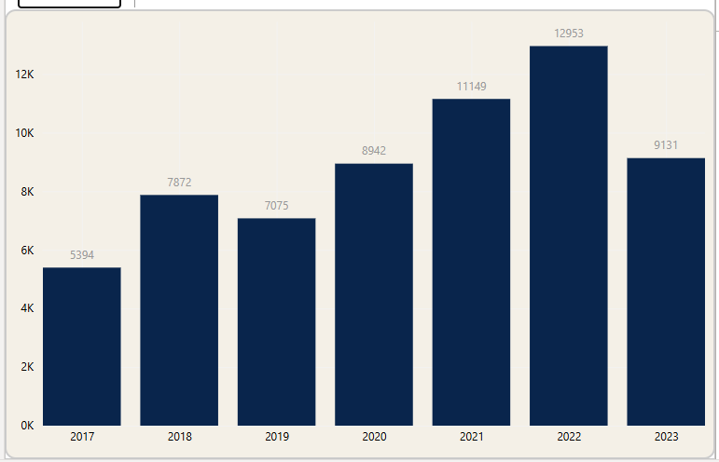
Figure 2. Complaint totals for all years in the supplied extract.
YEAR | COUNT | INTERPRETATION
2018 | 7,872 | Full year; 2017 is partial
2019 | 7,075 | −10.12% versus 2018
2020 | 8,942 | +26.39% versus 2019
2021 | 11,149 | +24.68% versus 2020
2022 | 12,953 | +16.18% versus 2021
2013 | 9131 | Incomplete calendar

The 2017 data start in May and 2023 stop on 28 August. Therefore annual 2017/2018 and 2022/2023 comparisons must not be presented as like-for-like year-over-year performance. July 2023 is the highest recorded month (1,749), but its status mix needs separate examination on page 9.

CONCENTRATION AND TAXONOMY

Account complaints dominate the portfolio; problems differ by product
Checking/savings (24,814) and credit/prepaid cards (16,197) account for 41,011 complaints, or 65.60% of the extract. The most common issue across all products is Managing an account (15,109). Every one of those records belongs to checking/savings, representing 60.89% of that product’s complaints.
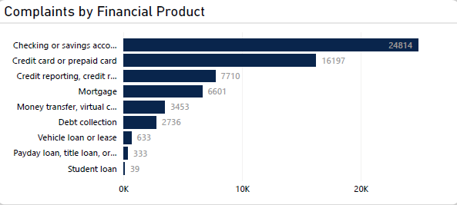
Figure 3. Product complaints across all recorded dates. Counts are not adjusted for number of customers or accounts.

A product-specific issue hierarchy is more useful than one overall top-ten ranking
PRODUCT | LEADING REPORTED ISSUE | COUNT | WITHIN PRODUCT
Checking/savings | Managing an account | 15,109 | 60.89%
Credit/prepaid card | Problem with a purchase shown on your statement | 4,415 | 27.26%
Credit reporting | Incorrect information on your report | 4,145 | 53.76%
Mortgage | Trouble during payment process | 2,827 | 42.83%
Money transfer/services | Fraud or scam | 1,951 | 56.50%
Debt collection | Attempts to collect debt not owed | 1,351 | 49.38%

These are consumer-reported issue labels. For example, a “Fraud or scam” classification describes the consumer allegation, not a verified finding of fraud.

COMPANY RESPONSE CLASSIFICATION

“Closed with explanation” is the most common recorded disposition
Most complaints have an explanation recorded (41,044; 65.65%). Others show monetary relief (14,697; 23.51%) or non-monetary relief (5,273; 8.43%). Another 1,494 were In progress, and 8 are simply recorded Closed. These categories describe the company’s database response classification, not consumer satisfaction or verified resolution quality.
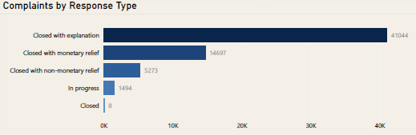
Figure 4. Company response to consumer distribution, as recorded in the source data.

CFPB COMPLAINT FORWARDING

Most complaints were forwarded promptly, but a long tail merits review
The mean CFPB receipt-to-forwarding interval is 1.2249 calendar days, while the median is 0. A total 58,891 fall in the 0–4 day range.
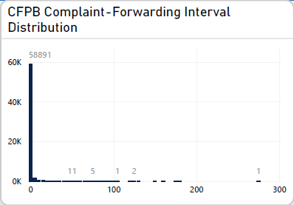
Figure 5. Mutually exclusive forwarding interval bands.
DIFFERENCES ACROSS PRODUCTS

Forwarding intervals vary by product, with small-group uncertainty
The average forwarding interval ranges from 0.74 days for credit reporting to 2.13 days for student loans. But student loans have only 39 complaint records. Product comparisons should be treated as descriptive, not a diagnosis of company speed or a statistically comparable service standard.
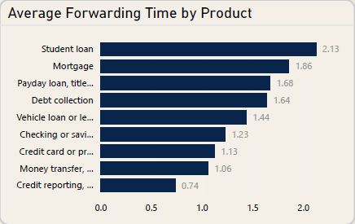
Figure 6. Average CFPB forwarding interval by product. Each label includes its source denominator.

EXISTING POWER BI DASHBOARD EVIDENCE

POWER BI DASHBOARD

Page 1: Executive Complaint Overview
Figure 7. Page 1: KPI cards, monthly trend, product share and year filter.
The first page gives management an immediate overview of the complaints recorded during the study period. It answers three key questions: How many complaints were received? Which products accounted for most of them? How timely were the recorded company responses?
The dashboard shows 62,516 complaints, with 61,022 having valid Yes or No timeliness indicators. Of these eligible complaints, 96.06% were marked as receiving a timely response. Another 1,494 complaints were excluded from this calculation because they were recorded as In progress.
Checking and savings accounts account for 39.69% of complaints, while credit and prepaid cards contribute 25.91%. Together, they represent approximately 65.60% of all complaints.
The monthly trend visual also indicates that complaint volumes generally increased in the later years of the dataset.

Page 2: Product and Issue Analysis
Figure 8. Page 2: ranked products, sub-products, issues and product-versus-issue table.
This page moves from the overall complaint figures to the underlying questions: Which financial products are associated with the most complaints, and what are consumers reporting?
It contains four visuals: complaints by financial product, the top ten sub-products, the top ten reported issues, and a product-versus-issue matrix.

What the data reveals
Top Complaints by Financial Product:
The leading product is Checking or Savings account, constituting 24,814 complaints while the lowest is Student Loan (39).
Top 10 Complaints by Sub-Product:
The sub-product visual adds another level of detail. Checking accounts is the largest sub-product category with complaints of 20,768.
Top 10 Complaints by Issue:
The leading issue is Managing an account, accounting for 15,109 complaints, approximately 24.17% of all records.
This suggests that account management is a particularly important area for further investigation. It may be useful to review more detailed complaints to understand whether they concern account access, transactions, account restrictions or other account-related activities.
The product-versus-issue matrix allows stakeholders to identify which issues are associated with each financial product. For example, it can help distinguish account-management complaints from credit-reporting or mortgage-related issues.

Page 3: Company Response Analysis
Figure 9. Page 3: timeliness, response types, in-progress and public response.
This page examines what response categories were recorded for complaints and whether they were marked as timely.
The most common response was Closed with explanation, representing 41,044 (approximately 65.65%) of all complaints.
Another 14,697 complaints were closed with monetary relief, while 5,273 were closed with non-monetary relief.
It is important to note that complaint recorded as Closed with explanation does not necessarily mean that the consumer was satisfied or that the underlying concern was resolved to their satisfaction.
The public-response summary also shows that 60,311 complaints were assigned the category indicating that the company responded to the consumer and the CFPB but chose not to provide a public response. Another 2,175 have no public-response category recorded.

Page 4: Complaint Timeline Analysis
Figure 10. Page 4: monthly/annual volumes, forwarding intervals and YoY comparisons.
The fourth page explains how complaint volumes changed over time and how long complaints took to move from the CFPB to the company.
It contains monthly and annual complaint trends, a forwarding-interval distribution, average forwarding time by financial product, unusually long forwarding intervals and year-over-year comparisons.
The data shows complaint volumes increasing from 7,075 in 2019 to 12,953 in 2022, an increase of approximately 83.08%.
The annual totals should be interpreted carefully. The dataset contains only part of 2017 and 2023, so these years cannot be compared directly with full calendar years without adjusting for coverage.

CFPB forwarding intervals
The dashboard records an average forwarding interval of approximately 1.22 days and a median of zero days.
This means that many complaints were forwarded on the same calendar date they were received by the CFPB. However, a smaller number experienced much longer intervals, with the highest recorded interval reaching 275 days.
The product comparison shows that student loan complaints had the highest average forwarding interval, approximately 2.13 days. However, there are only 39 student loan records, so this average should be interpreted cautiously.
These figures measure CFPB complaint-forwarding time, not Bank of America's response or resolution time.

Three actionable recommendations
1. Prioritise account-management complaints. Review the 15,109 complaints involving Managing an account, particularly within checking and savings products, to identify recurring themes that warrant operational investigation.
2. Monitor recorded response timeliness by month and product. The 96.06% overall rate should be supported by more detailed monitoring so that periods or products with weaker performance are not hidden by the aggregate figure. Report in-progress complaints separately.
3. Investigate unusually long forwarding intervals. Examine the complaints in the longest 1% of forwarding intervals, identify recurring characteristics and assess whether the CFPB-to-company forwarding process needs further review.
Conclusion
In conclusion, this project transformed 62,516 consumer complaint records into an interactive intelligence dashboard that supports better monitoring and evidence-based decision-making.
The analysis revealed that complaint volumes were concentrated in checking and savings accounts and credit card products, with account management representing the most frequently reported issue.
Although the overall recorded timely-response rate was 96.06%, the analysis also highlighted the importance of monitoring response classifications, incomplete records and unusually long forwarding intervals separately.
The dashboard provides stakeholders with a structured way to identify complaint patterns, investigate potential areas of concern and prioritise further analysis.
Ultimately, the value of this project is not simply in displaying complaint statistics, but in turning those statistics into information that can guide responsible operational decisions.

APPENDIX A / DEFINITIONS AND DAX REFERENCE

The 12 required KPI groups, with calculation basis and interpretive rules
KPI | CALCULATION | INTERPRETATION
1 · Total complaints | DISTINCTCOUNT(Complaint ID) | Unique complaint records, not consumers
2 · Annual complaint volume | Total complaints grouped by Year | 2017 and 2023 partial
3 · Monthly complaint volume | Total complaints grouped by Month Start | Chronological monthly series
4 · By financial product | Total complaints grouped by Product | Counts are not risk-adjusted
5 · By reported issue | Total complaints grouped by Issue | Issue is consumer-reported
6 · By sub-product/sub-issue | Total complaints grouped by each | Preserve missing labels
7 · Product contribution % | Product complaints ÷ total in filter context | Remove Product filter only for denominator
8 · Company response distribution | Count by Company response to consumer | Do not assume satisfaction
9 · Timely-response % | Yes ÷ (Yes + No) | Exclude blanks; show eligible count
10 · In progress | Count response = In progress | 1,494; not classified as No
11 · Forwarding mean/median | AVERAGE/MEDIAN(received − submitted) | Calendar days, CFPB forwarding
12 · Year-over-year % | (This year − prior year) ÷ prior year | Comparable full years 2019–2022

