**PROJECT REPORT**

**TITTLE: INDIAN’S AGRICULTURAL CROP PRODUCTION ANALYSIS (1997-2021)**

1. **INTRODUCTION** 
   1. **OVERVIEW**

**AGRICULTURAL SERVES AS A VITAL SOURCE OF LIVELIHOOD FOR A LARGE PORTION OF THE POPULATION, ESPECIALLY IN RURAL AREAS. IT PLAYS A CRUCIAL ROLE IN ENSURING FOOD SECURITY AND ALLEVIATING POVERTY BY PROVIDING EMPLOYMENT OPPORTUNITIES AND INCOME GENERATION. MOREOVER AGRICULTURAL ACTIVITIES CONTRIBUTE OF THE OVERALL SOCIO-ECONOMIC DEVELOPMENT OF RURAL COMMUNITIES, FOSTERING SOCIAL COHESION AND PRESERVING CULTURAL TRADITIONS.**

**1.2 PURPOSE**

**THIS PROJECT USE TO DEFINE OUR CONTRIBUTION IN AGRICULTURAL FIELD. AND THIS PROJECT SHOWS THE LOW CULTIVATIONS CROPS. IT SHOWS STATEWISE CULTIVATION.BY THIS WE EASILY FIND THAT WHICH STATE LEADS IN AGRICULTURAL SECTORS.**

1. **PROBLEM DEFINITION AND DESIGN THINKING**

**2.1 EMPATHY MAP**

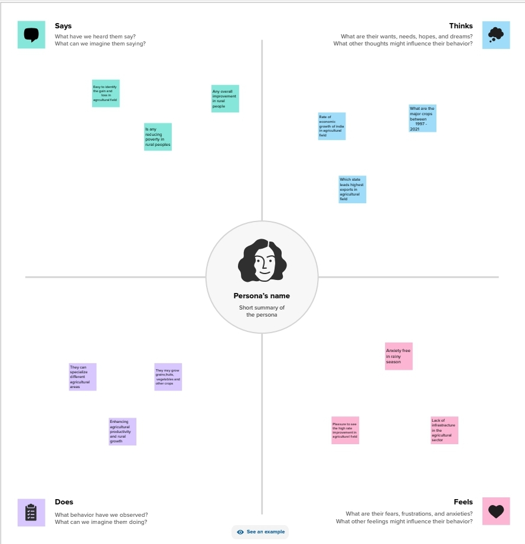

**2.2 IDEATION AND BRAINSTORMING MAP**

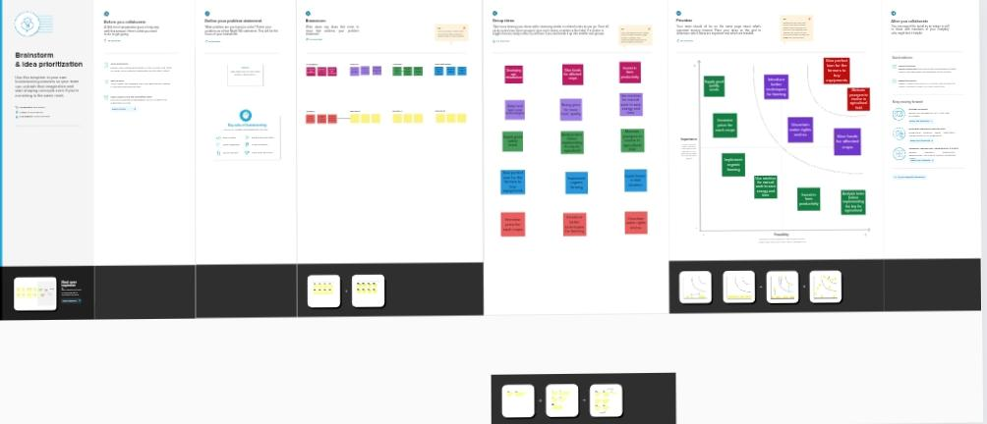

1. 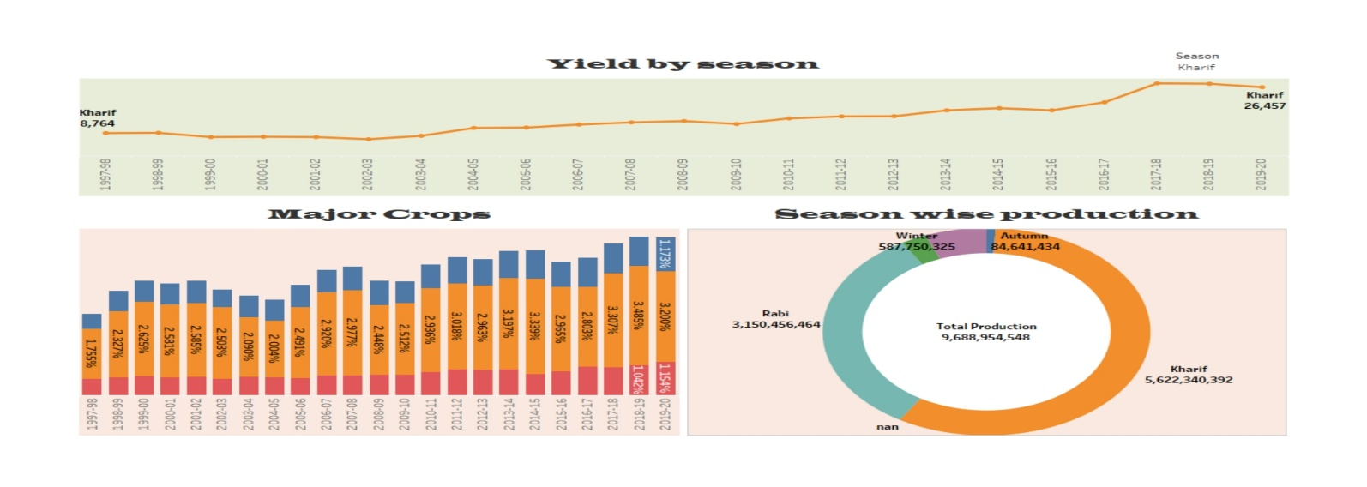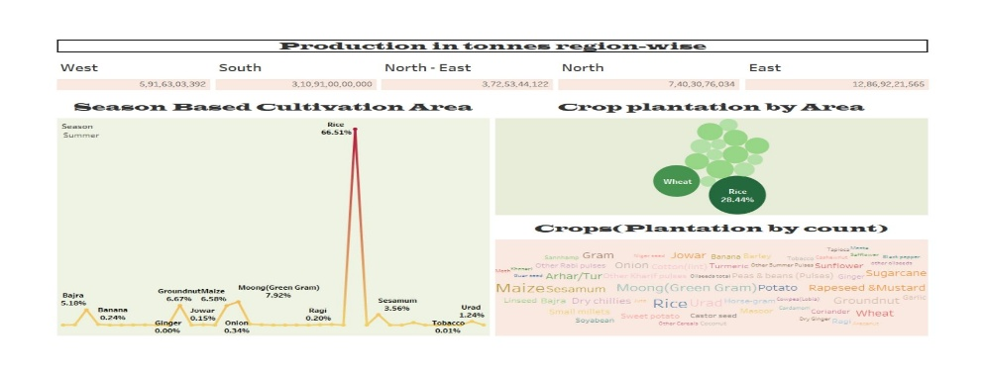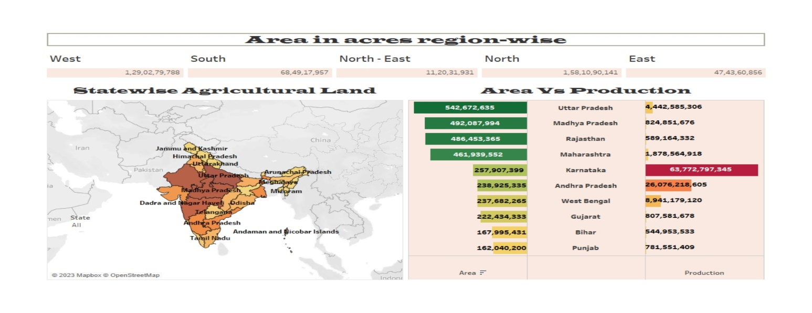 **RESULT**

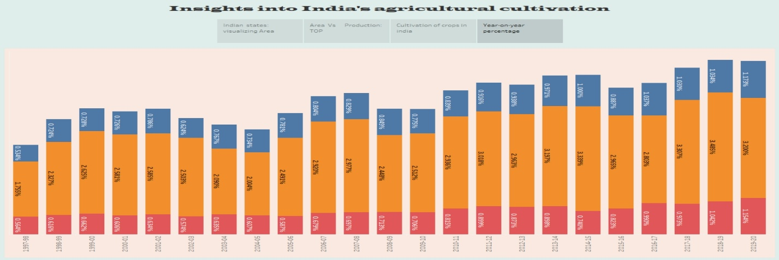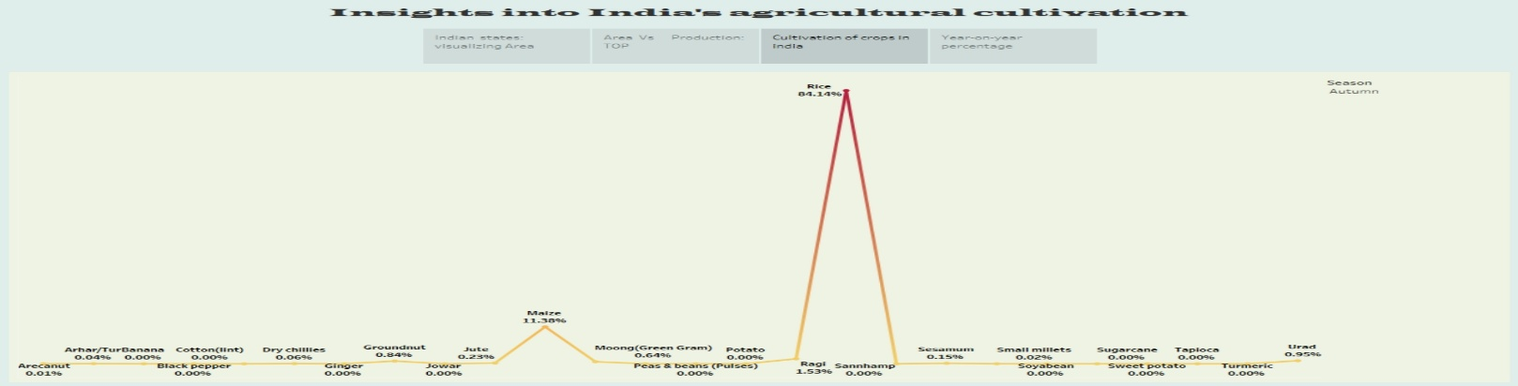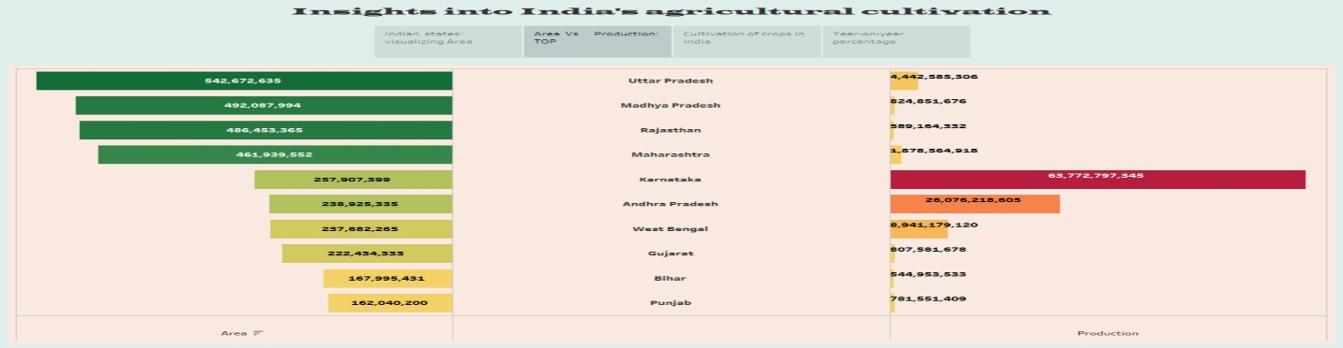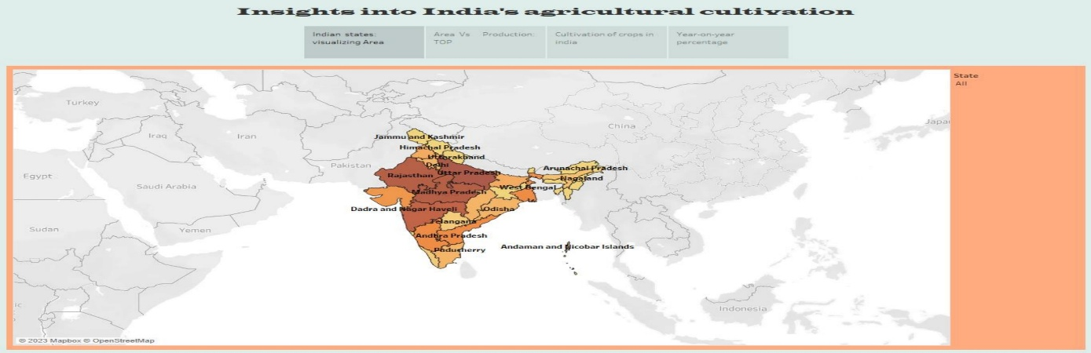

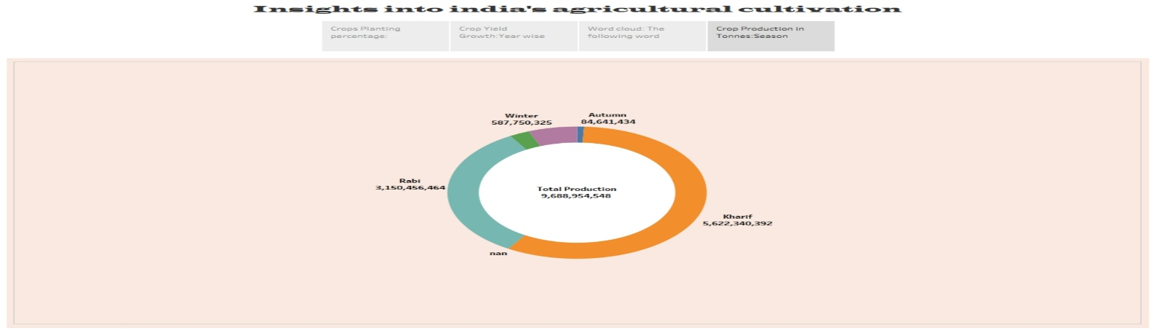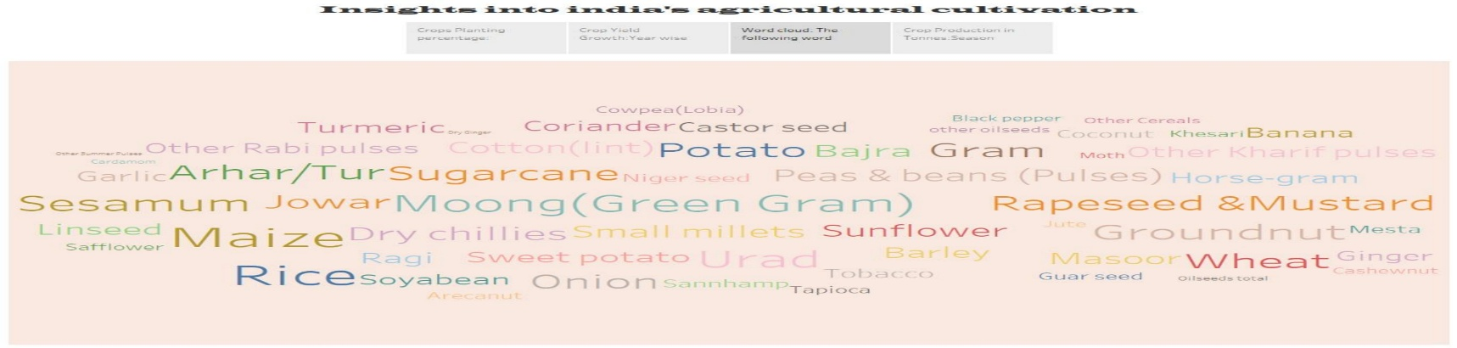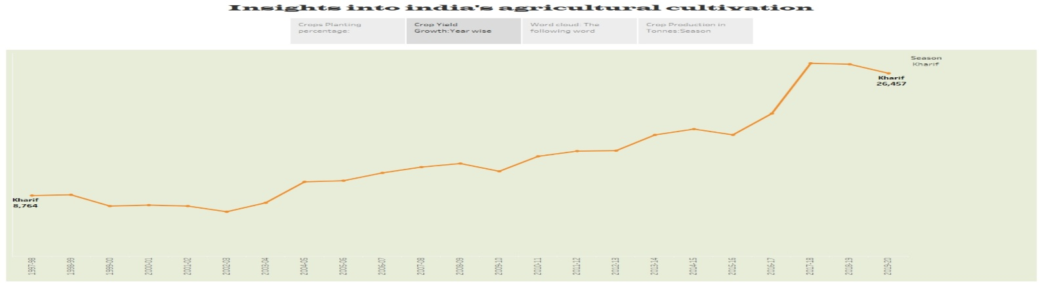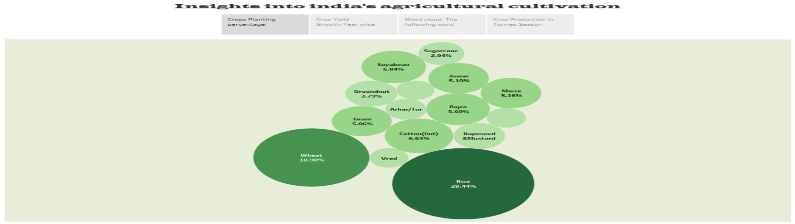

1. **ADVANTAGE AND DISADVANTAGES**

|  |  |
| --- | --- |
| **EASY** **TO** **UNDERSTAND** **THE** **RATE** . **BECAUSE OF SHOWING ALL INFORMATION IN A FEW SHEETS** | **THERE IS NO PROPER DATASET** |
| **IT SHOWS INFORMATION THROUGH MAP,BAR LINES, CHART….** | **IT IS USEFUL TO KNOW HOW OUR PAST CULTIVATION .BUT NOT SHOWS OUR CURRENT DATAS** |
| **IT HELPS TO KNOW,WHAT IS OUR STATE LEVEL? AND HOW TO INCREASE OUR CULTIVATIONS IN AGRICULTURAL FIELD** | **NOT GAIN ANYTHING. SIMPLY COPYING THE VEDIOS AND DOING IN OUR DEVICE** |

1. **APPLICATIONS**

**OUR DATA ANALYSIS PROJECT USEFUL FOR LEARNER’S TO UNDERSTAND EASILY, THEN IT IS USEFUL FOR GOVERNMENT TO GIVE FUND FOR LOW RANGE CULTIVATION AREAS. IT IS APPLICABLE FOR AGRICULTURAL RESEARCH FIELD. INSPIRES THE FORMERS TO DO DIFFERENT TECHNIQUES TO GET MORE PROFIT….**

1. **CONCLUSION**

**IN THE ABOVE DATA ANALYSIS RESEARCHERS DEMOCRATE THAT ASSUMPTION OF INDIA IS THE SECOND LARGEST PRODUCER OF RICE ,SUGARCANE…..**

**\*RICE IS SOWN ON THE LEARGEST AREA IN INDIA**

**\*BECAUSE IT NOT TAKES MORE TIME.AND IT GIVE MORE PROFIT IN SPECIFIC SEASON**

**\*KHARIF SEASON IS BEST SEASON. BECAUSE MOST OF CROPS WERE CULTIVATED IN KHARIF SEASON**

**\*KARNATAKA GAVES MORE PRODUCTION COMPARING WITH OTHER STATES**

1. **FUTURE SCOPE**

**MAYBE SOME YOUNGSTERS INSPIRE THIS INFORMATION AND TO DO FARMING. IT IS BEST PLATFORM TO DO PROJECT LIKE THIS . BY ADDING ATTRACTIVE FEATURES IN TABLEAU TO DO PROJECT IN BETTER WAYS..**