Global Atmospheric Carbon Monitoring Lakehouse
Phase 3: Gold layer, business intelligence and final architecture report
Muhammad Hamid Abad (24L-2534) and Abdullah Zia (24L-2507)
Repository: https://github.com/Hamid4325/Carbon-Emission-Lakehouse

1. Summary
We built an automated Medallion pipeline on Databricks Free Edition. Hourly air-quality concentrations (CO, CO₂, PM2.5, PM10, NO₂) for 100 cities come from the Open-Meteo API. Bronze keeps the raw files as they arrive, Silver holds one typed row per city per hour, and Gold is a star schema with one fact row per city per day. A Power BI dashboard reads Gold through a SQL warehouse and also charts the pipeline's own audit tables.
Item | Value
Data | 100 cities, about 3 years of hourly history (Oct 2023 to Oct 2026), plus daily incremental files
Silver | 2,647,200 rows from the first load (100 cities x 26,472 hours), one row per city per hour
Gold | dim_location (100 rows), dim_date (about 1,100 rows), fact_concentrations (about 111,000 rows)
Idempotency | Re-running the same input inserts 0 and updates 0 rows in Silver and Gold
Typical daily run | about one minute of compute across Bronze, Silver and Gold (measured, section 9)

2. Architecture
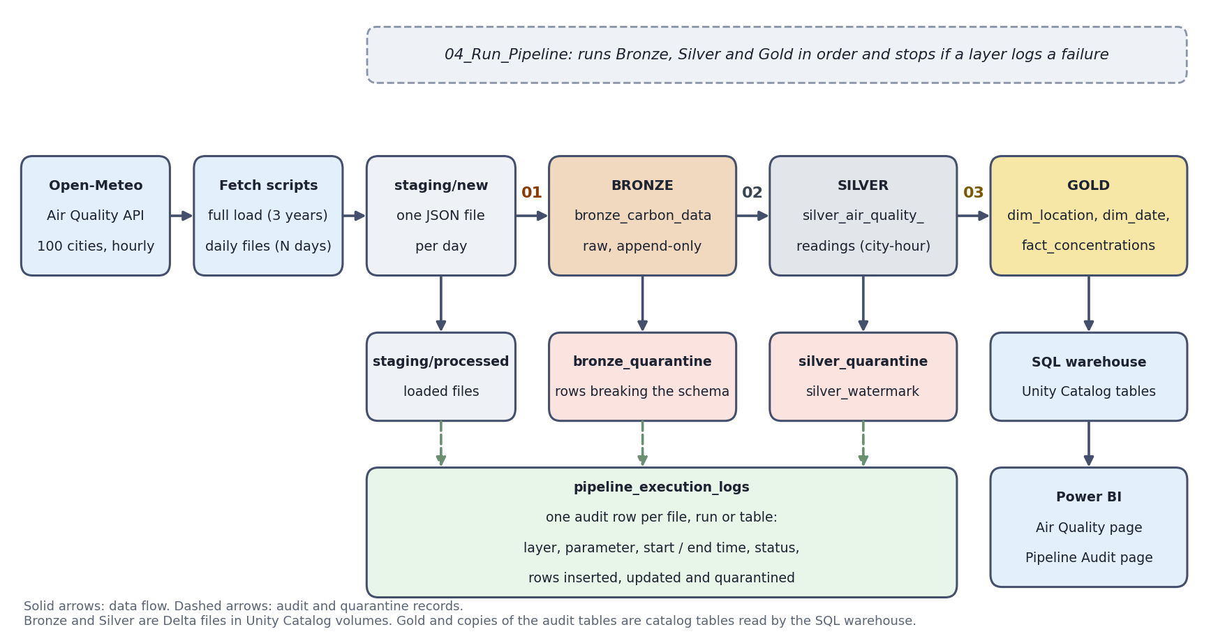
Figure 1. End-to-end flow from the API to Power BI. Notebooks 01 to 03 are the three layers, 04 runs them in order.
Raw to Bronze (01). Daily JSON files wait in staging/new. Each file is read with an explicit schema, good rows are appended to Bronze with a source file and a load timestamp, rows that do not fit the schema go to a quarantine table, and the file is moved to staging/processed.
Bronze to Silver (02). The nested hourly arrays are exploded to one row per city per hour, cast to proper types and validated. MERGE INTO on (city, reading_time) inserts new rows and updates only rows whose values changed. A watermark remembers the newest Bronze load already processed.
Silver to Gold (03). Silver rows that changed since the last Gold run identify the affected city-days. Those days are re-aggregated from Silver and merged into the fact table. The two dimensions are merged the same way. Copies of the audit tables are published next to Gold for the dashboard.
Automation (04). One notebook runs the three layers in sequence and stops if a layer logs a failure, so a new file that reaches Silver always refreshes Gold. The same dates flow through all three layers for a backfill.

3. Data models
Full column dictionaries for Bronze and Silver are in the repository README. The Gold star schema is below. Keys are informational Unity Catalog constraints, which lets Power BI detect the one-to-many relationships.
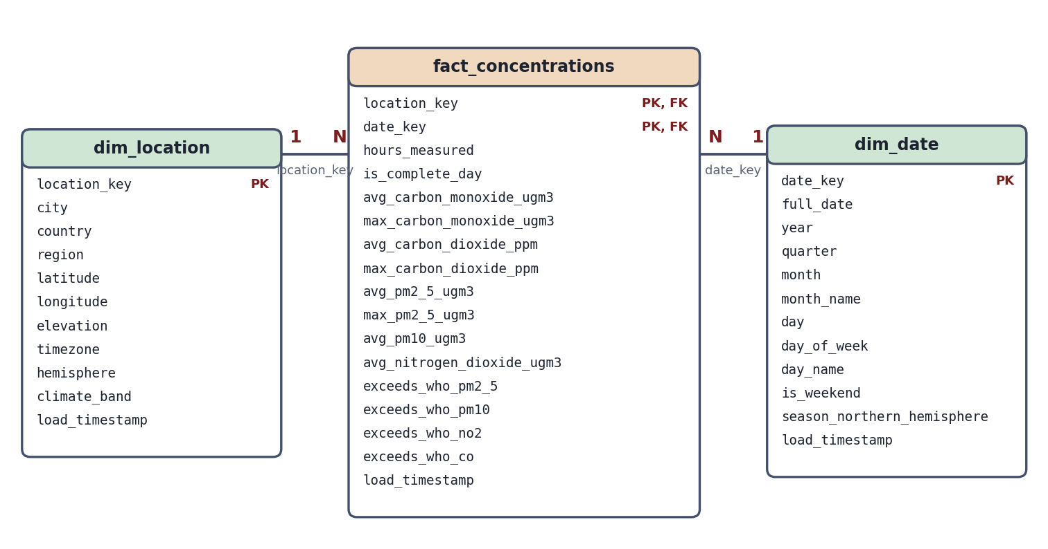
Figure 2. Gold star schema. The fact table has one row per city per day. Both relationships are one-to-many.
Table | Grain | Primary key | Foreign keys
dim_location | one row per city | location_key | none
dim_date | one row per calendar date | date_key (yyyymmdd) | none
fact_concentrations | one row per city per day | (location_key, date_key) | location_key to dim_location, date_key to dim_date

Fact measures. Daily average and maximum of each pollutant (concentrations in ppm or µg/m³), the number of hours measured, an is_complete_day flag (at least 23 hourly readings), and four flags that mark a daily mean above the WHO 2021 24-hour guideline for PM2.5 (15), PM10 (45), NO₂ (25) and CO (4,000 µg/m³). The WHO publishes no CO₂ guideline, so CO₂ is analysed as a trend only.
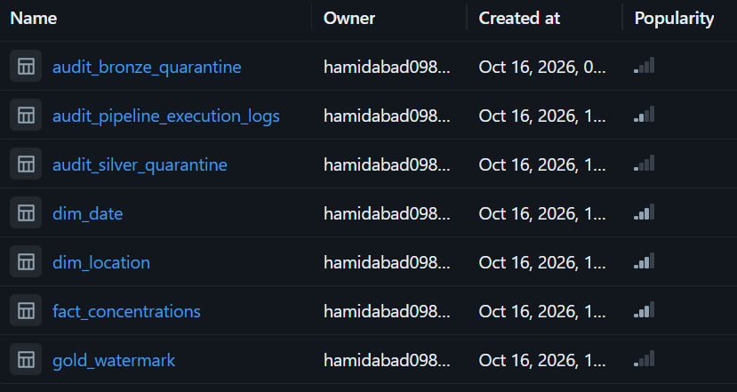
Figure 3. Gold tables in the Databricks Catalog (workspace.gold), including the audit copies used by the dashboard.

4. Pipeline integration and logging
- Chained execution. Notebook 04 runs 01, 02 and 03 in one session. After each layer it checks the audit log and stops the run if that layer wrote a Failure row.
- Refresh strategy. Silver and Gold both use a watermark: Silver keeps the newest Bronze load it has processed, Gold keeps the newest Silver change it has processed. A normal run needs no dates and processes only what is new.
- Gold refresh. Affected city-days are recomputed in full from Silver and merged. Aggregates are rounded to four decimals so that re-aggregating identical data produces identical values, and the merge only updates rows whose values differ.
- Backfill. The same notebooks take a start and end date. The range selects files in Bronze and reading dates in Silver and Gold.
- Logging continues into Gold. Each Gold run writes one Silver-to-Gold row per table with start and end time, rows inserted and rows updated. The row text records how many Silver rows were aggregated into how many city-days (for example 14,400 Silver rows into 600 city-days).
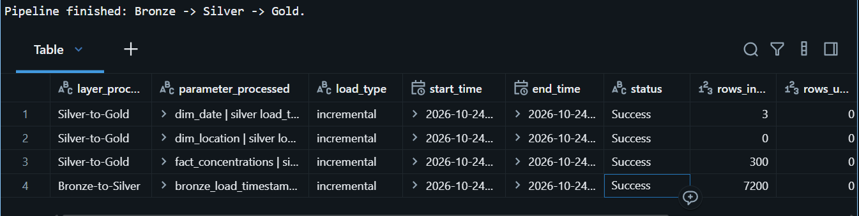
Figure 4. End-to-end run of notebook 04 and the resulting rows in pipeline_execution_logs for all three layers.

5. Gold read optimisation
The fact table is created with Liquid Clustering on (location_key, date_key) and OPTIMIZE runs after every refresh that changed rows. These are the two columns every dashboard query filters or joins on (which city, which dates), so rows that are read together are stored together and Delta can skip files that do not match.
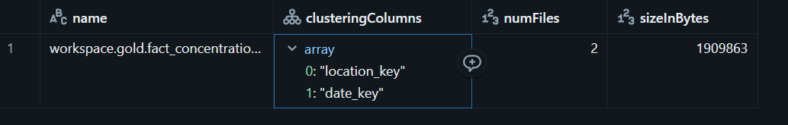
Figure 5. DESCRIBE DETAIL on fact_concentrations: clustering columns, number of files and size.

6. Business intelligence
Power BI Desktop connects to the Databricks SQL warehouse with the Databricks connector and imports the Gold tables and the three audit tables. The model mirrors the star schema: dim_location and dim_date each have a one-to-many relationship to fact_concentrations, and dim_date is marked as the date table.
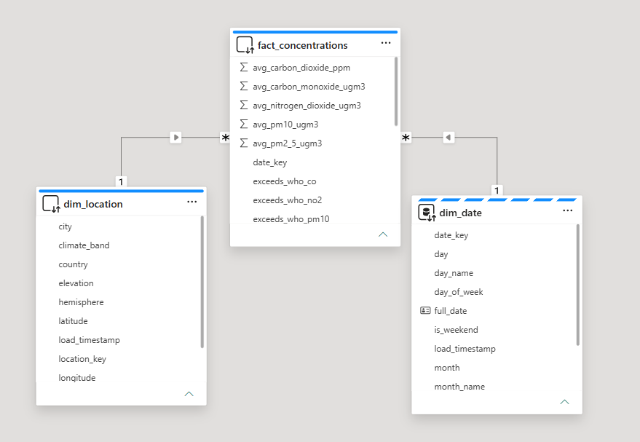
Figure 6. Power BI Model view showing the one-to-many relationships from both dimensions to the fact table.
Phase 1 business question | Visual
Which regions show the highest year-over-year change in concentrations? | Clustered column: average PM2.5 by region and year (2024 vs 2025, the two full years)
How do concentrations vary across the day, month and season per city? | Month by region heat matrix, monthly line chart by region, CO₂ trend by month
How often do cities exceed WHO guideline values? | Days above the WHO PM2.5 guideline by city, and the share of city-days above it (KPI)
Which cities are most polluted? | Map of average PM2.5 by city and a top-10 bar chart
Is the pipeline healthy? | Runs by layer and status, duration by layer, rows loaded, quarantined rows, problem-run table

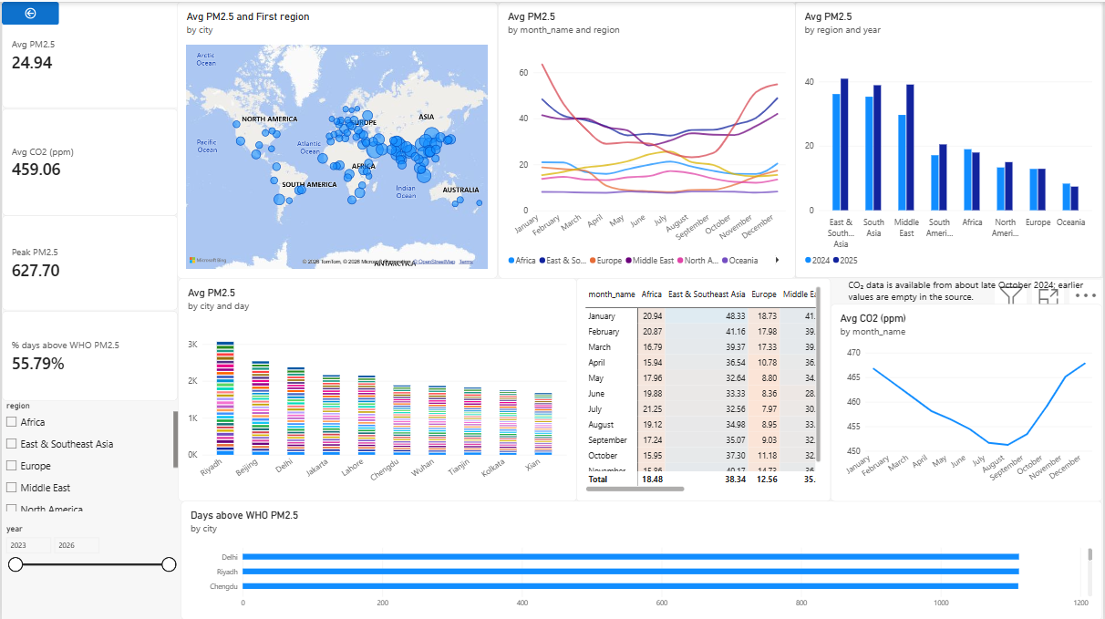
Figure 7. Dashboard page 1: Air Quality.
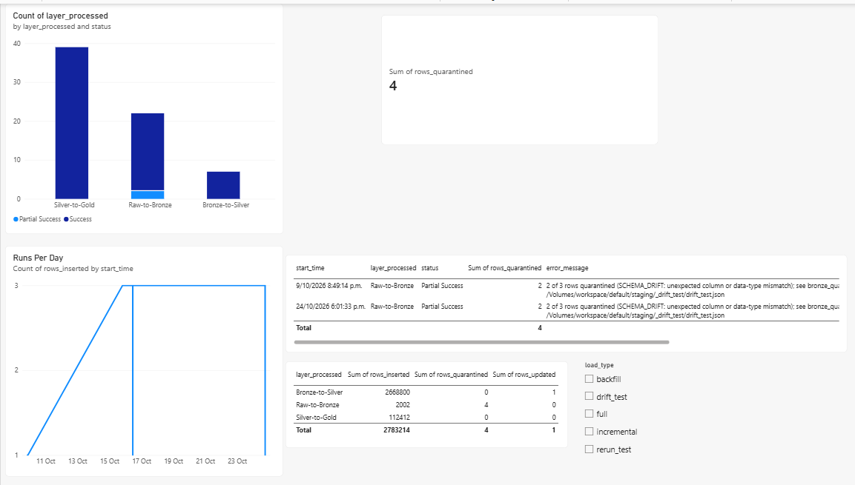
Figure 8. Dashboard page 2: Pipeline Audit (built from the audit and quarantine tables).
Data note. CO₂ values are empty in the source before about late October 2024, so CO₂ charts start there and a text box on the dashboard says so. The year-over-year chart uses 2024 and 2025 only, because 2023 (from October) and 2026 (to October) are partial years.

7. Decision log
Decision | Alternative | Why
Bronze is append-only and keeps the API's nested shape | Overwrite or de-duplicate in Bronze | It is an audit trail of exactly what arrived. Idempotency is enforced in Silver, so reloading a file only repeats raw rows.
Explicit StructType schema, no inferSchema | Schema inference | The schema is the contract. It is a course requirement and it makes drift visible.
MERGE updates only rows whose values differ (null-safe comparison) | Update every matched row, or overwrite | Running the same input twice leaves Silver and Gold unchanged, including timestamps. A revised forecast value still updates in place.
Watermark for incremental runs, dates only for backfill | Always pass a date window | A normal run needs no input and cannot skip data. Dates are for replaying a past period.
Re-fetch a rolling window of recent days (TA feedback) | Append only yesterday | Recent values are forecast-model output that later runs revise. Re-fetched days arrive as new Bronze loads and the merge updates the changed hours.
One file per day in staging/new, moved to staging/processed | One big file or a file-name log | The file name carries the date so Bronze can backfill by date, and the folders show what is waiting and what is loaded.
Silver and Gold are not partitioned. The Gold fact uses Liquid Clustering on (location_key, date_key) | Partition by year and month (our Phase 1 plan) | Silver is about 2.6 million rows and the fact table about 111,000 rows. Partitions that small create many tiny files and slow reads. Clustering on the query keys gives file skipping without that cost.
Star schema with a daily fact | Copy of Silver, or snowflake with separate country and region tables | Hourly Silver is already the detailed layer. Daily grain suits the questions and keeps joins short. With 100 cities a snowflake saves almost nothing.
Gold and audit copies are Unity Catalog tables, Bronze and Silver are Delta files in volumes | Everything as catalog tables | BI tools can only read catalog tables through a SQL warehouse. Bronze and Silver never need to be exposed to BI.
Analyse concentrations, not emissions; WHO thresholds on CO, PM2.5 and NO₂ | Emissions and a CO₂ threshold | The API reports how much is in the air, not how much was released, and the WHO sets no CO₂ guideline (TA feedback).
Settings cells with validation instead of widgets or input() | Notebook widgets, input() | Widgets ran with default values on Run All and input() does not work in Databricks notebooks. The shared validation prints the options and rejects bad values before anything runs.
Existence checks force the read with .columns | load(path) alone | Reads on serverless are lazy, so load() never fails for a missing folder. We hit this bug and fixed it.

How we handled schema drift
The Open-Meteo feed did not change shape during the project, so we proved the handling with an injected test file of three records: one valid, one with a new column and one with a text value where a number belongs. Bronze reads files with an explicit schema plus the rescued-data column. The valid record loads, the other two are rescued into a quarantine table with their original values, and the run logs Partial Success with 1 row inserted and 2 quarantined. The rest of the batch is never lost. Silver does the same for bad values (invalid timestamp, -999 sentinel, negative or zero concentration) with its own quarantine table.

How we handled PII
The data holds no personal information. Each record has model-grid coordinates, elevation, timezone and pollutant readings, and there are no names, emails, device or account identifiers. We confirmed this against the real payload, so no masking or hashing is needed. No credentials are stored in the code: the API needs no key, and the Databricks access token used by Power BI is kept outside the repository.

8. Spark execution analysis
Databricks Free Edition runs on serverless compute, which does not expose the classic Spark UI. We used the Query Profile (Query history, opened from the 'See performance' link under a notebook cell) and the physical plan from explain(), which show the same stages, exchanges and scans.
The most complex transformation is the Gold fact build: aggregate hourly Silver rows to one row per city per day, then merge into the fact table.
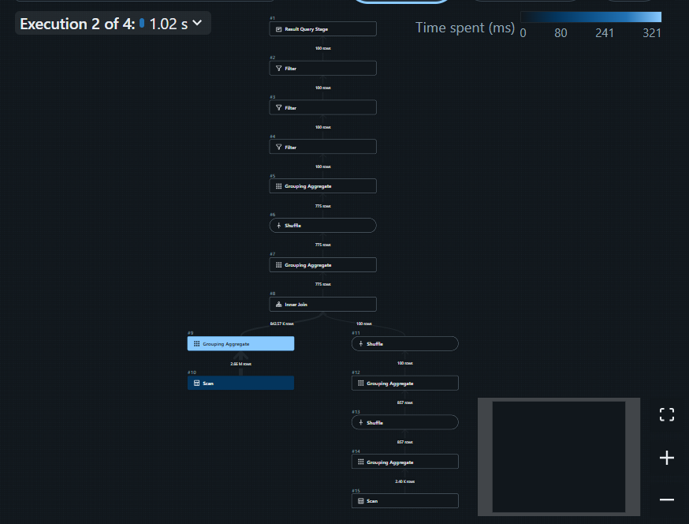
Figure 9. Query Profile for the Gold fact aggregation and merge.
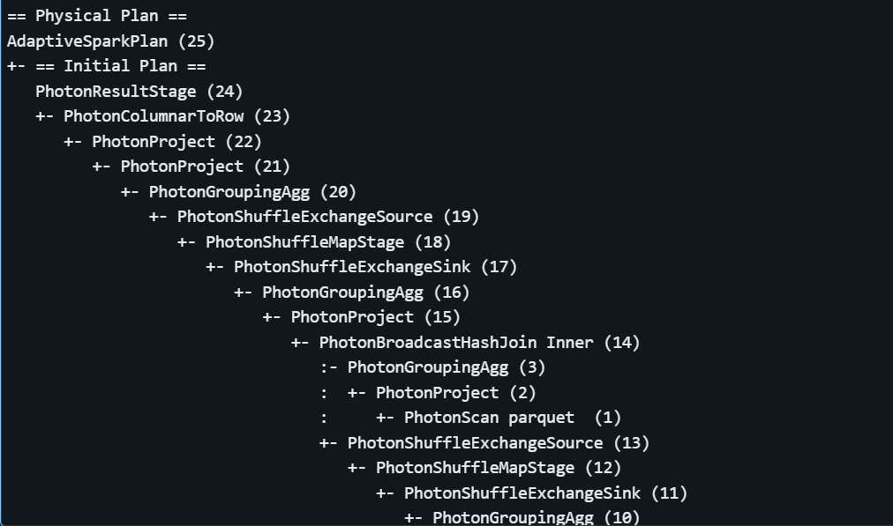
Figure 10. Physical plan of the fact aggregation (explain 'formatted').
How Spark executed it.
- Scan with predicate pushdown. The filter on Silver's load_timestamp is pushed into the Delta scan, so Delta compares it with each file's min and max statistics and skips files without changed rows. A daily incremental run therefore reads only a small part of Silver.
- Shuffle 1: distinct city-days. Selecting the distinct (city, date) pairs that changed needs rows with the same key on the same executor, so Spark repartitions the data by those columns (an Exchange) and de-duplicates.
- Join. The changed city-days are joined back to Silver to pull in every hour of those days. The set is small, so Spark can broadcast it instead of shuffling the large side.
- Shuffle 2: group by city and date. The aggregation (counts, averages, maximums) runs as a partial aggregate on each partition, then an Exchange by (city, date), then a final aggregate. The partial step cuts the data volume before the shuffle.
- Merge. The result is joined to the fact table on (location_key, date_key). Delta rewrites only the files that contain matched rows and adds new files for inserts, which is why an unchanged re-run writes nothing.
Shuffles are the expensive part, because data crosses the network and spills to disk. Keeping the input small with pushdown, and aggregating before the second shuffle, are what keep a daily run to seconds.

9. Cost and FinOps
Everything ran on Databricks Free Edition, which has no billing, so we report measured run times from our own audit log and convert them to a list-price estimate.

Measured run times (from pipeline_execution_logs)
Step | Input | Time
Raw to Bronze | one daily file (100 cities) | 2 to 3 seconds per file (about 13 s for the first file after a cold start)
Bronze to Silver | 6 new days (14,400 rows) | 14 seconds
Silver to Gold | 600 city-days re-aggregated, three tables merged | 33 seconds
Bronze to Silver and Silver to Gold | nothing new | 1.4 s and 4.6 s
Whole catch-up | 7 files through all three layers | about 2 minutes
First full load into Silver | 2,647,200 rows (3 years, 100 cities) | 33 seconds
Typical daily incremental run | one new day | about 45 to 60 seconds of compute in total

If this ran hourly for an enterprise for a year
The estimate below uses illustrative list prices (third-party 2026 price guides: about $0.40 per DBU for serverless jobs, $0.15 to $0.30 for classic jobs compute, about $0.70 per DBU for serverless SQL) and two stated assumptions: a small serverless job uses about 4 DBU per hour, and a 2X-Small serverless SQL warehouse uses 4 DBU per hour. Real figures must come from the billing usage data of the account.
Component | Assumption | DBU per year | Cost per year
Pipeline, hourly | 8,760 runs x 1.5 min = 219 compute hours x 4 DBU/h, at $0.40 | 876 | about $350
Pipeline, daily (for comparison) | 365 runs x 1 min = 6 hours x 4 DBU/h, at $0.40 | 24 | about $10
BI refresh, hourly | SQL warehouse awake 1 min per refresh = 146 h x 4 DBU/h, at $0.70 | 584 | about $410
Storage | about 0.5 GB of Delta files at roughly $0.023 per GB-month | - | under $1
Total, hourly |  | 1,460 | about $760 (about $540 at $0.15 per DBU for the pipeline)

At our data size the cost is small. Cost grows with compute time, so as an upper bound a data volume 100 times larger on the same fixed compute would multiply the pipeline line by 100 (about $35,000 per year). The optimisations below aim to keep it far below that.

How we would optimise it
- Run only when there is data. Trigger on file arrival instead of a fixed hourly schedule. An empty run already takes under 6 seconds, but it still pays start-up cost.
- Use classic jobs compute for steady schedules. Its DBU rate is lower than serverless, and clusters can be sized to the job.
- Cluster or partition Bronze by load date. The Silver incremental read filters on load_timestamp. At enterprise size, clustering Bronze on that column makes the filter skip files.
- OPTIMIZE on a schedule. Running it daily or weekly instead of after every refresh saves compute, and VACUUM old files to cap storage.
- Auto-stop the SQL warehouse after one minute and refresh the dashboard less often than the pipeline runs.
- Delta Change Data Feed instead of watermark scans, so Silver and Gold read only changed rows.
- Commit-based discounts for steady workloads, and per-job cost tags so each pipeline's cost is visible.

10. Limitations and future work
- CO₂ is missing before about late October 2024 in the source, so CO₂ trends cover about two years.
- Bronze appends raw rows again if a file is loaded twice. Silver and Gold are unaffected because of the merge.
- Timestamps are the API's local-time labels, not converted to UTC.
- The watermarks assume one pipeline run at a time.
- Free Edition has no Spark UI and no billing view, so cost is estimated from measured run times.

Appendix: how to run
Purpose | Where | Settings
Daily load, all layers | 04_Run_Pipeline | MODE = incremental
Replay a past period, all layers | 04_Run_Pipeline | MODE = backfill, START_DATE, END_DATE
One layer only | 01, 02 or 03 | Same settings cell in each notebook
Reload one exact file | 01_Raw_to_Bronze | MODE = backfill, FILE_NAME = the file name

Notebooks: 00_Config_and_Logging, 01_Raw_to_Bronze, 02_Bronze_to_Silver, 03_Silver_to_Gold, 04_Run_Pipeline. Fetch scripts: full load (3 years) and incremental (one file per day). Data dictionaries: README and GOLD_MODEL.md in the repository.

