-Past project on your wamp server.

-Create a database name : mywp

-import given DB (mywp.sql file)

-Open db table : wp_options and rename URL as attached screen shot below:

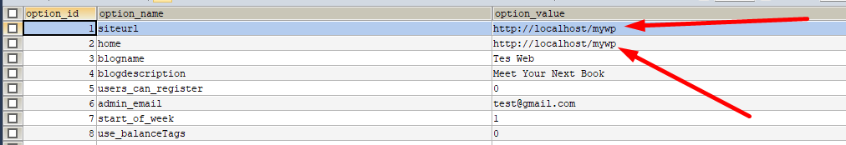

-Open wp-config.php file and change below lines :

define( 'DB_NAME', 'wpstory' );

/** Database username */

define( 'DB_USER', 'root' );

/** Database password */

define( 'DB_PASSWORD', '' );

Now run on your browser :

<http://localhost/mywp/>

website should be displayed without any error

Now login to wordpress backend with below url :

<http://localhost/mywp/wp-admin>

user: test

pass: james

after login go to : Settings -> Permalink

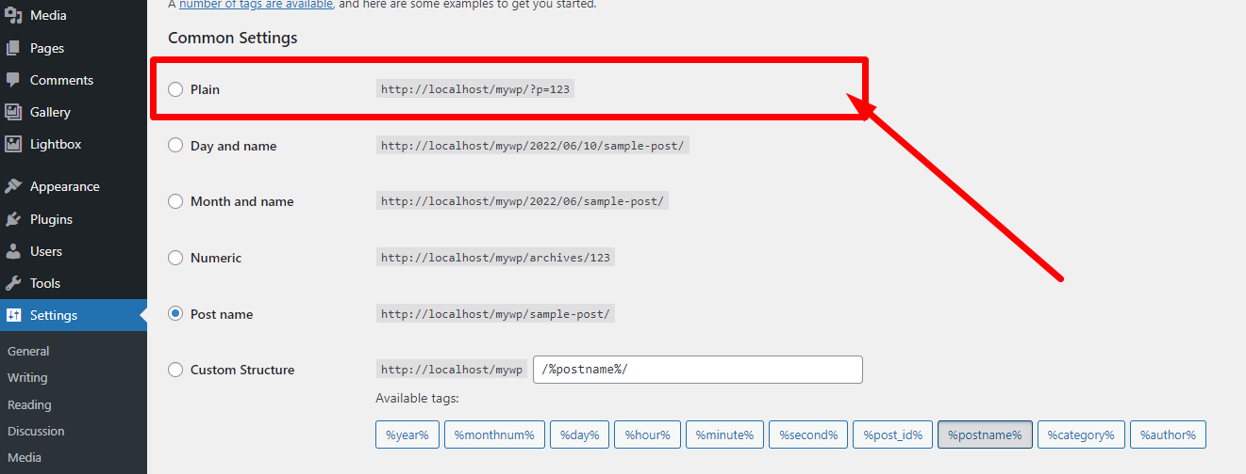

Choose “Plan” option and press save.

Then again choose “Post name” option and save it.

Now go to the path of your project : wp-content\themes\storytrees

And here you will have to work for your new theme.

You need to set header, footer, index page and add css, js, images files/folder here.

Take your code from html template and place it :

Header.php

Footer.php

Inside the folder : Templates : you can created different templates for your pages.