**Final Assignment**

**Name : Hamid Mustafa Dahri**

**Roll no : 2K17/SWEE/22**

**SUBJECT : SOFTWARE PROJECT MANAGEMENT**

**Department :Software Engineering**

**Faculty :FET**

**Semester :7th Semester**

**Submited to :Dr Kamran Taj Pathan**

**Q-1 Software Development roles with a little description.**

**Q-2 GANTT CHART**

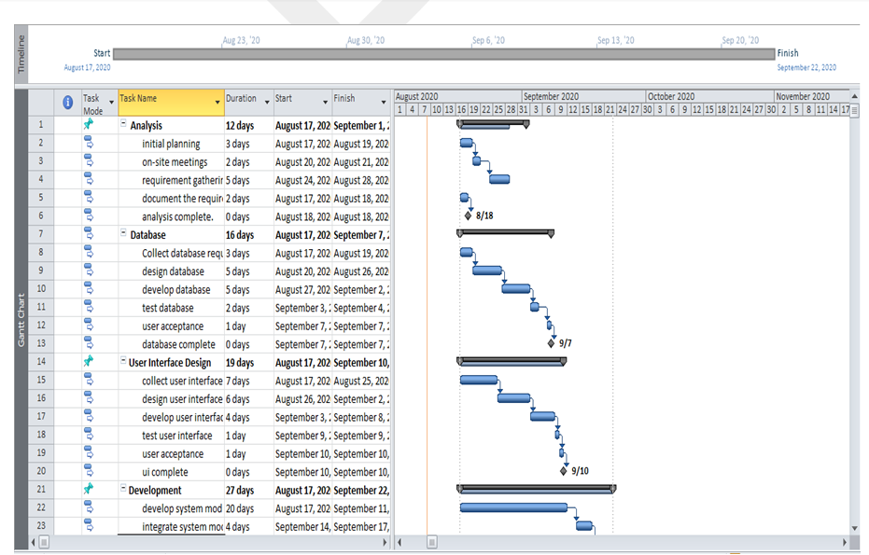

**Q-3 Work-Break-Down-Structure**

**Q-4 RACI CHART**

