ERD Diagram:
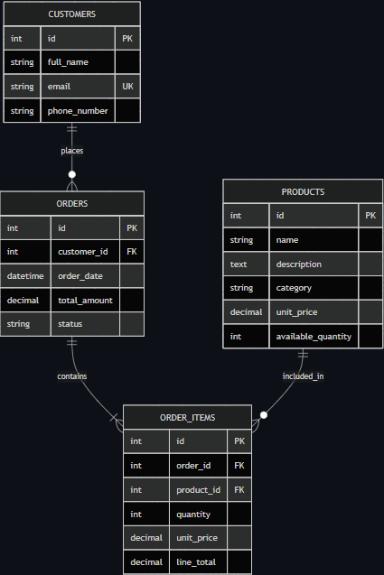
The design separates customers, products, orders, and order line items to avoid repeating product and customer data inside orders.
CUSTOMERS 1 -> many ORDERS ORDERS 1 -> many ORDER_ITEMS PRODUCTS 1 -> many ORDER_ITEMS
customers (id PK, full_name, email UK, phone_number)
products(id PK, name, description, category, unit_price, available_quantity)
orders(id PK, customer_id FK, order_date, total_amount, status)
order_items(id PK, order_id FK, product_id FK, quantity, unit_price, line_total

