SWIGGY ORDER DATA
Sales Performance Report
January – August 2025

₹53.01M  TOTAL REVENUE | 197,403  TOTAL ORDERS | ₹268.51  AVG ORDER VALUE | 4.34 / 5  AVG RATING | 28  CITIES COVERED

Author: Hamid Nasir
Prepared for: Sales Leadership & Regional Managers
Data source: Platform order-level export (197,430 rows, 28 states/cities, 984 restaurants)
Report date: August 2026

1. Executive Summary
Between January and August 2025, the platform processed 197,430 orders across 28 cities, 984 restaurants, and 4774 menu categories, generating ₹53.01M in gross revenue at an average order value (AOV) of ₹268.51. Customer satisfaction is high and stable, with an average rating of 4.34/5.
Revenue is consistent month to month (₹6.27M–₹6.83M), indicating a mature, steady-state business rather than one driven by seasonal spikes. The clearest strategic signal in the data is geographic: Bengaluru alone generates 10.3% of total revenue — more than double any other city — while the next 22 cities each contribute under 3%. This report discuss that, area where the real, data-backed opportunities are: like weekend demand, other city growth, and category-level bundling.

2. Data & Methodology
This report is based on a single order-level data covering the following points:
- Period: January 1, 2025 – August 31, 2025 (8 full months; Q3 2025 includes only July and August, not a full quarter)
- Scope: 197,430 order received on platform in 28 states/cities (one city per state in this dataset), 984 restaurants, 56,588 distinct dish names, 4,774 category of foods.
- Data Fields: order date, geography, restaurant, category, dish name, price(INR), rating, and rating count

Known limitations
- Every State have only one city in this dataset, so state-level and city-level findings are the same, not independent confirmation.
- “Category” is free text defined by restaurants like (4,774 unique values, e.g. “Recommended,” “Chef’s Special” etc.). Many top categories are just defined Label instead of food types, so category totals should be read as “where on the menu revenue comes from,” not a clean cuisine breakdown.
- Q3 2025 is incomplete (2 of 3 months). It is excluded from any month-over-month growth claims below.
- No cost, margin, or delivery-fee data is included — all figures are gross order value (INR), not profit.

3. Revenue & Order Performance

3.1 Monthly trend
Monthly revenue remain stable between ₹6.27M–₹6.83M over the year, with no month deviating from the average by more than 5%. February was the weakest month; January and May were the strongest.

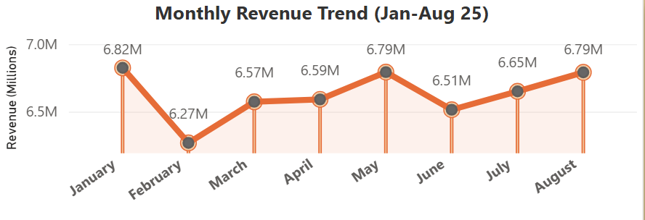

Figure 1. Monthly gross revenue, January–August 2025.

3.2 Quarterly view
Quarter | Revenue (INR) | Orders | Months Covered
Q1 2025 | 19664881.2 | 73085 | 3 (Jan–Mar)
Q2 2025 | 19896935.54 | 74155 | 3 (Apr–Jun)
Q3 2025 | 13441167.73 | 50163 | 2 (Jul–Aug only)

Q2 recorded more orders than Q1, but the difference is under 1%. Q3's lower total is expected and not a decline signal in orders because it is missing September entirely, so it will not be compared directly to the two full quarters above it.

4. Daily Demand
Weekend order volume is modestly higher than week day volume, not dramatically so. Comparing weekend days such as Saturday and Sunday to the average of week days from Monday–Friday average of 28,000 orders/day:

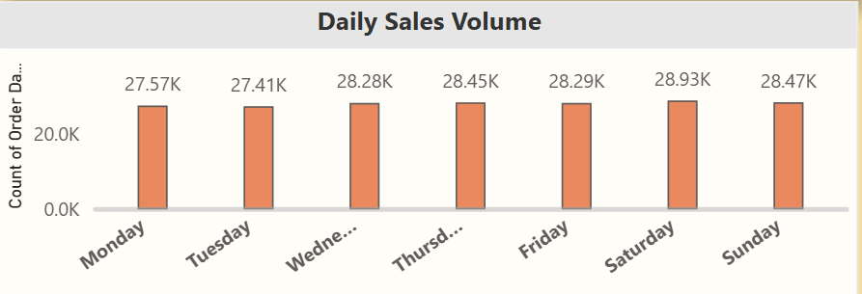
Figure 2. Order volume by day of week (Jan–Aug 2025 total).
- Saturday: 28,933 orders — +3.2% vs. weekday average
- Sunday: 28,470 orders — +1.7% vs. weekday average
- Tuesday is the single lowest day (27,415 orders), 2.1% below the weekday average
This is a modest effect — useful for lightly weighting weekend promotions, not for building a campaign around a “major weekend surge,” which the data does not support.

5. Geographic Performance
Revenue is heavily concentrated at the top of the city list. The top 5 cities generate 32.9% of total revenue, but Bengaluru alone generate more than the next two cities combined revenue.

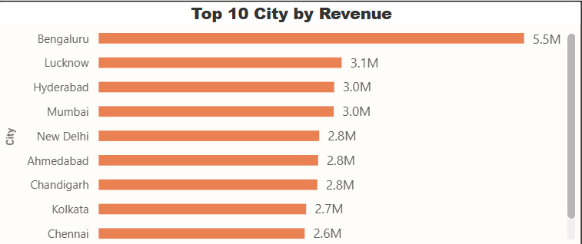
Figure 3. Top 10 cities by gross revenue.
City | Revenue (₹) | Orders | % of Total
Bengaluru | 5455887.73 | 20,072 | 10.2%
Lucknow | 3117359.65 | 10,192 | 5.2%
Hyderabad | 3021711.62 | 10,309 | 5.2%
Mumbai | 3015573.35 | 10,507 | 5.3%
New Delhi | 2829180.6 | 10,191 | 5.2%

The other 23 cities each contribute between 1.1% and 3.7% of revenue, and collectively make up 67% of the business. Some cities like Gangtok, Kohima, and Aizawl are the smallest markets, each under ₹850K, likely reflecting either lower population density or earlier-stage market entry rather than lower demand potential per capita — this dataset cannot distinguish between the two.

6. Product & Category Performance

6.1 Best-selling dishes
No single dish dominates — this platform have a long catalog of food menu, with 56588 distinct dishes. Even the top seller represents just 0.15% of all orders. Choco Lava Cake leads on order count and shows the most stable month-to-month demand of any top dish.
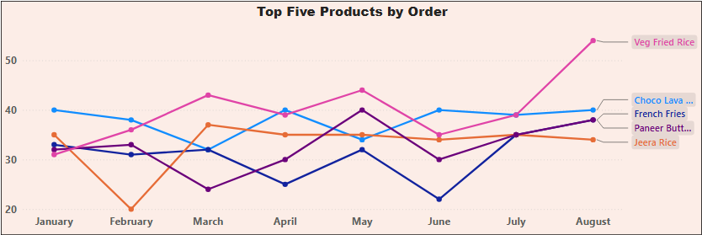
Figure 4. Top 10 dishes by order volume, Jan–Aug 2025.

6.2 Category revenue
“Recommended” is the largest single category at 12.2% of total revenue (₹7.19M, AOV ₹298), well ahead of the next largest, Main Course (1.5%). Actually “Recommended” is most likely a menu-placement label rather than a food category, so this should be read as evidence that menu placement drives order value.

Category | Revenue (₹) | Orders | AOV (₹) | % of Total
Recommended | 7188273 | 24098 | 298 | 12.2%
Main Course | 767175 | 2983 | 257 | 1.5%
Burgers | 695149 | 2539 | 274 | 1.3%
Sweets | 475068 | 1954 | 243 | 1.0%
Burger Combos ( 3 Pc Meals ) | 507774 | 1331 | 381 | 0.7%

7. Quality & Ratings
Rating quality is strong across the board: 96.5% of orders carry a rating of 3.5 or higher, and the average of 4.34 has held steady across the period. This is not a business with a widespread quality problem.
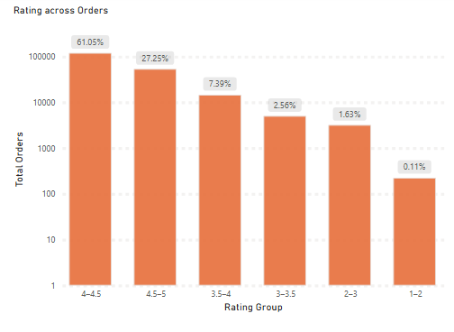
Figure 5. Distribution of order ratings (log scale). Note the small slices at the low end.

8. Recommendations
Each recommendation below is tied directly to a figure quantified in this report.

8.1 Grow the other cities, deliberately
- Finding: 23 non-top-5 cities already generate 67% of revenue but average under 3% each — there is no single dominant secondary market to “copy,” so this is a portfolio play, not a single-city bet.
- Action: Identify the 3-4 cities just behind the top 5 (Ahmedabad, Chandigarh, Kolkata, Chennai — all within ₹460K of each other) as the next tier for targeted delivery-fleet and restaurant-acquisition investment, since they are already close together and likely to respond similarly to a shared playbook.

8.2 Weekend promotions to the real lift, not an inflated one
- Finding: weekend order volume is +1.7% to +3.3% above weekday average — real, but modest.
- Action: Use light weekend-targeted promotions (like a small delivery-fee discount on Saturday) rather than large promotional budgets sized for a “major spike” that the data does not show.

8.3 Test menu placement as a revenue lever
- Finding: dishes placed in the “Recommended” slot carry a 30% higher AOV (₹298 vs. the ₹268 platform average) and drive 13.6% of all revenue from a single placement.
- Action: Run an A/B test with partner restaurants on what gets featured in that slot — this is a low-cost, high-leverage lever compared to a platform-wide pricing change.

8.4 Investigate two specific dishes, not a broad quality audit
- Finding: only 2 dishes with a meaningful order volume (≥15 orders) fall below a 3.8 rating.
- Action: Have the relevant restaurant partners review “Penne McN Cheese Pasta” and “2 Farm Spicy Paneer” specifically, rather than commissioning a platform-wide dark-kitchen quality audit that this data does not justify.

Appendix: Data Dictionary
Field | Description
State / City | Delivery region; 1:1 mapped in this dataset (28 of each)
Order Date | Date of order, DD-MM-YY
Restaurant Name | Partner restaurant (984 unique)
Category | Restaurant-defined menu section (4774 unique, free text)
Dish Name | Item ordered (56,588 unique)
Price (INR) | Gross order value for that line item
Rating / Rating Count | Customer rating (1-5) and number of ratings behind it, at time of export

