**ING INFO SECTION B**

2023-2024

**FINAL PROJECT**

**INFORMATION AND COMMUNICATION TECHNOLOGY**

* **CHERIFI Kaouther**
* **HAMIDI Assala**
* **KAHLI Aya Meriem**
* **OUGOUR Sarah**
* **TABTI Sabrina**

Sommaire

1.Introdiction: 2

2. Deffinition of ICT: 3

3. History: 5

4. Use of ICT 8

4.1 Health 8

4.2 Commerce 9

4.3 Financial Services 10

4.4 Education 11

4.5 Industry 12

5 Benefits of ICT 13

7. Security and confidentiality linked to the use of ICT: 15

7.1Security Measures: 15

7.2. Confidentiality Potection: 16

7.3.Challenges and Mitigations: 16

8.Information on ICT policies and regulations: 17

# 1.Introdiction:

Information and communication technology, or ICT, serves as the bedrock of our digital infrastructure, empowering individuals and businesses a like . It encompasses a diverse array of tools and system that enable the creation, storage, retrieval, and transmission of data. ICT’s evolution has fostered a global network, revolutionizing how we access information, communicate across distances, and collaborate on a scale never before imagined. This technological ecosystem continues to shape the way we live, learn, and interact in today’s interconnected world.

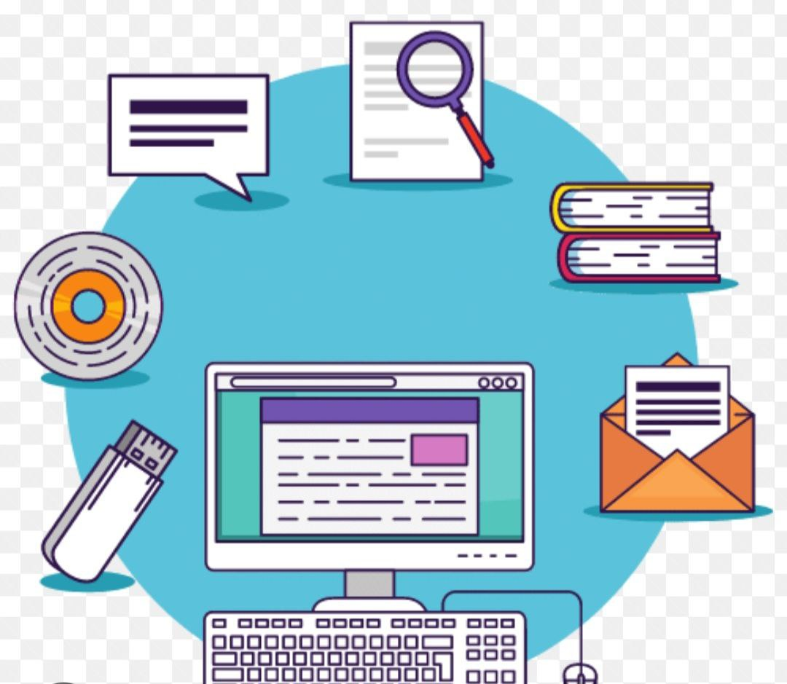

# 2. Deffinition of ICT:

Information and communication technology (ICT) a broad term that to all communication technologies, including the, wireless networks, cell phones,, software, middleware, video-conferencing, social networking, and other media applications and services that enable users to access, retrieve, store, transmit, and manip information in a digital form. ICT also includes the convergence of media technology such as audio-visual and telephone networks with computer networks, and encompasses a diverse set of technological tools and resources used to transmit, store, create, share or exchange information. ICT is generally used to represent a more comprehensive list of all components related to computer and digital technologies, and its capabilities have brought cost savings, improved communication, and revolutionary changes to how people work, communicate, learn and live, although it has also created problems and challenges such as cybercrime and the digital divide.

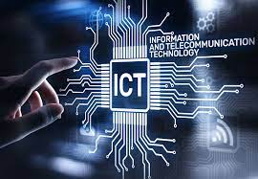

**3.** History**:**

The history of information and communication technologies is marked ba a diversity of innovations .

It begins in 19th century with inventions such as telegeraph and telephone ,which revolutionized communication by enabling near real time , long distance exchanges .

The mid ${20}^{th}$ century witnessed the rise of mass communication through radio and television. by the end of century , the internet had become an essential tool for communication ,commerce, and leisure . since then, these technologies have rapidly evolved , transforming our work methodologies, interactions, and communication prectices, thereby contributing to shaping the modern world.

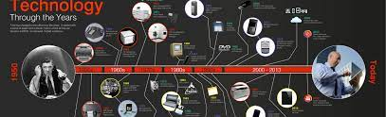

|  |  |  |
| --- | --- | --- |
| Year | Technological innovations | inventor |
| 1837 | Telegraph and morse code | Sanuel morse and Alfred vail |
| 1882 | Telephone | Alexander graham bell |
| 1896 | Wireless telegraphy | Guglielmo Marconi |
| 1927 | Television | J.logie,P.nipkom,V.zworykin |
| 1947 | Transistor | W.shockley ,J. Bardeen |
| 1951 | **UNIVAC 1** | J.presper Eckert |
| 1969 | **ARPANET** | Paul baran and Donald davie |
| 1971 | First email | Ray toumlinson |
| 1975 | Microsoft | Bill gates and paul allen |
| 1989 | World wide web | Tim burners_lee |
| 1990 | **GSM** | ETSI group |
| 1994 | Netscape navigator | Mark andreesson and james |
| 1998 | Google | Larry page and sergey brin |
| 2001 | Commercial 3G networks | NTT DoCoMo |
| 2004 | Facebook | Mark zuckerberg |
| 2007 | Iphone | Steve jobs |
| 2008 | **BITCOIN** | Satoshi nakamoto |
| 2010 | 4G networks | ETSI |
| 2016 | **ALPHAGO** | Deepmind technologies |
| 2020 | 5G networks | ETSI |

UNIVAC 1**:**  first commeratial computer .

ARPANET**:**  foundation of the internet .

GSM **:**  global system for mobile communication .

BITCOIN **:**  first block chainbased cryptocurrency.

ALPHAGO**:**  Ai system defeating world champion go player.

As another example, and like many programs and technologies,

Microsoft also developed and created the Microsoft Office pack-

age. Where The first version of Microsoft Office, initially named

“Microsoft Office System”, was introduced in 1989 for Macintosh

computers. However, the Microsoft Office suite for Windows plat-

forms only appeared in 1990 with Office 1.0.

Since its inception in the 1990s, Microsoft Office has seen nu-

merous major updates with regular versions. Some of the no-

table versions include Office 95, Office 97, Office 2000, Office XP

(2002), Office 2003, Office 2007, Office 2010, Office 2013, Office

2016, Office 2019, and the Office 365 suite, which operates on a subscription-based model and receives regular updates.

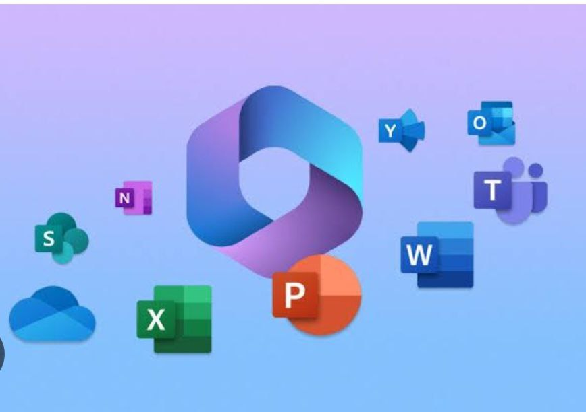

Github too has undergone significant evolution since its incep-

tion. The company, GitHub, Inc., was formed in 2007 by Chris

Wanstrath, P. J. Hyett, Tom Preston-Werner, and Scott Chacon .

Development of the GitHub platform began on October 19, 2007

. The site was officially launched in April 2008 by Tom Preston-

Werner and Chris Wanstrath .

Over the years, GitHub has transformed how people code and

revolutionized the way software developers think about program-

ming . It has become a central hub for collaboration and version

control in software development projects.

One notable milestone in GitHub’s evolution was its acquisition

by Microsoft. This acquisition further solidified GitHub’s position

as a leading platform for developers worldwide .

Overall, GitHub’s journey from its founding to becoming an es-

sential tool for developers showcases its continuous growth and

impact on the software development community



# 4. Use of ICT

Information and Communication Technologies include various tools

like computers, internet, social media, smart phones, software, databases, communication systems, and more.

They’re used to share information, communicate remotely, automate processes, store data, and facilitate global collaboration.

These technologies are omnipresent in daily life and play a central

role in the functioning of numerous inductries and sectors:

## 4.1 Health

Within healthcare, informations and communication technologies

serve various purpose :

**- Electronic Health Records(EHR):** Managing patient information

electronically for secure and convenient access to medical records

**- Health focused mobile Applications:** Tracking personal health

metrics (such as activity levels, diet, and sleep), offering meditation

reminders, and delivering tailored health guidance.

**- Data analysis for medical research** Using data analysis to study

patterns, effective treatments, and novel discoveries in healthcare.

**- Medical Imaging Systems:** Utilizing technologies like digital ra-

diology to capture, store, and share medical images.

These ICT applications aim to streamline healthcare operations, enhance access to medical services, and optimize the management of medical information.

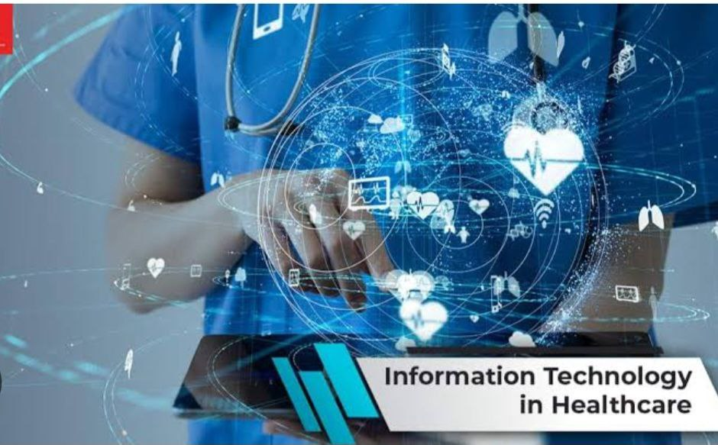

## 4.2 Commerce

ICT has revolutionized commerce in various ways:

**- E-commerce:** Online platforms enable businesses to sell and con-

sumers to purchase goods and services over the internet.

**- Digital Marketing:** Online tools like social media, SEO, and tar-

geted advertising are utilized to promote products and services.

**- Inventory and Sales Management:** Inventory management soft-

ware and point-of-sale systems streamline stock management and trans-actions.

**- Customer Data Analysis:** Companies employ data analysis to

comprehend customer behavior, personalize offerings, and enhance the customer experience.

These ICT applications in commerce have significantly altered how busi-nesses operate and interact with consumers, simplifying transactions andenhancing the overall purchasing experience.



## 4.3 Financial Services

Information and Communication Technologies (ICT) have transformed financial services in several ways:

**- Online Banking:** Customers now have access to their accounts,

can transfer funds, and manage finances through banking websites or

mobile applications.

**- Digital Payments:** Technologies like mobile wallets, contactless

payments, and cryptocurrencies offer secure and convenient payment methods.

**- Risk Management Systems:** Advanced software and analytics

assist financial institutions in assessing and managing risks more effectively.

**- Automated Trading:** ICT enables high-frequency and algorithmic

trading in financial markets.

These ICT applications within financial services improve accessibility, security, efficiency, and innovation, influencing how transactions are conducted and financial data is handled.



## 4.4 Education

ICT have transformed the field of education in various ways:

**- E-learning Platforms:** Online courses, virtual classrooms, and

educational resources accessible via the internet.

**- Personalized Learning:** Adaptive learning systems that tailor ed-

ucational content to individual student needs and learning styles.

**- Interactive Learning:** Educational software and applications that

engage students through interactive content and simulations.

**- Remote Learning Tools:** Video conferencing, webinars, and col-

laboration platforms enabling remote teaching and learning.

These ICT applications in education enhance accessibility, engagement, and the effectiveness of teaching and learning methods, providing more diverse and personalized learning opportunities.

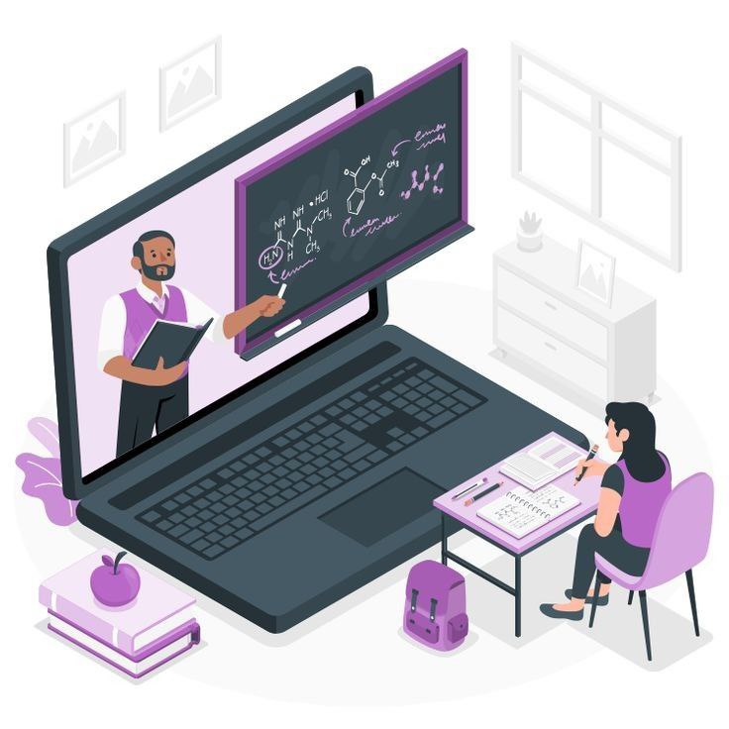

## 4.5 Industry

Information and Communication Technologies have revolutionized

the industry in several ways

**- Process Automation:** Computerized systems and robots are em-

ployed to automate production and repetitive tasks, enhancing effi-

ciency and precision.

**- Supply Chain Management:** Management software aids in inven-

tory tracking, logistics, and coordinating various production stages.

**- Additive Manufacturing (3D printing):** This groundbreaking

technology is used for rapid prototyping and customized part pro-

duction.

**- Internet of Things (IoT):** Connected devices enable real-time

tracking, data collection, and optimization of industrial operations.

These ICT applications in the industry enhance operational efficiency, productivity, and process management, contributing to a more modern and competitive industry landscape.

# 5 Benefits of ICT

Information and Communication Technologies has contributed

greatly to the development that the world has reached today, as it

has many benefits that it brings to humanity in a comprehensive

way, which are represented in the following:

• Information and Communication Technologies (ICT) enable instant and global communication through the internet, emails, messaging tools, using real-time communication and collaboration tools, leading to improved access to information and resources, effective decision-making, and enhanced project management.

• They provide quick and easy access to an immense amount of in-formation and resources online. Through online libraries, e-learning platforms, open-access journals, easy access to educational rsourcees, research findings, and a wide range of materials.

• Access to information: They provide quick and easy access to an immense amount of information and resources online. Through online libraries, e-learning platforms, open-access journals, easy access to educational resources, research findings, and a wide range of materials.

* ICT enables efficient data storage and secure sharing, facilitating collaboration.

• ICT automates processes, thereby enhancing efficiency and productivity across various sectors, through cost-effective solutions such as automation, streamlined workflow processes, cloud computing, and virtual meetings, resulting in cost reduction, time savings, and increased productivity.

- ICT stimulates innovation, fostering new ideas, industries, and economic opportunities, enhancing problem-solving skills, improving collaboration capabilities, generating new ideas and innovative solutions, providing access to information for informed decision-making, and automating repetitive tasks to focus more on problem-solving.

**6. The of ICT**

**1. Over-dependence:** ICT can lead to addiction, particularly to social media and online gaming, affecting productivity and mental health.

**2. Loss of privacy:** The widespread use of ICT can compromise the privacy of individuals, with risks of constant surveillance and unauthorized collection of personal data.

**3. IT Security:** ICT is vulnerable to cyberattacks, such as viruses, malware and data breaches, putting user privacy and security at risk.

**4. Digital divide:** Unequal access to ICT creates a disparity between those who have technological resources and those who do not, contributing to a digital divide at the social and economic level.

**5. Environmental impact:** The production and disposal of electronic devices contributes to e-waste, while intensive energy use for data centers impacts the environment.

**6. Disinformation:** ICTs facilitate the rapid spread of false information and conspiracy theories, compromising the reliability of information available online.

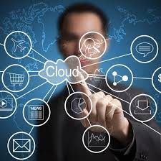

# 7. Security and confidentiality linked to the use of ICT:

## 7.1Security Measures:

|  |  |
| --- | --- |
| Encryption Protocols | Implementing robust encryption algorithms is crucial to protect data during transmission. Utilizing protocols like TLS(transport layer security) /SSL(secure sockets layer) enhances the security of communication channels. |
| Access Controls | Restricting access based on user roles and permissions helps prevent unauthorized entry. Multi-factor authentication adds an extra layer of security to verify user identities. |
| Network Security | Employing firewalls, intrusion detection systems, and regular security audits fortifies the TCI infrastructure against external threats, ensuring the integrity of the network. |

## 7.2. Confidentiality Potection:

|  |  |
| --- | --- |
| Data Classification | Categorizing data based on sensitivity enables tailored security measures. Confidential information receives heightened protection, reducing the risk of unauthorized disclosure. |
| Data Encryption at Rest | Applying encryption to stored data on devices or servers prevents unauthorized access in case of physical breaches or unauthorized access to storage media. |
| Compliance with Regulations | Adhering to data protection regulations and industry standards (e.g., GDPR, HIPAA) ensures legal compliance and fosters a culture of responsible data handling. |

## 7.3.Challenges and Mitigations:

|  |  |
| --- | --- |
| Cybersecurity Threats | Continuous monitoring for evolving cyber threats and promptly applying security patches mitigates vulnerabilities, minimizing the risk of data breaches. |
| User Education | Educating users on security best practices and the importance of confidentiality helps create a security-conscious environment, reducing the likelihood of unintentional breaches. |

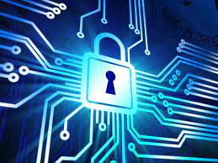

# 8.Information on ICT policies and regulations:

Policies and regulations regarding Information and Communication Technologies (ICT) vary by country. Generally, they cover areas such as data protection, cybersecurity, privacy, and equitable access to the internet.

Laws like GDPR (general data protection regulation) in Europe or CCPA (California consumer privacy act) in California aim to safeguard individuals' privacy. Telecommunications regulation and combating cybercrime are also integral parts of these policies. It's crucial to stay updated on legislative developments to ensure ethical and compliant use of ICT.