**Requirements**

* Windows operating system
* Download and install R v3.1.0 available [here](http://cran.r-project.org/bin/windows/base/old/3.1.0/)
* Download and install RStudio

**Running BMI Analysis**

Open RStudio

Check for library “xlsx” which is used for writing Excel files. Type library(xlsx) in the console

If you receive an error you will have to install xlsx. Do this by typing install.packages(“xlsx”)

In RStudio, select File > Open File… and select BMI_Analysis.R. You can download the file [here](https://github.com/HamiltonFHT/ChildWellness) if you do not have it. In the top right of the code window click the “Source” button

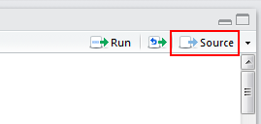

A file browser will pop up which will allow you to select the files of interest. You may select multiple files for the same practice to trend results over time.

Once you select these files, a second file browser will pop up to select the output directory.

Two new dialogs will ask what age range to analyze the data over (either 2-5 or 5-18)

The analysis will now run and a dialog indicating progress and completion will appear

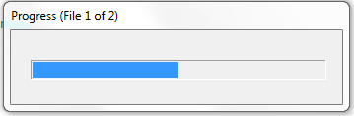 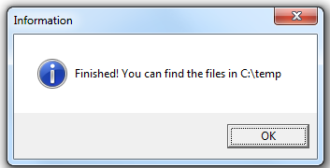

**BMI Analysis Results**

Go to the folder you selected for your output. There will be 3 graphs and one excel file per file read in. If you read in multiple files there will also be one additional graph and excel file.

**BMI Status**

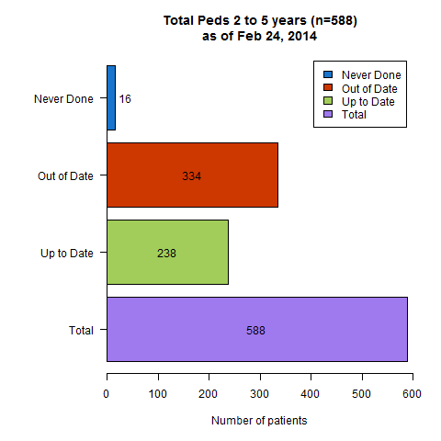This graph indicates how many patients in the selected age range have up-to-date, out-of-date, or never measured BMIs. BMI is considered out of date if either the height or weight was measured longer than one year ago.

**Height and Weight box plot**

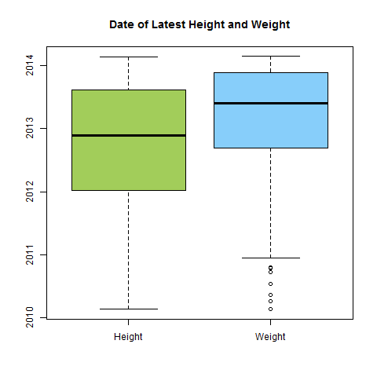Height and weight are typically measured at the same time, but this chart shows whether that is the case. In the example on the right, the date of the latest height measurement tended to be older than the latest weight, showing that they are not always measured at the same time.

**BMI Status**

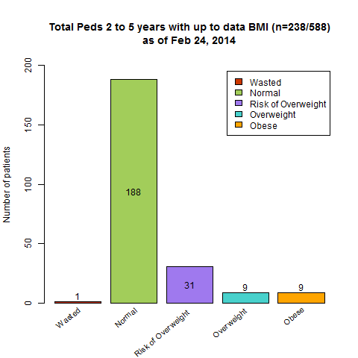The BMI Status graph shows what percent of patients are in each BMI percentile, as defined by the Dieticians of Canada. The categories are as follows:

|  |  |  |
| --- | --- | --- |
|  | 2 - 5 | 5 – 19 |
| Severely Wasted | <0.1st | <0.1st |
| **Wasted** | <3rd | <3rd |
| **Normal** | 3rd – 85th | 3rd-85th |
| **Risk of overweight** | 85th-97th | N/A |
| **Overweight** | >97th | >85th |
| **Obese** | >99.9th | >97th |
| Severely Obese | N/A | >99.9th |

**Registries**

An excel spreadsheet containing three sheets is produced.

1. Out-of-date
   1. height or weight last measured over one year ago
2. At risk
   1. any patients not in the “Normal” BMI percentile category
3. Outliers
   1. A patient can be considered an outlier because they have a very low BMI (<3rd percentile), very high BMI (>99th percentile), or a dramatic change in BMI between reports (two percentile groups).

These spreadsheets will contain the doctor number, patient number, and clinical data. They can be used to inspect patient records and to search for patients in the EMR.