Screener

Detailed Functional Specification

Kathleen Orechia Jordan Hamilton Daniel Barber

Introduction

Screener is an online software application designed to allow Wheaton students to stream films and videos related to their coursework that are uploaded by their professor. The service will provide students with access to educational content previously unavailable to them free of charge.

General Description

Screener provides Wheaton students an interface for viewing films their professor has assigned for class. Currently, a professor may assign a film and leave a copy outside his or her door for students to take turns viewing. However, this is a flawed system because only one student may watch the film at a time. Additionally, fewer and fewer Wheaton students have access to a DVD player, making viewing physical media additionally difficult. With Screener, students will be able to view the required course films without sharing a disc or pirating.

Any copyrighted content is illegal to host privately for public consumption according to copyright law in America. Even though our service hosts copyrighted content, it does not violate copyright law because it operates within the Classroom Use Exemption (17 U.S.C &110(1)). This exemption allows for the viewing of any content within certain limitations: The viewer must be in a classroom or a place devoted to instruction (In this case, the entire Wheaton campus where Screener is available exclusively), and must be enrolled in a nonprofit educational institution. Screener satisfies these requirement by being only accessible on campus as well as being secured with a two factor authentication system (username and password) to prevent unauthorized users from accessing the content.

Each teacher who registers with Screener will have an individual login for the site assigned by the system administrator. Ideally, their username and password would be the same as their Wheaton accounts. The students will only be able to select and to view the videos that have been shared with them, while the teacher can both select, upload, delete, and view the videos on the site.

Administrator

The ideal configuration for our application will require an administrator to interact with the server only twice per semester. The first check-in will be to submit the class list and add Wheaton account credentials to the system (for professors who have registered). The second check in will be to erase the films that were uploaded for just one semester which were stored on the local server, clear student account information (class code) from the database, and to disable the server during break.

Goals

The goal of Screener is to allow teachers to provide educational content to students via the internet and to make it easier for students to find the media they were assigned to watch.

Environmental Scan

There is no competition for the service Screener would provide to Wheaton students because no other service allows professors to upload their own video for students to view. Wheaton subscribes to two services (Academic Online and Films On Demand) which also allow for the streaming of course related films. However, neither of these services allow for professors to upload their own content and films, making the other Wheaton video streaming services useless when a professor video is not already on the site.

Use Cases

1. Professor Jane

Professor Jane is a Wheaton professor who needs to share a video with her class. However, the video is not available to view on Wheaton’s subscribed streaming services. The video is not a widely distributed film. How can she get her class to view the video? Screener is the perfect option.

She begins by going to the homepage and clicking the link to register with the administrator. After receiving her credentials, she will log in to the system and go through the brief video upload process. If she does not possess a copy of the film in MP4 format than she will have to pubarchase it on the internet as a digital download. Now students have access to the video and may log in to the site with the class code generated by the system to view the film in their leisure time.

1. Wheaton Student Joe

Joe was asked to watch a video from his professor. He looks for it online but has no luck finding it. He knows the professor has a copy, but only one. The class has forty students, so they can not all share one DVD to be watched outside of class. Additionally, he does not have a DVD player on his MacBook Air and wouldn’t have a way to play the disc even if he could get his hands on it. This is a situation where Screener would be perfect. Joe should ask his professor to upload video onto the site.

Data Storage

The information for the website will be stored in a database. The database will have Videos, User tables. The videos will be stored in separate files. The links to the files will be stored in the database along with the other information entered into the upload section. The class table contains all of the student’s wheaton ids and the class code they are allowed to use with it.

Project Timeline

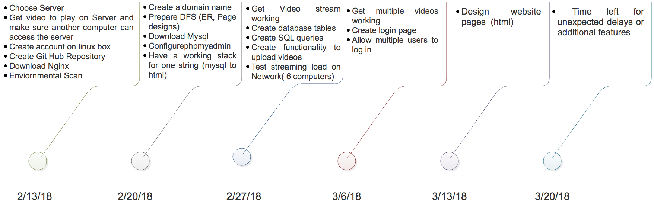

**User Interface (Student Login & Video Upload)**

A screenshot of a cell phone

Description generated with high confidence

A screenshot of a cell phone

Description generated with very high confidence

**User Interface (Available Films & Movie Viewer)**

