AMERICAN INTERNATIONAL UNIVERSITY-BANGLADESH
Department of Electrical and Electronic Engineering

Open Ended Lab (OEL) Report

WiFi-Controlled Remote Car Using ESP32 Microcontroller and Relay-Based Motor Driver

Course Name | Microprocessor and Embedded System | Course Code | EEE 4103
Semester | Summer 2025-26 | Section | [ K ]
Faculty Member | Prof. Dr. Engr. Muhibul Haque Bhuyan | Group # | [ 5 ]
OEL Title | WiFi-Controlled Remote Car Using ESP32 and Relay Module

Declaration and Statement of Authorship
- I/we hold a copy of this Assignment/Case Study, which can be produced if the original is lost/damaged.
- This Assignment/Case Study is my/our original work; no part has been copied from any other student's work or any other source except where due acknowledgment is made.
- No part of this Assignment/Case Study has been written for me/us by any other person except where such collaboration has been authorized by the concerned teacher and is acknowledged in the assignment.
- I/we have not previously submitted or am submitting this work for any other course/unit.
- This work may be reproduced, communicated, compared, and archived to detect plagiarism.
- I/we permit a copy of my/our marked work to be retained by the Faculty Member for review by any internal/external examiners.

Sl No | Student Name | Student ID | Program | Signature
1. | Hamim Mehdi Leo | 23-52828-2 | BSc in CSE
2. | Mutasimul Haque Rafi | 23-52274-2 | BSc in CSE
3. | Meskatul Hasan Sajib | 23-52785-2 | BSc in CSE
4. | MD Abrar Hossain Rafi | 23-51860-2 | BSc in CSE
5. | Shibendu Sutradhar Sparsha | 23-52269-2 | BSc in CSE
6. | Nafiz Ahmed | 23-55113-3 | BSc in CSE

Faculty Comments | Marks Obtained (out of 10)

Table of Contents
1. Objective
2. Theory and Methodology
2.1 System Block Diagram
2.2 Operational Flowchart
3. Apparatus
4. Experimental Setup and Procedure
5. Simulation Setup
6. Codes of the Program
7. Data Collection / Comparison Table
8. Discussion
9. Conclusion
10. Course Outcome Mapping with the OEL
11. References

1. Objective
To design, simulate, and implement a WiFi-controlled remote control (RC) car using an ESP32 microcontroller, a 5V 4-channel relay module, and two 5V DC motors, controllable directly from a smartphone's web browser without requiring any dedicated mobile application.

2. Theory and Methodology
The ESP32 is programmed to host its own WiFi Access Point (AP) rather than connecting to an existing network, and simultaneously runs an embedded HTTP web server (TCP/IP over 802.11 WiFi). A smartphone connects directly to this access point, and its browser loads a control webpage served by the ESP32 itself. The page contains Forward, Backward, Left, Right, and Stop buttons; tapping a button sends an HTTP GET request to the ESP32, which switches the corresponding relays to drive the two motors.
Since a relay is a simple ON/OFF switch and cannot reverse a motor's direction on its own, direction reversal is achieved by assigning two relay channels to each motor, forming a relay-based H-bridge:
- One relay connects the motor's first terminal to Battery (+) when ON, and to Battery (−) when OFF.
- A second relay does the same for the motor's other terminal.
- Energizing one relay of the pair while the other is de-energized drives current through the motor in one direction; swapping which relay is energized reverses the motor.
- Energizing both relays of a pair, or neither, leaves both motor terminals at the same potential, stopping the motor safely with no possibility of a short circuit across the battery.
A dedicated AMS1117-3.3V linear regulator supplies the ESP32's logic separately from the motor/relay power path, since the sudden current draw of WiFi transmission and relay switching can otherwise cause voltage dips severe enough to reset the microcontroller.

2.1 System Block Diagram
Figure 1 shows the overall system architecture, including the power distribution between the AMS1117 regulator (feeding the ESP32's logic) and the direct battery feed to the relay/motor circuit, as well as the WiFi communication link between the smartphone and the ESP32.
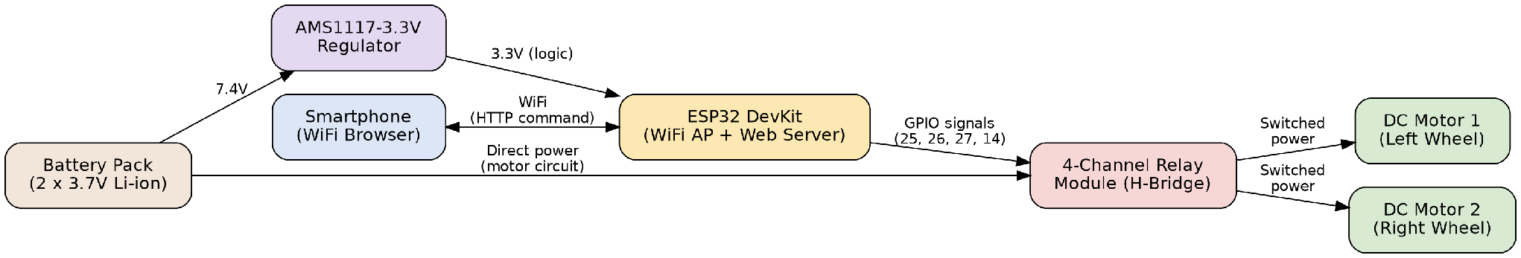
Diagram 1: System Block Diagram of the WiFi-Controlled RC Car

2.2 Operational Flowchart
Figure 2 shows the firmware's operational flow: after initializing the relay pins and starting the WiFi Access Point and web server, the ESP32 continuously waits for an HTTP command from the phone's browser and calls the corresponding motor-control function before returning to wait for the next command.
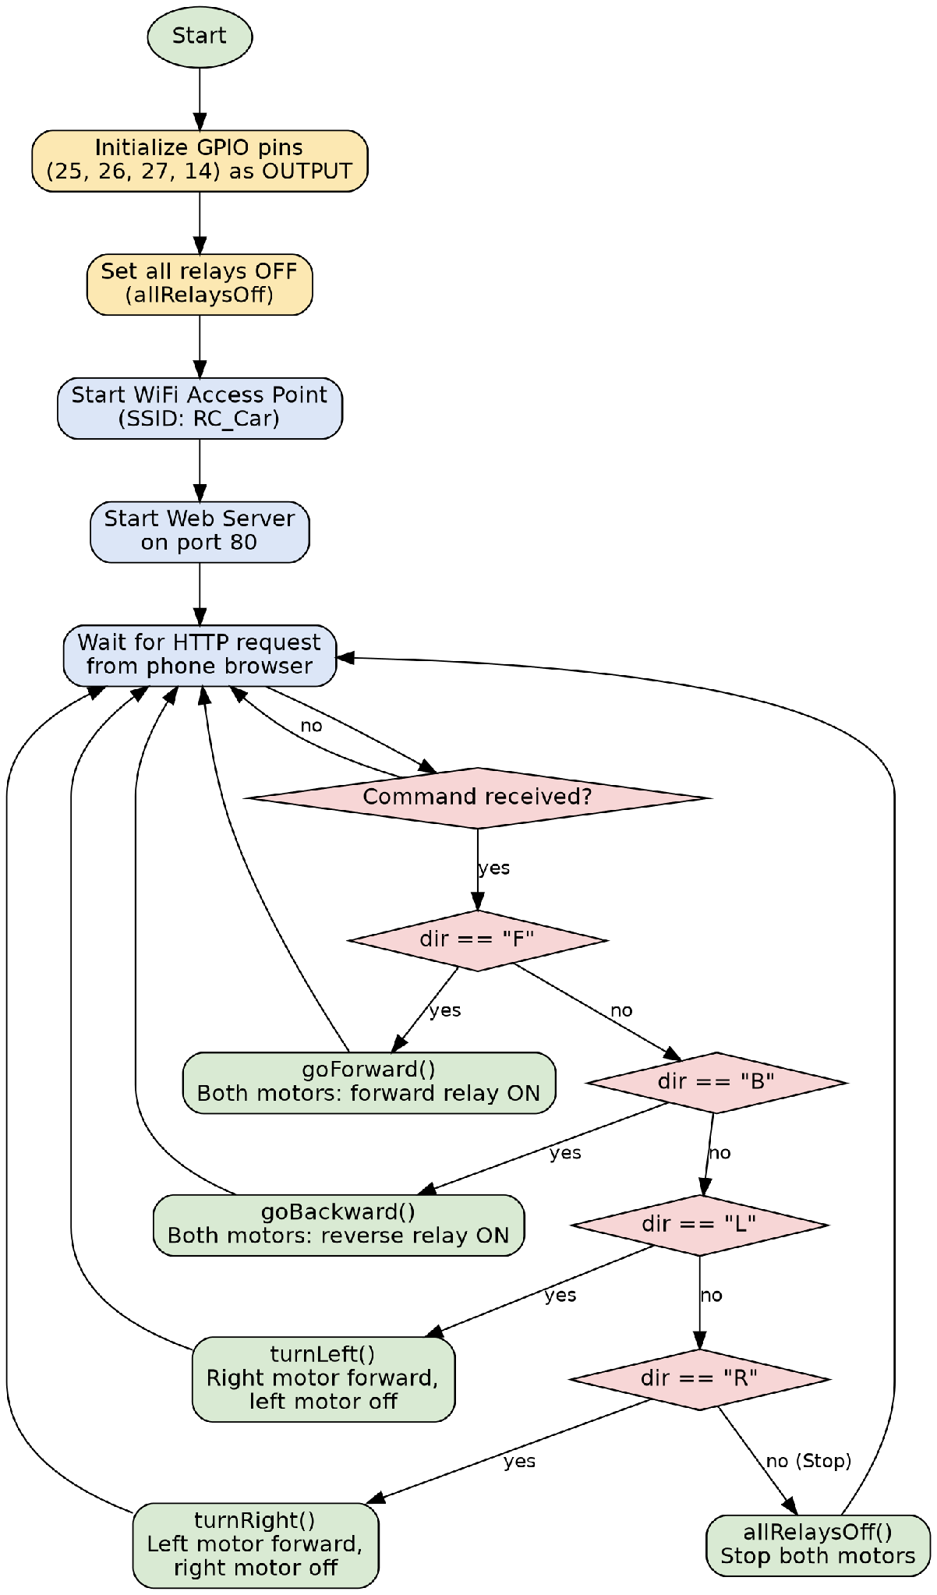
Diagram 2: Firmware Operational Flowchart

3. Apparatus
Component | Specification / Notes
Microcontroller | ESP32 38-pin DevKit board (ESP32-WROOM-32)
Relay Module | 5V 4-channel relay board (opto-isolated), used as the H-bridge motor driver
DC Motors | 2 x 5V DC motor, 2-wire type
LED | Used only in the simulation stage, as replacement of the DC motors and Motor Drivers
Power Source | 2 x 3.7V Li-ion 2600mAh cells in series (approx. 7.4V, measured 6.4V)
Breadboard / Jumper Wires | For prototyping all connections
Push Button Switches | Used only in the simulation stage, as a WiFi-free stand-in for the phone control buttons
Software Tools | Arduino IDE (firmware development), Wokwi (circuit and logic simulation)

4. Experimental Setup and Procedure
- The hardware was assembled and tested in stages.
- The battery supplies the ESP32 logic power through the AMS1117 regulator.
- The battery separately supplies the relay board and motor circuit directly.
- A common ground is shared across all sections of the circuit.
- The four relay signal pins (IN1–IN4) are connected to ESP32 GPIO25, GPIO26, GPIO27, and GPIO14, respectively.
- Each relay's switching contacts are connected to drive one motor in the forward/reverse H-bridge configuration described in Section 2.
- The ESP32 was programmed using the Arduino IDE with the ESP32 board package installed through the Boards Manager.
- After uploading the final firmware, the ESP32 was powered on.
- A smartphone was connected to the ESP32's broadcast WiFi network.
- The Forward, Backward, Left, Right, and Stop controls were tested through the web control page..
Figure 1: Image of the completed hardware setup (top view showing ESP32, relay board, motors, and battery)

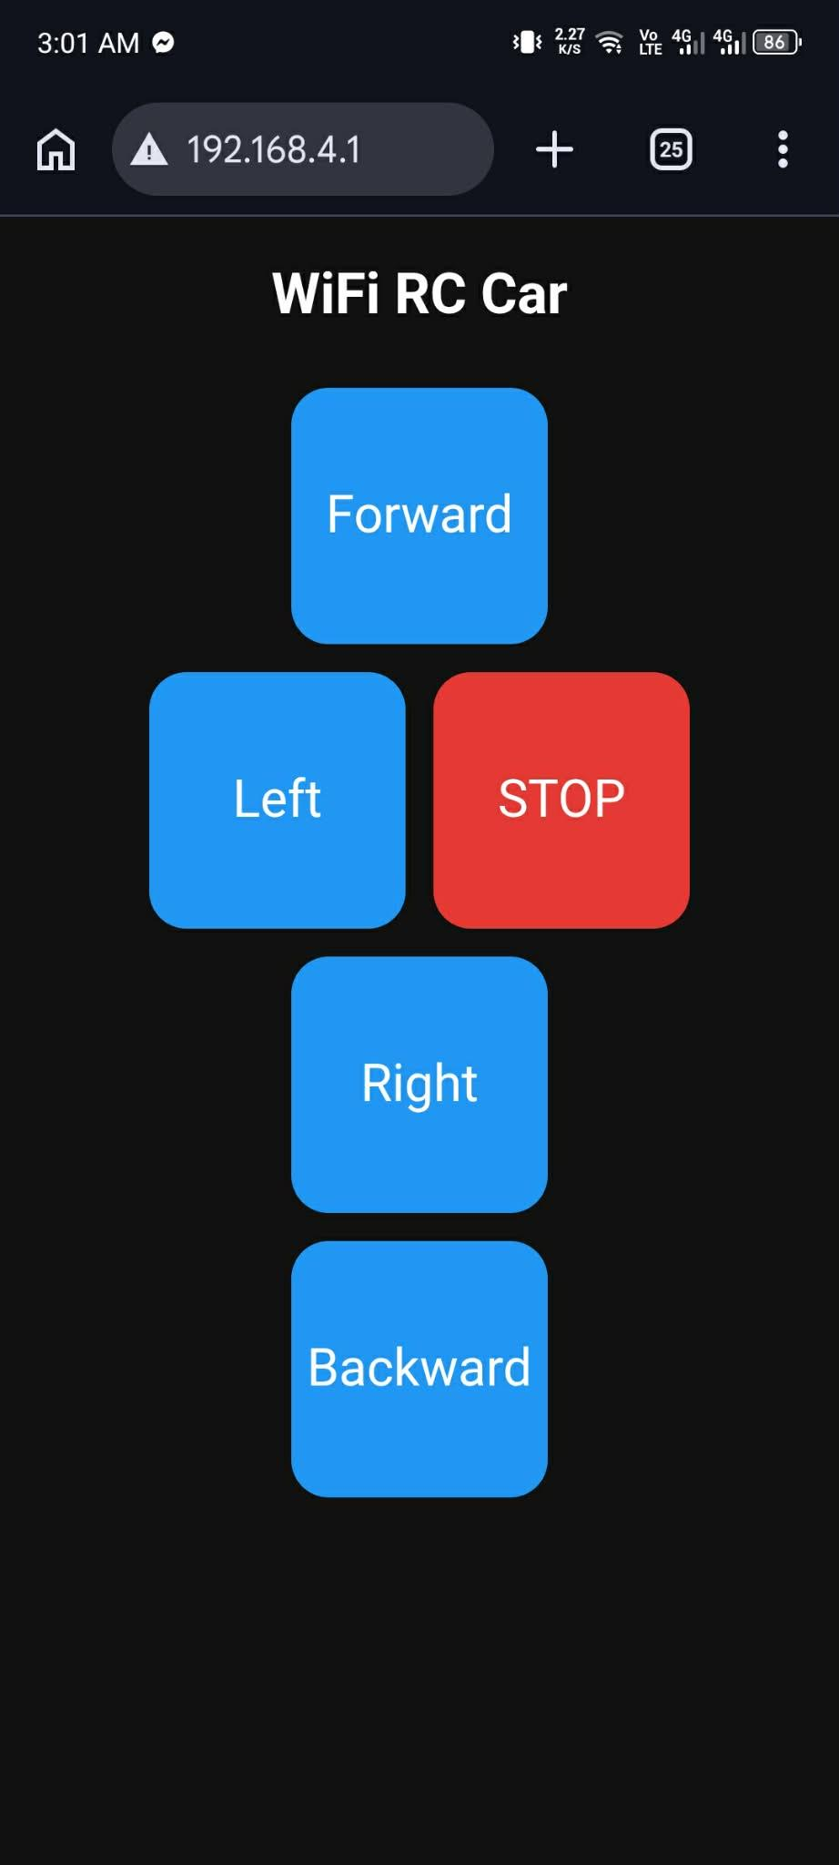
Figure 2: Image of the phone's browser showing the control webpage connected to the car's WiFi network

5. Simulation Setup
Direct simulation of the WiFi Access Point and phone-browser interaction was not possible in the available simulation tools (Proteus 8 Professional and Wokwi), since neither tool provides a virtual WiFi client capable of joining a simulated ESP32 access point and browsing its hosted page. To validate the relay-driving logic before hardware implementation, the project was instead simulated in Wokwi using four push buttons as direct substitutes for the phone's Forward/Backward/Left/Right controls, while keeping the relay and motor wiring identical to the real design.
In this simulation, each push button was wired to one ESP32 GPIO pin (GPIO32, GPIO33, GPIO4, GPIO16), and the same relay control functions used in the final WiFi code (goForward, goBackward, turnLeft, turnRight, allRelaysOff) were triggered directly by button state instead of by an HTTP request. Relay modules were connected to GPIO25, GPIO26, GPIO27, and GPIO14, matching the hardware design, and LED indicators were used in place of the physical DC motors to visually confirm correct switching behavior.
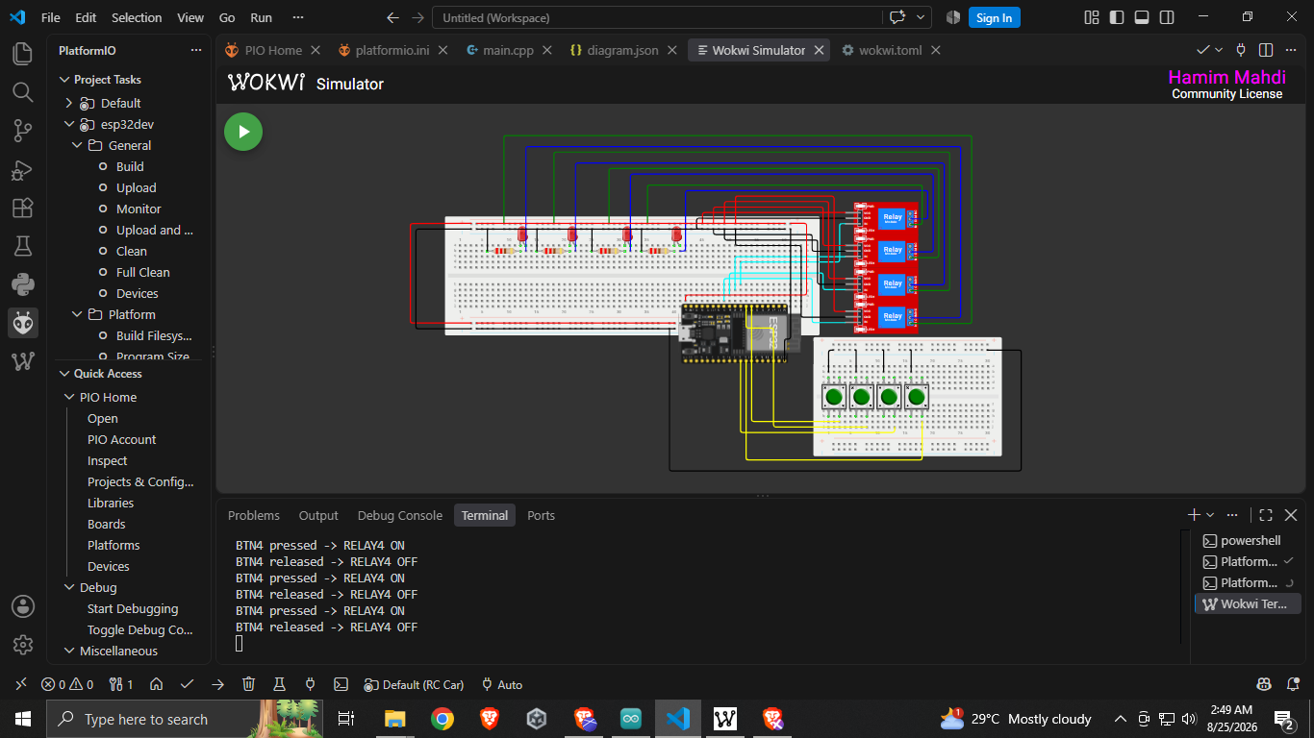 Figure 3: The complete simulation circuit (ESP32, relays, buttons, LEDs)

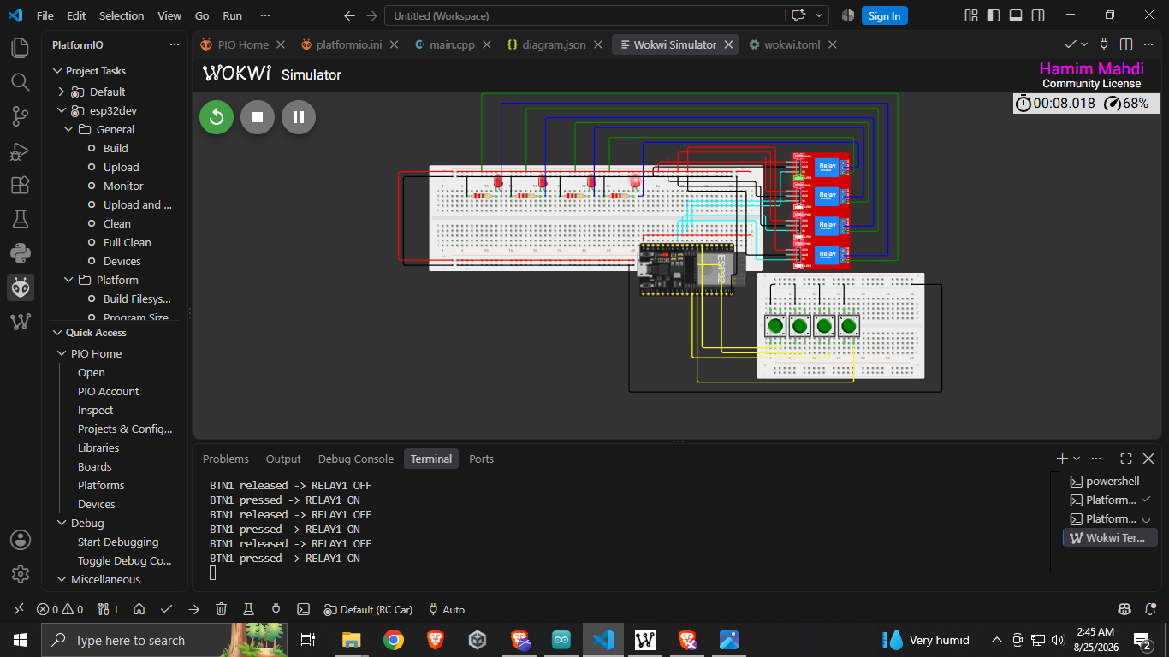Figure 4: Screenshot of the simulation running, showing button 1 press and the corresponding relay/LED response
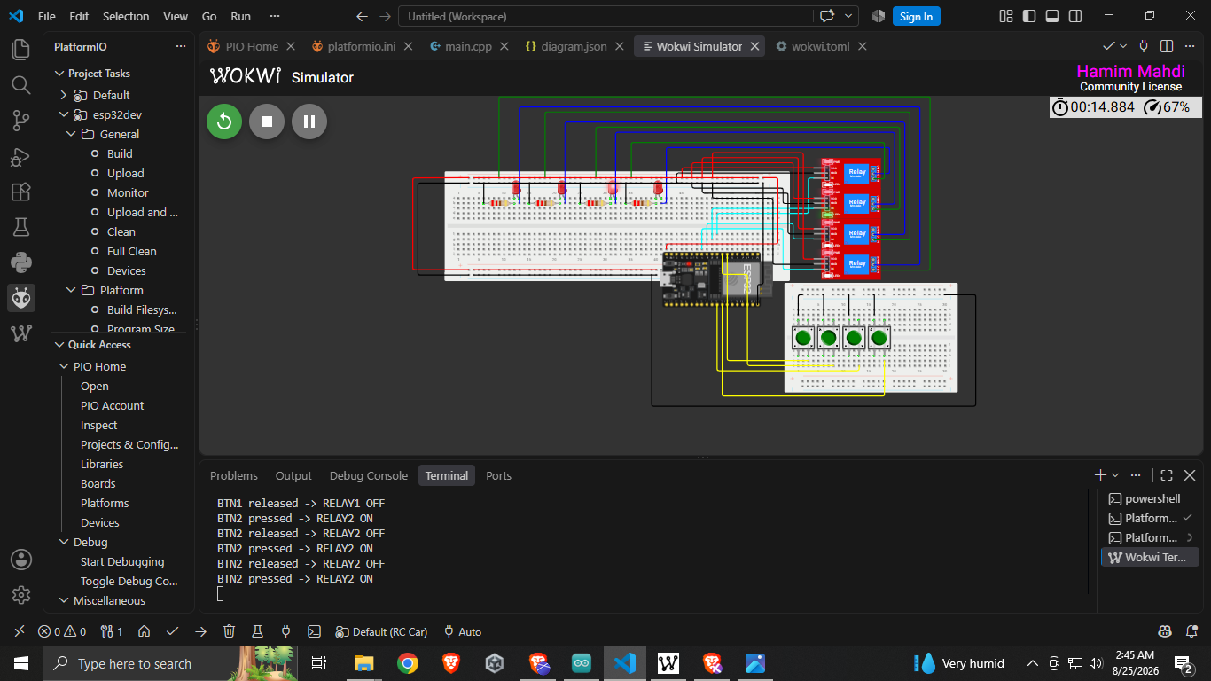Figure 5: Screenshot of the simulation running, showing button 2 press and the corresponding relay/LED response
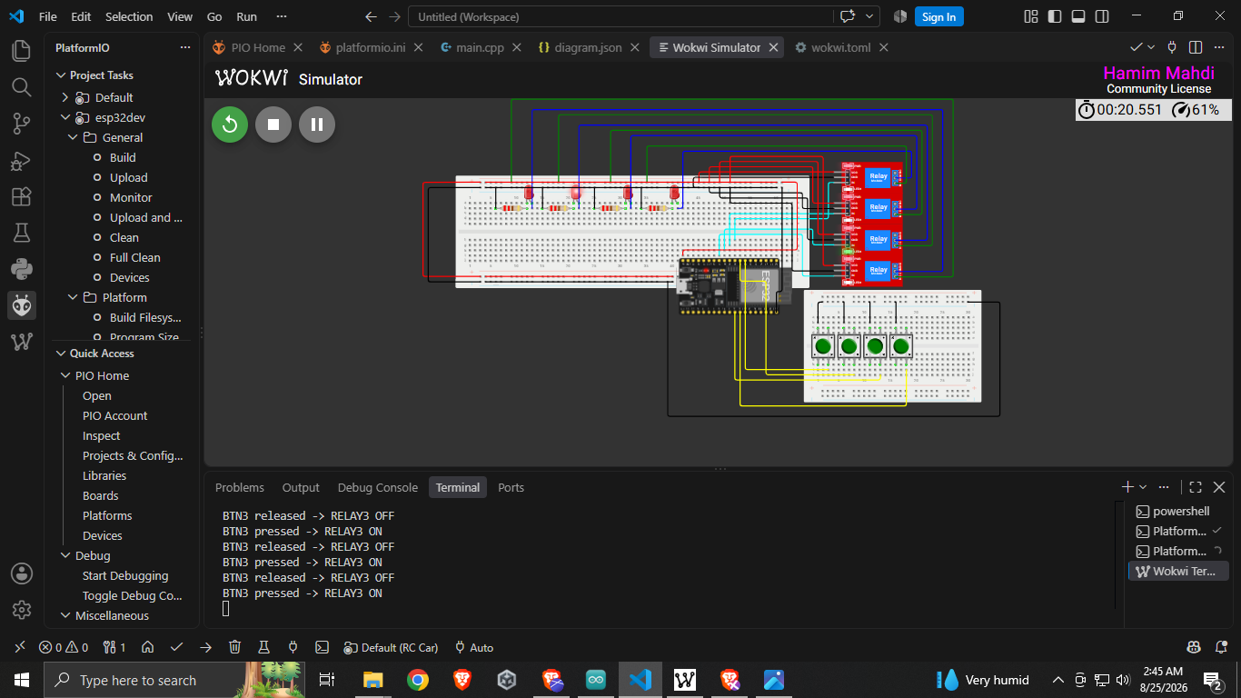Figure 6: Screenshot of the simulation running, showing button 3 press and the corresponding relay/LED response
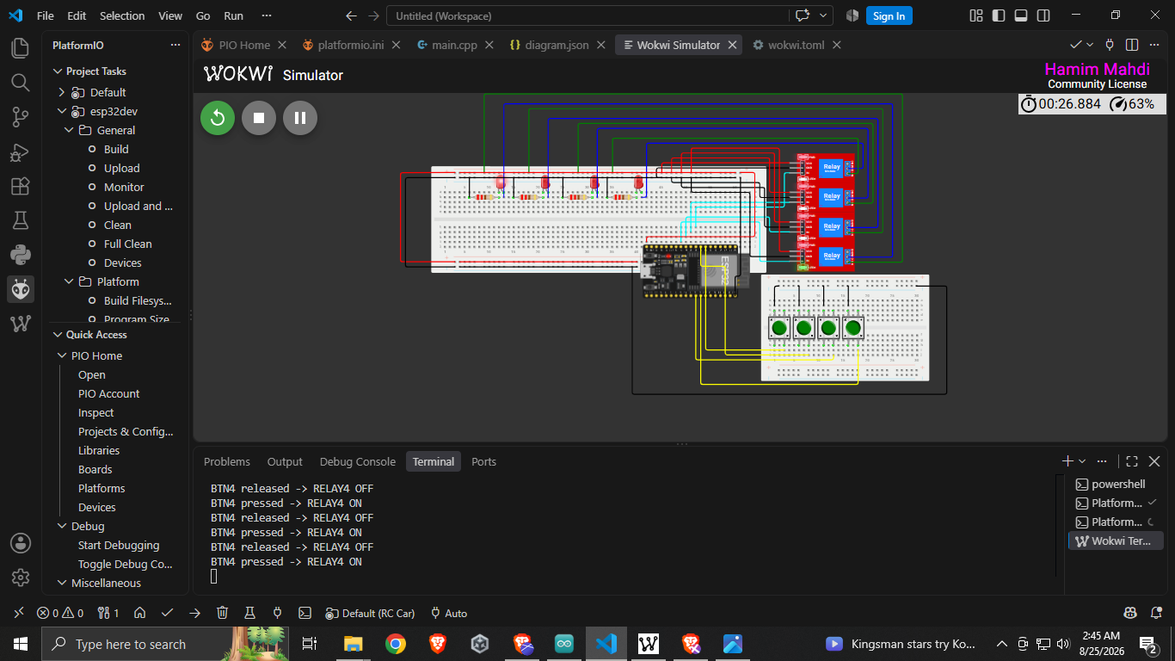Figure 7: Screenshot of the simulation running, showing button 4 press and the corresponding relay/LED response
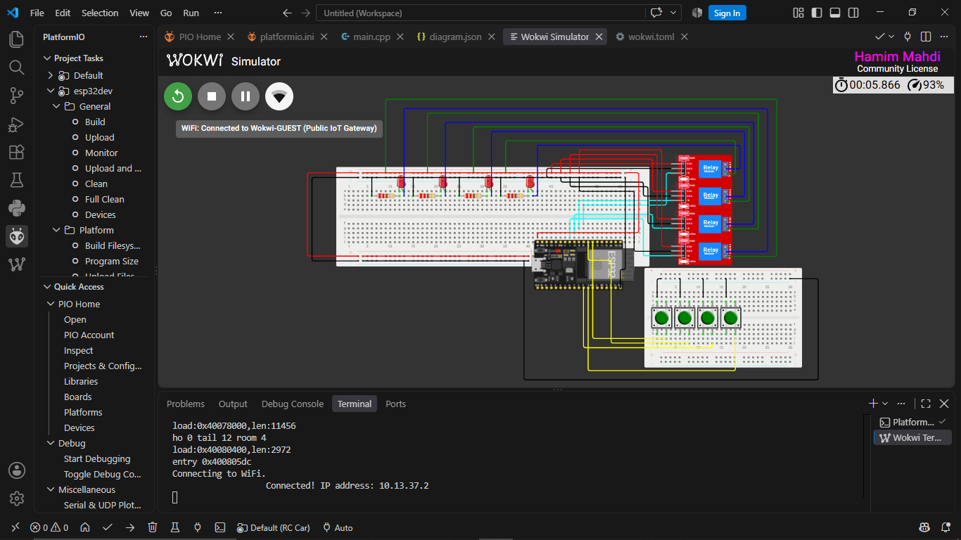Figure 8: Screenshot of the simulation running, showing WiFi connected

6. Codes of the Program

6.1 Final Hardware Code (Arduino IDE) - WiFi Access Point and Web Server
#include <WiFi.h>
#include <WebServer.h>
const char* ssid = "Wokwi-GUEST";
const char* password = "12345678";
#define LEFT_FWD 25
#define LEFT_REV 26
#define RIGHT_FWD 27
#define RIGHT_REV 14
#define RELAY_ON HIGH
#define RELAY_OFF LOW
WebServer server(80);
void allRelaysOff() {
digitalWrite(LEFT_FWD, RELAY_OFF);
digitalWrite(LEFT_REV, RELAY_OFF);
digitalWrite(RIGHT_FWD, RELAY_OFF);
digitalWrite(RIGHT_REV, RELAY_OFF);
}
void goForward() {
digitalWrite(LEFT_REV, RELAY_OFF);
digitalWrite(RIGHT_REV, RELAY_OFF);
digitalWrite(LEFT_FWD, RELAY_ON);
digitalWrite(RIGHT_FWD, RELAY_ON);
}
void goBackward() {
digitalWrite(LEFT_FWD, RELAY_OFF);
digitalWrite(RIGHT_FWD, RELAY_OFF);
digitalWrite(LEFT_REV, RELAY_ON);
digitalWrite(RIGHT_REV, RELAY_ON);
}
void turnLeft() {
digitalWrite(LEFT_FWD, RELAY_OFF);
digitalWrite(LEFT_REV, RELAY_OFF);
digitalWrite(RIGHT_REV, RELAY_OFF);
digitalWrite(RIGHT_FWD, RELAY_ON);
}
void turnRight() {
digitalWrite(RIGHT_FWD, RELAY_OFF);
digitalWrite(RIGHT_REV, RELAY_OFF);
digitalWrite(LEFT_REV, RELAY_OFF);
digitalWrite(LEFT_FWD, RELAY_ON);
}
String htmlPage() {
String html = "<!DOCTYPE html><html><head><title>RC Car</title>";
html += "<meta name='viewport' content='width=device-width, initial-scale=1'>";
html += "<style>";
html += "body{font-family:sans-serif;text-align:center;background:#111;color:#fff;}";
html += "button{width:110px;height:110px;font-size:22px;margin:6px;border-radius:16px;border:none;background:#2196F3;color:white;}";
html += "button:active{background:#0b5eab;}";
html += ".stopbtn{background:#e53935;}";
html += "</style></head><body>";
html += "<h2>WiFi RC Car</h2>";
html += "<div><button onclick=\"send('F')\">Forward</button></div>";
html += "<div>";
html += "<button onclick=\"send('L')\">Left</button>";
html += "<button class='stopbtn' onclick=\"send('S')\">STOP</button>";
html += "<button onclick=\"send('R')\">Right</button>";
html += "</div>";
html += "<div><button onclick=\"send('B')\">Backward</button></div>";
html += "<script>";
html += "function send(cmd){ fetch('/cmd?dir=' + cmd); }";
html += "</script></body></html>";
return html;
}
void handleRoot() {
server.send(200, "text/html", htmlPage());
}
void handleCommand() {
String dir = server.arg("dir");
if (dir == "F") goForward();
else if (dir == "B") goBackward();
else if (dir == "L") turnLeft();
else if (dir == "R") turnRight();
else if (dir == "S") allRelaysOff();
server.send(200, "text/plain", "OK");
}
void setup() {
pinMode(LEFT_FWD, OUTPUT);
pinMode(LEFT_REV, OUTPUT);
pinMode(RIGHT_FWD, OUTPUT);
pinMode(RIGHT_REV, OUTPUT);
allRelaysOff();
WiFi.softAP(ssid, password);
server.on("/", handleRoot);
server.on("/cmd", handleCommand);
server.begin();
}
void loop() {
server.handleClient();
}

6.2 Simulation Verification Code (Wokwi) - Push-Button Substitute
This version replaces the phone/WiFi control with push buttons, used only to verify the relay-driving logic in simulation prior to hardware implementation.
#define LEFT_FWD 25
#define LEFT_REV 26
#define RIGHT_FWD 27
#define RIGHT_REV 14
#define BTN_FWD 32
#define BTN_BACK 33
#define BTN_LEFT 4
#define BTN_RIGHT 16
#define RELAY_ON HIGH
#define RELAY_OFF LOW
void allRelaysOff() {
digitalWrite(LEFT_FWD, RELAY_OFF);
digitalWrite(LEFT_REV, RELAY_OFF);
digitalWrite(RIGHT_FWD, RELAY_OFF);
digitalWrite(RIGHT_REV, RELAY_OFF);
}
void goForward() {
digitalWrite(LEFT_REV, RELAY_OFF); digitalWrite(RIGHT_REV, RELAY_OFF);
digitalWrite(LEFT_FWD, RELAY_ON); digitalWrite(RIGHT_FWD, RELAY_ON);
}
void goBackward() {
digitalWrite(LEFT_FWD, RELAY_OFF); digitalWrite(RIGHT_FWD, RELAY_OFF);
digitalWrite(LEFT_REV, RELAY_ON); digitalWrite(RIGHT_REV, RELAY_ON);
}
void turnLeft() {
digitalWrite(LEFT_FWD, RELAY_OFF); digitalWrite(LEFT_REV, RELAY_OFF);
digitalWrite(RIGHT_REV, RELAY_OFF); digitalWrite(RIGHT_FWD, RELAY_ON);
}
void turnRight() {
digitalWrite(RIGHT_FWD, RELAY_OFF); digitalWrite(RIGHT_REV, RELAY_OFF);
digitalWrite(LEFT_REV, RELAY_OFF); digitalWrite(LEFT_FWD, RELAY_ON);
}
void setup() {
pinMode(LEFT_FWD, OUTPUT); pinMode(LEFT_REV, OUTPUT);
pinMode(RIGHT_FWD, OUTPUT); pinMode(RIGHT_REV, OUTPUT);
pinMode(BTN_FWD, INPUT_PULLUP); pinMode(BTN_BACK, INPUT_PULLUP);
pinMode(BTN_LEFT, INPUT_PULLUP); pinMode(BTN_RIGHT, INPUT_PULLUP);
allRelaysOff();
}
void loop() {
if (digitalRead(BTN_FWD) == LOW) goForward();
else if (digitalRead(BTN_BACK) == LOW) goBackward();
else if (digitalRead(BTN_LEFT) == LOW) turnLeft();
else if (digitalRead(BTN_RIGHT) == LOW) turnRight();
else allRelaysOff();
}

7. Data Collection / Comparison Table
The following table summarizes the expected relay states for each control command and the observed result during testing.
Command | Left Relay Pair State | Right Relay Pair State | Observed Motor Behavior
Forward | Forward relay ON, Reverse relay OFF | Forward relay ON, Reverse relay OFF | Car goes forward
Backward | Reverse relay ON, Forward relay OFF | Reverse relay ON, Forward relay OFF | Car goes backward
Left | Both relays OFF | Forward relay ON, Reverse relay OFF | Car turns left
Right | Forward relay ON, Reverse relay OFF | Both relays OFF | Car turns right
Stop | Both relays OFF | Both relays OFF | Car stops

8. Discussion
This project demonstrates that a standard 4-channel relay module, typically used only for simple ON/OFF switching, can be adapted into a functional two-motor H-bridge by pairing two relay channels per motor. This avoids the need for a dedicated motor driver IC while still allowing full forward, reverse, and turning control.
A significant practical challenge encountered was the lack of true WiFi Access Point simulation support in both Proteus and Wokwi, which meant the phone-control experience could only be verified on real hardware. Additionally, early testing revealed that powering the ESP32 and the relay/motor load from a single shared source could cause the WiFi connection to drop when a relay engaged, due to the sudden current draw destabilizing the supply voltage. This was resolved in the final design by separating the ESP32's logic power (via a dedicated AMS1117-3.3V regulator) from the relay/motor power path, while keeping a common ground reference.
Overall, the design successfully balances low cost and simplicity, making it suitable as an introductory embedded systems and IoT project for students without prior electronics experience.

9. Conclusion
A WiFi-controlled RC car was successfully designed, simulated, and implemented using an ESP32 microcontroller, a 4-channel relay module configured as a two-motor H-bridge, and a smartphone browser as the control interface, with no additional mobile application required.

10. Course Outcome Mapping with the OEL
CO/CLO Number | CO/CLO Statement | P (Program Outcome) | Assessed P Outcome Indicator | BNQF Indicator | Teaching-Learning Strategy | Assessment Strategy
CO1 | Simulate laboratory experiments using microcontrollers, sensors, actuators, switches, display devices, etc., and a suitable simulator related to the fields of electrical and electronic engineering. | P1, P4, P5 | P.e.2.P4 | F.S.6 | Practical Demonstration | OEL Report

11. References
[1] Espressif Systems, "ESP32 Series Datasheet," Espressif Systems, 2024.
[2] Arduino, "WiFi Library / WebServer Library Documentation," docs.arduino.cc.
[3] Wokwi, "ESP32 Simulation Documentation," docs.wokwi.com.

