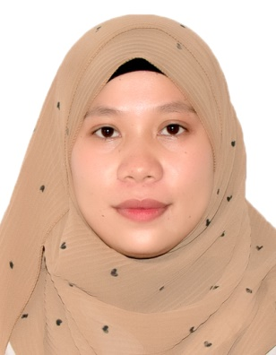**Hamima M. Capunol**

**Poblacion Muslim Titay ZSP**

**Titay, Zamboanga Sibugay, 7003**

**capunolh@gmail.com**

**09383066174**

**_____________________________________________________________________________________**

**Objective:**

I am committed to using what I already know and proving that I will work hard to become an invaluable member of your staff. My mission is to successfully contribute to the success and progress of the using skilfully fusing academic understanding with hands-on experience.

**Education:**

**Tertiary**

- Bachelor of Science in Computer Science (BSCS)

- Dr. Aurelio Mendoza Memorial Colleges

- 2023-2024

**Secondary**

- General Academic Strand (GAS)

- Sibugay’s Matthew Jackson School Incorporated

- 2018-2019

**Primary**

-Poblacion Muslim Elementary School

-2013-2014

**On-the-Job Training Experience:**

OJT Position: Faculty Staff

Company/Organization: Municipality of Ipil Zamboanga Sibugay Province

**Experience and Achievements:**

- Assisted in Printed by given names of the citizenship

- Developed skills in about Computer and more knowledge that I get in the time of OJT

- Received positive feedback from supervisors for their given me advise and compliments of my work

**Skills:**

* Oriented in Microsoft Office Application such as

-Microsoft Office Word

-Microsoft Office PowerPoint

* Capable of Editing pictures

References:

Activities required