Let's write unit tests in Groovy!
Competing ideas:
- “Testability in Groovy is easy”
- Groovy is a "notational convenience"
What do you expect get from using Groovy? Are you introducing Groovy to aide in testing, or as a stepping stone towards using it in production? What do you expect to get out of using Groovy to unit test?

What is the reality? Next few topics will show.

A Success Story?
Long project used Groovy for unit tests. In general, those that authored Groovy unit tests were pleased, those that didn't weren't. Coverage was very high. We didn't spend less time writing tests, but did write 3-4 times as many tests. Error conditions and edge cases were all better tested. Started adding Groovy tests to shared code and triggered an “enterprise review session”. It was decided to not proceed with any more Groovy development.

Advantages

Is Groovy a Testing DSL?
Terseness of syntax inherent to Groovy language makes tests clearer:

def input = ['Jane','Doe', 25.0, 4]
def expected = ['Jane', 'Doe', 100.0]

assertTransformation(expected, transform(input))

Mapping design documents and requirements to test cases is simplified.
Does not require overhead of FIT or similar framework. It's just the language.

Default Parameters
Unit testing is about building tons of data, all in different configurations or states of construction, and then throwing that data at the system under test, observing and verifying the results. Unit tests look a lot different from production code. In production code, subroutines exist to perform smaller pieces of a larger, decomposed problem. In test code, subroutines exist to build objects. The design principles between production and test are different, and it makes sense that some language features might be very useful in test but of more limited value in production.
JFrame frame1 = makeLoginWindow()
JFrame frame2 = makeLoginWindow("some username")
JFrame frame3 = makeLoginWindow("some username", "some password")
Easily implemented as:
private JFrame makeLoginWindow(String username = null, String password = null) {

JTextField userField = new JTextField()
JTextField passwordField = new JTextField()
if (username != null) userField.text = username
if (password != null) passwordField.text = password

JFrame frame = new JFrame()
frame.contentPane.add(userField)
frame.contentPane.add(passwordField)
return frame
}
There is a single source for all the test data configuration, and navigating (ie reading) the test case is made easier by having a single source. Conceptually, the Java version requires 3 added entities to the test case that didn't exist before. Navigating around labyrinths of production code is a necessary evil. There are other design constraints at play and stuffing everything into one place isn't always the right thing to do. But in the test tree, labyrinths of chained code are just evil, nothing necessary about it. Having to chase down dependencies undermines one the chief principles of testing: show clearly and simply how input is transformed to output.

Groovy Assertion Methods
assert new File('foo.bar') == new File('example.txt')
Caught: Assertion failed:
assert new File('foo.bar') == new File('example.txt')
| | |
foo.bar | example.txt
false
This is better than stack trace (although that is still present). We've made mountains out of molehills debating alternatives to “assertEquals”. What is more natural than using the assert keyword?

Builders!
Writing your own builder rocks.
def element = new OMElementBuilder().root {
child(attribute: 'sample1')
chile(attribute: 'sample2')
}
Builder support in Groovy is a big win. However... compare to this:
OMElement e = AXIOMUtil.stringToOM(
"<root>" +
"<child attribute=\"sample1\" />" +
"<child attribute=\"sample2\" />" +
"</root>");

But is dynamic typing that much better than stuffing something in a String? Which is more type safe?
Your production code is written in Java, and presumably most your libraries. Making some creative factory methods for String and File types can go a long way towards cleaning up Java tests.

Better Tools, like easyB and Spock
easyb won the Jolt award. It must be great, right?
behavior driven development is different
Spock is very different
BDD is maybe a great idea. Spock is maybe a cool framework.
I like easyb for heirarchical test fixtures, regardless of BDD claims.
Are these too radical of ideas? What problem will you solve by introducing these ideas? Are you just trying to get people to write plain old JUnit tests?

Multiline Strings
def garage = new Garage(
new Car(CAR_NAME1, CAR_MAKE1),
new Car(CAR_NAME2, CAR_MAKE2),
new Car(CAR_NAME3, CAR_MAKE3)
)

def expected = """
<garage>
<car name="$CAR_NAME1" make="$CAR_MAKE1" />
<car name="$CAR_NAME2" make="$CAR_MAKE2" />
<car name="$CAR_NAME3" make="$CAR_MAKE3" />
</garage>"""

assertXmlEqual(expected, serialize(garage, Garage))

There is symmetry and conciseness, and I find it pretty easy to see how the input relates to the expected output.

Garage garage = new Garage(
new Car(CAR_NAME1, CAR_MAKE1),
new Car(CAR_NAME2, CAR_MAKE2),
new Car(CAR_NAME3, CAR_MAKE3)
);

String expected =
"<garage>" +
" <car name=\"" + CAR_NAME1 + "\" make=\"" + CAR_MAKE1 + "\" /> " +
" <car name=\"" + CAR_NAME2 + "\" make=\"" + CAR_MAKE2 + "\" /> " +
" <car name=\"" + CAR_NAME3 + "\" make=\"" + CAR_MAKE3 + "\" /> " +
"</garage>";

assertXmlEqual(expected, serialize(garage, Garage.class));
I can't see how the expected block lines up with the input anymore, it's lost in a sea of accidental complexity, back slashes, and quotes. The tests as documentation idea starts to suffer without multiline strings because the only thing that finds this format easy to read is the compiler. Speaking of documentation, how about copy and pasting the XML snippet into a user document or email? Or heaven forbid generating user documentation off the test case!

Partial Interfaces with Maps
Incredibly nice feature in code with very wide interfaces.
def listener = [ mouseEntered : { ... } ] as MouseListener
I can't think of a better interface for example. This is insanely useful. Especially in a system with many narrow interfaces. Here is the problem:
boolean wasCalled = false
def listener = [ mouseEntered : { wasCalled = true } ] as MouseListener
// ... exercise system under test
assert wasCalled == true

There is no verification/mock phase. This is best for stubs, in which it works extremely well.

Problems: Find usages don't always work. Refactorings don't always work. Mocks lead to fragile tests. Mockist style is same as consultant style. Once you live with mock code for 6 months+ you feel the pain. Talk about mocks more.

The quality of the feature is dependent on the quality of your abstractions. Extracting an interfaces on top of every class just to mock it out creates a meaningless abstraction.

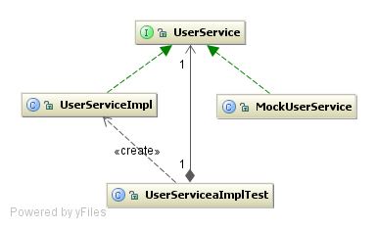
Fake objects - is this an advantage of Groovy? Yes and No. Better for stubs, not for mocks.

Private method access
Groovy ignores the private access modifier in code
Insanely useful?
Insanely boring debate on whether you should test private methods?
It's both useful and evil, depending on how you use it.
Define input/output and direct/indirect distinction.

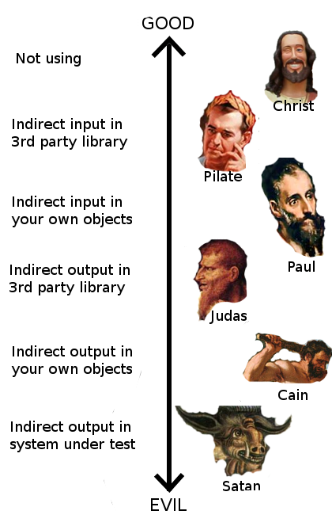
I don't often ask myself "What would Jesus do?" I try to live my live more like Pilate. I try my best but, hey man, sometimes stuff happens

Hitting the Java Wall

Easy Mocking with mockFor and stubFor
mockFor and stubFor demo well
Easily mock out static method calls and constructor invocations

public class Service {
static long getFileSize(String path) {
return new File(path).length();
}
}

def mock = new MockFor(Service)
mock.demand.getFileSize { -1 }
mock.use {
assert -1 == Service.getFileSize('file.txt')
}

MockFor and Stub for effect only Groovy classes. The required indirection does not exist in Java compiled classes. To mock out constructors and static method calls you'll need another tool like:
http://code.google.com/p/powermock/
https://jmockit.dev.java.net/

The Flow of Groovy
“I'd rather program Groovy in vi than Java in IDEA” - Neal Ford

“If vi is the answer, the question had better be about Roman numerals” - Hamlet D'Arcy

But I see his point in pure Groovy projects. Doesn't carry into Java projects.

"Changes are often easier that you would expect because you can make changers to the tests and then make changes to the code, moving the structure along in small safe increments". Michael Feathers

Especially true in Groovy. You never needs more than 2 editor windows open at once... production and test. In Java, when you make a slight change, you need to fix every single instance before the compiler lets you even run a unit test. Not so in Groovy. Your workspace is conceptually 2 files: unit tests and class under test. Only when you decide to broaden the scope do the other tests get compiled and run.

In mixed Groovy/Java projects, all production code must compile. You're still stuck wading/mired in fixing all compiler warnings before getting test feedback on your changes.

Downsides
- Lost benefits of TDD?
Idea is possibly from Dierk Konig [cite needed]. Using TDD and Groovy will evolve your system to have a lot of functions that operate/return lists. And a lot of reuse of closure/runnable/callable types. This is a lot different than the API you'd produce by test driving the code with Java unit tests. The API design must end up being sub-optimal when called from other production code. Should you care?
- Questionable IDE support?
IDEA has great support. But not perfect. Sometimes tests don't run. Sometimes your caches need to be cleared. Refactorings don't always work or you get a lot of false positives. Will the entire team have the patience to deal with this? JetGroovy is not perfect. And when it fails, Groovy will be blamed and people will come to you all a dither.
- No Pain No Gain?
"It might sould kind of sadistic, but the pain that we feel working in a legacy code base can be an incredible impetus to change. We can take the sneaky way out, but unless we deal with the root causes, overly responsible classes and tangled dependencies, we are just delaying the bill" Michael Feathers
The risk is that Groovy (or a mock framework) cover the pain points to where your code sucks worse than it did before. The IDE in general is guilty of this. Massive projects don't exist with eMacs. The pain is too great.

- Is this a language decision?
Is putting groovy.jar into your codebase a language decision? There is no real answer. In some ways yes, in some ways no. Some companies will shy away from Groovy claiming it is a language decision. Some companies will embrace it saying it is Java++ (this isn't my experience though). This is a big decision. Treating it like it isn't will not help you sell your idea.

Summary
Competing ideas:
- “Testability in Groovy is easy”
- Groovy is a "notational convenience"

Now you've seen the evidence. Which of these techniques is going to make your production code more testable? Any?

Is debating and investing in this the best usage of your time? Would you be better off doing a Refactoring book club? Or Rafactoring to Patterns book club.
Either you want to use groovy or you don't. Is any of this really convincing?

Writing tests in Groovy is definitely more enjoyable. Writing complete tests is definitely easier. Getting the first test written on a monster object is going to be painful either way.

What's missing is the cultural benefits (more on this later).

