Applications of ICT — Lab 7 Report
Name: Hammad Ahmed Afridi CMS ID: 543803
Moorche

Introduction
The report covers professional documentation and and version control
The machine is described in Table 1 and the hash-cracking evidence appears in Figure 3.

System Specification

Hardware
Hardware is the physical aspect
Table 1: System specification of my machine
Item | Value
CPU model | 11th Gen Intel(R) Core(TM) i5-1145G7 @ 2.60GHz
Physical / logical cores | 4 physical / 8 logical
RAM | Total: [fill in – Task Manager → Performance → Memory]; 6.6 GB in use (Process Explorer)
Storage type & size | SSD, 477 GB
Partition style (MBR/GPT) | GPT (Windows host); Kali VM disk reports MBR (dos)
Boot mode (BIOS/UEFI) | UEFI
Windows version | [fill in – run winver]
WSL Ubuntu version | [fill in – run wsl --list --verbose]

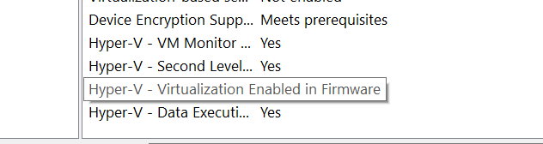
Figure 1: Windows virtualization status on the host machine (Lab 1)

Boot
Boot is for making the system and os run
The disk layout of the Kali VM was checked with the command below (Lab 4); the Disklabel line shows the partition-table type.
kali@kali:~$ sudo fdisk -l /dev/sda
Disk /dev/sda: 80.09 GiB, 86000000000 bytes, 167968750 sectors
Disk model: VMware Virtual S
Units: sectors of 1 * 512 = 512 bytes
Sector size (logical/physical): 512 bytes / 512 bytes
I/O size (minimum/optimal): 512 bytes / 512 bytes
Disklabel type: dos
Disk identifier: 0xb08d942a

Device Boot Start End Sectors Size Id Type
/dev/sda1 * 2048 167968749 167966702 80.1G 83 Linux

Storage
Storage is used for saving files and documents
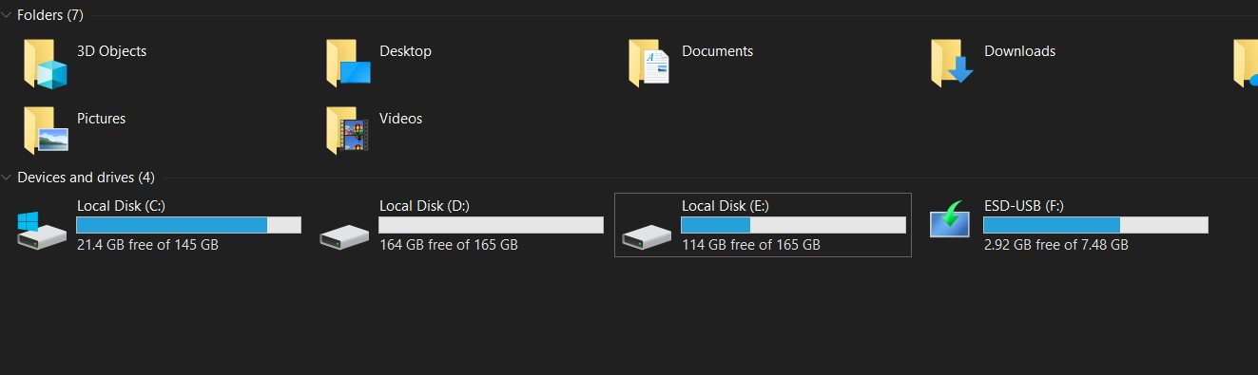
Figure 2: Host drives: C: 145 GB, D: 165 GB, E: 165 GB (Lab 3)

Data and Encoding

Number Systems and Hashing
Hashing is a one way function
Table 2: Data and encoding results produced in CyberChef
Input | CyberChef operation | Result
181 | To Binary | 10110101
181 | To Hex | b5
MCS | To Charcode (decimal) | 77 67 83
Hammad | SHA2 (256) | 047cb6daf109f1c6e340c26b3b0048b5092ca38fe039b160103632bed9684f11
The conversions in Table 2 were produced with CyberChef [1]; the same hashing idea explains why the NT hashes in Figure 3 fall quickly to a wordlist attack.
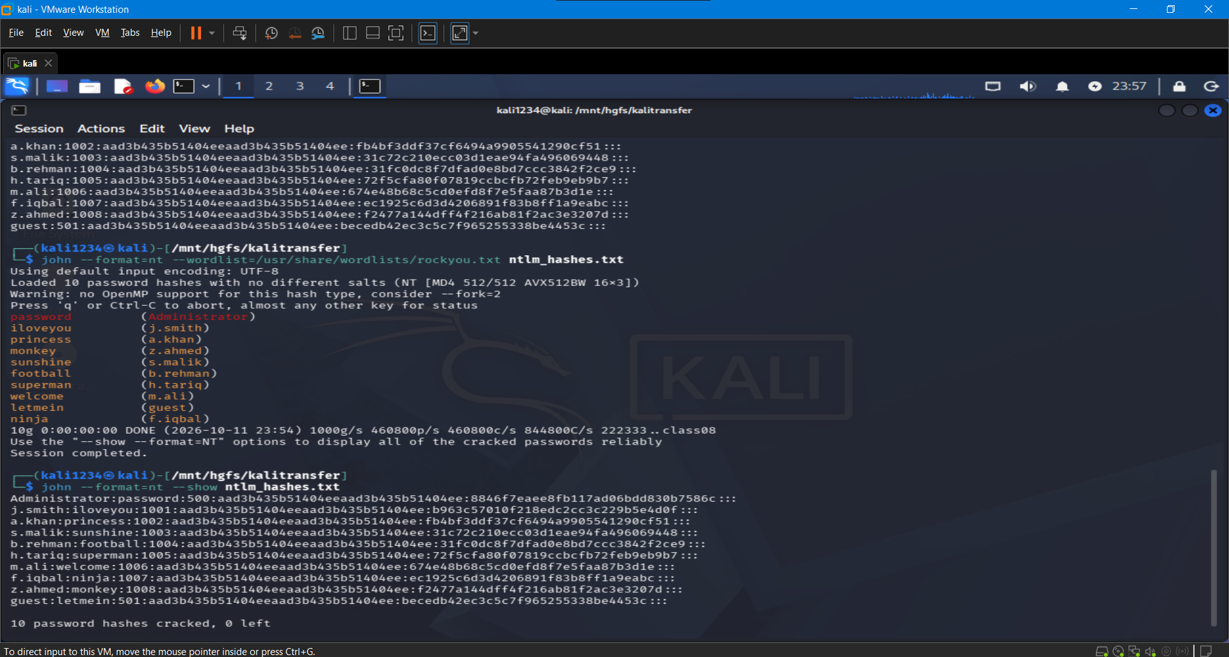
Figure 3: John the Ripper recovering passwords from NT hashes (Lab 5)

Web Architecture

Network Trace
Network trace is understanding what is happening in the network
Browsers and servers exchange requests and responses over HTTP [2].

My Web Page
Web page is basically an online page rendered in a browser
The page is version-controlled and published with GitHub [3].

Conclusion
This is the conclusion

References
[1] GCHQ, “CyberChef.” [Online]. Available: https://gchq.github.io/CyberChef/
[2] MDN Web Docs, “An overview of HTTP.” [Online]. Available: https://developer.mozilla.org/en-US/docs/Web/HTTP/Overview
[3] GitHub Docs, “Hello World.” [Online]. Available: https://docs.github.com/en/get-started/start-your-journey/hello-world

