
DATABASE SYSTEMS


LAB TASK-09

CS-2204

Name: Hammad Ahmed
Roll No: 2023-SE-01
Department: Software Engineering
Course Name: Database Systems
Instructor: Engr. Tahir Jahangir

Table of Content
Objective 3
Task 01: Domain Exploration and Entity Extraction 3
Task 02: Attribute Modeling and Visual Sketch 3
o Club_ID → Simple 3
o Student_ID → Simple 3
o Name → Composite (First_Name, Last_Name) 3
o Membership_ID → Simple 3
o Join_Date → Derived (from system records) 3
Task 03: Entity vs Attribute Decision-Making 4
Task 04: Guided ERD Design 4
o Faculty_ID (PK), Name, Designation, Email 4
Task 05: Independent ERD (Library System) 5
Reflection 5

Objective
This lab aims to develop skills in recognizing entities, their attributes, and primary keys from practical domains, and presenting them through Entity-Relationship Diagrams (ERDs). It serves as a fundamental step towards ER modeling before introducing relationships in future sessions.

Task 01: Domain Exploration and Entity Extraction
Scenario: The scenario involves a university that manages multiple student clubs. Every club includes a name, category, and faculty advisor, while students are allowed to participate in more than one club.
Entity | Attributes | Primary Key | Strong/Weak | Justification
Club | Club_ID (PK), Name, Type, Faculty_Advisor | Club_ID | Strong | A club exists independently in the system.
Student | Student_ID (PK), Name, Email, Program | Student_ID | Strong | A student is independent of clubs.
Membership | Membership_ID (PK), Join_Date, Role | Membership_ID | Weak | Membership depends on Student and Club participation.

Task 02: Attribute Modeling and Visual Sketch
Attribute Classification:
- Club
  - Club_ID → Simple
  - Name → Simple
  - Type → Simple
  - Faculty_Advisor → Composite (Advisor_Name, Department)
- Student
  - Student_ID → Simple
  - Name → Composite (First_Name, Last_Name)
  - Email → Simple
  - Program → Simple
- Membership
  - Membership_ID → Simple
  - Join_Date → Derived (from system records)
  - Role → Simple
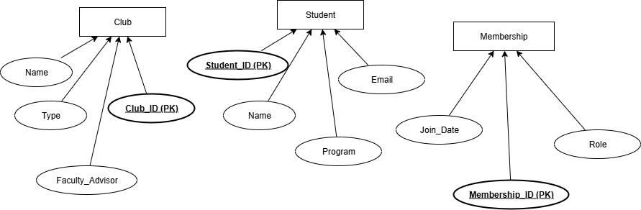
Mini ERD of Club, Student, and Membershi

Task 03: Entity vs Attribute Decision-Making
Conference Management System Items:
Item | Entity/Attribute | Justification
Conference | Entity | Independent concept
Location | Attribute | Property of Conference
Start Date | Attribute | Property of Conference
Speaker | Entity | Person delivering sessions
Session | Entity | Core unit of the conference
Session Duration | Attribute | Belongs to Session
Attendee | Entity | Independent participant
Attendee Name | Attribute | Belongs to Attendee
Registration | Entity | Records event participation
Fee Paid | Attribute | Belongs to Registration
Missing Entities/Attributes:
- “Delivers” → Relationship between Speaker and Session
- “Registers For” → Relationship between Attendee and Conference

Task 04: Guided ERD Design
Entities given:
- Department
  - Department_Code (PK), Department_Name, Building
- Faculty
  - Faculty_ID (PK), Name, Designation, Email
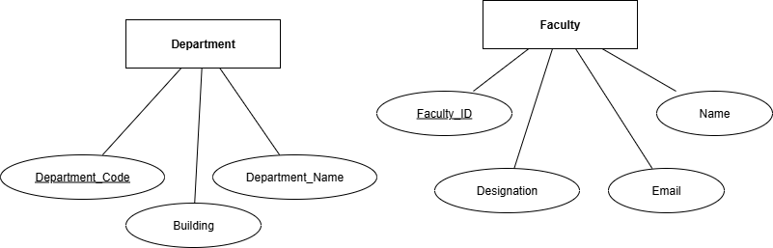
Picture: ERD with Department and Faculty

Task 05: Independent ERD (Library System)
Entities and Attributes:
- Book → ISBN (PK), Title, Author, Category
- Member → Member_ID (PK), Name, Address, Phone
- Librarian → Emp_ID (PK), Name, Shift, Section
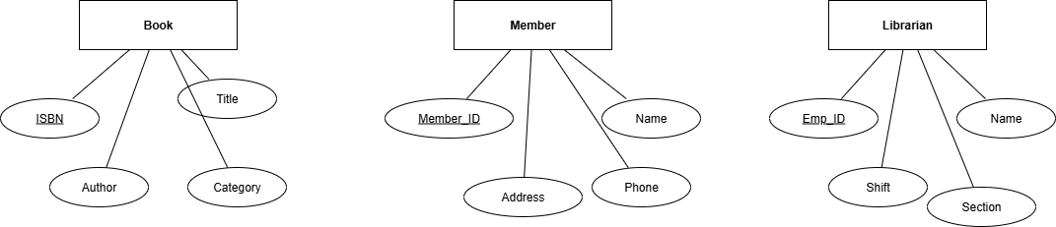
Picture : ERD of Library Entities.
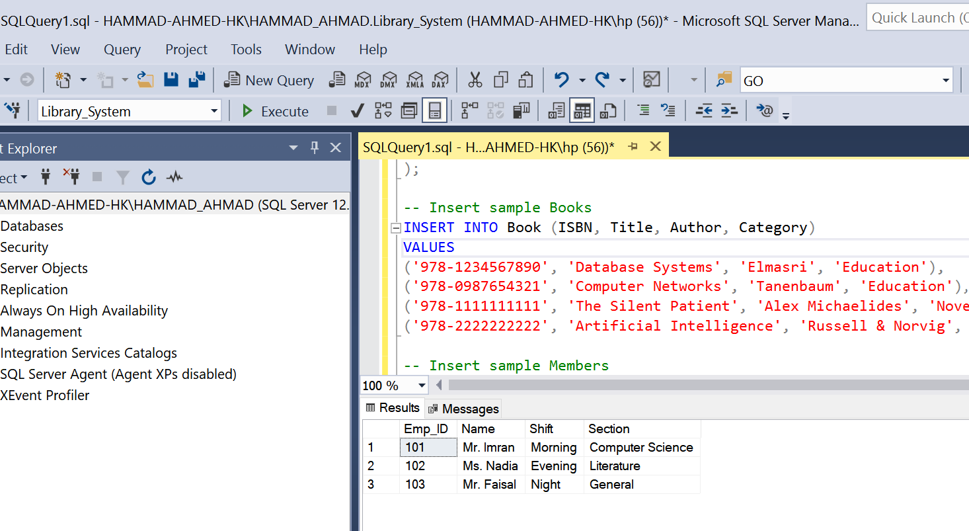

Reflection
Throughout this lab, I gained experience in recognizing entities and categorizing attributes into types such as simple, composite, derived, or multivalued. I also worked on differentiating between entities and attributes, which can often be tricky in practical scenarios. The hardest part was deciding whether a concept should be treated as an entity or an attribute, but this activity made the process of ER modeling much easier and more structured.

