
Database Systems


Lab Task :08

CS-2204

Name: Hammad Ahmed
Roll No: 2023-SE-01
Department: Software Engineering
Course Name: Database systems
Instructor: Engr. Tahir Abbasi

Database Systems
Lab Task – 8: SQL Server – Grouping & Aggregation

Objective:
In this lab, students will explore SQL aggregate functions and GROUP BY clauses to summarize, analyze, and gain insights from relational data. Students will build on existing knowledge by writing queries using SUM(), AVG(), COUNT(), MIN(), MAX() and GROUP BY/HAVING to produce analytical outputs from the dataset.

Task 01: Database and Table Setup:
Create a new database with your name in the format: Hammad_Ahmed_lab_task_08
Recreate the following tables (from Lab 7) and insert records:
- CUSTOMERS
- ORDERS
- PRODUCTS
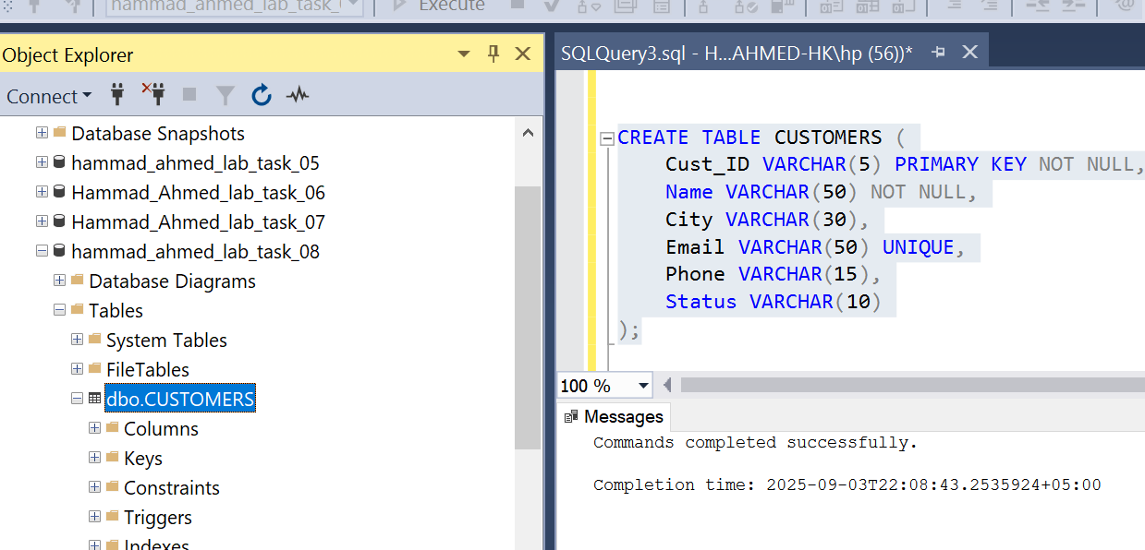
Data insertion:
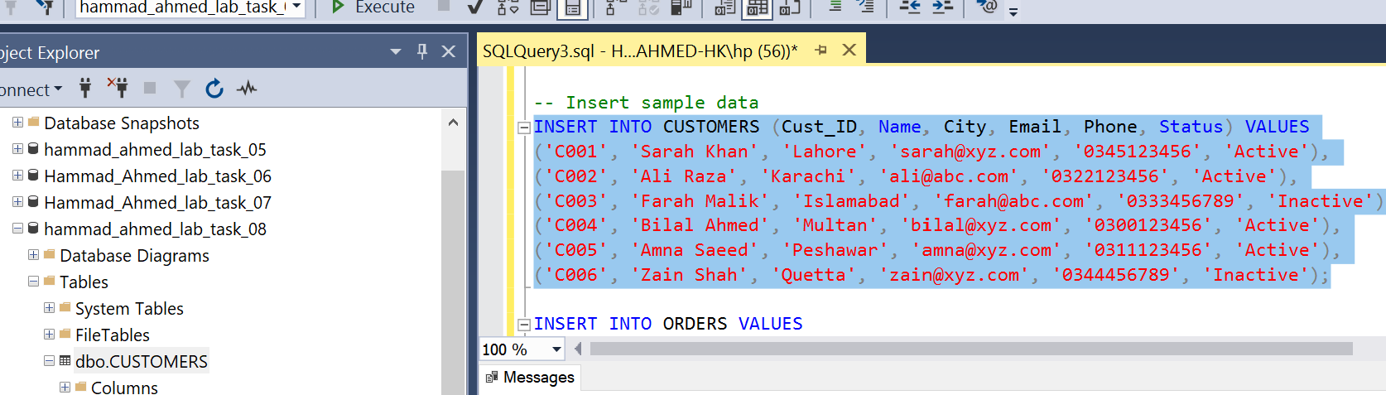

Task 02: Applying Basic Aggregate Functions:

1. Calculate total number of customers SELECT COUNT(*) AS Total_Customers FROM CUSTOMERS:
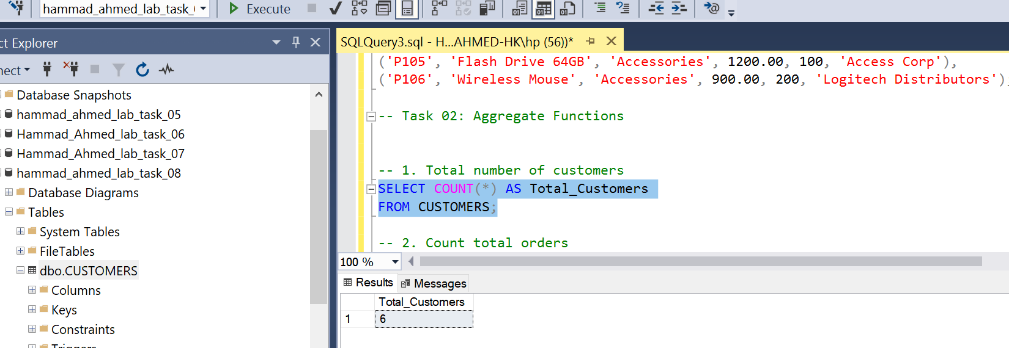
2. Count how many orders have been placed
SELECT COUNT(*) AS Total_Orders FROM ORDERS:
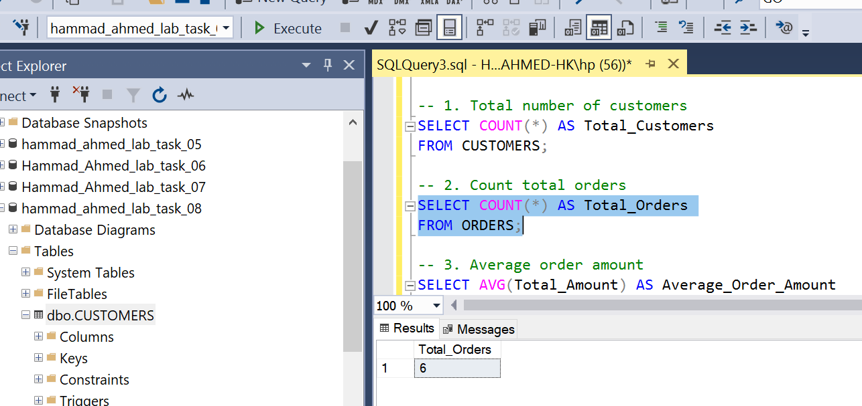
3. Calculate average order amount SELECT AVG(order_amount) AS Average_Order_Amount FROM ORDERS;
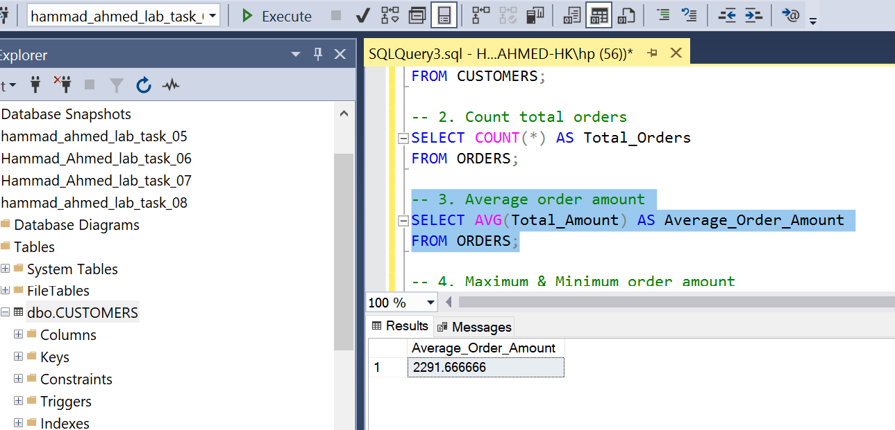
4. Find maximum and minimum order amount SELECT MAX(order_amount) AS Max_Order, MIN(order_amount) AS Min_Order FROM ORDERS:
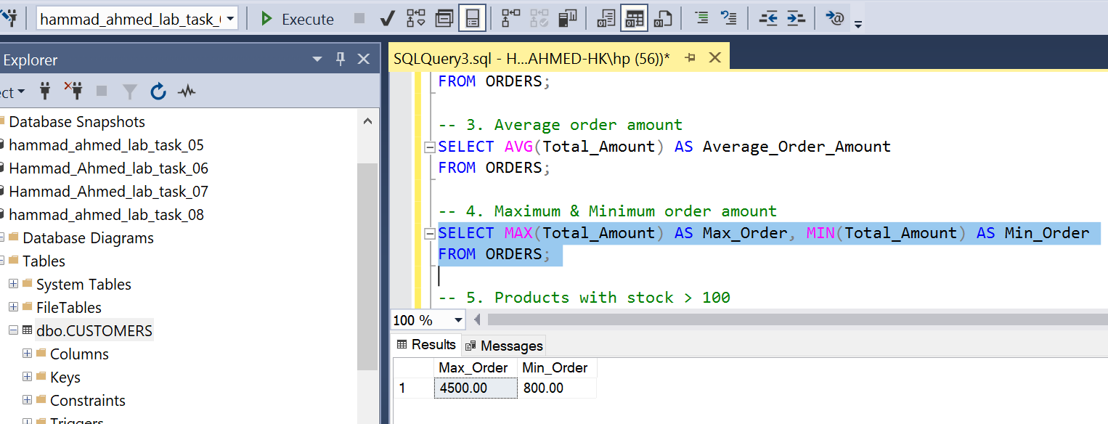
5. Count how many products have stock > 100 SELECT COUNT(*) AS Products_In_Stock FROM PRODUCTS WHERE stock > 100:
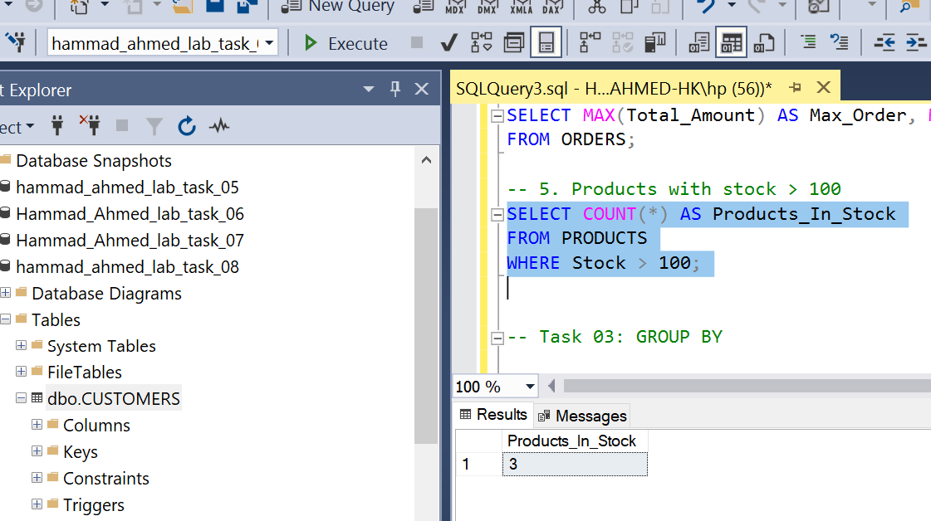

Task 03: GROUP BY Clause in Action
1. Total order amount per customer SELECT customer_id, SUM(order_amount) AS Total_Order FROM ORDERS GROUP BY customer_id;

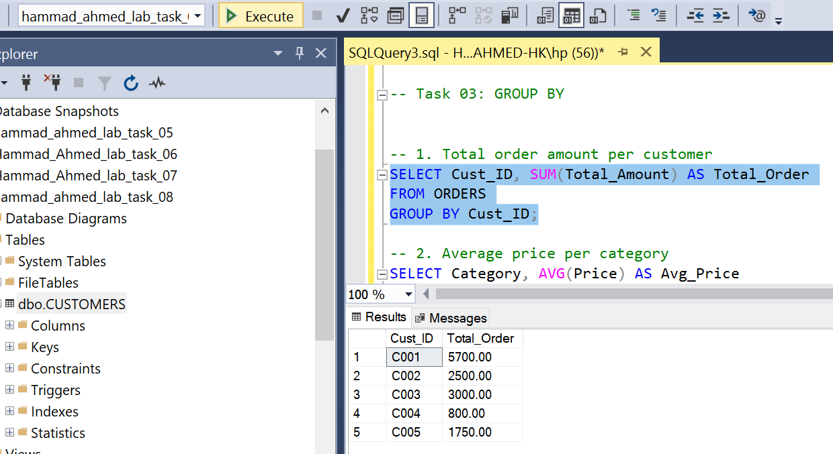
2. Average price per category SELECT category, AVG(price) AS Avg_Price FROM PRODUCTS GROUP BY category;
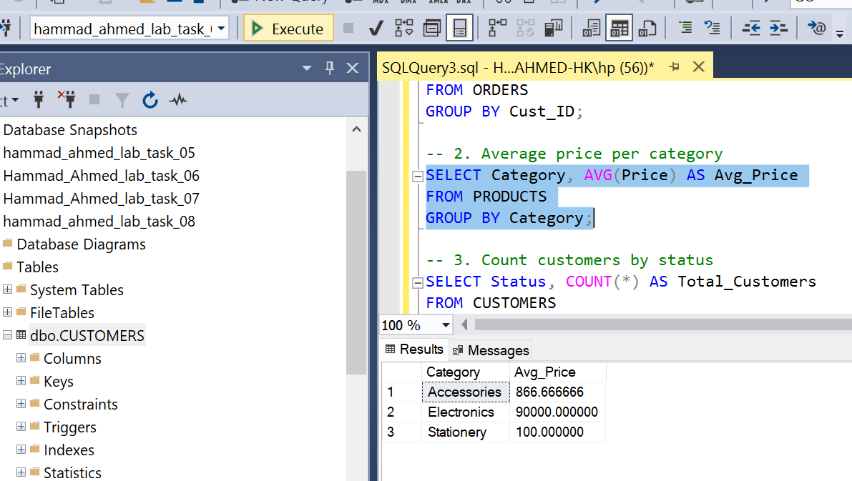
3. Customers by status SELECT status, COUNT(*) AS Total_Customers FROM CUSTOMERS GROUP BY status;
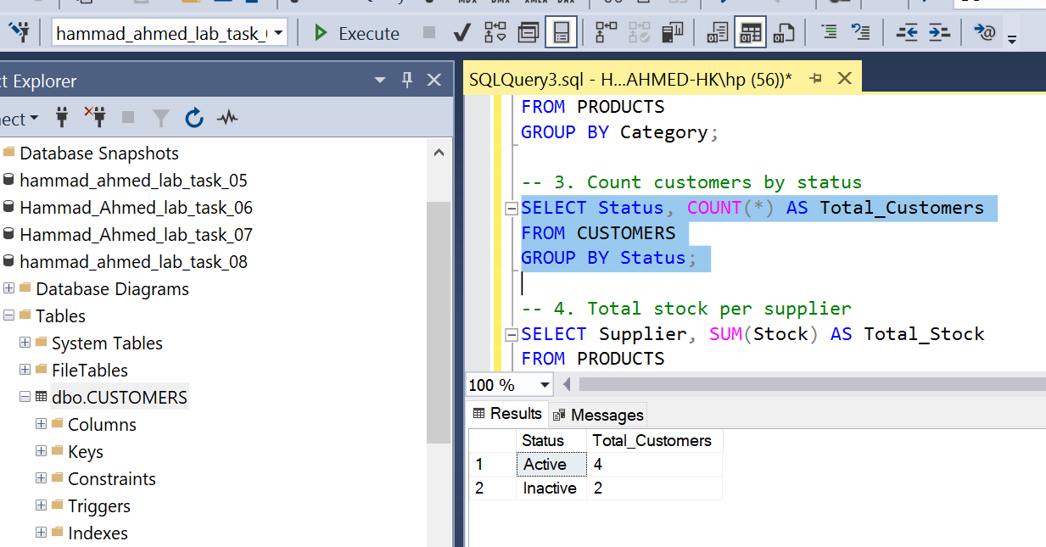
4. Total stock per supplier SELECT supplier_id, SUM(stock) AS Total_Stock FROM PRODUCTS GROUP BY supplier_id:
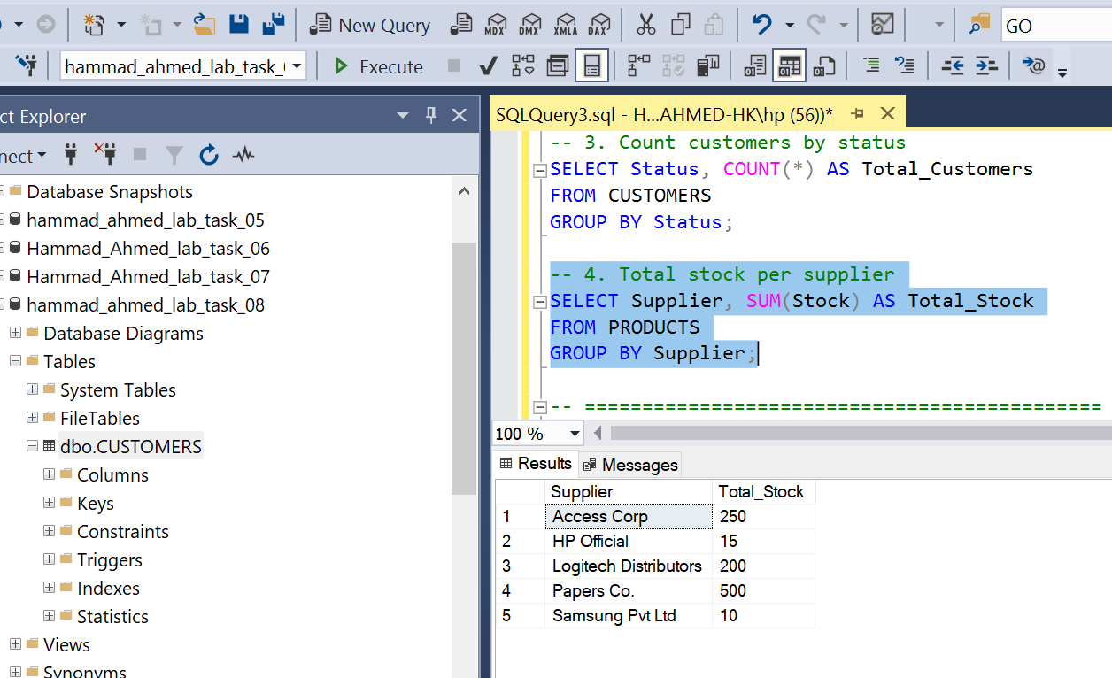

Task 04: Filtering Groups Using HAVING Clause
1. Customers who placed more than one order
SELECT customer_id, COUNT(order_id) AS Order_Count FROM ORDERS GROUP BY customer_id HAVING COUNT(order_id) > 1;
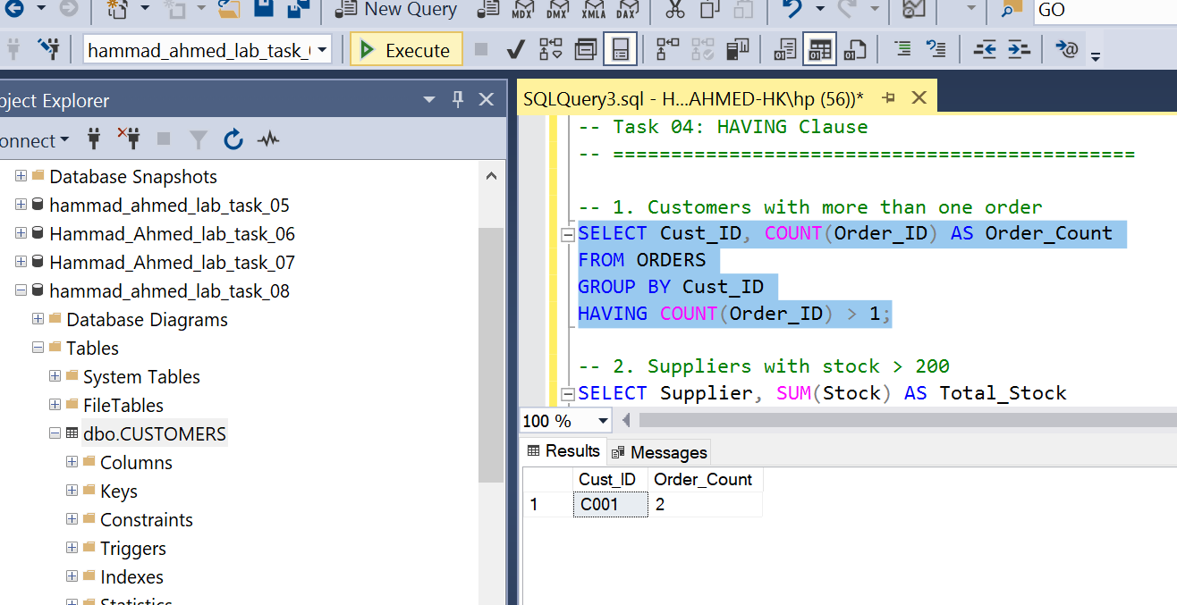
2. Suppliers with stock > 200 SELECT supplier_id, SUM(stock) AS Total_Stock FROM PRODUCTS GROUP BY supplier_id HAVING SUM(stock) > 200:
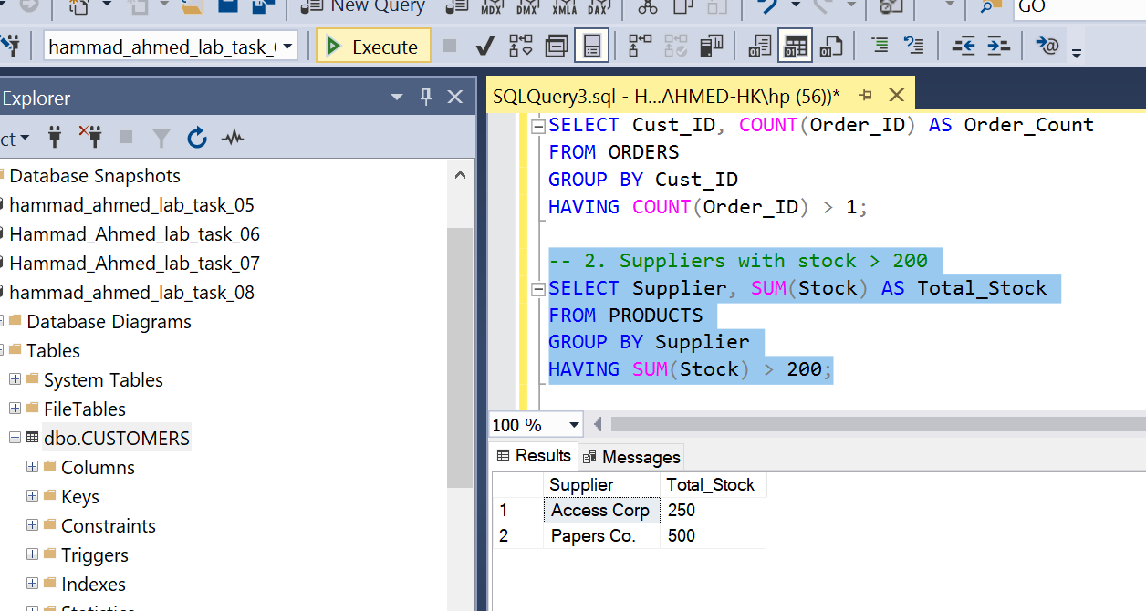
3. Cities with more than one active customer SELECT city, COUNT(customer_id) AS Active_Customers FROM CUSTOMERS WHERE status = 'Active' GROUP BY city HAVING COUNT(customer_id) > 1;
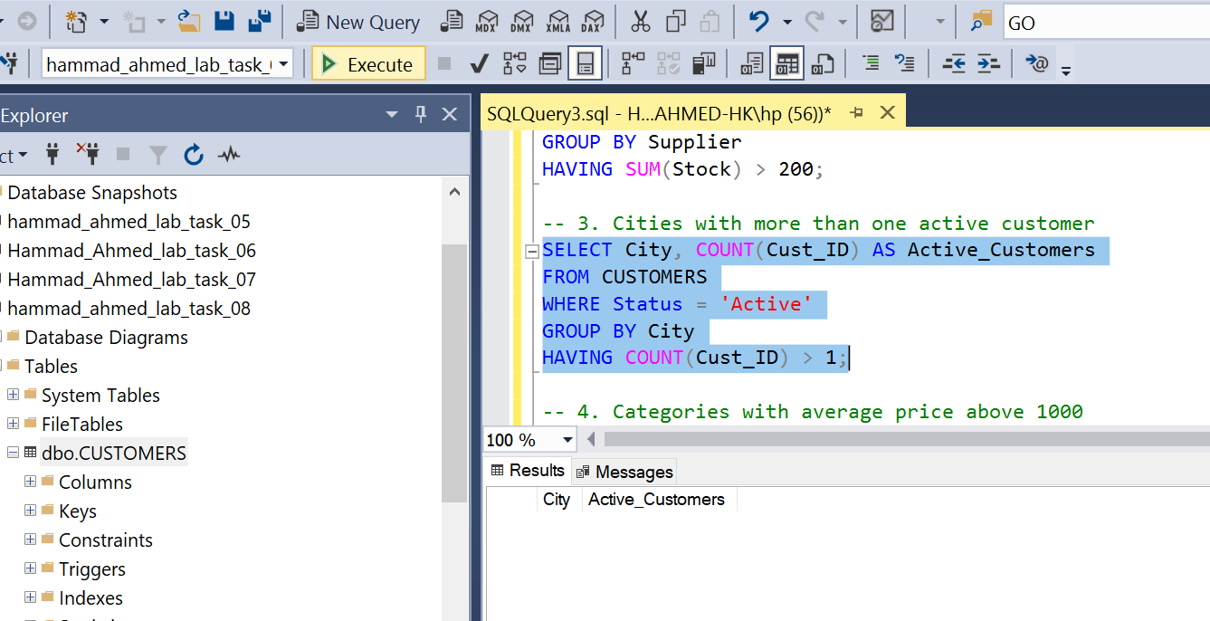
4. Categories with average price above 1000 SELECT category, AVG(price) AS Avg_Price FROM PRODUCTS GROUP BY category HAVING AVG(price) > 1000;
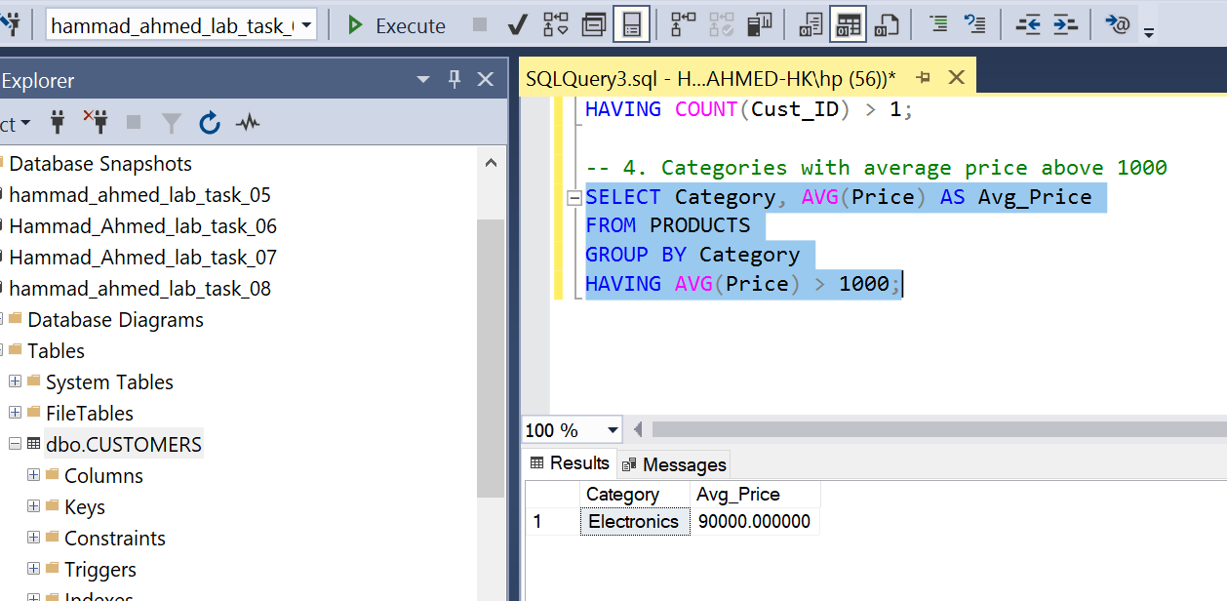

Task 05: Conceptual Understanding:
1. Aggregate Functions in SQL:
- SUM(): Adds up values in a column
- AVG(): Calculates the average value
- COUNT(): Counts number of rows
- MIN(): Finds smallest value
- MAX(): Finds largest value
2. Difference between WHERE and HAVING:
Clause | Usage | Example
WHERE | Filters rows before grouping | SELECT * FROM CUSTOMERS WHERE status='Active';
HAVING | Filters groups after aggregation | SELECT city, COUNT(*) FROM CUSTOMERS GROUP BY city HAVING COUNT(*)>1;
3. Why GROUP BY is necessary:
It organizes rows into groups based on column values, allowing aggregate functions to compute results per group.
4. Example of HAVING:
SELECT supplier_id, SUM(stock) AS TotalStock FROM PRODUCTS GROUP BY supplier_id HAVING SUM(stock)>200;
5. Aggregate without GROUP BY:
It applies the function to the entire table, returning a single value. Example: SELECT AVG(price) FROM PRODUCTS;

Task 06: Lab Documentation & Summary
Summary:
In this lab, I learned how to apply SQL aggregate functions, use GROUP BY to summarize data, and filter grouped results using HAVING. I also understood the difference between WHERE and HAVING, and how aggregation can provide meaningful insights into datasets.

