
DATABASE SYSTEMS


LAB TASK-11

CS-2204

Name: Hammad Ahmed
Roll No: 2023-SE-01
Department: Software Engineering
Course Name: Database Systems
Instructor: Engr. Tahir Jahangir

Database Systems
Lab Task – 11: SQL Server – Views & Indexes

Objective
In this lab, students will explore the creation and usage of Views and Indexes in SQL Server to enhance data abstraction, security, and performance. The lab reinforces understanding of database optimization and controlled access by engaging students in real-world data modeling and query execution without revealing physical table structures.

Task 01: Database and Table Setup:
Objective:
Create a sample database and tables for practice with views and indexes.
Create Database:
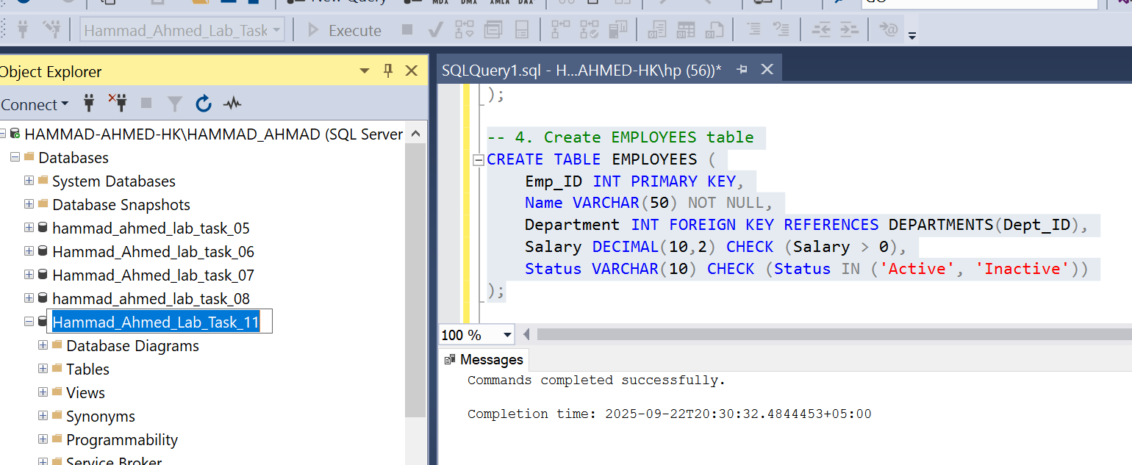
Inserted Data from Employee and Department:
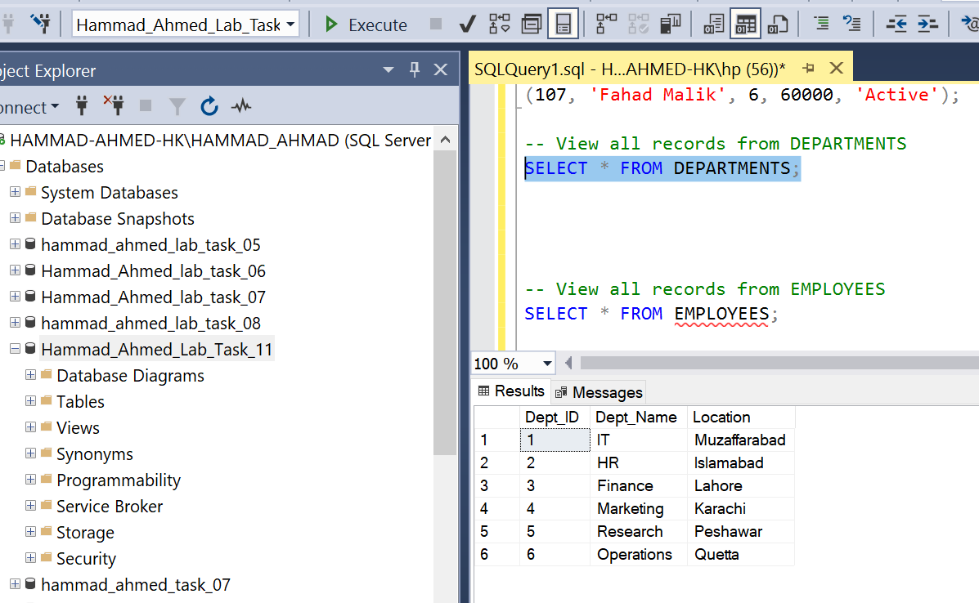
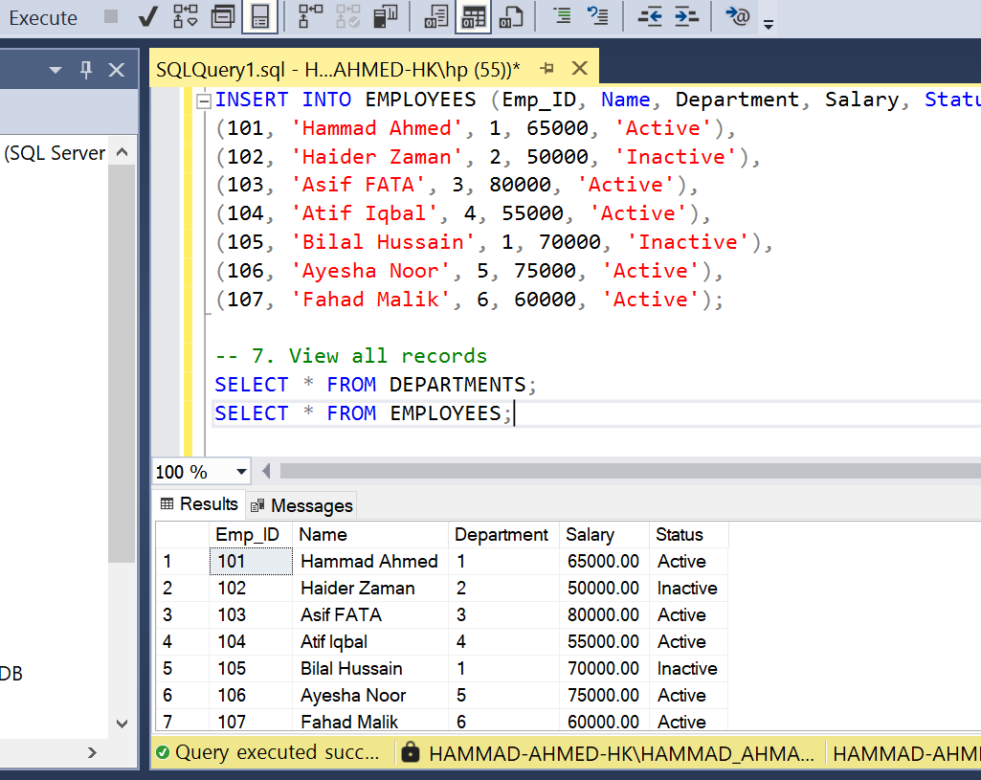

Task 02: Creating and Querying Views
- View showing only active employees:
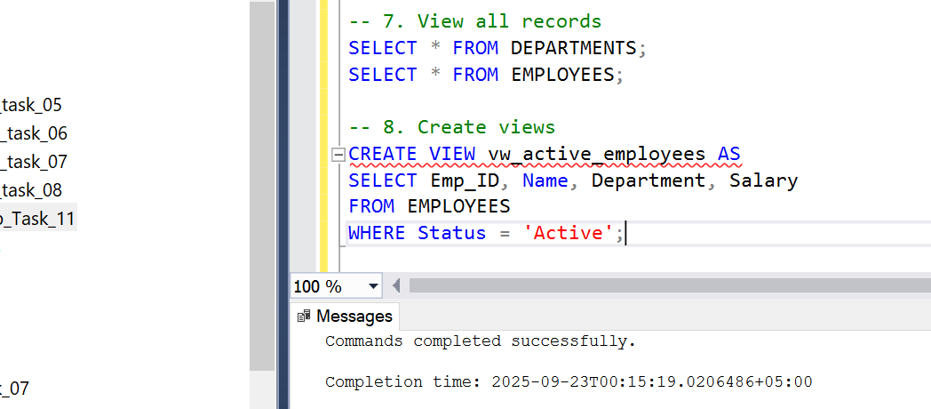
- 2. View joining EMPLOYEES and DEPARTMENTS:
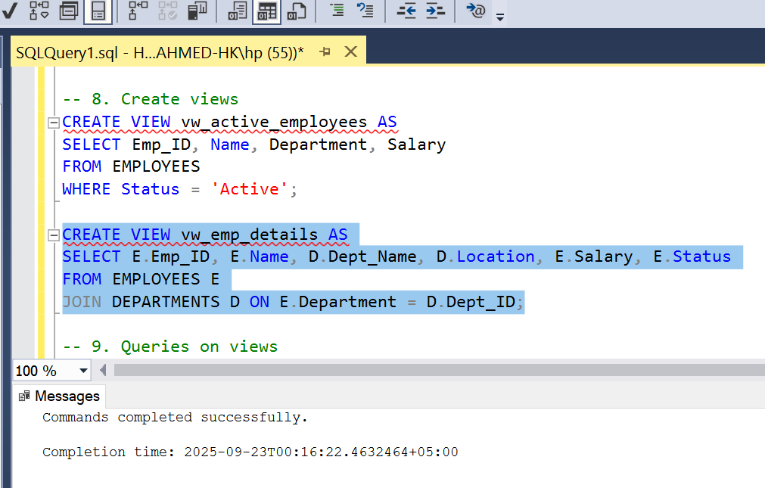
Sample Queries:
SELECT * FROM vw_active_employees WHERE Department = 1;
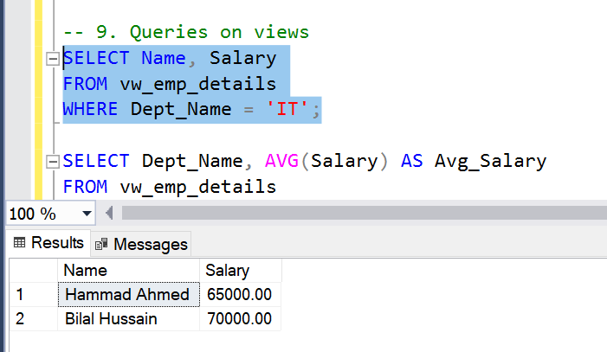

- SELECT Dept_Name, AVG(Salary) AS Avg_Salary FROM vw_active_employees A
JOIN DEPARTMENTS D ON A.Department = D.Dept_ID GROUP BY Dept_Name;
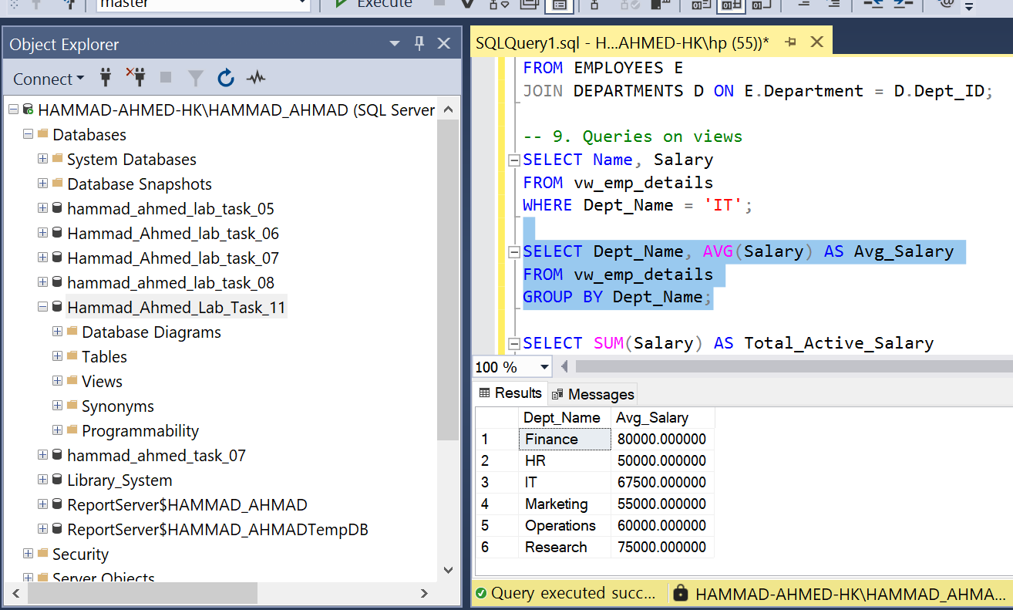

Sum of Salary:

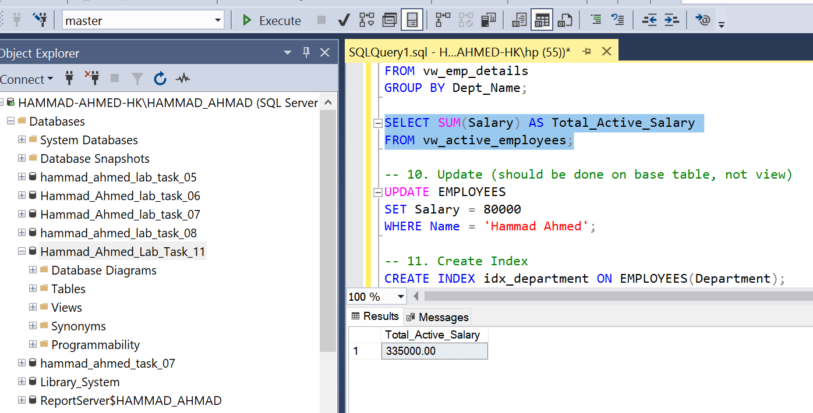

Task 03: Update and Delete Operations Using Views
- Update operation through view:
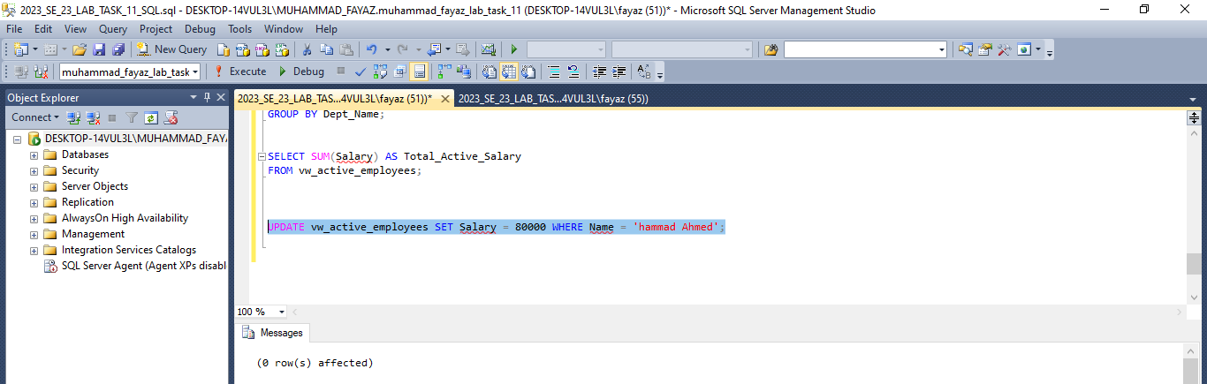

2. Delete operation attempt:
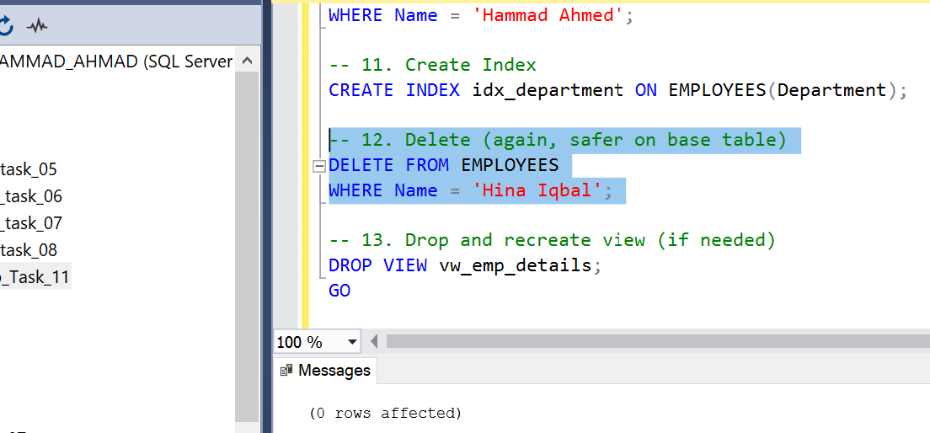
Observation: The UPDATE operation works as expected because the view directly references a single table with no aggregations. The DELETE may or may not work depending on SQL Server restrictions, as some views are not inherently updatable. In our case, deleting from a simple view may succeed, but complex views with joins will fail.

Task 04: Index Creation and Analysis
We chose the Department column in the EMPLOYEES table for indexing, as queries frequently filter or join on this column.
CREATE INDEX idx_department ON EMPLOYEES(Department);
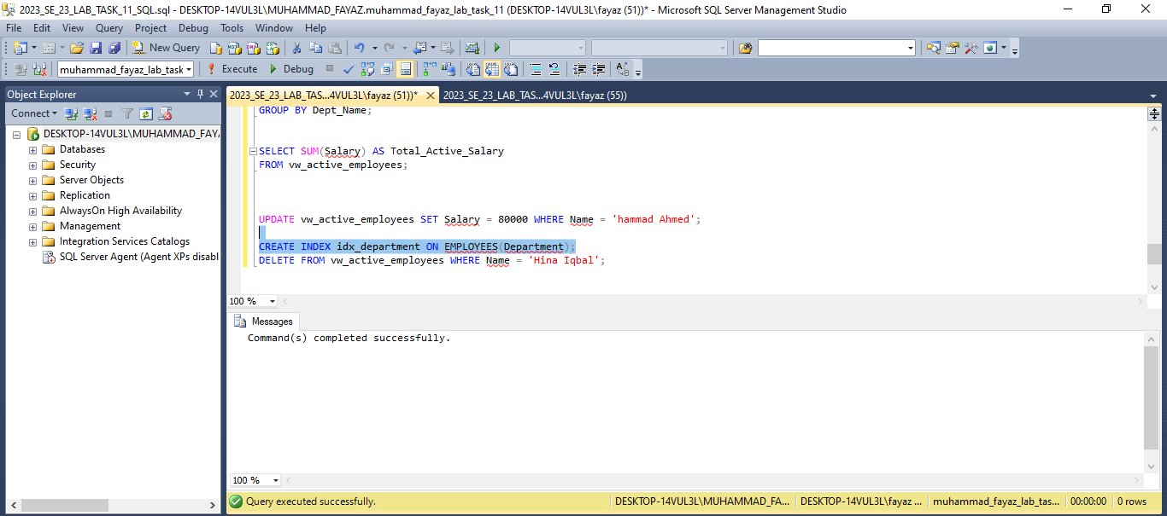
Observation:
Queries filtering by department executed faster after index creation. Indexing all columns is not advisable because it increases storage cost and slows down INSERT/UPDATE operations.

Task 05: Conceptual Reflection – Views vs. Indexes
- Key differences: Views provide virtual data abstraction, while indexes are physical structures that speed up data retrieval.
- . Views enhance abstraction and security by hiding table structures and restricting columns.
3. Indexes improve performance but increase storage and maintenance overhead.
4. Not all views are updatable. For example, our vw_active_employees allowed UPDATE but vw_emp_details with a JOIN did not allow DELETE directly.
5. Overusing indexes leads to higher storage consumption and slower write operations, so DBAs use them carefully based on query needs.

Task 06: Lab Documentation and Reflection:
I did not face any challenges while completing this lab task, as all steps were clear and easy to follow. From this activity, I gained practical knowledge about the use of views in SQL Server for abstraction and security. I also understood the role of indexing in query optimization along with its trade-offs, as indexes improve performance but can affect data modification speed. Lastly, I learned about the restrictions on performing DML operations through views, which highlighted the importance of making updates directly on base tables. This lab enhanced my understanding of views, indexing, and SQL Server limitations.

THE END

