
DATABASE SYSTEMS


LAB TASK-10

CS-2204

Name: Hammad Ahmed
Roll No: 2023-SE-01
Department: Software Engineering
Course Name: Database Systems
Instructor: Engr. Tahir Jahangir

Objective
The objective of this lab is to understand and model relationships between entities in ERDs, including 1:1, 1:M, and M:N relationships, relationship attributes, and associative entities. This lab emphasizes cardinality, participation, and the construction of complete ERDs to represent real-world scenarios.
Task 01:
Understanding Relationship Types through Scenario Mapping
Scenario: Hospital system
Theory:
- 1:1 Relationship: One entity instance is associated with only one instance of another entity.
- 1:M Relationship: One entity instance is associated with multiple instances of another entity.
- M:N Relationship: Many instances of one entity can be associated with many instances of another entity.
- Participation:
- Total: Every instance of the entity must participate in the relationship.
- Partial: Some instances may not participate in the relationship.
Table for Relationship Mapping:
Entity A | Entity B | Relationship | Type | Participation
Doctor | Patient | Treats | 1:M | Partial
Patient | Medication | Prescribed | M:N | Total
Room | Patient | Assigned | 1:1 | Total

Task 02: ERD with Relationships – Guided Design:
Scenario: University database – Department, Faculty, Projects
Theory:
- Entities:
  - Department: DepartmentID (PK), DeptName
  - Faculty: FacultyID (PK), FacultyName, Designation
  - Project: ProjectID (PK), Title, Duration
- Relationships:
  - Department (1) → Faculty (M)
  - Faculty (1) → Project (M)
- Notation: Crow’s foot or ERDPlus symbols for cardinality and participation.
Diagram:
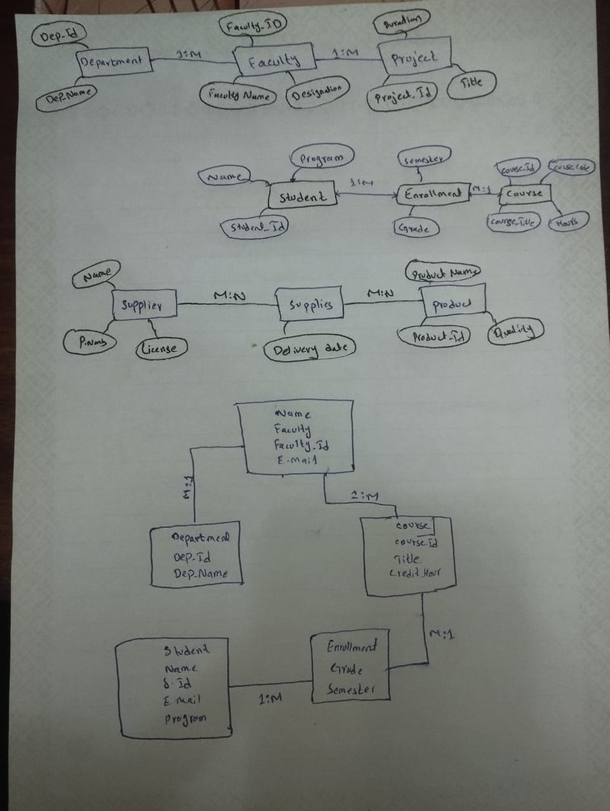

Task 03: Modeling M:N Relationships with Associative Entities
Scenario: Students enroll in Courses
Theory:
- M:N relationships cannot be directly implemented in relational databases.
- Associative entity resolves M:N relationships, holding the foreign keys of both entities along with relationship-specific attributes.
- Entities:
  - Student(StudentID, Name, Program, Semester)
  - Course(CourseID, Title, CreditHours)
  - Enrollment(StudentID, CourseID, Grade, Semester) – associative entity
- Relationship: Student ↔ Enrollment ↔ Course (M:N)
Diagram:

Task 04: Relationship Attribute Modeling
Scenario: Suppliers supply Products
Theory:
- Relationship attributes are properties of a relationship rather than an entity.
- M:N relationship between Supplier and Product is modeled with an associative entity or a relationship diamond containing attributes like DeliveryDate.
- Entities: Supplier(SupplierID, Name, Location), Product(ProductID, Name, Price)
- Relationship: Supplies (M:N) with attribute DeliveryDate
Diagram:

Task 05: Complete ERD Design from Real-World Scenario
Scenario: University database – Students, Courses, Faculty, Departments
Theory:
- Entities:
  - Student(StudentID, Name, Program)
  - Course(CourseID, Title, CreditHours)
  - Faculty(FacultyID, Name, Designation)
  - Department(DeptID, DeptName)
  - Enrollment(StudentID, CourseID, Grade, Semester) – associative entity
- Relationships:
  - Student ↔ Enrollment ↔ Course (M:N)
  - Course → Faculty (1:M)
  - Faculty → Department (M:1)
- Cardinality & Participation: Clearly label 1:M, M:N, and total/partial participation.
Diagram:

Reflection:
During these tasks, I gained practical experience in modeling different types of relationships in ER diagrams, such as 1:1, 1:M, and M:N. I learned how associative entities are used to resolve many-to-many relationships and how attributes can be incorporated into relationships. Developing complete ERDs enhanced my understanding of cardinality, participation, and their application in real-world database design. Initially, I found it challenging to label relationships and participation accurately, but my skills improved through practice with guided diagrams.

THE END

