
Database Systems


Open Ended Lab

CS-2204

Name: Hammad Ahmed
Roll No: 2023-SE-01
Department: Software Engineering
Course Name: Database systems
Instructor: Engr. Tahir Abbasi

Open Ended Lab

Task 01: Conceptual Modeling (ERD)

Design Justification & Key Decisions

The database design for Newbury Bus:
iness School (NBS) requires managing multiple entities and complex many-to-many relationships (M:N). The Crow's Foot notation is used for clarity and precision in representing relationships.

Core Entities and Relationships
Entity | Attributes (PK is bold) | Relationships
CAMPUS | CampusID, Name, Location (e.g., London) | 1:M with COURSE
MANAGER | ManagerID, Name, Email, Phone | 1:M with TUTOR
TUTOR | TutorID, Name, Salary, Type, Qualifications, Email, ManagerID (FK) | 1:M with CLASS
LEARNER | LearnerID, Name, Email, Age, Gender, Phone, LearningStyle | 1:M with ENROLLMENT
COURSE | CourseID, Name (e.g., English), CampusID (FK) | 1:M with CLASS, M:N with LEARNER (via ENROLLMENT)
SEMESTER | SemesterID, Name, StartDate, EndDate, IsFullTime | 1:M with ENROLLMENT
CLASS | ClassID, StartDate, EndDate, Size, CourseID (FK), TutorID (FK) | M:N with ENROLLMENT (via ENROLLMENT_CLASS)
LEARNING_RESOURCE | ResourceID, Type, Duration, Author, IssueDate | M:N with COURSE (via COURSE_RESOURCE)
LEARNING_ACTIVITY | ActivityID, IssueDate, Marks (Max), ResourceID (FK), ActivityType | 1:M with LEARNING_RESOURCE

Bridge/Associative Tables
Bridge Table | Purpose | Primary Key | Foreign Keys
ENROLLMENT | Links LEARNER to COURSE and SEMESTER, holding enrollment-specific data. | EnrollmentID | LearnerID, CourseID, SemesterID
ENROLLMENT_CLASS | Links ENROLLMENT to CLASSes taken. | EnrollmentID, ClassID | EnrollmentID, ClassID
COURSE_RESOURCE | Links COURSE to LEARNING_RESOURCEs. | CourseID, ResourceID | CourseID, ResourceID

Secreenshot of ER-D Diagram:
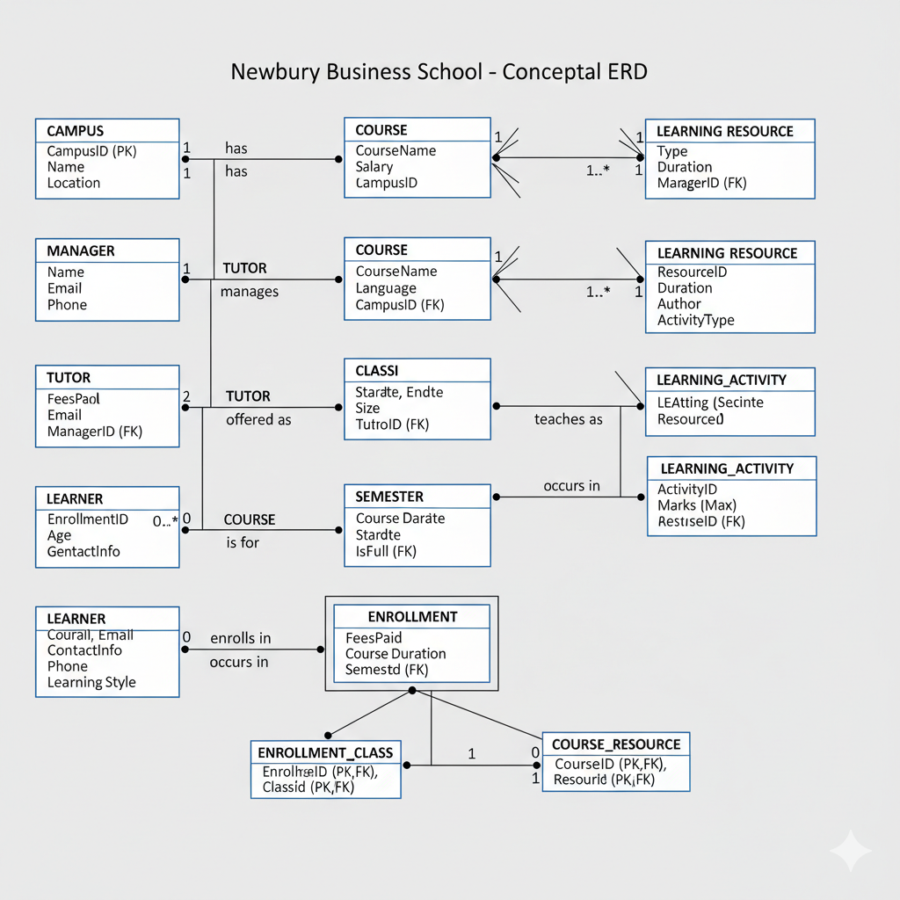
ERD-Diagram

Task:02 Schema Implementation (DDL)
The schema is implemented in SQL Server using DDL commands to define tables and constraints. Below are sample implementations:

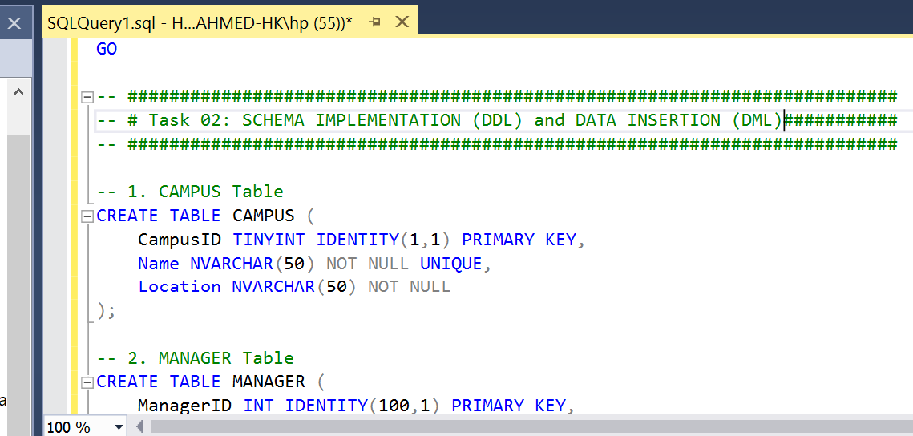
schema implementation

Data Insertion:
Data Manipulation Language (DML) statements are used to insert and query data. Example insertions are:
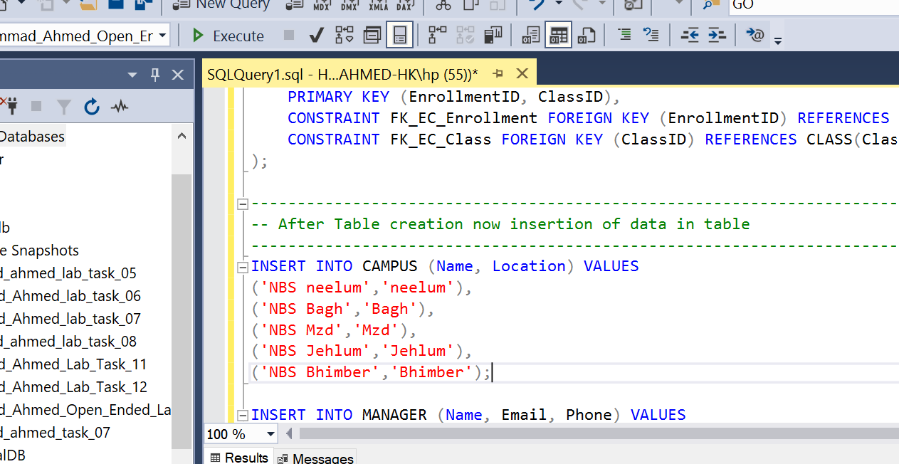
inserted data
Task 03:Data Analysis using DML.
In task 02: I create different table and insert data whose ss I include in report now in task 03 I display its data using joins and other commands.
Using inner join to take tutor name from tutor table and manager name from from manager table using inner join:

1. Advanced Query: INNER JOIN (Tutors and their Managers)
Find the names of all Tutors and the Managers they report to.
SQL
SELECT
T.Name AS TutorName,
M.Name AS ManagerName,
T.Email AS TutorEmailFROM
TUTOR TINNER JOIN
MANAGER M ON T.ManagerID = M.ManagerID;

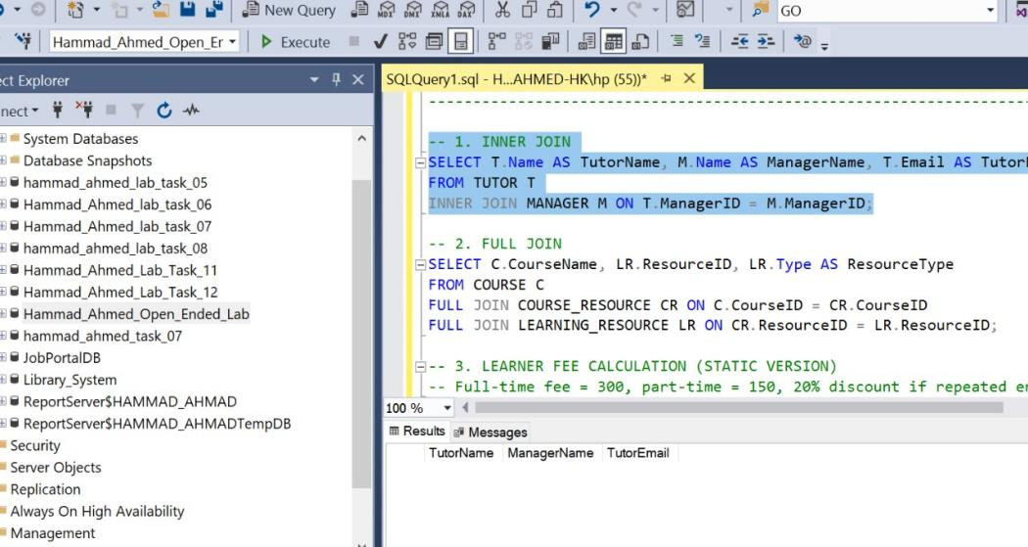
inner join
Similarly inner join we use full join for linked between different tables and make them connection :

Advanced Query: FULL JOIN (Courses and their assigned Resources):
Show all Courses, all Learning Resources, and their pairing. This is useful for identifying Courses without resources or resources not yet assigned to any course.
SQL
SELECT
C.CourseName,
LR.ResourceID,
LR.Type AS ResourceTypeFROM
COURSE CFULL JOIN
COURSE_RESOURCE CR ON C.CourseID = CR.CourseIDFULL JOIN
LEARNING_RESOURCE LR ON CR.ResourceID = LR.ResourceID;

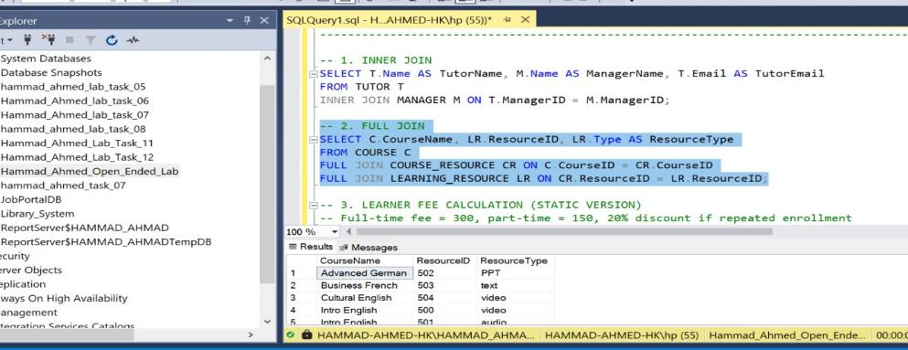
full join

3. Stored Procedure:
A procedure to calculate the current fees payable for a specific learner and semester, applying the 20% discount logic.
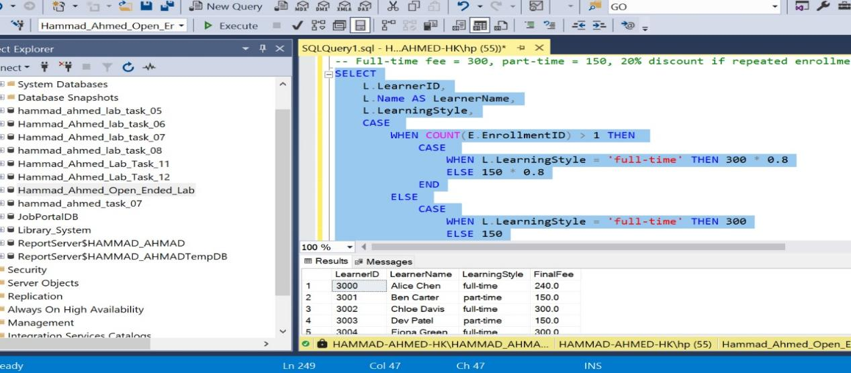

Advanced Query: Subqueries (Tutors teaching high-size classes)
Find Tutors who teach a class with a size greater than the overall average class size.
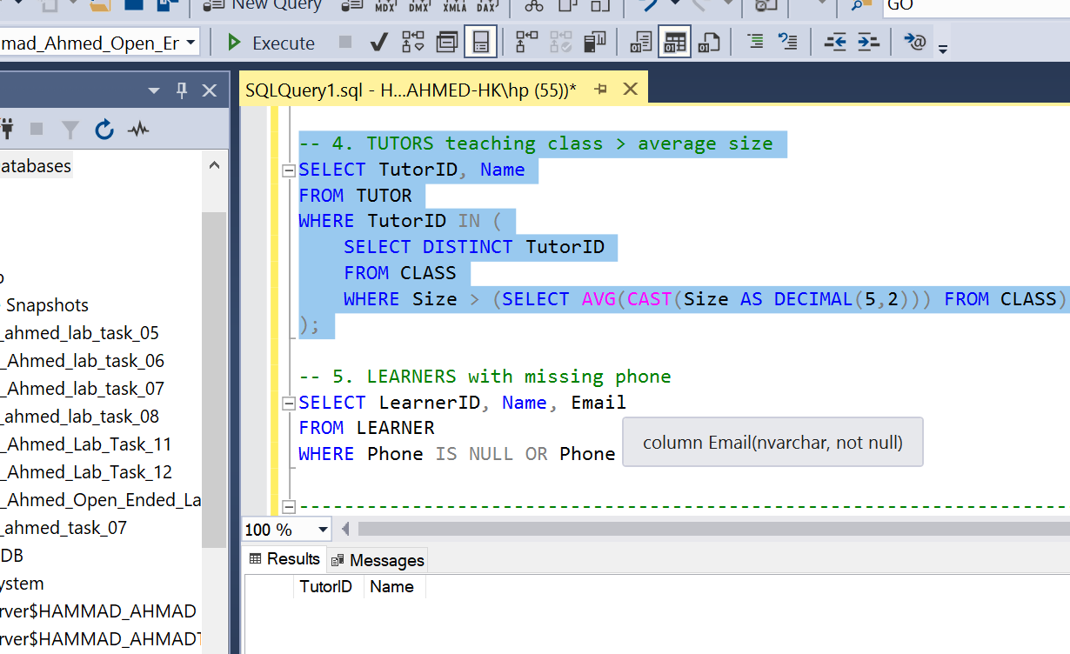

Advanced Query: NULL checks (Learners without a Phone Number)
Find all Learners who have not provided a phone number.

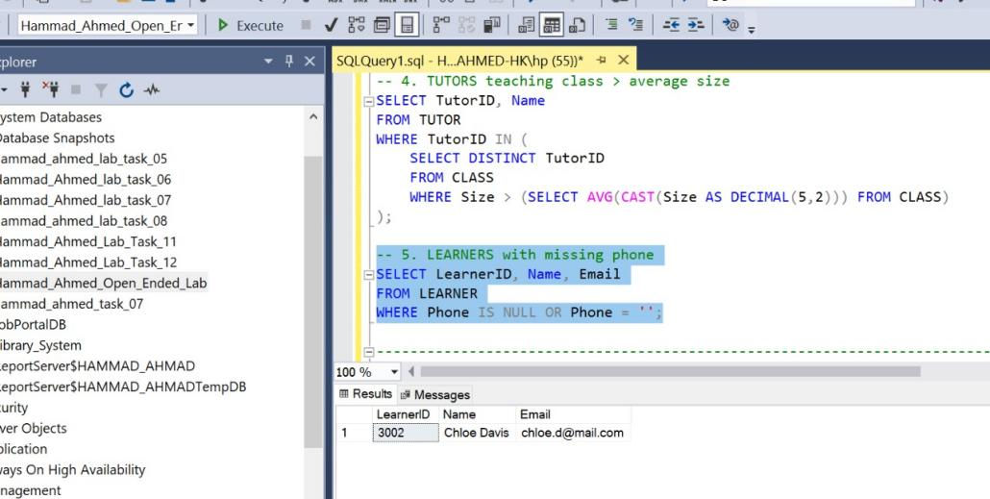

Task 04:Normalization:
Database normalization is the process of organizing data to minimize redundancy and improve data integrity. It involves dividing large tables into smaller ones and defining relationships between them. Normalization helps maintain consistency, reduces anomalies, and ensures efficient data retrieval and storage.
The main stages of normalization include Unnormalized Form (UNF), First Normal Form (1NF), Second Normal Form (2NF), and Third Normal Form (3NF). Each stage systematically removes redundancy and improves data structure.
Unnormalized Form (UNF)
In the Unnormalized Form, all data is stored in a single table, which includes repeating groups and redundant information. This structure leads to data anomalies and inefficient updates.
LearnerID | Name | CourseID | TutorName | ResourceType | ActivityMarks
3001 | Alice | C1-English | Bob | Video | 10
3001 | Alice | C1-English | Bob | Audio | 5
3002 | John | C2-German | Eva | Text | 8
In this stage, there are repeating groups for resources and activities for each learner. This design causes redundancy because learner and course information are repeated multiple times.
First Normal Form (1NF) To convert to 1NF, we eliminate repeating groups and ensure that each field contains only atomic (indivisible) values. Every record is uniquely identifiable using a primary key.

LearnerID | Name | CourseID | TutorName | ResourceID | Marks
3001 | Alice | C1 | Bob | R1 | 10
3001 | Alice | C1 | Bob | R2 | 5
3002 | John | C2 | Eva | R3 | 8
Now, each field contains atomic values, and the primary key can be identified as {LearnerID, CourseID, ResourceID}.
Second Normal Form (2NF)
In 2NF, we remove partial dependencies, meaning non-key attributes should depend on the entire primary key, not just part of it. We separate data into distinct tables such as Learner, Course, Tutor, and Resource.
Entity | Primary Key | Attributes | Description
LEARNER | LearnerID | Name, Email, LearningStyle | Stores learner details
COURSE | CourseID | CourseName, Campus | Contains course information
TUTOR | TutorID | TutorName, Salary | Contains tutor information
Each table now represents one entity, ensuring that data depends on the whole primary key, eliminating partial dependencies.
Third Normal Form (3NF):
In 3NF, transitive dependencies are removed. Non-key attributes should depend only on the primary key. We further divide tables such that non-key attributes are not dependent on other non-key attributes.
LEARNER | LearnerID | -
COURSE | CourseID | CampusID
CLASS | ClassID | CourseID, TutorID
LEARNING_ACTIVITY | ActivityID | ResourceID
ENROLLMENT | EnrollmentID | LearnerID, CourseID, SemesterID
At this stage, all transitive dependencies are eliminated, and the database is fully normalized into 3NF.
Normalization is essential in database design as it improves efficiency, reduces redundancy, and maintains consistency across data storage. The normalization process, from UNF to 3NF, ensures that each table represents a single concept with well-defined relationships.
Task 05:Views, Indexes & Functions:

View (Learner Financial Summary)
A view to provide a quick summary of a learner's enrollment status and fees.
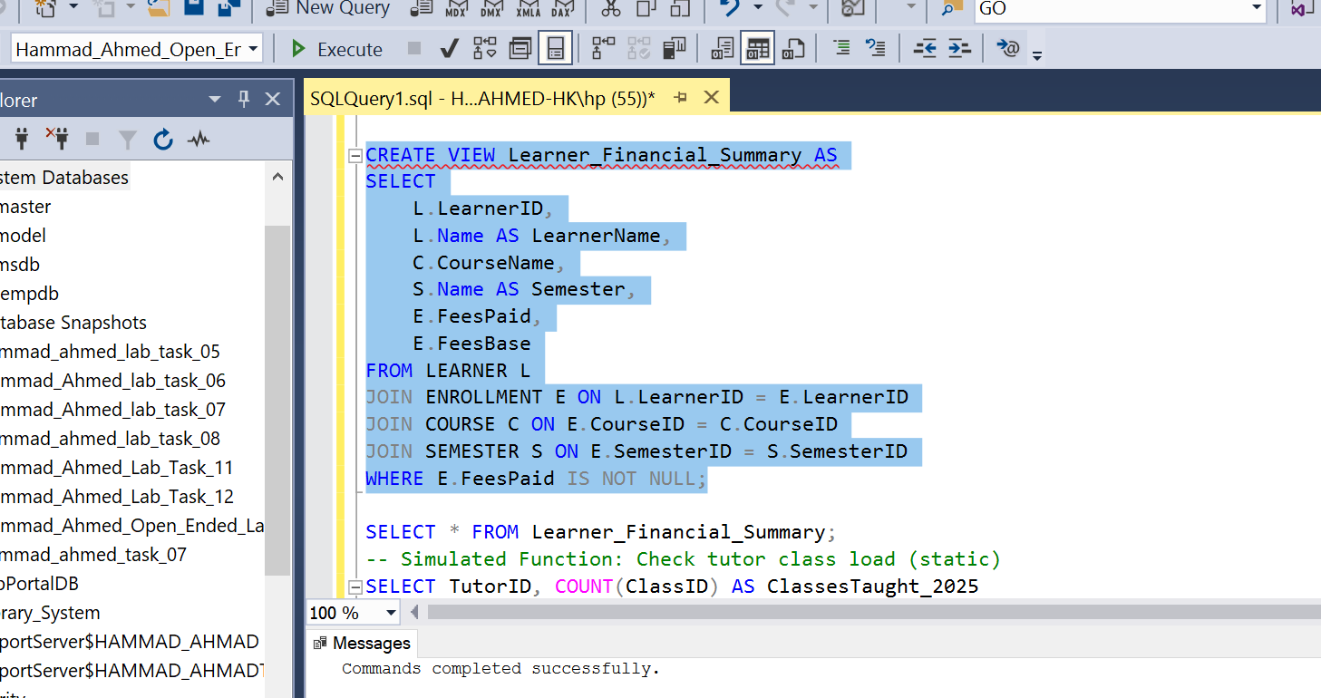
create view
Show Data of view:
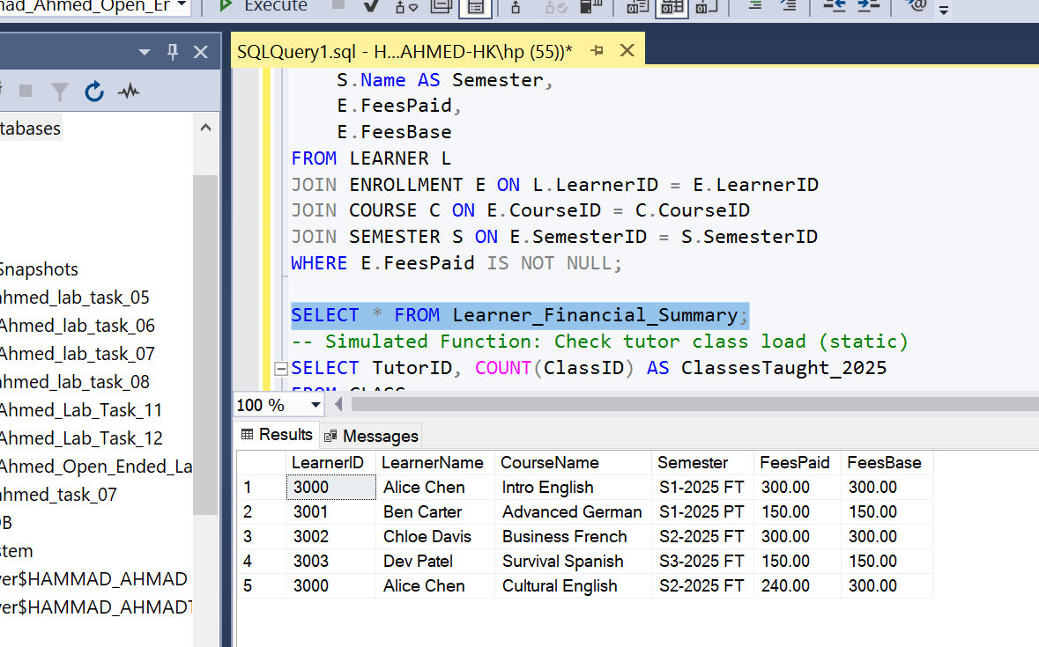
view data

User-Defined Function (Single-Parameter, Scalar)
A function to check a Tutor's availability by calculating the number of classes they are currently assigned to in a specific year.

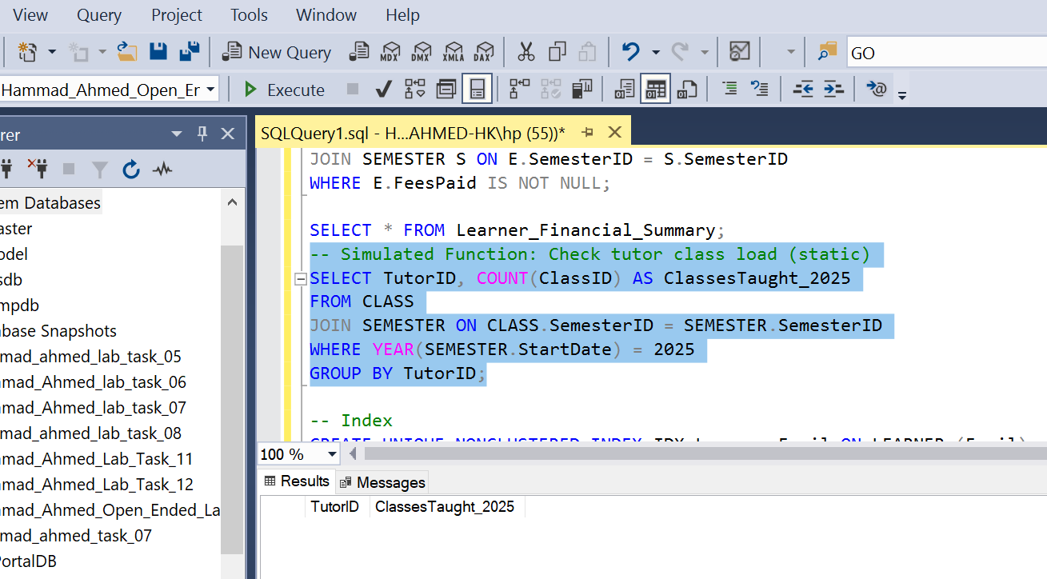
Functions'

3. Index for Performance Optimization
An index on the Email column of the LEARNER table to speed up logins and email-based lookups, which are likely frequent operations.
SQL
CREATE UNIQUE NONCLUSTERED INDEX IDX_Learner_EmailON LEARNER (Email);
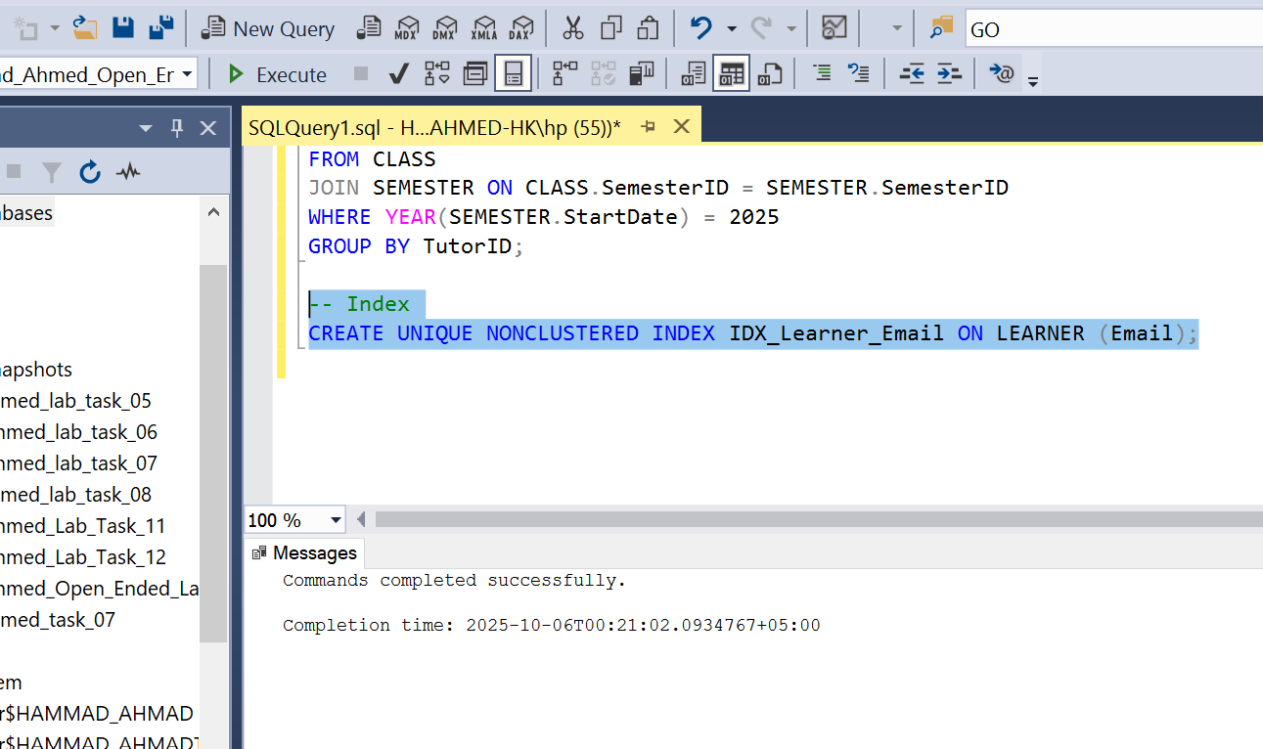
index
Justification: The Email column is used for unique identification (constraint) and will be a common search parameter (e.g., "find learner by email"), making an index highly beneficial for query performance. The UNIQUE constraint ensures data integrity.

Task 06: Reflection & Troubleshooting

Design Decisions
Surrogate Keys: I used surrogate keys (IDENTITY columns like EnrollmentID) for bridge/associative tables (ENROLLMENT) rather than complex composite keys. This simplifies joins and referencing the table from other places (like ENROLLMENT_CLASS).
Campus Entity: Although Campus could be an attribute of COURSE, promoting it to a full entity (CAMPUS) makes the design more robust, allowing us to manage campus-specific details in the future (e.g., address, capacity) without altering the COURSE table.
Tutor-Class Relationship: Decided on a 1:M relationship where a CLASS has one TUTOR. The limit of "up to 5 classes per term" is enforced through application logic or a trigger, as a hard DDL constraint is overly complex and restrictive for a simple count.

Challenges Faced & Debugging
Handling the Fees Logic: The 20% discount logic based on "multiple courses/year" required an assumption about how a "year" is defined in the database (I chose a simplified check based on previous semesters). This highlights the need for a Data Dictionary to formally document such business rules and assumptions. The logic was isolated into a stored procedure to allow for easy updates to the fee structure.
M:N Relationships: Setting up the complex M:N relationships (e.g., between ENROLLMENT and CLASS to track which classes a specific enrollment includes) required careful definition of the composite primary keys in the bridge tables (ENROLLMENT_CLASS). Debugging involved ensuring the foreign key references correctly prevented orphaned records.

Performance & Optimization
The implementation of the IDX_Learner_Email index directly addresses a potential performance bottleneck (user login/lookup).
Using Views (like Learner_Financial_Summary) simplifies complex join operations for end-users and reporting tools, indirectly boosting perceived performance and maintainability.
The use of Stored Procedures and Functions centralizes business logic, reducing the need to send large blocks of SQL code over the network, which is a key performance and security benefit in a production environment.

8. Conclusion
The Newbury Business School database was successfully designed and implemented following the principles of relational modeling, normalization, and optimization. The open-ended lab format fostered self-learning, analytical thinking, and applied database skills that are essential for professional software engineering practice.
THE END

