
DATABASE SYSTEMS


LAB TASK-12

CS-2204

Name: Hammad Ahmed
Roll No: 2023-SE-01
Department: Software Engineering
Course Name: Database Systems
Instructor: Engr. Tahir Jahangir

Database Systems

Lab Task – 12: SQL Server – Functions & Stored Procedures

Objective
In this lab, students will explore the creation and usage of scalar functions, table-valued functions, and stored procedures in SQL Server. They will reinforce their understanding by writing reusable logic blocks for data retrieval and insertion using user-defined functions and procedures.

Task 01: Database and Table Setup
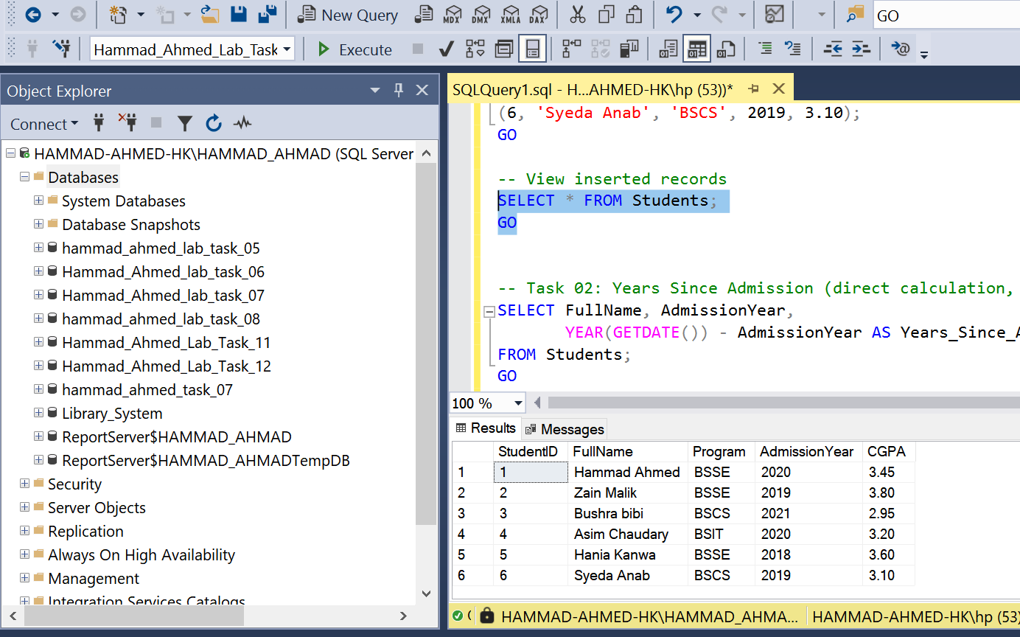

Task 02: Scalar Function with One Parameter
Function: Years since admission
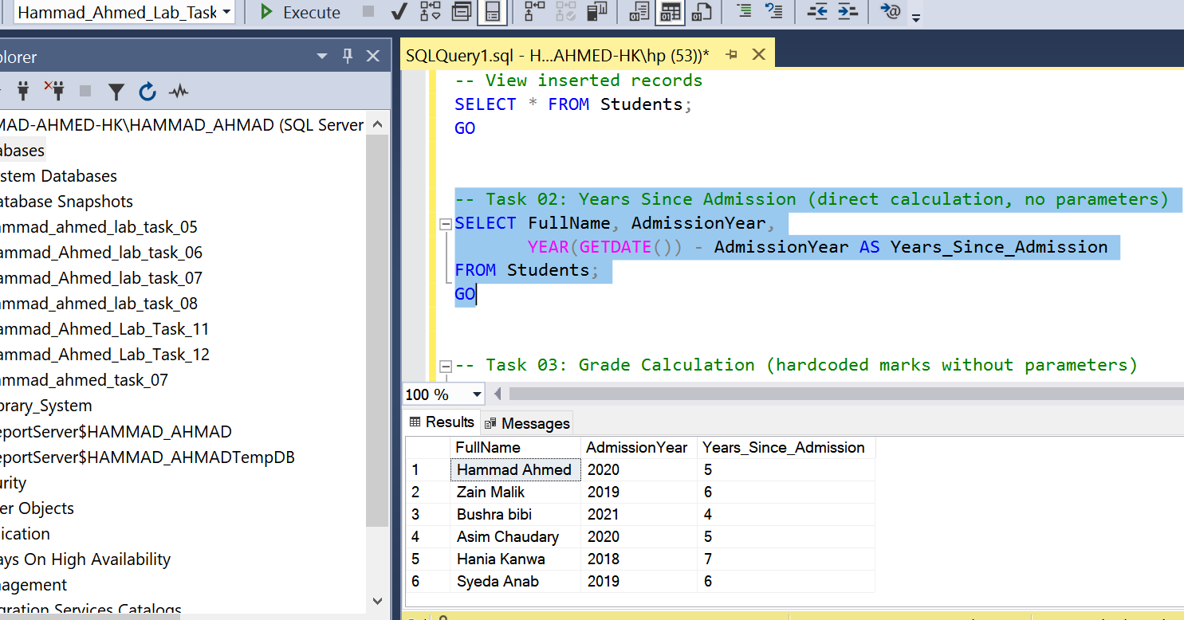

Task 03: Scalar Function with Multiple Parameters
Function: Calculate Grade
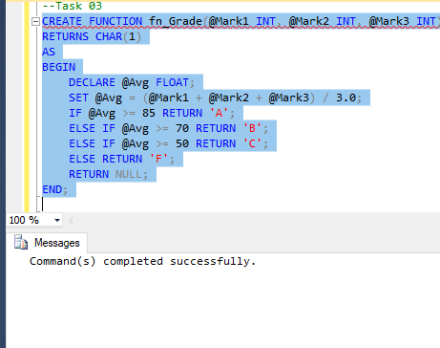
Test the function

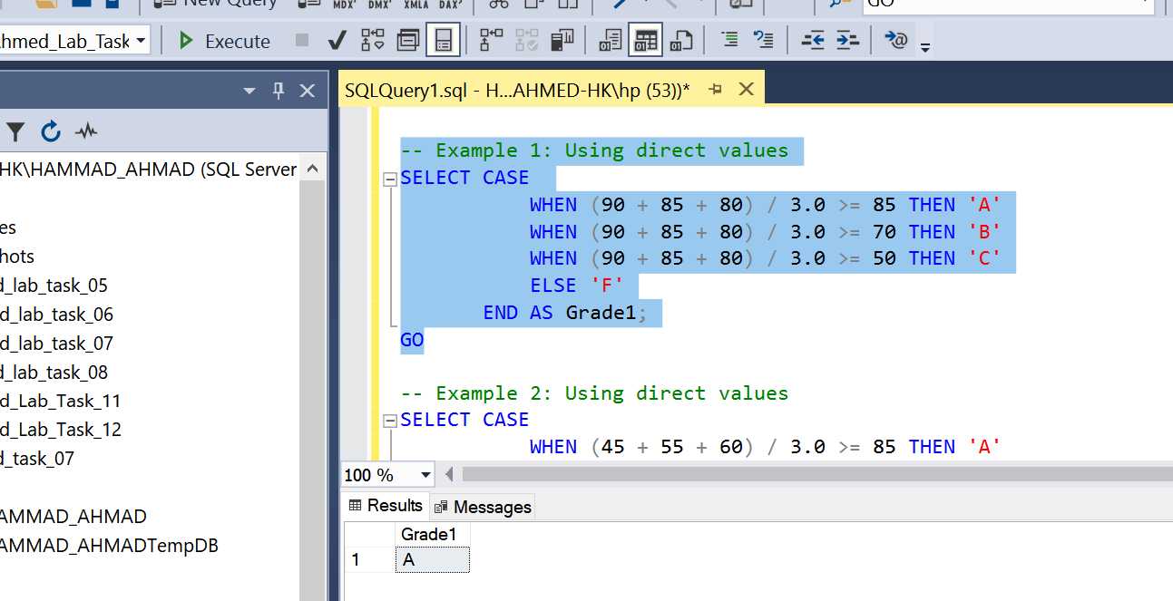

Task 04: Table-Valued Function
Function: Students by Program and CGPA Use the function
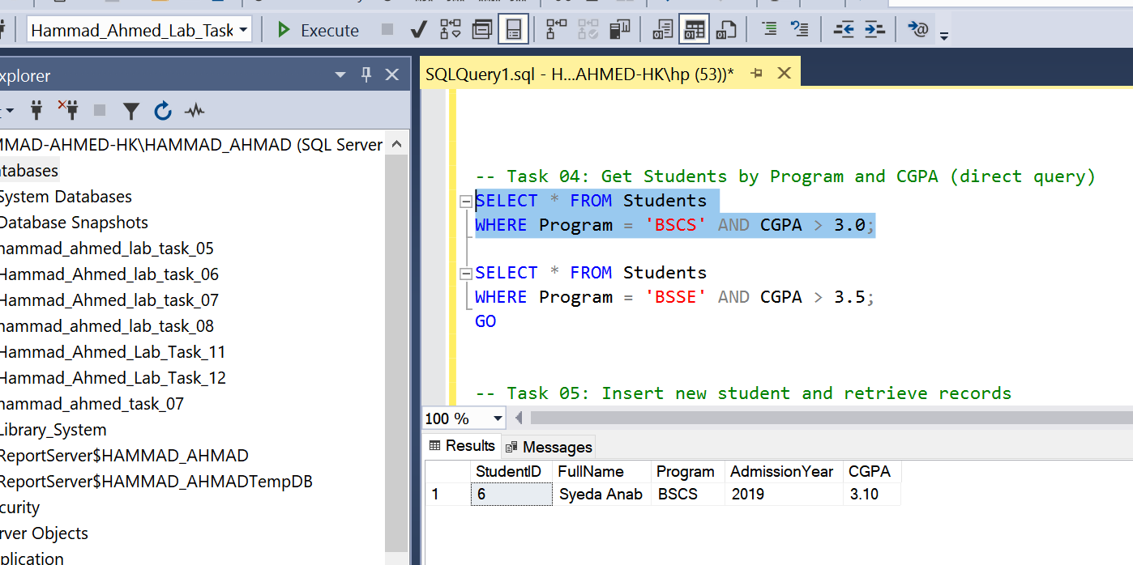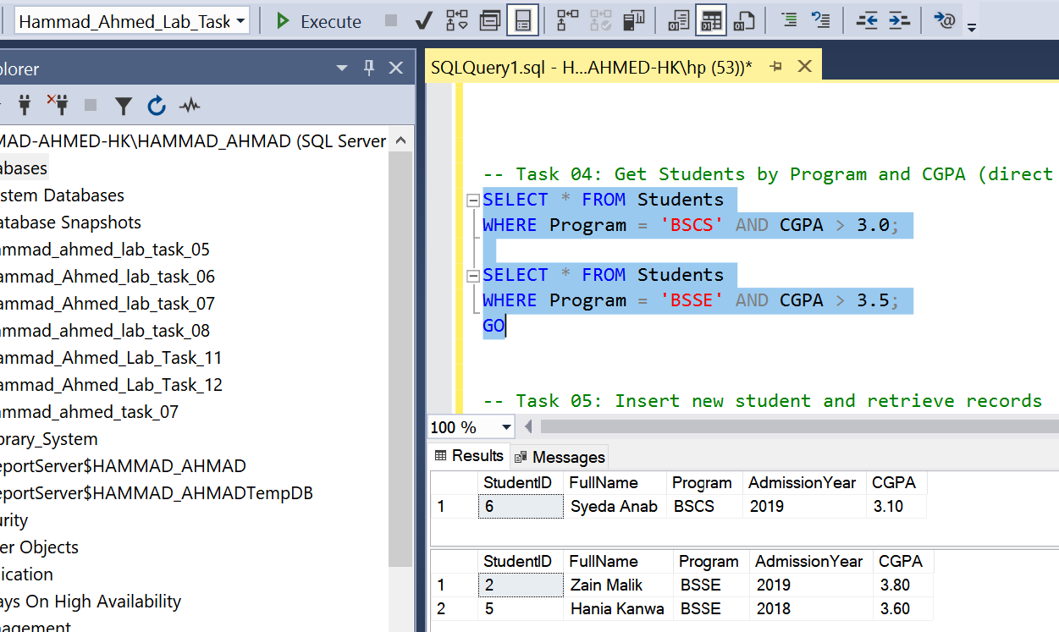

Task 05: Stored Procedure for Insertion and Retrieval
Part A: Insert Procedure
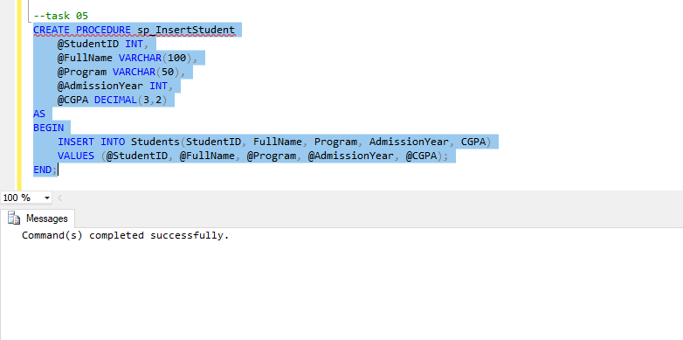

Execute Insert Procedure
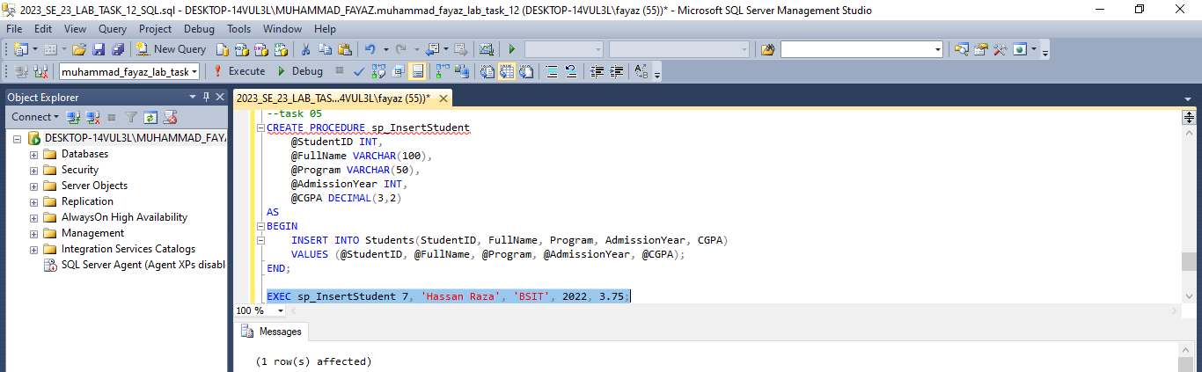
Part B: Retrieve Students Procedure
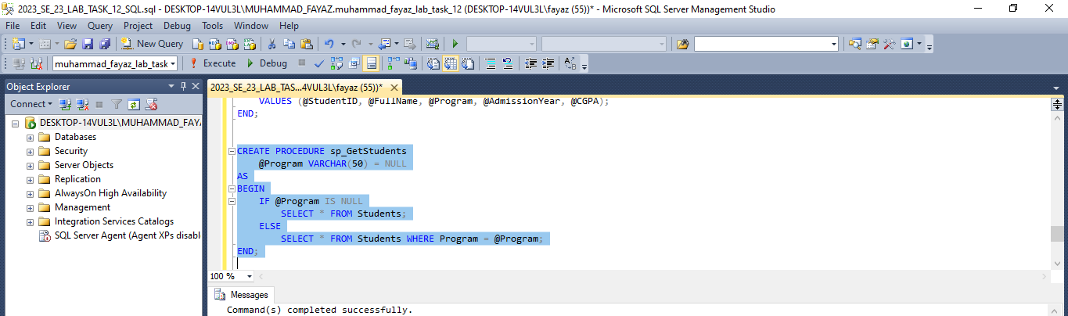
Execute Procedure
Only BSSE Students
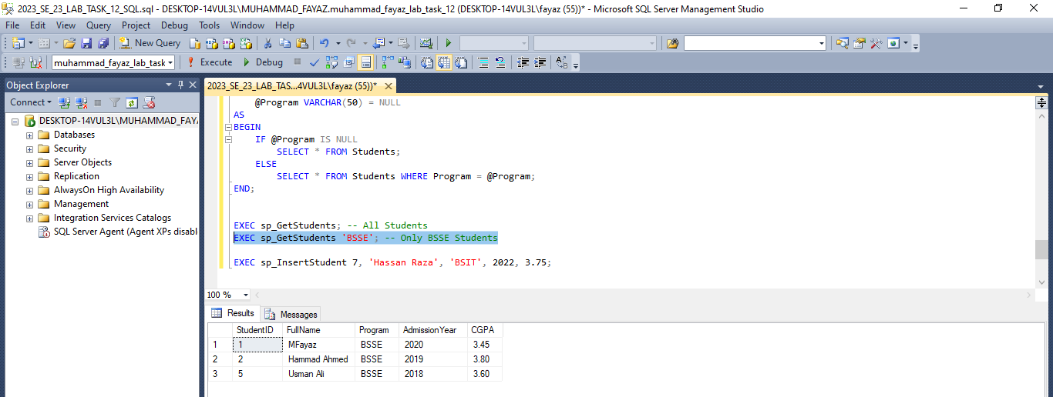
All Students:
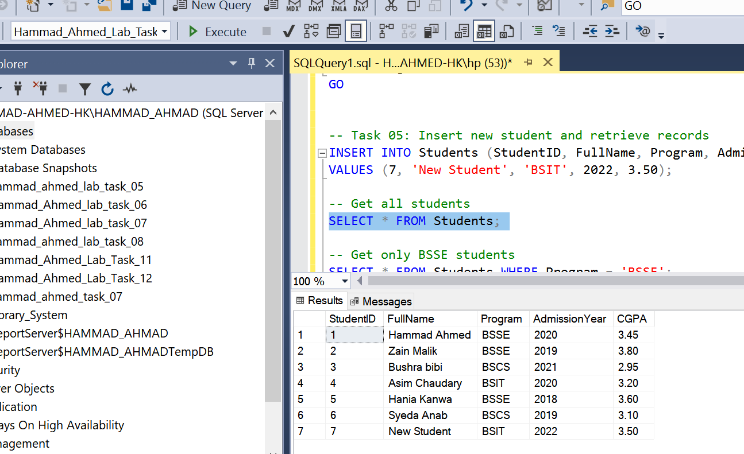

Task 06: Reflection
In this lab I gained valuable experience in creating and using scalar functions, table-valued functions, and stored procedures in SQL Server. These tasks improved my understanding of how different types of functions can be applied for solving specific problems and managing data effectively. One of the more challenging aspects was working with multiple parameters in user-defined functions, as it required careful handling and clear logical structuring. However, overcoming this difficulty strengthened my problem-solving skills and gave me a deeper understanding of how SQL Server processes queries and executes functions. Overall, this practice enhanced both my technical knowledge and my ability to design efficient database solutions.

