


The University of Azad, Jammu, and Kashmir.
Department of Software Engineering

LAB TASK 01
Name | Hammad Ahmed
Roll no | 2023-SE-01
Course Code | CS-2204
Course Instructor | Engr.Tahir Abbasi
course | Database System
Session | 2023-27

1. Lab Objective

The objective of this lab includes:
- Creating a new Access database and defining table structures
- Entering and formatting data
- Designing a form for easy way to input data
- Generating a report grouped by specific fields
- Creating queries for filtered data

2. Steps Followed

TASK 01

2.1 Creating the Database and Table
Definition: A database is an organized collection of data. In Microsoft Access, we create tables to store information in rows (records) and columns (fields).

Step-by-step:
- First I Open Microsoft Access and click on Blank Database.
- Name the file using the format: hammad_ahmed.accdb
- Click Create.

Table Creation:
- Then Switch to Design View and name the table as Student List.
- Add the following fields :
- Then I set field size and properties i.e. upper case according to which given in task.
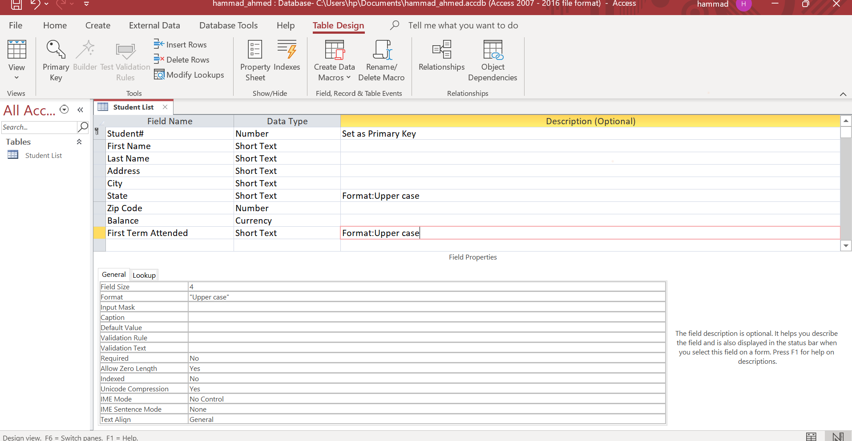

TASK 02

2.2 Entering Data in Datasheet View

Step-by-step:
- After that I Switch to Datasheet View.
- Enter the 10 student records provided, including my own and my best friend’s.
Formatting:
- Then Center-align all columns
- Change font to Times New Roman, Size 12
- Adjust column widths for readability
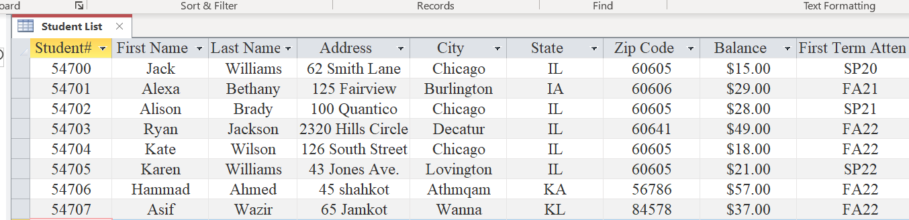

TASK 03

2.3 Creating a Form using Form Wizard
Definition: A form provides a user-friendly interface for data entry or viewing in a database.

Steps:
- For creating form I use Form Wizard, here I perform some actions includes:
- choose Student List table
- Include all fields
- Layout: Columnar
- Then I save the form with name Student Form.
- After that I Switch to Design View
- Apply Ion Theme
- Add new student records using the form.
- After entering two new student records, the records also added in table.
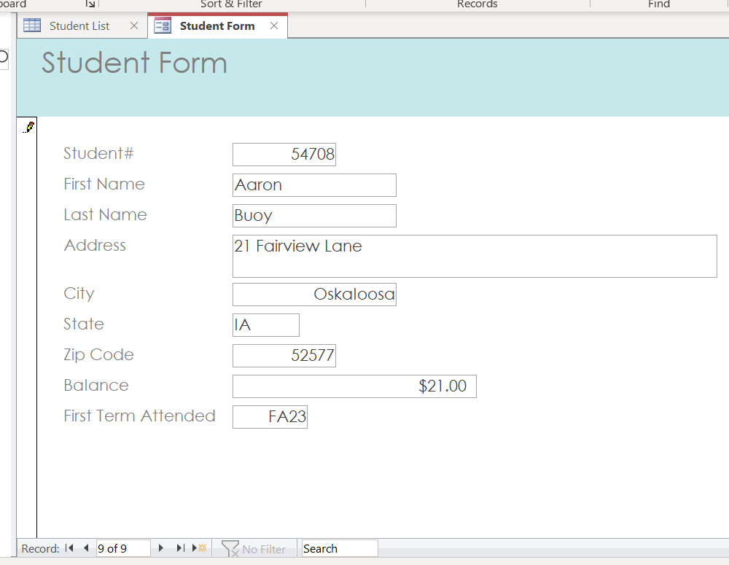

TASK 04

2.4 Creating a Report using Report Wizard
Definition: A report displays data in a formatted, printable layout. It can be grouped, sorted, and filtered.

Steps:
- After two tasks I created report using Report Wizard and perform the following asked steps in task:
- choose Student List table
- Include all fields
- Group by: First Term Attended
- Layout: Stepped
- Orientation: Landscape
- Then I save the report with name Student Report.
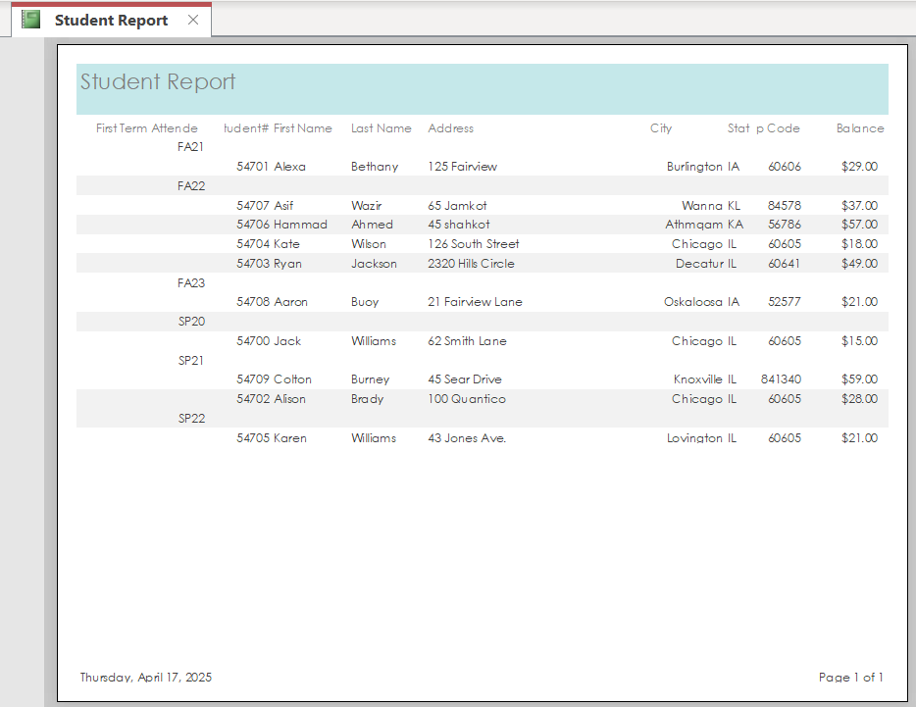

2.5 Creating Queries
Definition: A query is a request to extract specific information from the database based on certain criteria.

Query 1: Students who first attended in Fall 2022
- I create query using Simple Query Wizard
- Select Fields: Student #, First Name, Last Name,First Term Attendent.
- Criteria: First Term Attended = "FA22"
- Name: Fall_2022_Students
- Fall _2022_students query
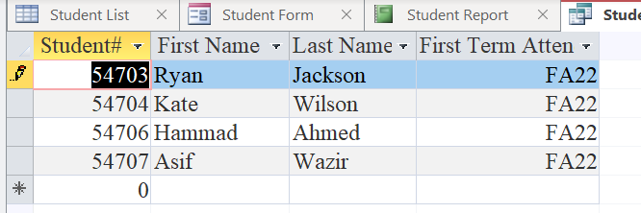

Query 2: Students with Balance > $30
- I create another query using Simple Query Wizard
- Select some mentioned field
- I set Criteria for Balance > 30
- Save the query with name Balance_over_$30.
- Balance _over _$30 query :
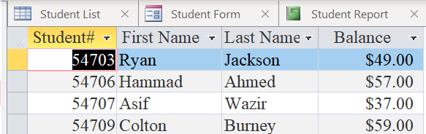
THE END

