★ ★ ★
HUMAN COMPUTER INTERACTION
Department of Software Engineering
─────────────────────────────
Academic Session 2023 – 2027
Lab Task:03

Lab Task | 03
Course / Subject | Human Computer Interaction
Submitted By | Hammad Ahmed
Roll No. | 2023-SE-01
Submitted To | Engr Sidra Rafiqe
Department | Software Engineering
Institution | UAJK
Submission Date | 28-Apri-l 2026

Select Application And work on it

Table of Contents
Q no 1️. What is the name of the application you selected? 3
Q no 2️. What changes do you think are needed? 3
1. Improve User Interface Simplicity 3
2. Better Tool Organization 4
3. Add Interactive Tutorials 4
4. Improve Navigation 4
5. Improve Help System 4
Q no 04. Provide the screenshot of the selected application after amendments. 5
Conclusion 7

Lab Task 03
Affinity Designer is a professional graphic design software developed by the company Serif (Europe) Ltd and now part of Canva. It is used by designers to create logos, illustrations, digital artwork, UI designs, and marketing graphics.
Affinity provides powerful tools for vector design, photo editing, and layout creation in a single platform. The software is known for its fast performance, user-friendly interface, and professional design features. It works on Windows, macOS, and iPad, allowing designers to work smoothly across different devices.
Many graphic designers prefer Affinity because it offers high-quality design tools without requiring a monthly subscription, making it a strong alternative to other professional design programs.
Source: Affinity https://share.google/vZFS6440pM5lzn88j

Q no 1️. What is the name of the application you selected?
Answer:
The selected application is Affinity by Canva.
Affinity is a professional graphic design and photo editing software used to create illustrations, edit images, design logos, posters, brochures, and digital graphics. It combines tools for vector design, photo editing, and page layout in one platform which makes it very powerful for designers.
It works on Windows and Mac computers and allows users to create professional designs without switching between different applications.

Q no 2️. What changes do you think are needed?
Answer:
Some improvements that can make the Affinity interface better are:

1. Improve User Interface Simplicity
The interface contains many tools which can be confusing for beginners.
A simpler beginner mode should be added for new users.

2. Better Tool Organization
Some tools are grouped in complex menus.
Tools should be arranged in a clear and easy-to-understand layout.

3. Add Interactive Tutorials
New users may find it difficult to learn the software.
Adding built-in tutorials and guides will help users learn faster.

4. Improve Navigation
Switching between Vector, Pixel, and Layout workspaces can sometimes be confusing. A clearer navigation bar would improve usability.

5. Improve Help System
A quick help feature or tooltip explanations for tools would make the system easier to use.
These improvements would increase usability, learnability, and efficiency, which are important principles of Human Computer Interaction.

Q no 3️. Please paste the screenshot of the chosen application.
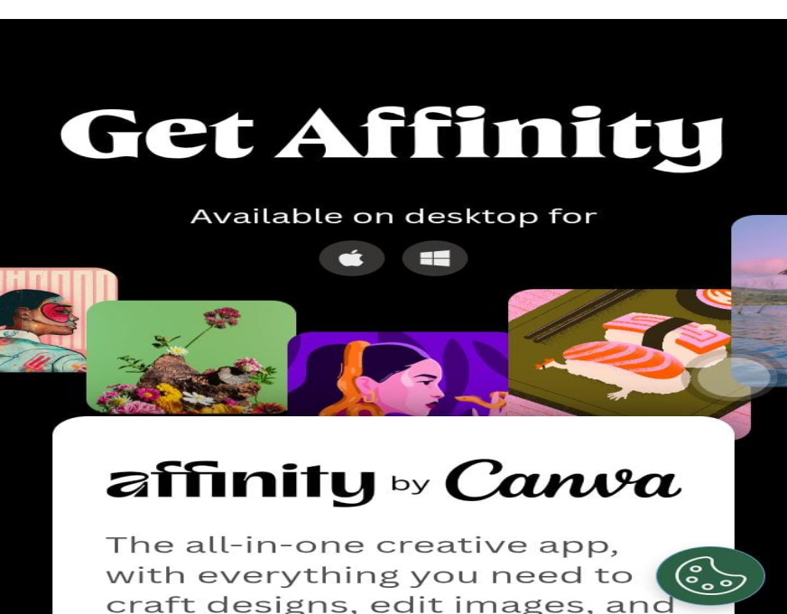

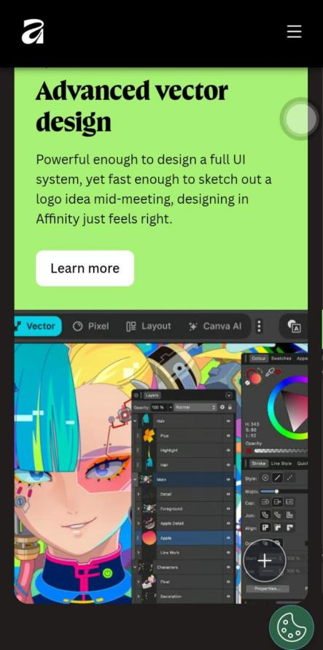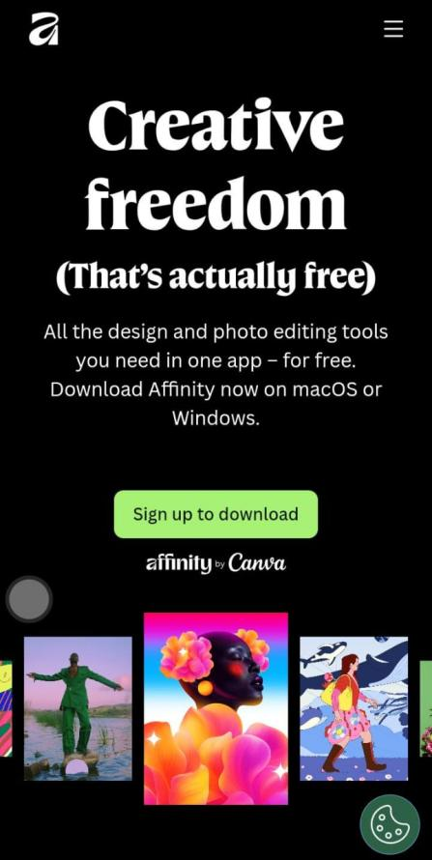

Q no 04. Provide the screenshot of the selected application after amendments.
Answer:
After improvements, the interface could look like this:
Suggested changes in amended interface:
- Simplified toolbar
- Clear navigation menu
- Beginner mode toggle
- Tooltips for tools
- Quick tutorial button
Example changes:
Original Interface → Many tools and complex menus
Amended Interface → Clean layout with grouped tools and help tips
For the assignment you can edit the screenshot in PowerPoint, Canva, or Paint and show:
- Labels for tools
- Arrows pointing to improvements
- Text explaining UI changes
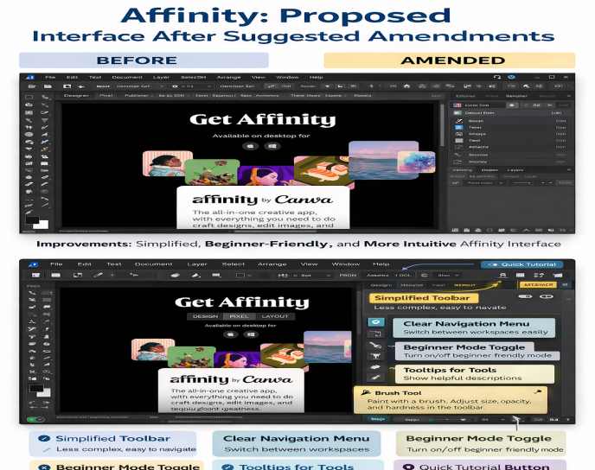

Conclusion
In conclusion, Affinity Designer is a powerful and modern graphic design software used for creating professional digital artwork, illustrations, and image editing. It provides many useful tools that help designers work efficiently and produce high-quality designs.
Although the software offers advanced features and good performance, some improvements such as a simpler interface, better navigation, and beginner tutorials can make it easier for new users. By improving usability and user experience, the software can become more accessible and efficient for both beginners and professional designers.
Overall, Affinity is a reliable and effective graphic design application that supports creative work and follows many important principles of Human Computer Interaction (HCI).

THE END !

