★ ★ ★
HUMAN COMPUTER INTERACTION
Department of Software Engineering
─────────────────────────────
Academic Session 2023 – 2027
Lab Task:01

Lab Task | 01
Course / Subject | Human Computer Interaction
Submitted By | Hammad Ahmed
Roll No. | 2023-SE-01
Submitted To | Engr Sidra Rafiqe
Department | Software Engineering
Institution | UAJK
Submission Date | 28-Apri-l 2026

Guideline Mapping on Namal University Website

Table of Contents
1. Introduction 4
Objectives of This Lab: 4
Task 1: Guideline Mapping on Namal University Website 4
Detailed Usability Evaluation 5
1. Visibility of System Status 5
2. Match between System & Real World 5
3. User Control & Freedom 5
4. Consistency & Standards 5
5. Error Prevention 5
6. Recognition Rather Than Recall 6
7. Flexibility & Efficiency 6
8. Aesthetic & Minimalist Design 6
9. Error Recovery 6
10. Help & Documentation 6
Overall Evaluation: 8/10 6
Task 2: Guideline Mapping on Higher Education Commission Website 7
Detailed Usability Evaluation 7
1. Visibility of System Status 7
2. Match between System and Real World 7
3. Information Architecture & Cognitive Load 8
4. Consistency and Standards 8
5. Error Prevention and Feedback 8
Overall Evaluation (Task 2) 8
Strengths: 9
Weaknesses: 9
Task 3: Heuristic-Based Scoring of National Database and Registration Authority Website
Detailed Heuristic Scoring 9
1. Visibility of System Status – 4/5 9
2. Match with Real World – 4/5 10
3. User Control and Freedom – 3/5 10
4. Consistency – 4/5 10
5. Error Handling – 4/5 10
Total Score: 19/25 10
Advanced Analysis 10
Task 4: Guideline Mapping on Federal Board of Intermediate and Secondary Education Website 10
Detailed Evaluation 11
1. Visibility 11
2. Aesthetic and Minimalist Design 11
3. Consistency Issues 11
4. Cognitive Load 12
Conclusion (Task 4) 12
Task 5: Desktop Certificate Template Application 12
Current Interaction Design 12
Design Problems 13
1. Recognition Overload 13
2. Efficiency Issues 13
3. Lack of Categorization 13
4. Poor Feedback 13
Recommended Redesign 13
Reflection: 13

Guideline Mapping & Usability Evaluation

1. Introduction
Human Computer Interaction (HCI) is the study of how users interact with computer systems and how interfaces designed to improve usability, efficiency, and satisfaction.
In this lab, usability guideline checklist (based on Nielsen’s Heuristics and interface mapping principles) applied to evaluate real-world websites and interfaces.

Objectives of This Lab:
- Apply usability guidelines on real interfaces
- Identify strengths and weaknesses
- Analyze mapping between user expectations and system behavior
- Evaluate cognitive load and design consistency
- Suggest improvements

Task 1: Guideline Mapping on Namal University Website
URL: https://www.namal.edu.pk
Your task is to apply the mapping of the guideline’s checklist to the interface of the selected.
Namal University https://www.namal.edu.pk website as shown in the Figure.
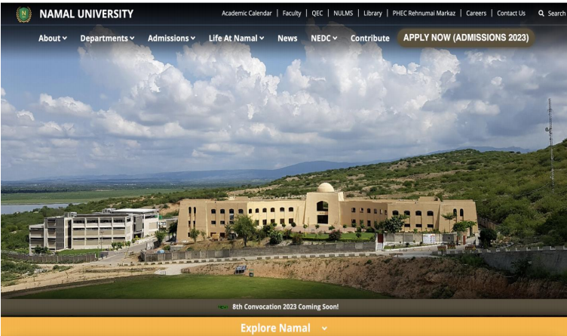
Figure 1: Namal University

Detailed Usability Evaluation

1. Visibility of System Status
The active navigation tab is clearly highlight. Announcements and updates are display on homepage. Hover effects provide interaction feedback.
- Users are aware of their current location and system response.
- Feedback provided in reasonable time.

2. Match between System & Real World
The structure reflects real academic hierarchy:
- Admissions
- Programs
- Faculty
- Research
Terminology is familiar to students and parents.
- Strong conceptual mapping.
- Natural interaction flow.

3. User Control & Freedom
Users can navigate easily through top menu. However:
- Breadcrumb navigation missing.
- No quick “Back to Top” in long pages.
Slight limitation in user freedom.

4. Consistency & Standards
- Uniform typography
- Same layout structure
- Standard button styling
- Predictable navigation
Interface learning is easy due to consistency.

5. Error Prevention
Forms mark required fields. However:
- Real-time validation limited.
- Errors appear mostly after submission.
Inline validation can improve usability.

6. Recognition Rather Than Recall
Navigation menus visible at all times. Footer repeats important links.
- User does not need to memorize paths.
- Low memory burden.

7. Flexibility & Efficiency
Basic search available. However:
- No advanced filters.
- No personalization.
Expert user efficiency can improve.

8. Aesthetic & Minimalist Design
Clean academic theme. Proper spacing. Balanced layout.
- Reduced cognitive load.
- Professional appearance.

9. Error Recovery
Basic error messages provided but:
- Not descriptive.
- No clear correction guidance.
Error messages can be more helpful.

10. Help & Documentation
FAQ section available. Contact details accessible.
Moderate user support.

Overall Evaluation: 8/10
Well-designed academic website with minor usability improvements required

Task 2: Guideline Mapping on Higher Education Commission Website
URL: http://hec.gov.pk/english/Pages/Home.aspx
Your task is to apply mapping of guidelines checklist shown in figure 1 on the interface of selected HEC http://hec.gov.pk/english/Pages/Home.aspx Website as shown in Figure.
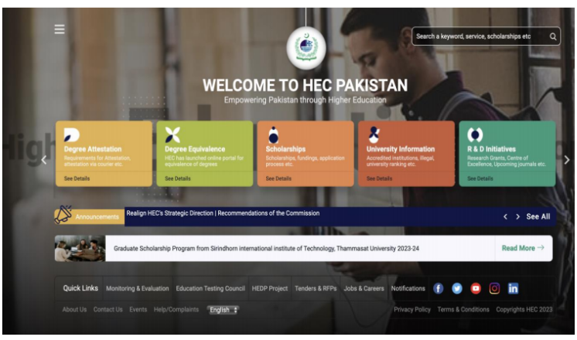
Figure 2: HEC Website Interface

Detailed Usability Evaluation

1. Visibility of System Status
The homepage displays news updates, announcements, and highlighted notices. Important government updates are visible.
However:
- Multiple scrolling sections make prioritization unclear.
- Important information competes visually with other elements.
Analysis: While visibility exists, the lack of clear prioritization reduces effectiveness.

2. Match between System and Real World
Sections such as:
- Scholarships
- Degree Attestation
- Universities
- Accreditation
Reflects real government education services.
Analysis: The conceptual mapping is strong and aligned with real-world processes.

3. Information Architecture & Cognitive Load
The homepage contains:
- Large mega menus
- Multiple content blocks
- Numerous quick links
This leads to:
- Information overload
- Increased scanning effort
- Slower decision-making
This violates Hick’s Law, which states that more choices increase decision time.
Impact: High cognitive load for first-time users.

4. Consistency and Standards
- Color theme consistent with government branding.
- However, font hierarchy and spacing lack clarity.
- Some sections visually compete for attention.
Improvement needed better visual hierarchy and spacing.

5. Error Prevention and Feedback
Forms are structured, but:
- Real-time validation is limited.
- Error messages appear mostly after submission.
Recommendation: Inline validation would improve usability.

Overall Evaluation (Task 2)

Strengths:
- Clear service categorization
- Government standard consistency

Weaknesses:
- Cluttered homepage
- High cognitive load
- Weak prioritization

Task 3: Heuristic-Based Scoring of National Database and Registration Authority Website
URL: https://www.nadra.gov.pk
Your task is to assign scores according to guidelines checklist shown in figure 1
On the interface of selected BBC https://www.nadra.gov.pk/ website

Figure 3: NADRA Website Interface

Detailed Heuristic Scoring

1. Visibility of System Status – 4/5
Service categories are clearly display. Tracking features are available for applications.
Minor issue: Some pages are text-heavy.

2. Match with Real World – 4/5
Workflow follows real-life procedures:
Apply → Pay → Track → Collect
Logical process mapping improves understanding.

3. User Control and Freedom – 3/5
Multi-step forms are lengthy. Users cannot easily jump between steps.
Efficiency could be improve.

4. Consistency – 4/5
Modern layout and consistent color scheme maintained.

5. Error Handling – 4/5
Validation present in forms. Instructions are generally clear.
However, some error messages lack specificity.

Total Score: 19/25

Advanced Analysis
- Good implementation of Fitts’s Law (large buttons).
- Clear call-to-action design.
- Multi-step process increases task completion time.

Task 4: Guideline Mapping on Federal Board of Intermediate and Secondary Education Website
URL: https://www.fbise.edu.pk/website
Your task is to apply mapping of guidelines checklist shown in figure 1 on the Interface of FBISE https://www.fbise.edu.pk/website

Figure 4: FBISE Website Interface

Detailed Evaluation

1. Visibility
Exam announcements and results are visible on the homepage.
Positive aspect: Important academic updates are easy to locate.

2. Aesthetic and Minimalist Design
The interface appears visually outdated.
Issues include:
- Limited white space
- Weak contrast
- Dense content
Violates modern UI aesthetic principles.

3. Consistency Issues
- Font sizes vary inconsistently.
- Alignment irregular in some sections.

4. Cognitive Load
Homepage contains dense content blocks with limited visual differentiation.
Users must spend extra effort scanning.

Conclusion (Task 4)
Functionally usable but visually outdated.
Modern UI redesign recommended.

Task 5: Desktop Certificate Template Application
Here is the screenshot of a desktop application in which you can select a Certificate template and then print it. To select a template, you go through the Scroll bar and then choose the template that you like. Discuss if this is a good Design, if not what are some of the main problems with the design.

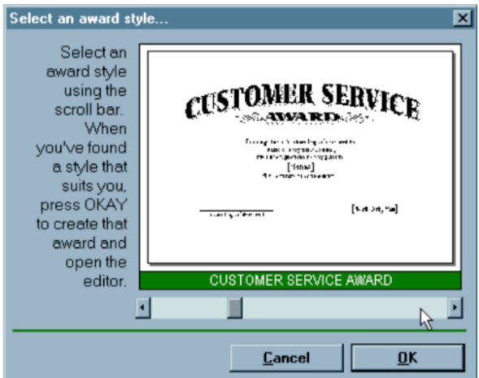
Figure 5: Desktop Application

Current Interaction Design
Users scroll vertically through templates to select one.

Design Problems

1. Recognition Overload
Long scrolling list increases cognitive effort.
Violates “Recognition Rather Than Recall”.

2. Efficiency Issues
Scrolling through many templates is time-consuming.
Violates “Flexibility and Efficiency of Use”.

3. Lack of Categorization
Templates are not group by type (e.g., Academic, Award, Participation).

4. Poor Feedback
No immediate large preview before final selection.

Recommended Redesign
- Grid-based template layout
- Filter and search options
- Category-based organization
- Live preview panel
This would significantly improve usability and efficiency.

Reflection:
This lab demonstrates that:
- Minimalism improves clarity
- Proper mapping reduces errors
- Visual hierarchy guides attention
- Error prevention increases trust
- Consistency enhances learnability
The practical evaluation of these systems provided strong understanding of real-world usability principles.
Thanks

