★ ★ ★
HUMAN COMPUTER INTERACTION
Department of Software Engineering
─────────────────────────────
Academic Session 2023 – 2027
Lab Task:02

Lab Task | 02
Course / Subject | Human Computer Interaction
Submitted By | Hammad Ahmed
Roll No. | 2023-SE-01
Submitted To | Engr Sidra Rafiqe
Department | Software Engineering
Institution | UAJK
Submission Date | 28-Apri-l 2026

UI Design for login and Registration pages

Table of Contents

UI Design for Login and Registration Pages 2
1. Introduction 2
2. Tool Used 2
3. Target Application 2
4. Login Page Design 2
Screenshot: 2
5. Registration Page Design 3
Screenshot: 3
6. UI Improvements 4
7. Conclusion 4

UI Design for Login and Registration Pages

1. Introduction
User Interface (UI) design is important for creating applications that are easy to use and visually appealing. In this task, login and registration pages designed using Figma. The goal was to create a simple and user-friendly interface that allows users to easily sign in or create a new account.

2. Tool Used
Figma used to design the user interface. It is a popular UI/UX design tool used for creating layouts, prototypes, and application designs.

3. Target Application
The designed pages are for a Task Management Application.
This app helps users manage their daily tasks, track productivity, and organize their schedules. Users must first create an account and then log in to access the application.

4. Login Page Design
The login page allows existing users to access their accounts.
Main components:
- Email input field
- Password input field
- Login Now button
- Link to create a new account

Screenshot:
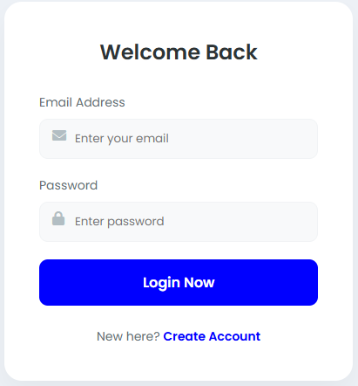
The layout is simple and clean, making it easy for users to quickly log in.

5. Registration Page Design
The registration page allows new users to create an account.
Main components:
- Full name field
- Email field
- New password field
- Register Now button
- Link to login for existing users

Screenshot:

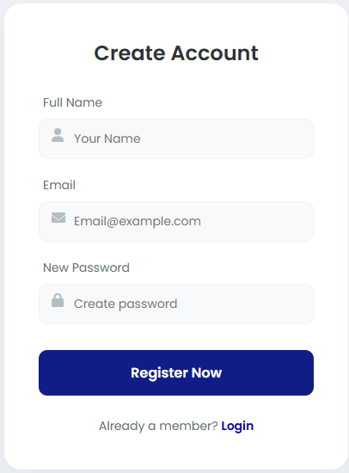
The design ensures that users can register quickly and easily.

6. UI Improvements
Many existing login pages are complex and difficult to use. The improvements in this design include:
- Minimal layout for better user experience
- Clear buttons for login and registration
- Icons in input fields for better understanding
- Easy navigation between login and registration pages

7. Conclusion
The login and registration pages successfully designed using Figma. The interface is simple, clean, and user-friendly, which improves usability and provides a better user experience.

The End…

