★ ★ ★
HUMAN COMPUTER INTERACTION
Department of Software Engineering
─────────────────────────────
Academic Session 2023 – 2027
Lab Task:05

Lab Task | 05
Course / Subject | Human Computer Interaction
Submitted By | Hammad Ahmed
Roll No. | 2023-SE-01
Submitted To | Engr Sidra Rafiqe
Department | Software Engineering
Institution | UAJK
Submission Date | 28-Apri-l 2026

Nibbler’s Analysis

Task 1: Nibbler Analysis — AJKU Website
Website URL: http://uajku.edu.pk/
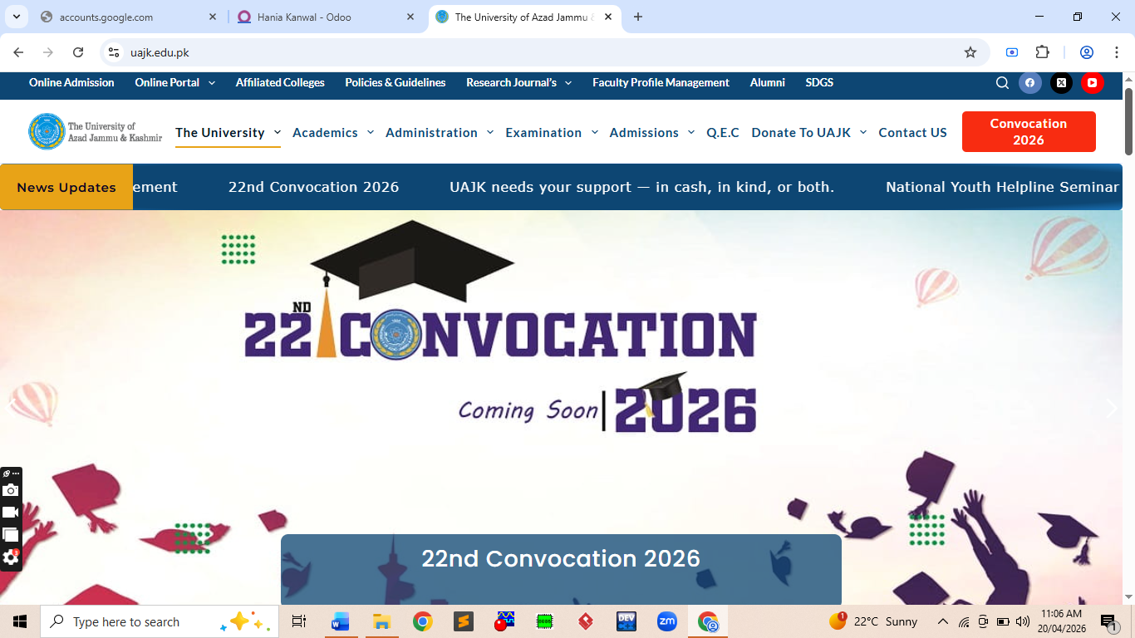

Objective
To evaluate the AJK University (AJKU) website using the Nibbler tool metrics and map them against standard usability guidelines. The evaluation examines ten key dimensions of web quality and usability, identifying areas of strength and weakness in the current implementation.

Guidelines Reference Table
The following table outlines the ten standard guidelines used in the Nibbler evaluation framework:

Guidelines | Description
Printability | Determines if a website is suitable for printing.
Mobile | Checks if the website is optimized for mobile devices.
Meta Tags | Checks for metadata presence (e.g., descriptions).
Images | Checks image formats and HTML attributes.
Internal Links | Checks how a website links to other pages.
URL Format | Checks if the format of URLs is appropriate.
Heading | Checks for appropriate use of headings.
Page Title | Checks whether <title> tags are used correctly.
Freshness | Checks how recently a website was updated.
Server | Checks server configurations and HTTP responses.

Nibbler Evaluation — Detailed Mapping Results
The table below presents the complete mapping of each Nibbler guideline applied to the AJKU website, along with detailed observations:

Guidelines | Description | Mapping Results
Printability | Determines if a website is suitable for printing. | The website lacks a dedicated print stylesheet. Printing pages such as admissions or notices results in cluttered layouts with unnecessary background elements, reducing readability.
Mobile | Checks if the website is optimized for mobile devices. | The website shows partial responsiveness. Some sections (especially tables and notices) overflow on smaller screens, requiring horizontal scrolling.
Meta Tags | Checks for metadata presence (e.g., descriptions). | Basic meta tags are present; however, several internal pages lack proper meta descriptions, negatively affecting SEO and discoverability.
Images | Checks image formats and HTML attributes. | Images are not fully optimized. Some lack alt attributes, reducing accessibility and impacting screen reader usability. Large images also slow page loading.
Internal Links | Checks how a website links to other pages. | Internal linking is functional but not fully optimized. Some links lead to outdated or irrelevant pages, causing user frustration.
URL Format | Checks if the format of URLs is appropriate. | URLs are moderately structured but include unnecessary parameters in some cases, reducing readability and memorability.
Heading | Checks for appropriate use of headings. | Improper use of heading hierarchy. Some pages use styling instead of semantic tags (H1, H2), affecting accessibility and SEO.
Page Title | Checks whether <title> tags are used correctly. | Titles are present but not always unique across pages, which may confuse users and affect browser navigation.
Freshness | Checks how recently a website was updated. | Content is updated occasionally, but some sections (like notices) contain outdated information.
Server | Checks server configurations and HTTP responses. | Server performance is acceptable but not optimized. HTTPS is implemented, but response times can be improved.

Conclusion — Task 1
The AJKU website demonstrates basic functionality but lacks modern optimization in several critical areas. The following key issues were identified during the evaluation:

- Responsiveness: Partial mobile support; tables and notices overflow on small screens.
- Accessibility: Missing alt attributes on images and improper heading hierarchy reduce screen reader usability.
- Performance: Unoptimized images and slower server response times affect overall page loading speed.
- SEO & Discoverability: Missing meta descriptions on internal pages reduce search engine visibility.
- Content Freshness: Some sections, particularly notices, contain outdated information.

Improvements in responsiveness, accessibility, and performance optimization would significantly enhance the overall user experience and usability of the AJKU website.

Task 2: Website Analysis — Islamabad Traffic Police
Website URL: https://islamabadpolice.gov.pk/itp/
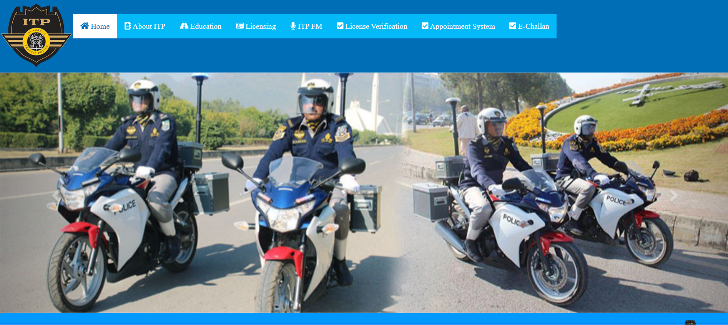

Objective
To apply the mapping of guidelines checklist on the interface of the Islamabad Traffic Police (ITP) website. This analysis evaluates the website against the ten standard usability guidelines to identify critical usability issues that affect user trust, navigation, and accessibility.

Detailed Guideline Mapping
The table below presents the complete mapping of each guideline applied to the Islamabad Traffic Police website:

Guidelines | Description | Mapping Results
Printability | Determines if a website is suitable for printing. | Poor printability. Forms and challan information pages do not adapt well when sent to a printer, wasting ink on background colors.
Mobile | Checks if the website is optimized for mobile devices. | The site has severe mobile viewport issues. Users must pinch and zoom to read text or interact with the licensing forms on smaller screens.
Meta Tags | Checks for metadata presence (e.g., descriptions). | The site lacks comprehensive meta descriptions on critical utility pages (like E-Challan), relying mostly on default title tags.
Images | Checks image formats and HTML attributes. | A significant percentage of images lack alt tags, reducing accessibility for visually impaired users. Large image file sizes slow down the homepage load time.
Internal Links | Checks how a website links to other pages. | Many internal links are hardcoded or lead to dead pages (404 errors) within the licensing verification portal.
URL Format | Checks if the format of URLs is appropriate. | URLs are somewhat complex and include unnecessary parameters (e.g., ?page_id=123), which is poor for SEO and user recall.
Heading | Checks for appropriate use of headings. | Inconsistent use of heading tags. Text sizing is often achieved through inline styling rather than proper H1/H2 semantic tags.
Page Title | Checks whether <title> tags are used correctly. | Page titles are present but often duplicated across multiple different pages, making tab navigation confusing for the user.
Freshness | Checks how recently a website was updated. | Content updates appear sporadic. While news tickers exist, core informational pages show older timestamps.
Server | Checks server configurations and HTTP responses. | The server lacks a proper HTTPS certificate implementation on all sub-pages, triggering browser security warnings for users.

Conclusion — Task 2
The Islamabad Traffic Police website demonstrates significant usability deficiencies across multiple evaluation dimensions. The following critical issues were identified:

- Poor Mobile Responsiveness: Severe viewport scaling issues requiring users to zoom and scroll excessively.
- Weak Accessibility: Large number of images missing alt tags; heading hierarchy entirely ignored.
- Broken Navigation: Multiple internal links lead to 404 error pages within the licensing portal.
- Security Concerns: Absence of HTTPS enforcement on certain sub-pages triggers browser security warnings — a critical issue for a government website.
- SEO Deficiencies: Missing meta descriptions and duplicate page titles reduce both search engine visibility and user orientation.

These combined issues significantly reduce the usability, trustworthiness, and accessibility of the website, presenting a poor digital experience for citizens who rely on it for essential traffic-related services.

Task 3: Website Analysis — UMW University
Website: UMW University — Home Page

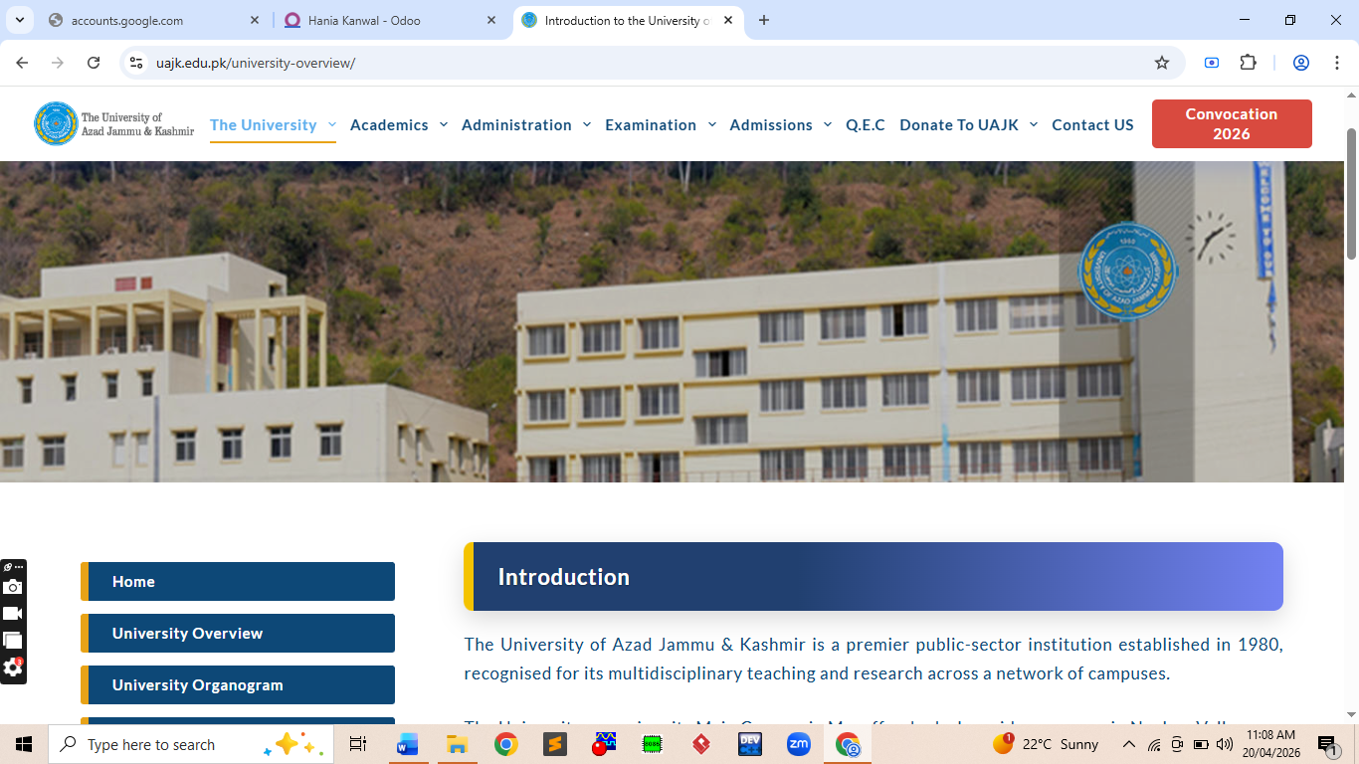

Figure 4: University Website Interface
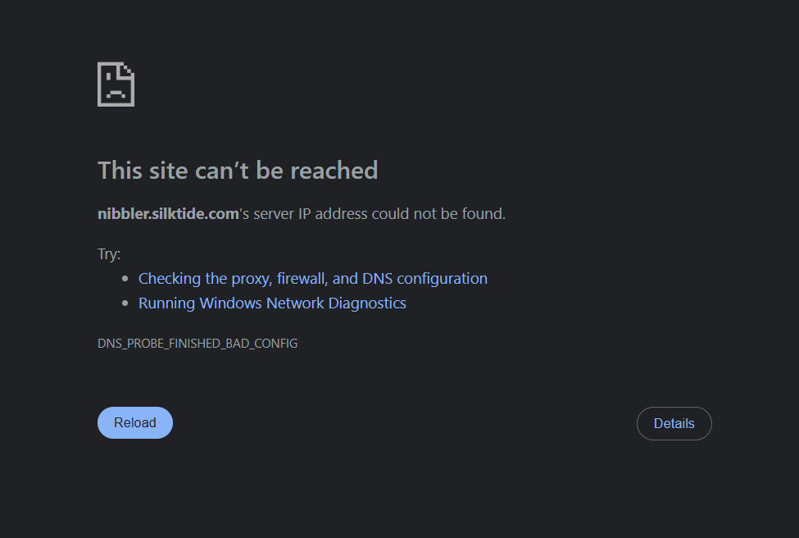

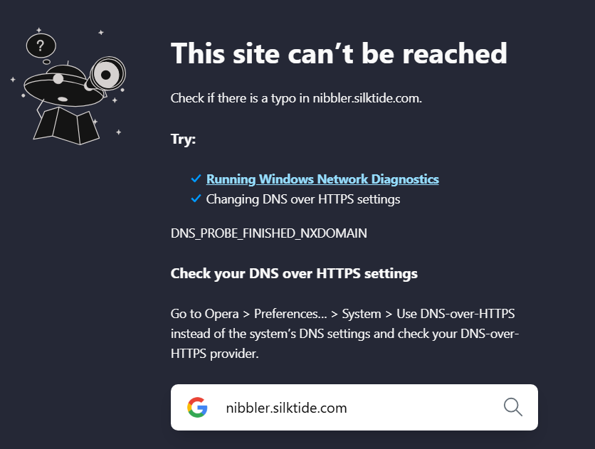

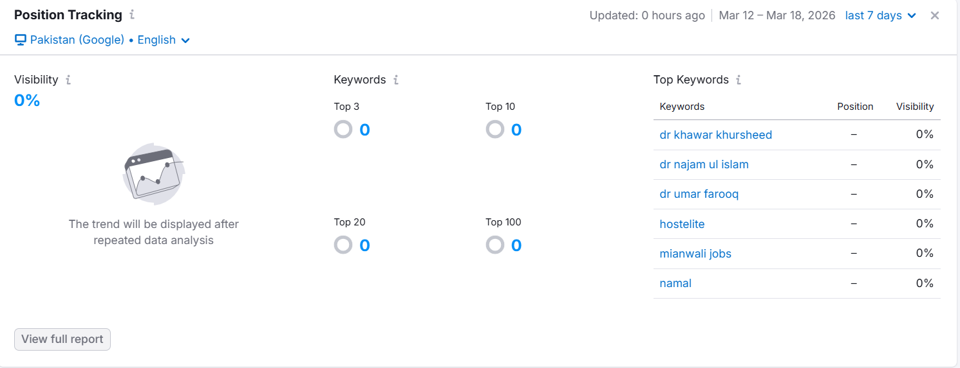
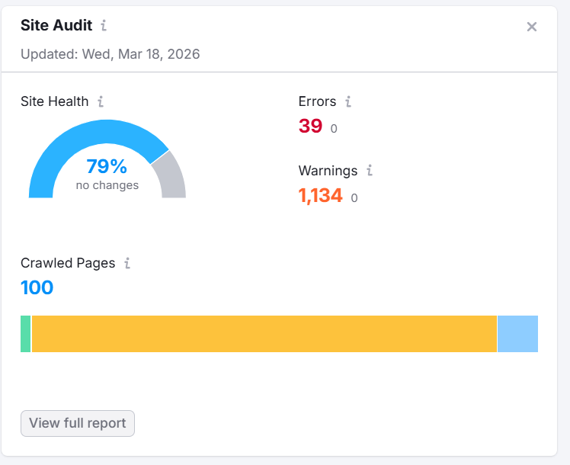
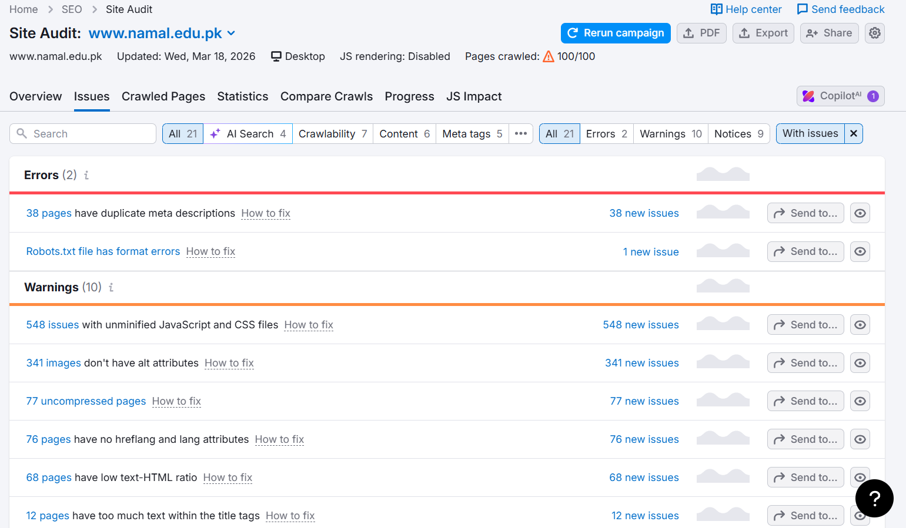

Objective
To apply the mapping of guidelines checklist on the interface of the UMW University website home page. This analysis evaluates the website against the same ten standard usability guidelines, identifying strengths in its current design and areas where minor improvements can be made.

Detailed Guideline Mapping
The table below presents the complete mapping of each guideline applied to the UMW University website:

Guidelines | Description | Mapping Results
Printability | Determines if a website is suitable for printing. | No specific print CSS detected. Printing syllabus or admission guidelines results in cluttered physical pages.
Mobile | Checks if the website is optimized for mobile devices. | The website is relatively mobile-friendly, though some large tables (like fee structures) overflow the mobile screen horizontally.
Meta Tags | Checks for metadata presence (e.g., descriptions). | Basic meta tags are present on the homepage, but deeply nested academic department pages lack specific descriptions.
Images | Checks image formats and HTML attributes. | Homepage slider images are high-resolution but lack proper compression, causing a slight delay in the First Contentful Paint (FCP).
Internal Links | Checks how a website links to other pages. | The navigation menu is heavily populated with internal links, but some deep links within the Downloads section fail to open in new tabs.
URL Format | Checks if the format of URLs is appropriate. | URL structure is clean and hierarchical (e.g., /academics/departments), which is excellent for user orientation.
Heading | Checks for appropriate use of headings. | Good semantic structure. The site correctly utilizes H1 for main page titles and H2 for sub-sections like the Vice Chancellor's Message.
Page Title | Checks whether <title> tags are used correctly. | Page titles are utilized correctly and dynamically update based on the academic department or facility being viewed.
Freshness | Checks how recently a website was updated. | High freshness score. The site is actively maintained with recent merit lists, tender notices, and news events.
Server | Checks server configurations and HTTP responses. | The server responds quickly, implements secure HTTPS protocols, and properly handles URL redirects without trailing slashes.

Conclusion — Task 3
The UMW University website demonstrates strong adherence to usability best practices, making it the highest-rated website across the three evaluations. Key strengths include:

- Clean URL Structure: Hierarchical and readable URLs that improve user orientation and SEO performance.
- Strong Navigation: Well-structured internal links provide consistent and intuitive user navigation.
- Content Freshness: Actively maintained content including merit lists, news events, and tender notices.
- Server Performance: Fast loading speeds with proper HTTPS implementation and clean URL redirect handling.
- Semantic Heading Structure: Correct use of H1 and H2 tags improves both accessibility and SEO.

Minor improvements recommended for the UMW website include: adding a print stylesheet, optimizing homepage slider images for faster loading, and ensuring all deep-level pages include relevant meta descriptions. Addressing these minor gaps would make the website an excellent benchmark for academic web design.

Final Overall Conclusion

Comparative Rankings
Based on the evaluation of all three websites across the ten Nibbler guidelines, the following overall rankings are established:

Rank | Website | Usability Level | Key Weakness
1st | UMW University | Good — Strong overall design | Print stylesheet & image optimization
2nd | AJKU Website | Average — Basic functionality works | Accessibility & responsiveness
3rd | ISB Traffic Police | Poor — Multiple critical failures | Broken links, HTTPS & mobile

Key Learning Outcomes
This lab assignment demonstrates the practical application of HCI evaluation principles to real-world web interfaces. The evaluation reveals a clear pattern of neglected usability fundamentals, particularly in public sector and academic websites. The following key learning outcomes were derived:

- Good UI design fundamentally requires responsiveness, accessibility, and proper semantic structure to serve diverse user needs.
- Poor design choices — such as broken internal links, missing HTTPS, and absent alt text — directly lead to user frustration and a loss of trust.
- Applying structured HCI guidelines such as the Nibbler framework provides measurable, actionable insights for improving digital products.
- Accessibility standards (WCAG) are largely overlooked across all three evaluated websites, representing a systemic gap that must be addressed.
- Government websites carry an additional responsibility to maintain high usability and security standards, as citizens depend on them for essential services.

