Project Report

Automation Framework

End-to-end

By

Hammad Tahseen Mughal: 18k-1076

Anas Aziz: 18k-1090

Hasan Salman: 18k-1101

Submitted

To

Sir Amir Imam

**Abstract**

The Framework automates the process of placing an order on the website named Swaglabs from End-to-end.

**Framework**

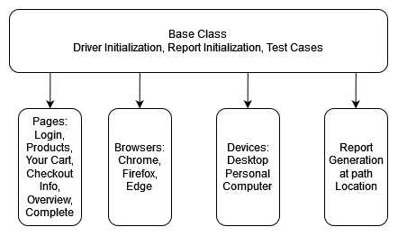

**Navigation**

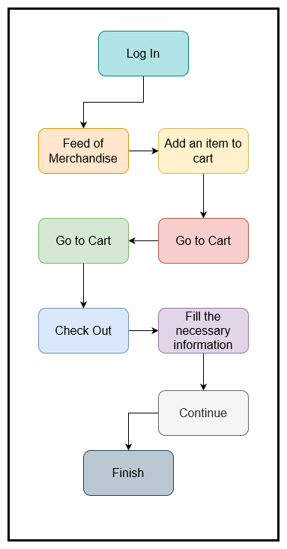

**Testing Methodology**

**Log In**

First enter a user and pass for in the respective fields and logging in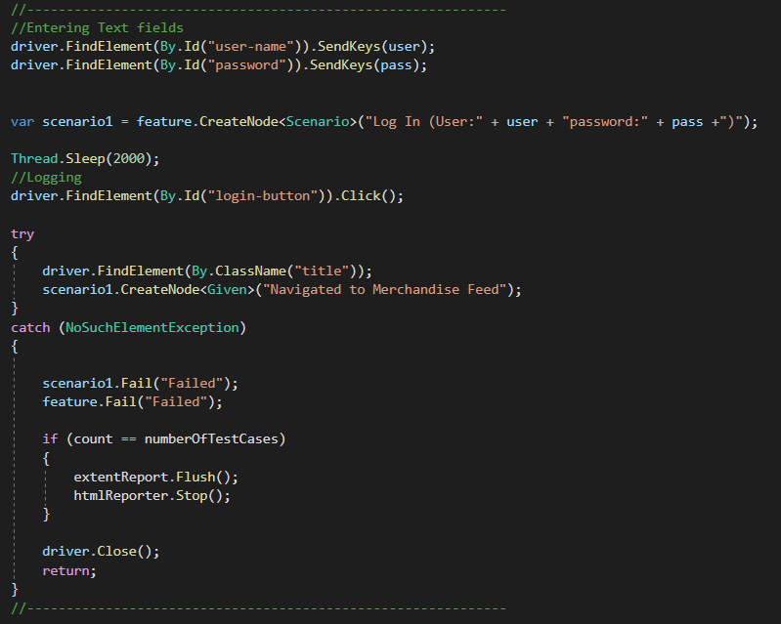

**Products and Checkout**

Checking if we have arrived on the right page and adding the product to the cart and clicking on the cart and checkout

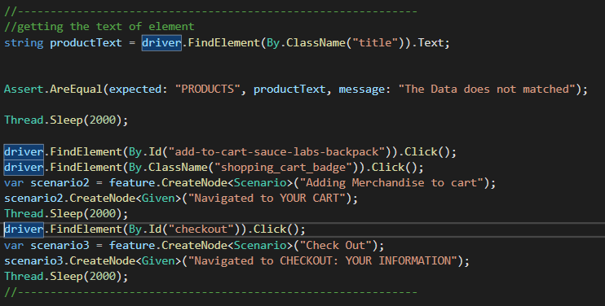

**Checkout: Information**

Entering relevant information in the First Name, Last Name and Zip/postal code fields and checking if arrived at the Overview

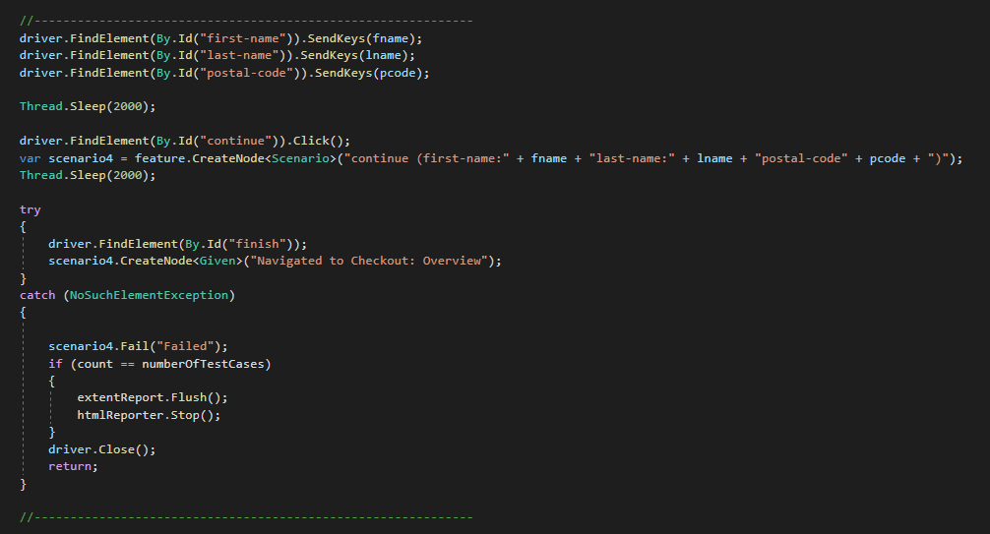

**Finish**

Finally clicking on the finish page and and navigating to Complete with the message THANK YOU FOR YOUR ORDER

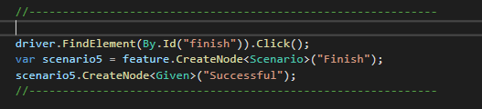

**Report Generation**

After executing multiple test cases the following the report was generated with the information if the test case was passed or failed and where it failed.

First test case passed

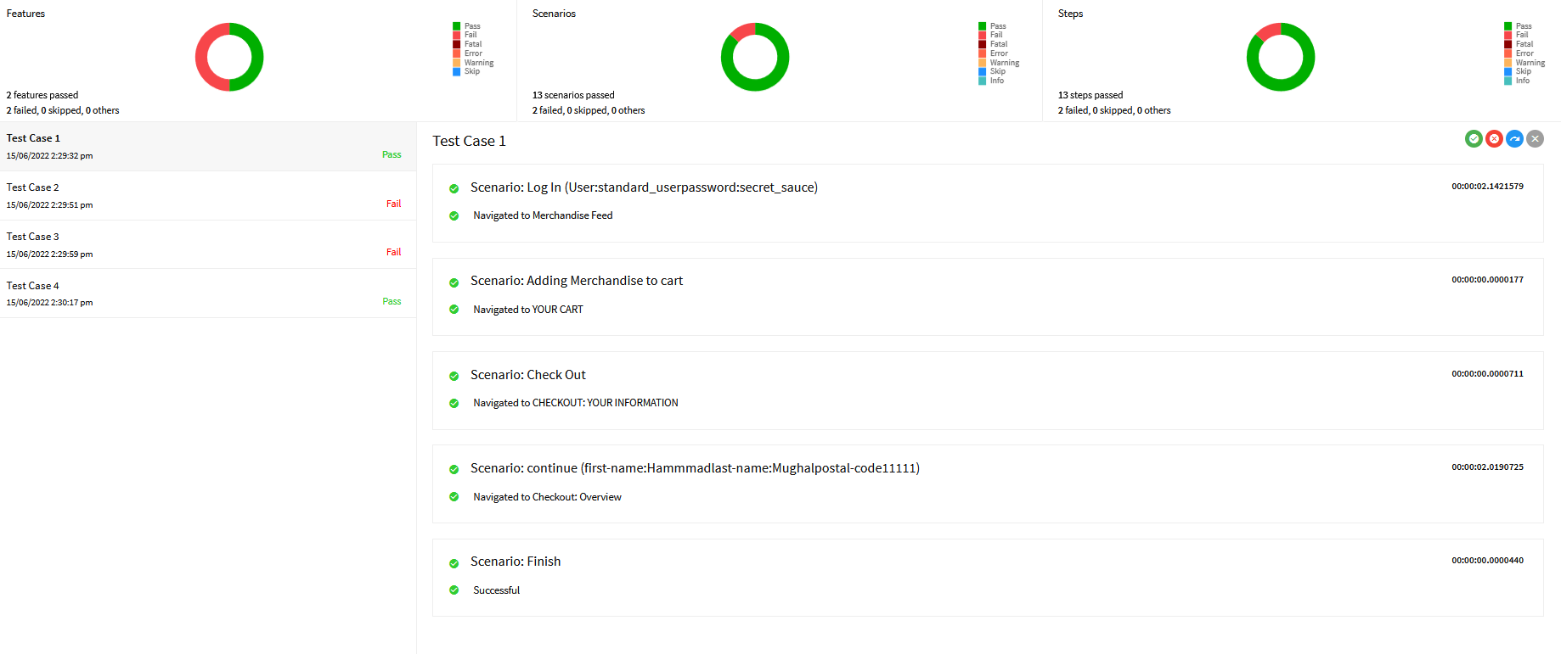

Second test case failed at login after entering wrong information particularly user

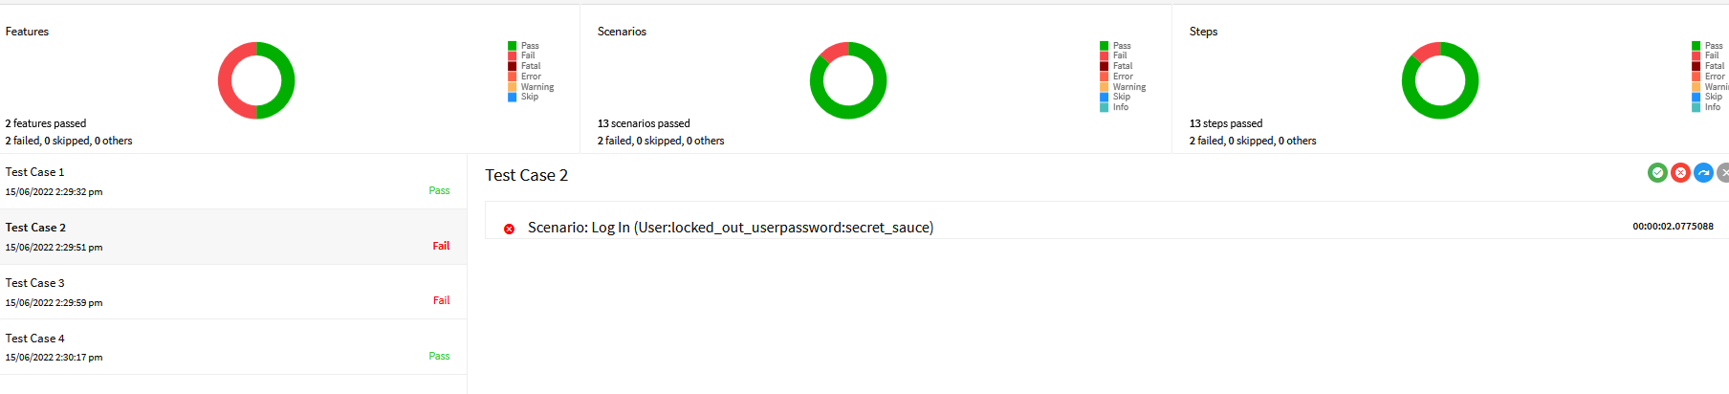

Third case failed at the checkout information

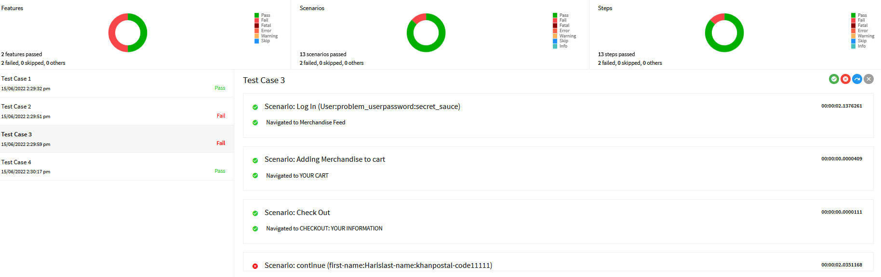

Fourth cased passed at every step

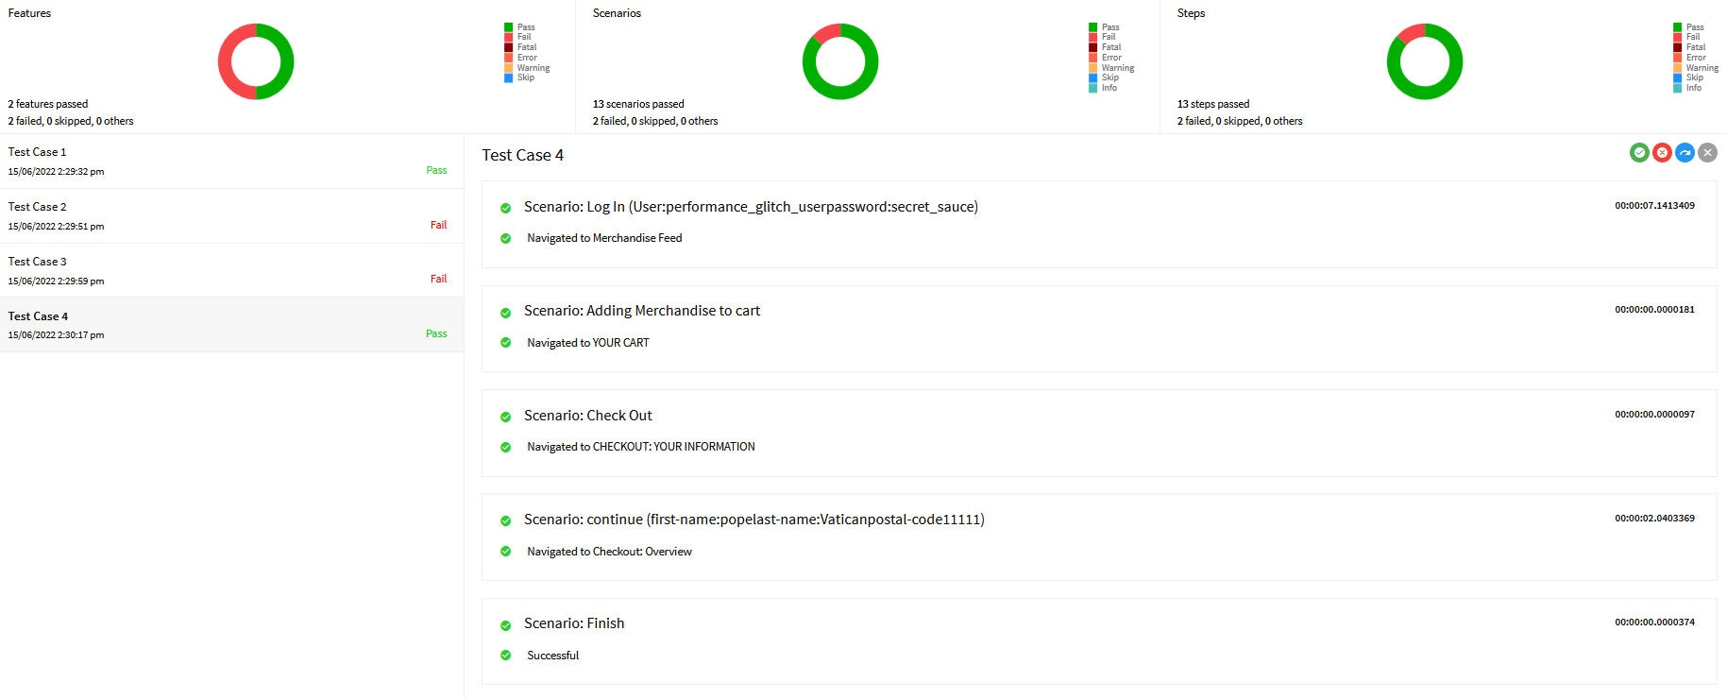

**Conclusion**

This automated testing framework is end-to-end testing from login to pacing and order and checkout. This framework helps in executing testing cases with testing the site manually.