Project Report

Automation Framework

End-to-end

By

Hammad Tahseen Mughal: 18k-0176

Anas Aziz: 18k-0176

Hasan Salman: 18k-1101

Submitted

To

Sir Amir Imam

Conducting tests on Various Fields

**Submitting Form**

Testing by entering different information in different fields. Fields includes simple textbox, option menu, date selection from Calendar, radio buttons and suggestion menu.

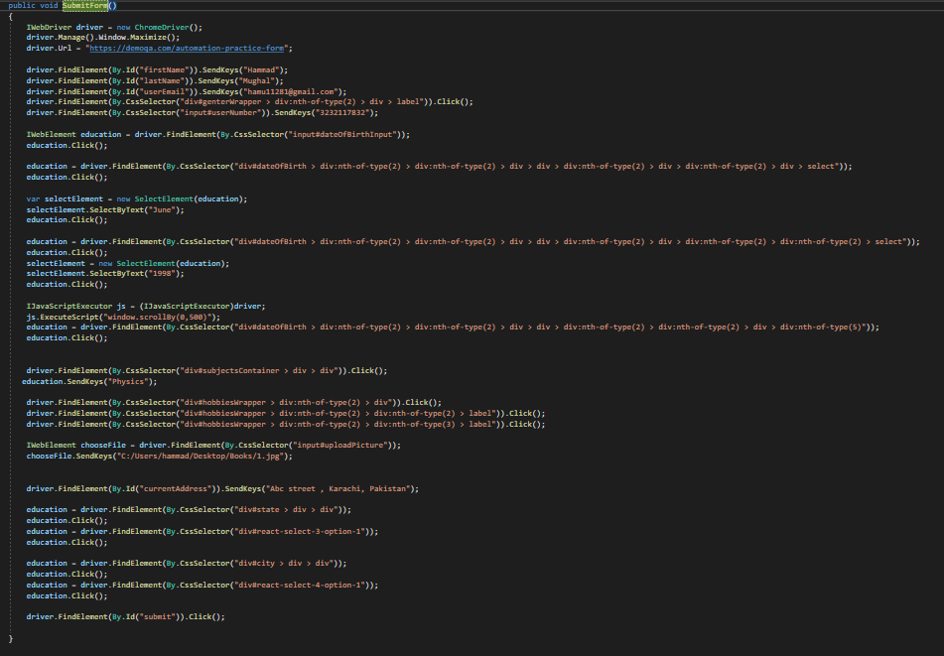

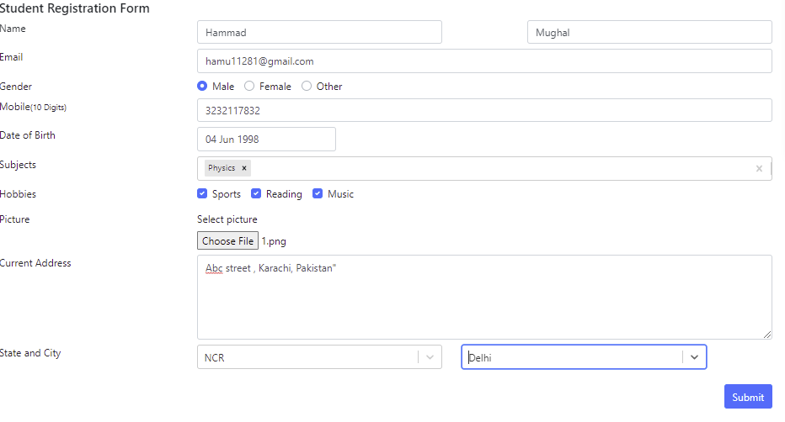

Tabs Selection

Executing manual test and selecting different tabs from the menu.

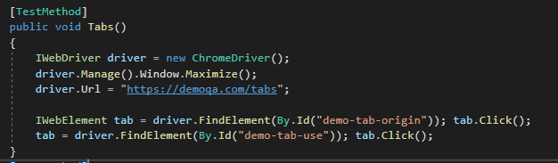

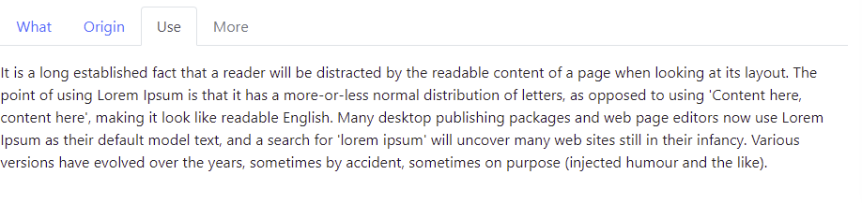

**Testing Different types of textboxes**

Testing manually different types of textboxes entering relevant information.

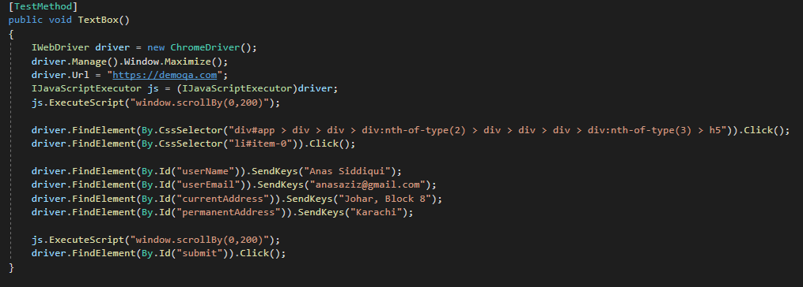

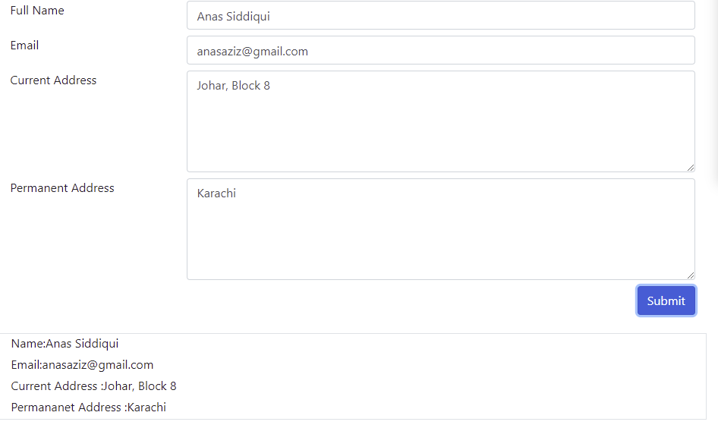

**Entering information in Web Tables**

Adding new information using a manual test.

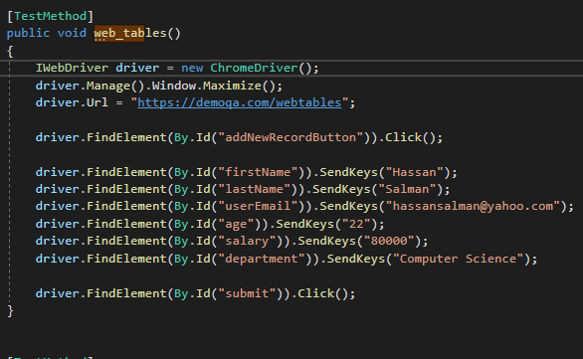

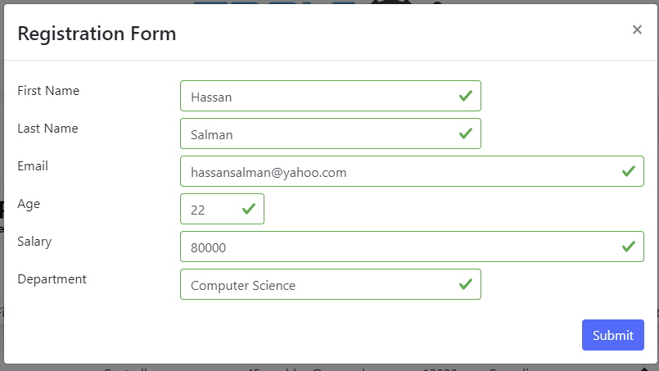

**Testing Widget**

Manal Test selection of different Widgets



