**EXPERIMENT NO.6**

**Sequential Circuit Design**

**SUBMITTED TO:**

Dr. Ubaid Ullah Fayyaz

**SUBMITTED BY:**

Hammad Jafar

2022-EE-176

**UNIVERSITY OF ENGINEERING & TECHNOLOGY, LAHORE**

**Circuit diagram using Vivado:**

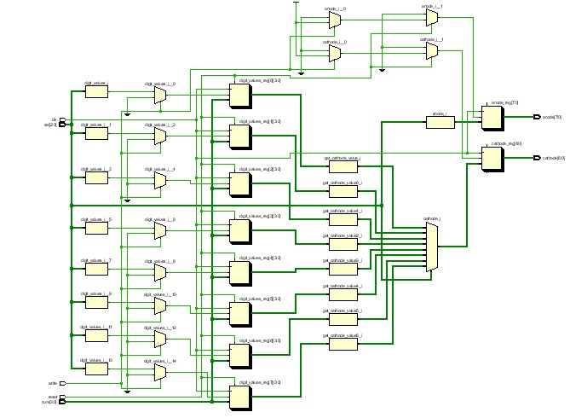

**Delay in Synthesis:**

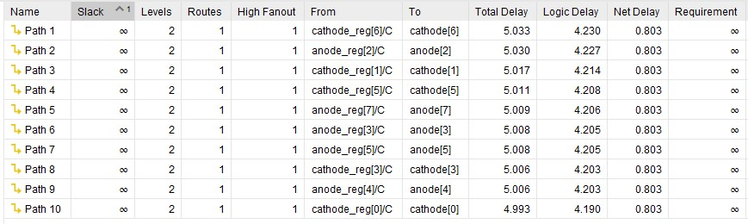

**Delay in Implementation:**

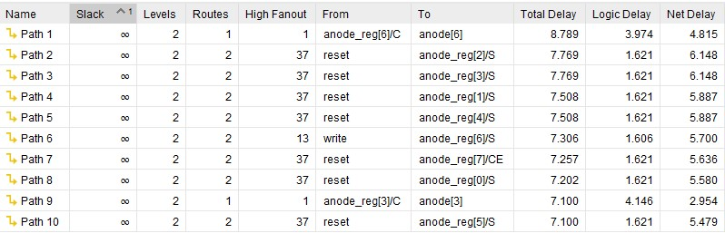

**Resource Utilization:**

