NEBOSH report

HSE


Submitted to:
Mr Yasir Hamid

Submitted By:

MUHAMMAD HAMMAD ABBASI | 23-CS-005
Muhammad sanaullah khan | 23-cs-185
Zainab bibi | 23-cs-097

Department of Computer Science,
HITEC University, Taxila

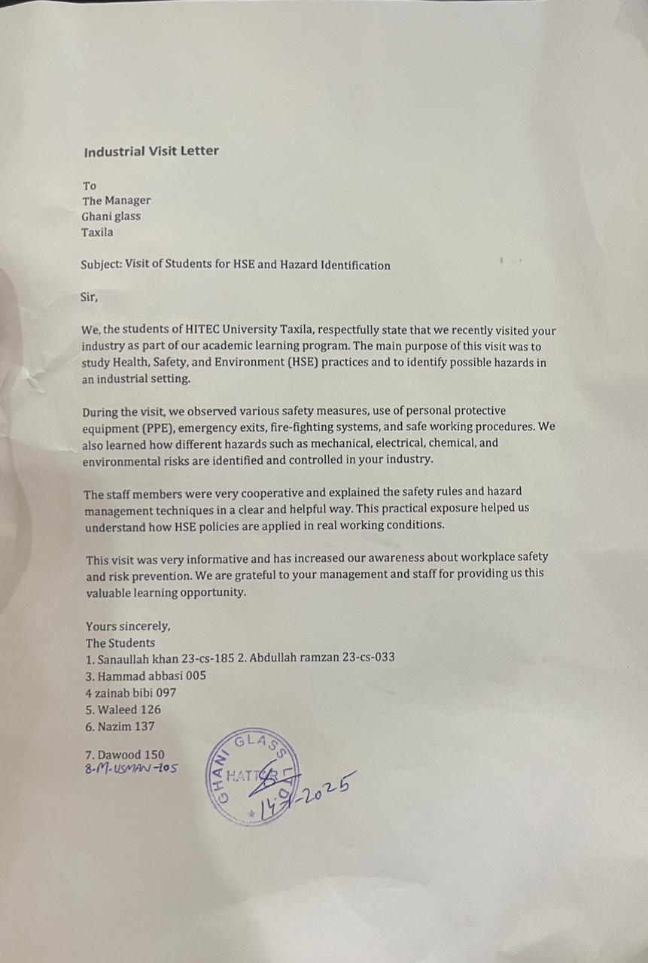

NEBOSH IG2 Risk Assessment Report – Al Ghani Glass Ltd.

Part 1: Background
Name of Organisation: Al Ghani Glass Ltd.
Location: Pakistan
Number of Workers: Approximately 500
Al Ghani Glass Ltd. is a leading glass manufacturing organization involved in the production of float glass and value-added glass products for construction and automotive industries. The manufacturing process includes raw material handling, batch mixing, high-temperature melting furnaces, glass forming, annealing, cutting, polishing, packing, and dispatch.
The organization operates in three shifts of 8 hours to ensure continuous production. Due to the nature of glass manufacturing, employees are exposed to various hazards including sharp glass edges, high temperatures, silica dust, noise, heavy machinery, electricity, fire, and manual handling risks.
The risk assessment covered furnace areas, cutting and polishing sections, packing area, warehouse, maintenance workshop, electrical rooms, and administrative offices. The HSE Manager is responsible for implementation and monitoring of health and safety controls.
Part 1: Introduction and Scope
This risk assessment has been carried out for Al Ghani Glass Ltd., a glass manufacturing factory. The assessment focuses on identifying key hazards in the workplace, evaluating risks, and recommending control measures to ensure the health and safety of all employees.
Scope:
- All production areas, including cutting, polishing, and furnace operations.
- Administrative and office areas.
- Maintenance and storage areas.
Purpose:
- Protect employees from harm.
- Comply with international safety standards (ILO Guidelines).
- Minimize accidents, injuries, and equipment damage.

Part 2: Risk Assessment
Hazard Category & Hazard | Who might be harmed & how | Existing Controls | Further Controls / Actions Required | Timescale | Responsible Person | Risk Level
Manual Handling – Glass Sheets | Workers may suffer back injuries, cuts, crushed fingers | Toolbox talks, basic PPE | Vacuum lifters, training, job rotation, supervision | 2 weeks | HSE Manager | High
Sharp Glass Edges | Cuts, amputations, eye injuries | Safety gloves provided | Cut-resistant gloves, face shields, training, disposal bins | 1 week | Production Manager | High
High Temperature – Furnace | Burns, heat stress, fatal injuries | Restricted access, fire extinguishers | Heat resistant PPE, barriers, ventilation, heat stress monitoring | 1 month | HSE Manager | Very High
Noise – Cutting Machines | Hearing loss, stress, headaches | Warning signage | Noise monitoring, ear protection, health surveillance | 3 weeks | Safety Officer | Medium
Silica Dust & Chemicals | Respiratory diseases, silicosis | Masks occasionally used | LEV systems, respirators, training, medical surveillance | 1 month | HSE Manager | High
Machinery – Cutting & Polishing | Entanglement, crushing, amputations | Emergency stops | Machine guarding, LOTO, maintenance | 2 weeks | Maintenance Manager | Very High
Electricity – Maintenance Work | Electric shock, electrocution | Warning signs | LOTO, insulated tools, electrical training | 1 week | Electrical Supervisor | High
Fire & Explosion | Burns, fatalities, property damage | Fire extinguishers | Fire alarms, no-smoking policy, drills | 3 weeks | Admin Manager | Very High
Work at Height | Falls, fractures, death | Basic PPE | Certified scaffolding, harnesses, PTW | 2 weeks | HSE Manager | High
Slips, Trips & Falls | Sprains, fractures | Housekeeping | Anti-slip flooring, signage, cable management | 1 week | Housekeeping Supervisor | Medium
Part 3: Prioritised Actions
Action 1: Lockout/Tagout on Electrical Equipment
- Legal Basis: ILO C155 & C167 – ensures safe machinery use.
- Likelihood & Severity: High likelihood during maintenance; severity can be major (hospitalization) to catastrophic (fatality). 20–30 workers affected.
- Effectiveness: Eliminates risk during maintenance.
- Timescale: 1 week
Action 2: Barricade Furnace & Fire-Prone Areas
- Legal Basis: ILO Article 29 & R175 – fire safety and training required.
- Likelihood & Severity: Daily exposure to furnace; severity can be catastrophic. ~50 employees affected.
- Effectiveness: Reduces risk drastically with fire drills and barricades.
- Timescale: 3–4 weeks
Action 3: Install Safety Guards on Cutting/Conveying Equipment
- Legal Basis: ILO C167 – machinery must have guards to prevent injury.
- Likelihood & Severity: High; daily handling of sharp glass. Severity: major to catastrophic (amputation). 20–30 workers affected.
- Effectiveness: Prevents direct contact with moving parts.
- Timescale: 2 weeks

Part 4: Review, Communicate & Check
- Review Date: Annually, or sooner if policies, equipment, or accidents occur. Next review: 1st June 2024.
- Communication: Findings will be shared via training, memos, emails, brochures, and presentations. Key stakeholders: HSE Manager, Production Manager, Safety Officer, Administration Manager, CEO, and all employees.
- Follow-Up: HSE Manager to track completion of all actions. Progress verified through site inspections, photos, and videos. Any delays escalated to Administration or CEO.

Conclusion
This risk assessment identifies key hazards in Al Ghani Glass Ltd. and provides practical, legally compliant measures to reduce risk. The prioritised actions target the most serious hazards first, ensuring employee safety while maintaining operational efficiency. Regular review and communication will maintain a safe workplace culture.

Thanks

