PanaVerse Assginment

Question#07&08:

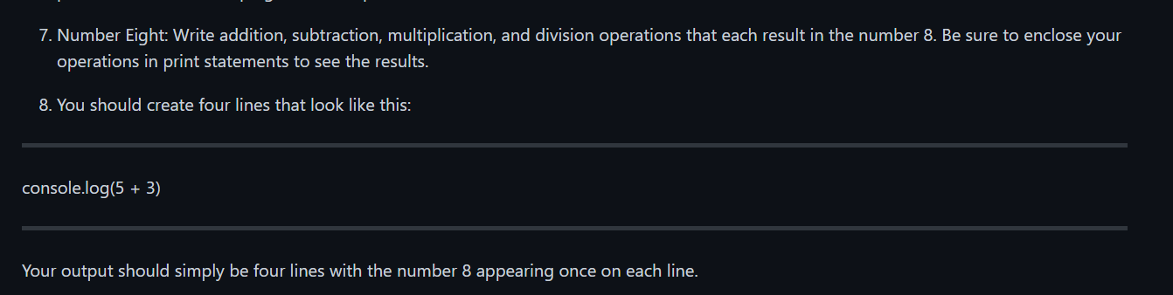

Solution:

|  |  |
| --- | --- |
| Step#01:  What we need(Requirements):   1. We need two number. 2. Perform operations (+, -, *, /) in console statement on numbers.   Step#02:  Let’s do code.   |  | | --- | | Code:  // '+' sign is used for addition.  console.log("2 + 6 = " + (2 + 6)); //display addition of 2 and 6 whose resultant will be 8.  // '-' sign is used for substraction.  console.log("12 - 4 = " + (12 - 4)); //display subtraction of 12 and 4 whose resultant will be 8.  // '*' sign is used for multiplication.  console.log("2 * 4 = " + (2 * 4)); //display multiplication of 2 and 4 whose resultant will be 8.  // '/' sign is used for division.  console.log("16 / 2 = " + (16 / 2)); //display division of 16 and 2 whose resultant will be 8. |   Step#03:  Let’s run the code.  Output/Result: |